**NAME: ……………………………………………………….……………CLASS……..…… ADM NO: ..……....……**

231/1

BIOLOGY

PAPER 1

THEORY

MARCH 2016

2 HOURS

**KAHUHO UHURU HIGH SCHOOL**

**END OF TERM 1 EXAMINATIONS 2016**

**INSTRUCTIONS TO CANDIDATES**

* *Answer* ***ALL*** *questions in this paper in the spaces provided.*

**QUESTIONS( 80 MARKS)**

1. (i) What biological knowledge or study is required in dealing with locusts that infest a maize crop. (1 mark)

(ii) State the functions of the following cell structures. (2 marks)

1. Sap vacuole.
2. Nucleolus.

2. Which **two** classes of phylum arthropoda have their head fused with the thorax? (2 marks)

3. The diagram below represents a stage during cell division.

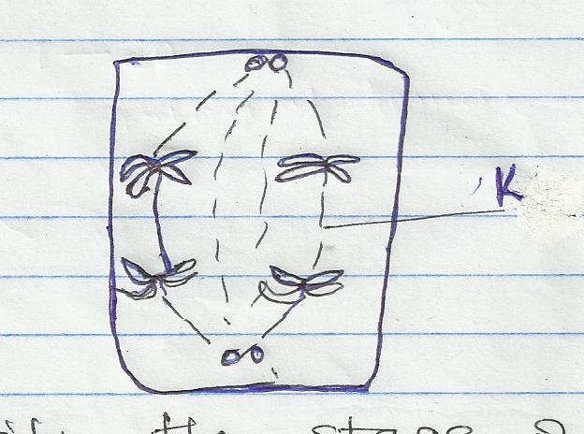

* 1. Identify the stage of cell division. (1 mark)
  2. Give two reasons for your answer (a) above. (2 marks)
  3. Name the structures labeled K. (1 mark)

4. (a) Name **two** raw materials for the dark stage process of photosynthesis. (2 marks)

1. The set up shows an experiment to investigate photosynthesis.

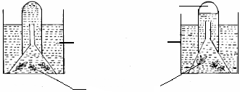

Aquatic plants

Gas collected

At the start

After the experiment

Water containing sodium hydrogen carbonate

(a) What gas was collected in the test tube? (1 mark)

1. What was the role of sodium hydrogen carbonate in the experiment? (2 marks)

5. State **three** adaptations of the phloem tissue. (3 marks)

6. i) Pregnancy continues if the ovary of an expectant mother is removed after 4 months. Explain. (2 marks)

ii) What is the role of testes in the mammalian reproductive system? (2 marks)

7. Name **two** enzymes and **one** metal ion that are needed in the blood clotting process. (3 marks)

Enzymes. ……………………………………….

……………………………………..

Metal ion………………………………………..

8. Name causative agents of each of the following diseases.

1. Typhoid
2. Malaria

9. Name **three** properties of the cell membrane. (3 marks)

10. (a) Define the term carrying capacity. (1 mark)

(b) The table below gives information about an aquarium community which is ecologically balanced.

Type of organism Dry weight (g)

Insect larvae 500

Fishes 5000

Water plants 5000

Bacteria 10

(c) What do you understand by term ecologically balanced? (1 mark)

11. List the changes that takes place during inhalation in the breathing cycle of mammal in the following. (4 marks)

1. Ribcage and thoracic cavity.
2. Diaphragm
3. External intercostal muscles.

1. Internal intercostal muscles.

12. The diagram below shows a section through plant organ.

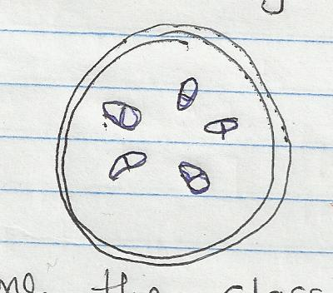

1. (i) Name the class of the section was obtained. (1 mark)

(ii) Give a reason for your answer in (a) above (1 mark)

1. What is the role of vascular bundles in plant nutrition? (2 marks)

13. (a) Give an example of a sex linked trait in humans. (2 marks)

Y chromosome.

X chromosome.

1. (a) Differentiate between hypogeal germination and epigeal germination. (2mks)

(b) State **TWO** internal causes of dormancy in seed. (2mks)

(b) Write the types of gene mutation represented by the following analogues. (2 marks)

(i) Intended message BRING THERMOS ON OUTING

Actual message BRING MOTHERS ON OUTING

Type ……………………………………

(ii) Intended message PLEAS SAY WHERE YOU ARE

Actual message PLEASE STAY WHERE YOU ARE

Type ……………………………………

15. Use the diagram below to answer the questions that follow.

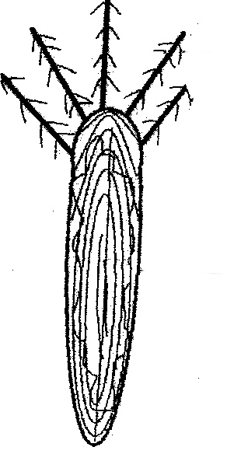

Hooks

Y

(a) Name structure labelled **Y**. (1 mark)

(b) (i) State the agent of dispersal for the structure above. (1 mark)

1. Give a reason for your answer in b(i) above. (1 mark)

16. The diagram shown below represents a male reproductive system.

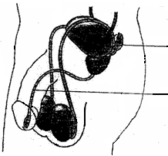

X

Y

(a) Name the structure labelled **X**. (1 mark)

(b) Name **two** substances that pass through structure labelled **Y**. (2 mark)

17. Give **two** reasons why the pressure of blood is greater in the arteries than in the veins in mammals. (2 marks)

18. The leaf of a potted green plant which had been kept in dark for 24 hours was smeared with petroleum jelly on its lower surface and then exposed to sunlight for 6 hours. Starch test on the leaf was negative. Account for the observation. (2 marks)

19. The diagram below shows a part of a nephron.

a) State TWO differences in composition of blood in parts P and R. (2 marks)

b) State a characteristic feature of blood capillaries in part Q that is not found in other capillarities (1 mark)

20. (a) State **two** disadvantages of self pollination in plants. (2 marks)

(b) Explain why the tube nucleus disintegrates just before reaching the embryo sac. (1 mark)

21. (a) State the circulatory system found in members of the class insecta. (1 mark)

(b) Name the blood vessels that transport blood from: (2 marks)

(i) Small intestine to the liver.

1. Lungs to the heart.

22. Why is the pancreas considered a dual gland? (2 marks)

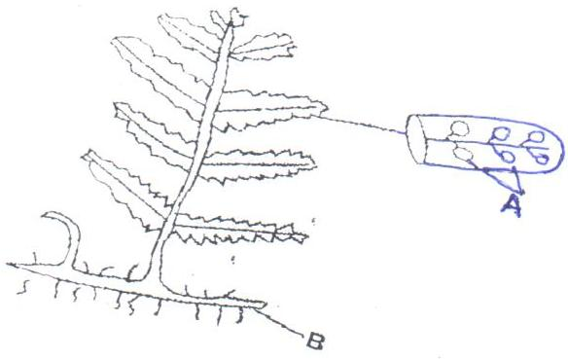23.The diagram below represents a fern.

1. Name parts labelled A and B. (2mks)

A

B

1. In which division does the plant belong? (1mk)
2. State the function of the part labelled A. (1mk)

24. Eight potato cylinder of the same size were used to investigate a certain physiological process. Four of the potato cylinders were placed in solution S. The other four potato cylinders were placed in solution T. After 2 hours, the potato cylinders from solution S were found to longer and stiff, while those from solution T were found to be shorter and flexible. Explain the results in solution S and T. (2 marks)

(b) Distinguish between active transport and diffusion. (2 marks)

25. List **two** enzyme that are secreted in their precursor forms. (2 marks)

26. State **two** effects of gibberellins on shoots of plants. (2 marks)

27. A portion of a nucleic acid is shown below;

-**S–P–S -P-S-P-S-P-S-P- S -**

**C C G U G C**

a) Name the nucleic acid to which the portion belongs. Give a reason. (2 marks)

b) Write down the sequence of bases of a complimentary strand to the one above. (1 mark)