**NAME: ……………………………………………………….……………CLASS……..…… ADM NO: ..……....……**

231/3

BIOLOGY

PAPER 3

PRACTICAL

MARCH 2016

1 ½ HOURS

**KAHUHO UHURU HIGH SCHOOL**

**END OF TERM 1 EXAMINATIONS 2016**

**INSTRUCTIONS TO CANDIDATES**

* *Answer* ***ALL*** *questions in this paper in the spaces provided.*

**QUESTIONS ( 80 MARKS)**

**1.** You are provided with a specimen labelled P. Study it carefully.

a) With observable features only identify specimen P (2 marks)

i) Identity

ii) A reason

b) Make a transverse section of specimen P.

i) Use one half of the cut section of specimen P to draw a well labelled diagram. (4 marks)

ii) Show your magnification. (1 marks)

c) Take another half of specimen P. Press it into the beaker to make an extract.

Use part of the extract and 2cm³ of DCPIP solution in a test tube to complete the table below. (3 marks)

|  |  |  |  |
| --- | --- | --- | --- |
| **TEST** | **Procedure** | **Observations** | **Conclusion** |
| DCPIP test |  |  |  |

d) Use the reagents provided to carry out various food tests.

i) Benedict's test.

Procedure. (1 mark)

Observations (1 mark)

Conclusion (1 mark)

ii) Iodine solution test

Procedure. (1 mark)

Observations. (1 mark)

Conclusion (1 mark)

2. Below is a section through a mammalian organ.

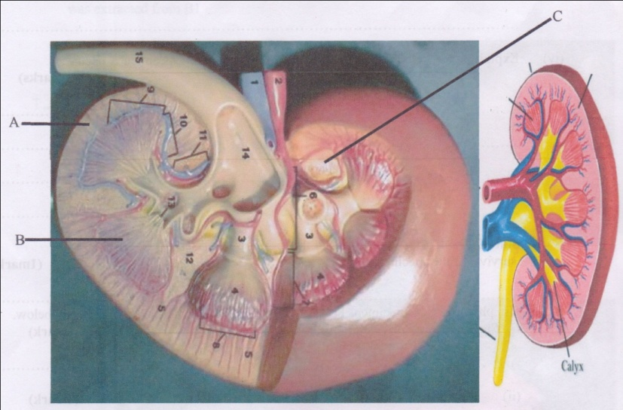

1. Identify the section. (1 mark)
2. Name the parts labeled A, B and C (3 marks)

A-

B-

C-

1. State TWO functions of the photographed specimen. (2 marks)
2. Name a process that occurs in the Glomerulus and Loop of Henle. (2 marks)
3. Glomerulus
4. Loop of Henle
5. The diagram below shows the lower and upper jaw of a certain mammal.



(i) Using observable features on the diagram identify the mode of nutrition for the above mammal. (2 marks)

(ii) Label parts marked P and Q and state the function of each. (2 marks)

P-

Q-

(iii) State the function of part labelled T. (1 mark)

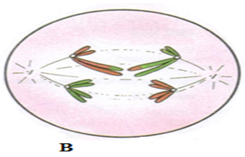3. a) Use the photograph of plant experiment to answer the questions that follow.

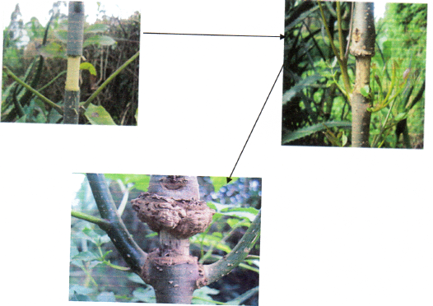

i) Name the process being investigated. (1 mark)

ii) Name the plant tissue involved in the physiological process illustrated above. (1 mark)

iii) Name the physiological process involved in the process illustrated above. (1 mark)

iv) How is the plant tissue named in 1 (a) (iii) above adapted to its function.

b) Study photographs C and D and answer the questions.

Photograph C Photograph D

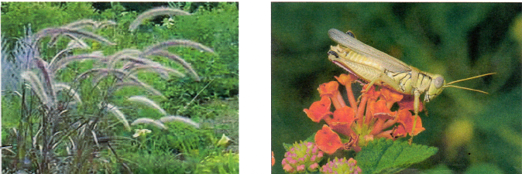

i) With a reason state the agent of pollination of each of the flowers. (4 marks)

ii) Classify the animal in photograph D using the taxonomic units below and reasons for your answer (4 marks)

**Taxonomic unit Reason**

Phylum…………………………. …………………………………………………………………….

Class……………………………. …………………………………………………………………….

231/3

BIOLOGY

PAPER 3

MARKING SCHEME

MARCH 2016

1 ½ HOURS

**KAHUHO UHURU HIGH SCHOOL**

**END OF TERM 1 EXAMINATIONS 2016**

**Marking scheme**

**1.a)** i) A fruit / fruit Rj. an orange***;***

ii) Presence of two scars / pericarp / endocarp / placenta / seed (s) ***2mks***



**b)**

***L = 2mks***

***D = 2mks***

***4mks***

ii) Magnification = Drawing length

object /actual length

× 0.5 - × 1.0 ***2 marks***

**c)**

|  |  |  |
| --- | --- | --- |
| Test | Observations | Conclusion |
| DCPIP | The blue colour of DCPIP solution disappears / is decolourised | the extract contains vitamin C / ascorbic acid |

**d)** i) **Procedure**: Place 2cm³ of extract into a test tube, add 2cm³ Benedicts solution to the extract, heat to boil. ***1 mark***

**Observation**: Colour changes to orange / brown. ***1 mark***

**Conclusion** - extract contains a reducing sugar ***1 mark***

ii) **Observation**: colour of iodine remains / brown colour of iodine solution persists; ***1mk***

**Conclusion:** starch absent in the extract; ***1mk***

2. (a) – kidney

(b) – A – cortex

B – medulla

C – pelvis

(c) - excretion

- osmoregulation

- ionic balance

- regulation of Ph

(d) mark on the diagram

(e) (i) ultra-filtration

(ii) osmosis

(f) – nephritis

- kidney stones

- albuminuria / proteinuria

- kidney failure

1. (a) (i) Translocation

(ii) Phloem tissue

(iii) Active transport/mass flow through diffusion.

(iv) - Have sieve plates that support the phloem tissue.

- Have sieve pores that acts as a pathway to allow movement of materials.

- Sieve tubes are cylindrical and joined end to end interconnected by cytoplasmic filaments.

- Sieve elements lack other cell components like nuclears.

- Has companion cells that have numerous mitochondria to supply energy needed for active transport.

- Presence of plasmodesmata between sieve elements and companion cells to facilitate movement of materials

between.

(b) (i) C wind – Inconspicuous petals/large anthers loosely attached to flexible filaments/long feathery stigma which hang outside the flower.

D – Insect – Large flowers with brightly coloured petals/produce nectar (insect on diagram)

Reason

(ii) Phylum Arthropoda - Jointed appendages/presence of exoskeleton/segmented body/

3 body parts (2 mks)

Class Insecta - 3 body parts/ A pair of antennae pair of compound

eyes/spiracles for breathing.