NAME……………………………………………………ADM NO….............CLASS………….

SIGNATURE…………………………………………………DATE………………………….

PRE-MOCK 1
BIOLOGY
PAPER 1
(THEORY)
TIME: 2 HOURS

INSTRUCTIONS TO CANDIDATES:

Write your Name, Class and Adm noin the spaces provided above.
Answer all the questions in this paper in the spaces provided.

FOR EXAMINER’S USE ONLY:
Question | Maximum  Score | Candidate’s  Score
1 - 25 | 80

1. (a) Define the term ‘parthenocarpy’. (1mk)

___________________________________________________________________________

___________________________________________________________________________

___________________________________________________________________________

(b) Name two plant growth hormones that promote parthenocarpy. (2mks)

___________________________________________________________________________

___________________________________________________________________________

2. Name the organelle that performs each of the following functions in a cell
(i) Protein synthesis. (1mk)

___________________________________________________________________________

(ii) Transport of cell secretions. (1mk)

___________________________________________________________________________

3. The diagram below shows a longitudinal section of mammalian skin.

a) Name the parts labelled F and G. (2mrks)

F _________________________________________________________
G _________________________________________________________
b) State onefunction of each of the parts labelled H and J (2mrks)
H _________________________________________________________
J __________________________________________________________

4. Other than carbon (IV) oxide, name other products of anaerobic respiration in plants (2mks)

___________________________________________________________________________

___________________________________________________________________________

5. (a) Name the fluid that is produced by sebaceous glands. (1mk)

___________________________________________________________________________

- State two functions of sweat on the human body. (2mks)

___________________________________________________________________________

___________________________________________________________________________

6. (a) State two characteristics that are used to divide the phylum arthropoda into classes.(2mks)
___________________________________________________________________________

___________________________________________________________________________

___________________________________________________________________________

___________________________________________________________________________

(b)Name the class with the largest number of individuals in the phylum Arthropoda. (1mk)

___________________________________________________________________________

7. Why are people with blood group O referred to as universal donors? (1mk)
______________________________________________________________________________
______________________________________________________________________________
______________________________________________________________________________
8. The diagram below represents a longitudinal section of a fruit
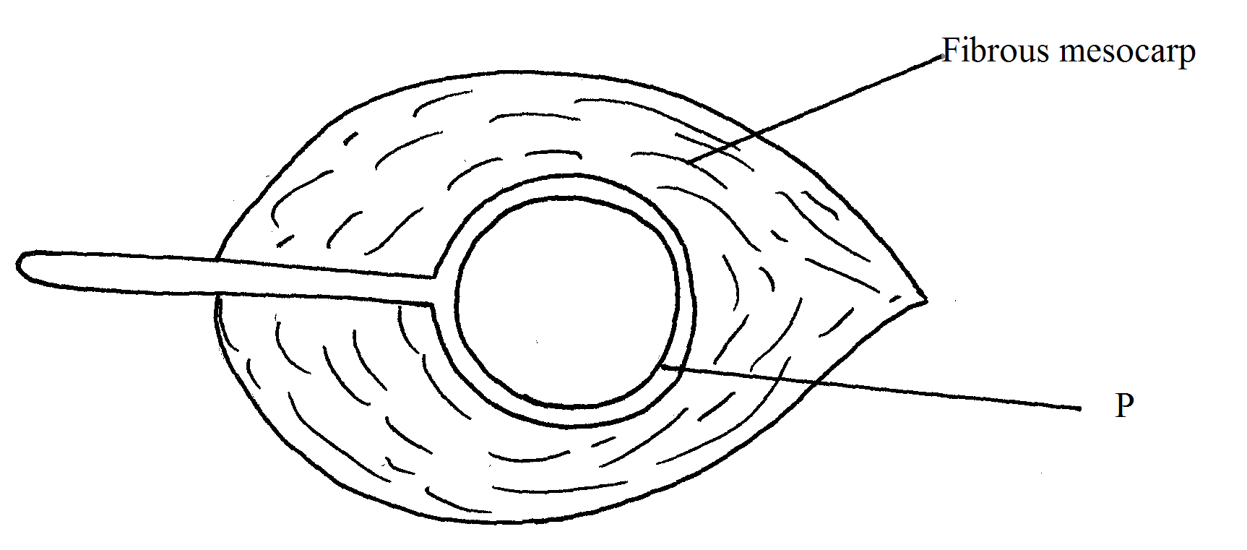
(a) Name structures labeled P (1mk)
______________________________________________________________________________
(b) Describe two adaptations of the fruit for its mode of dispersal (3mks)
(i) Mode of dispersal
____________________________________________________________________________
(ii) Adaptation
________________________________________________________________________________________________________________________________________________________________________________________________________________________________________________________________________________________________________________________

9. (a) What causes the following diseases?
(i) Diabetes mellitus. (1mk)
_____________________________________________________________________
_____________________________________________________________________

(ii) Diabetes insipidus. (1mk)
_____________________________________________________________________
_____________________________________________________________________

b) An individual shows the symptoms for diabetes mellitus, how would you determine in the school laboratory whether they are positive for the condition?(3mks)

___________________________________________________________________________

___________________________________________________________________________

___________________________________________________________________________

___________________________________________________________________________

10. In an attempt to estimate the number of weaver birds in a small woodland 435 were captured , marked and released. Three days later, 620 were captured 75 of which were marked.
a) What is the name of the sampling method described above? (1mk)

______________________________________________________________________________

b) Calculate the approximate size of the weaver bird population in the woodland.(2mks)
________________________________________________________________________________________________________________________________________________________________________________________________________________________________________________________________________________________________________________________________________________________________________________________________________________________________________________________________________________________________________________________________________________________________________________________________
c) Give one disadvantage of this method. (1mk)
________________________________________________________________________________________________________________________________________________________________________________________________________________________
11.Identify the nucleic acid whose base sequence is shown below.
G-A-C-U-A-G-A-C-G
i) Identify the type of nucleic shown above (1mk)
______________________________________________________________________________
ii) Give reason for your answer in (i) above. (1mk)
____________________________________________________________________________________________________________________________________________________________
iii) Write the base sequence of a DNA strandfor the nucleic acid shown above(1mk) ______________________________________________________________________________________________________________________________________________
12. The diagram below shows a mature embryo sac of a flowering plant.
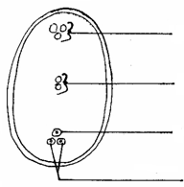
A
B
C
D

- Name the parts labeled A and B (2mks)

A________________________________________________________________

B________________________________________________________________

(b) What is the function of the structure labeled B? (1mk)

___________________________________________________________________________

___________________________________________________________________________

___________________________________________________________________________

13. (a) Name the tissues that transport water in plants. (1mk)

___________________________________________________________________________

(b) State why the tissue above is said to be dead. (1mk)

___________________________________________________________________________

___________________________________________________________________________

14. The diagram below shows regions of growth in a root. Study it and answer the questions that follow.

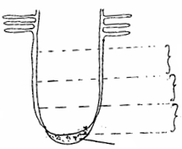
A
B
C
K

- Name the zone labeled B

__________________________________________________________ (1mk)

(b) State the function of part K (1mk)

_____________________________________________________________
(c) State three characteristics of the cells found in zone C(3 mks)
____________________________________________________________________________________________________________________________________________________________________________________________________________________________________________________________________________________________________________________________________________________________________________________________________________________________________________________________________________________
15. The enzymes pepsin and trypsin are secreted in their inactive forms. Explain why they are secreted in these inactive forms. (1mk)

___________________________________________________________________________

___________________________________________________________________________

__________________________________________________________________________

16. (a) Give two examples of natural selection in action. (2mk)
_______________________________________________________________________________________________________________________________________________________________________________________________________________
b) List three features that make man the most dominant species on earth. (3mks)
______________________________________________________________________________________________________________________________________________________________________________________________________________________________________________________________________________________________________________________________________________________________________________________________________
17. Study the diagram below of a neurone in human being.
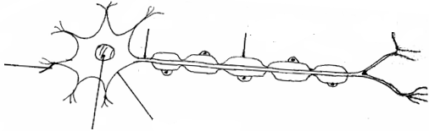
B
CcCCCAAAAxon
Cell body
Nucleus

A
Effector dendrites

(a) Identify the neurone. (1mk)

___________________________________________________________________________

- Name the parts labeled.

A ___________________________________________________ (1mk)

B ____________________________________________________ (1mk)

- Using an arrow indicate the direction of movement of a nerve impulse along the neuron (1mk)
18. Study the diagram of the mammalian tooth below and answer the questions that follow.
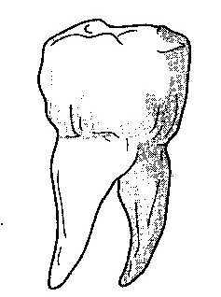

(a) Identify the tooth. (1mk)

___________________________________________________________________________

(b) Give a reason for your answer in (a) above. (1mk)

___________________________________________________________________________

___________________________________________________________________________

___________________________________________________________________________

(c) State one adaptation of the tooth to its function. (1mk)

___________________________________________________________________________

___________________________________________________________________________

___________________________________________________________________________

19.a) Name the part of the brain that regulates breathing (1mk)
______________________________________________________________________________
b) Give two ways through which the body responds to increased concentration of carbon (IV) oxide in the blood (2mks)
_______________________________________________________________________________________________________________________________________________________________________________________________________________________________________________________________________________________________________________________
c) Name the structures in pneumatophores through which gaseous exchange occurs. (1mk)

____________________________________________________________________________

20. The concentration of carbon (IV) oxide in a tropical forest was measured during the course of 24 hours period from mid-night to mid-night.

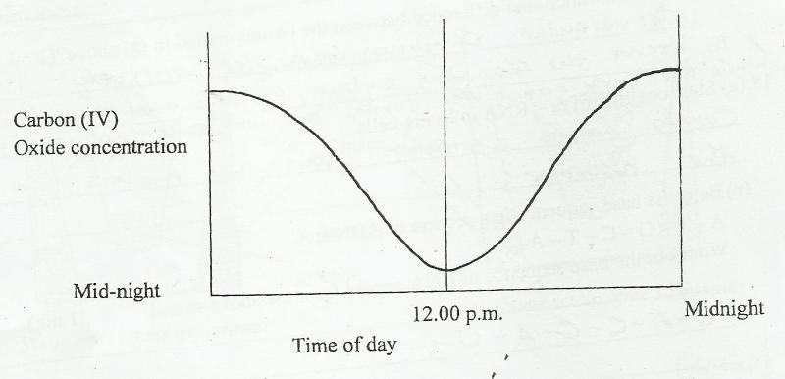

Account for the results obtained at mid day. (2mks)
______________________________________________________________________________________________________________________________________________________________________________________________________________________________________________________________________________________________________________________________________________________________________________________________________

21. The diagram below represents the anterior view of a certain vertebra.
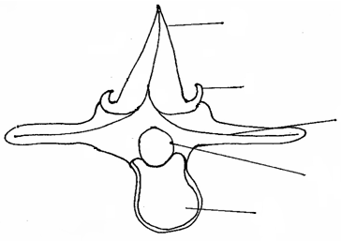
A
B
C
D
E

(a) With a reason, identify the type of vertebra shown above. (2mks)

___________________________________________________________________________

___________________________________________________________________________

___________________________________________________________________________

___________________________________________________________________________

- Name the parts labeled.

(i) A _________________________________________________ (1mk)

(ii) D _________________________________________________ (1mk)

(c) State the function of part E. (1mk)

___________________________________________________________________________

___________________________________________________________________________

22.(a) State one similarity between diffusion and osmosis (1mk)
__________________________________________________________________________________________________________________________________________________________________________________________________________________________________________
(b) State two factors that can reduce the rate of active transport (2mks)
________________________________________________________________________________________________________________________________________________________________________________________________________________________________________________________________________________________________________________________
23.Study the diagram below and use it to answer the questions.
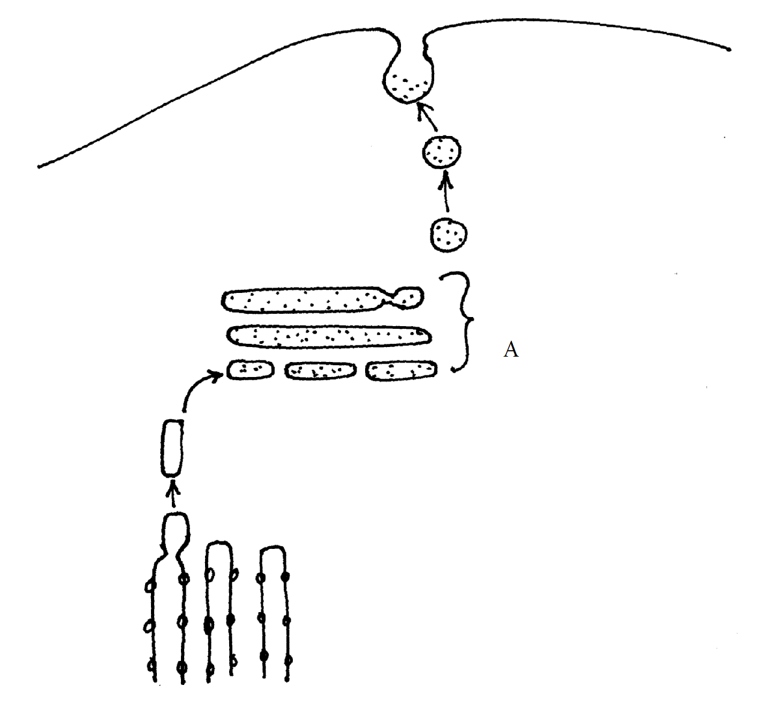
a) Identify the organelle marked A. (1mk)
______________________________________________________________________________

b) Give three functions of the organelle named in (a) above (3mks)
__________________________________________________________________________________________________________________________________________________________________________________________________________________________________________________________________________________________________________________________________________________________________________________________________________________________________________________________________________________________________________________________________________________________________

24. It was found that during germination of pea seeds 9.3cm³ of carbon (iv) oxide was produced while 9.1cm³ of oxygen was used up.
a) Calculate the respiratory quotient (RQ) of the reaction taking place.(2mks)
________________________________________________________________________________________________________________________________________________________________________________________________________________________________________________________________________________________________________________________________________________________________________
b) Identify the type of food substance being metabolized. (1mk)

______________________________________________________________________________
25. What is the biological importance of the larval stage during metamorphosis(2mks)
______________________________________________________________________________________________________________________________________________________________________________________________________________________________________________________________________________________________________________________________________________________________________________________________________

