**Name____________________________________Class_______________AdmNo:__________**

**Date__________________________________________Sign_______________**

**END OF TERM ONE EXAMINATION**

**FORM TWO**

**BIOLOGY**

**TIME: 2 HOURS**

**INSTRUCTIONS TO THE CANDIDATES**

1. Answer all questions in the spaces provided in the question paper.
2. Answer all questions in section A and two questions in section B.
3. Question 21 is compulsory

**FOR EXAMINERS USE ONLY**

|  |  |  |
| --- | --- | --- |
| **SECTION** | **MAXIMUM SCORE** | **CANDIDATES SCORE** |
| **A** | **70** |  |
| **B** | **30** |  |
| **TOTAL SCORE** | **100** |  |

**SECTION A (60MARKS) ANSWER ALL QUESTION**

1. State the importance of each of the following in living organisms
2. Nutrition (1mk)

……………………………………………………………………………………………..

1. Excretion (1mk)

……………………………………………………………………………………………..

1. State two functions of cell sap (2mks)

………………………………………………………………………………………………………………………………………………………………………………………………………………………………………………………………………………………………………

1. Which organelle would be abundant in: (2mks)
2. Skeletal muscle cell ……………………………………………………………………..
3. Palisade cell …………………………………………………………………….
4. The diagram below shows a specified plant cell

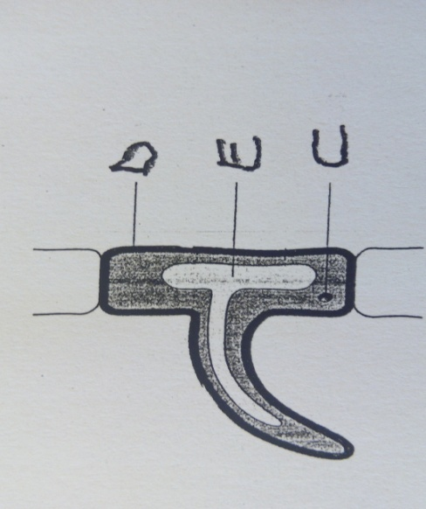

1. Name the cell (1mk)

……………………………………………………………………………………

1. Name the parts labelled D and E (2mks)

D ………………………………………………………………………………………………..

E ………………………………………………………………………………………………..

1. State the functions of the following parts of alight microscope. (2mks)
2. Objective lens

………………………………………………………………………………………………………

1. Diaphragm

………………………………………………………………………………………………………

1. Using a microscope, a student counted 55 cells across a field of view whose diameter was 6000 $μ$ m. Calculate the average length of cells. Show your working. (2mks)

7(a) Distinguish between diffusion and osmosis (2mks)

………………………………………………………………………………………………………………………………………………………………………………………………………………………………………………………………………………………………………

…………………………………………………………………………………………………

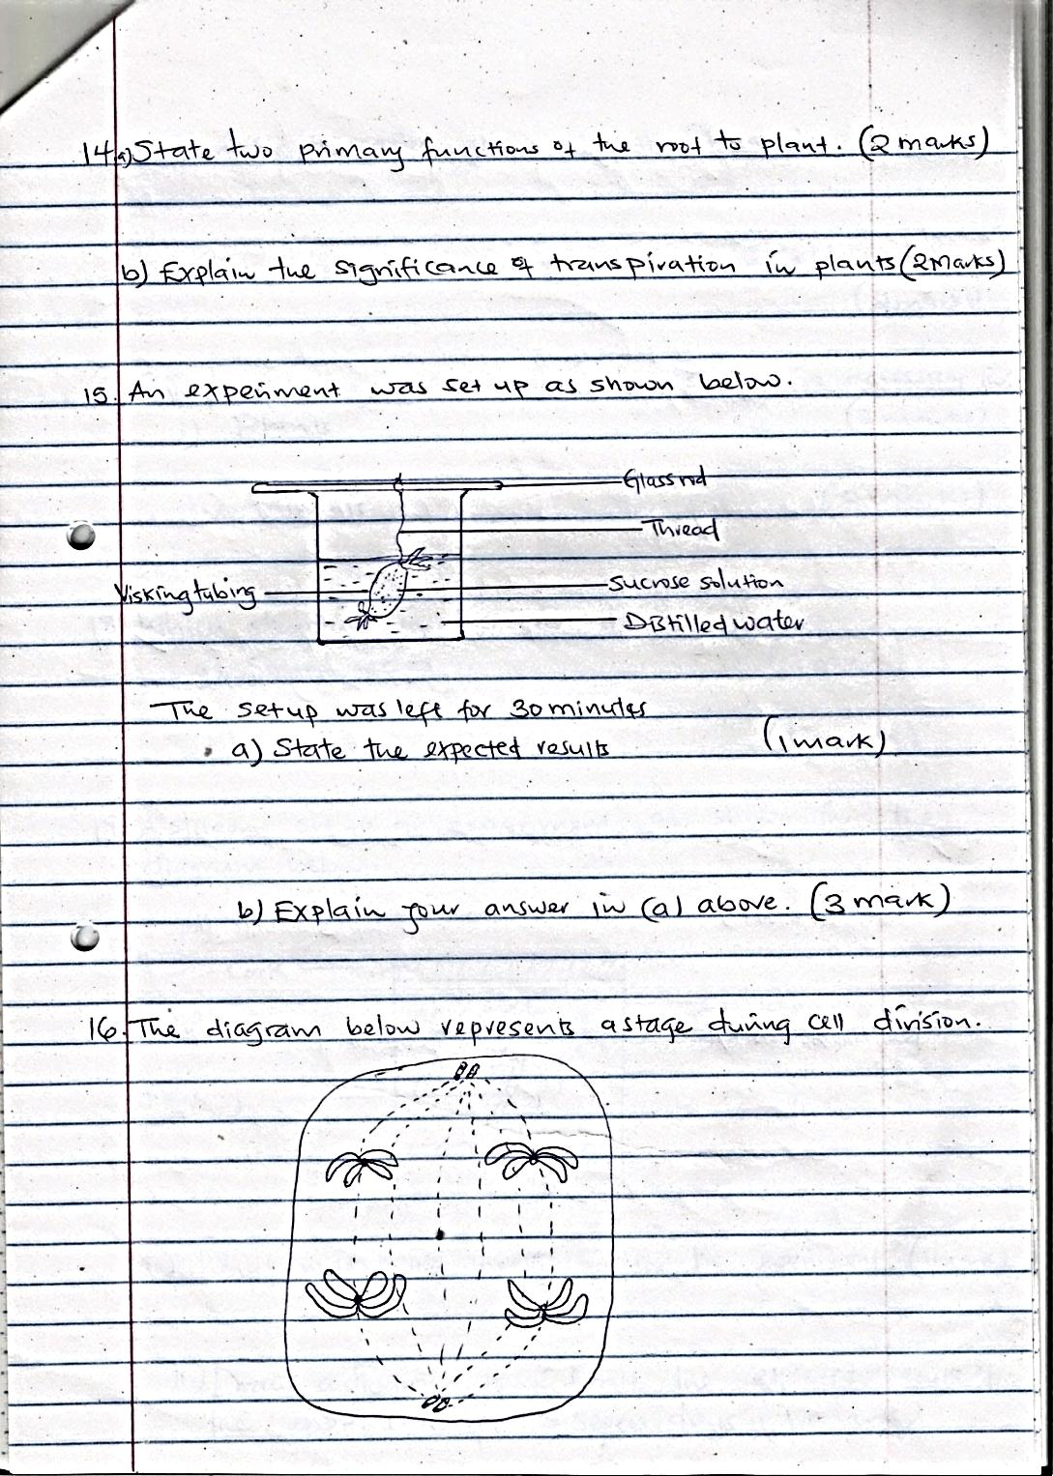b)An experiment was set as shown below

The set up was left for 30 minutes.

1. State the expected results (1mk)

………………………………………………………………………………………………………

1. Explain your answer in b(i) above (3mks)

………………………………………………………………………………………………………………………………………………………………………………………………………………………………………………………………………………………………………………………………………………………………………………………………………………………………

8.State four factors that increase the rate of diffusion (4mks)

………………………………………………………………………………………………………………………………………………………………………………………………………………………………………………………………………………………………………

……………………………………………………………………………………………………………………………………………………………………………………………………

9.What is meant by the following terms?

1. Crenated cell (1mk)

…………………………………………………………………………………………………….

1. Flaccid cell (1mk)

…………………………………………………………………………………………………….

10. Distinguish between heterotrophism and autotrophism (2mks)

………………………………………………………………………………………………………………………………………………………………………………………………………………………………………………………………………………………………………

11. Study the diagram below

T

1. Name the process which takes place in the organelle (1mk)

………………………………………………………………………………

1. Name the pigment in the structure labelled T and state its function (2mks)

Pigment……………………………………………………………………..

Function……………………………………………………………………

1. Name three cells of a leaf where the above structure is found (3mks)

………………………………………………………………………………………………………………………………………………………………………………………………………………………………………………………………………………………………………

12. State four external factors that affect the rate of photosynthesis (4mks)

………………………………………………………………………………………………………………………………………………………………………………………………………………………………………………………………………………………………………

……………………………………………………………………………………………………………………………………………………………………………………………………

13. State three properties of monosaccharide (3mks)

………………………………………………………………………………………………………………………………………………………………………………………………………………………………………………………………………………………………………

14. Discuss four adaptations of the carnivores to their mode of feeding (4mks)

………………………………………………………………………………………………………………………………………………………………………………………………………………………………………………………………………………………………………

………………………………………………………………………………………………………………………………………………………………………………………………………………………………………………………………………………………………………

15

1. What is the importance of mastication during digestion? (1mk)

……………………………………………………………………………………………………………………………………………………………………………………………………

1. State three roles of saliva during digestion (3mks)

………………………………………………………………………………………………………………………………………………………………………………………………………………………………………………………………………………………………………

……………………………………………………………………………………………………………………………………………………………………………………………………

16. The diagram below shows part of a mammalian circulatory system

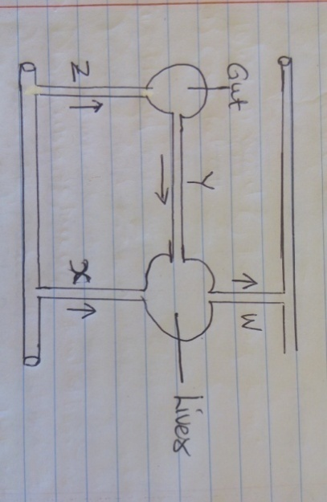

1. Name the blood vessels marked Y and Z (2mks)

Y ……………………………………………………

Z **………………………………………………………**

1. A student took a meal rich in proteins and carbohydrates. It was found that the glucose level in blood vessel W was lower than blood vessel Y. Explain (1mk)

………………………………………………………………………………………………………………………………………………………………………………………………………………………………………………………………………………………………………

17.

1. What is active transport? (1mk)

……………………………………………………………………………………………………………………………………………………………………………………………………

1. Give four roles of active transport (4mks)

………………………………………………………………………………………………………………………………………………………………………………………………………………………………………………………………………………………………………………………………………………………………………………………………………………………………………………………………………………………………………………………………………………………………………………………………………………

18. During a Biology practical lesson, the teacher provided students with the following apparatus; a porter, a scalpel, specimen bottle, a pair of forceps, sweep net and chloroform.

1. Give four precaution that a biology teacher gave the students before the practical when collection of specimen began (4mks)

……………………………………………………………………………………………………………………………………………………………………………………………………………………………………………………………………………………………………………………………………………………………………………………………………………………………………………………………………………………………………………

1. What was the function of the following apparatus (4mks)
2. Pooter

………………………………………………………………………………………………………

1. Sweep net

………………………………………………………………………………………………………

1. Chloroform

………………………………………………………………………………………………………

1. A pair of forceps

………………………………………………………………………………………………………

19. The following is an illustration of a certain process that occurs in mammals.

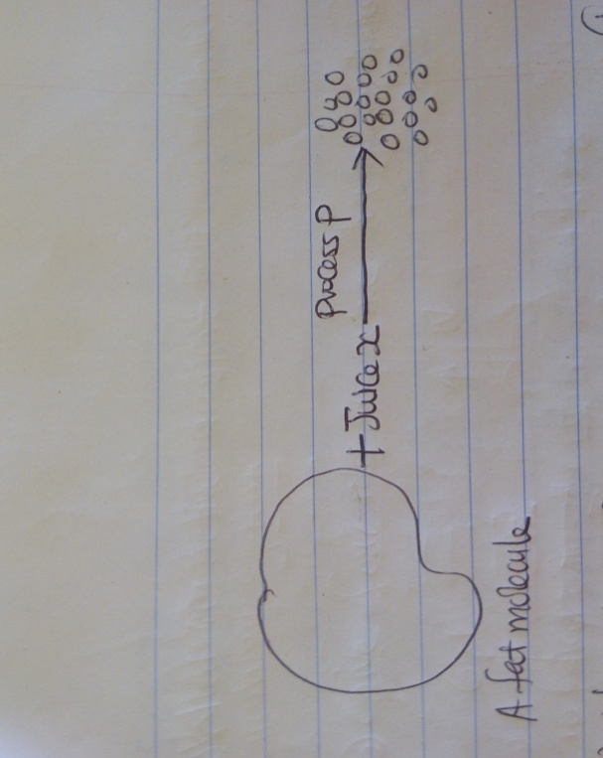

1. Name process P (1mk)

………………………………………………………………………………………………………

1. Name the juice involved in process P (1mk)

………………………………………………………………………………………………………

1. Give a reason why liver damage leads to impaired digestion of fats (1mk)

………………………………………………………………………………………………………………………………………………………………………………………………………………

1. What would be likely effect on digestion if the small intestine of a human being is reduced in an operation (1mk)

………………………………………………………………………………………………………………………………………………………………………………………………………………

20. Name two specialized tissue in mammals (2mks)

………………………………………………………………………………………………………………………………………………………………………………………………………………………………………………………………………………………………………

**SECTION B: 40 marks**

**Question 21 is compulsory**

**Answer question 21 and either question 22 or 23**

21.An experiment was carried out to investigate the effect of temperature on the rate of reaction catalyzed by an enzyme. The results are shown in the table below.

|  |  |
| --- | --- |
| TEMPERATURE (OC) | RATE OF REACTION IN MG OF PRODUCTS PER UNIT TIME |
| **5** | **0.2** |
| **10** | **0.5** |
| **15** | **0.8** |
| **20** | **1.1** |
| **25** | **1.5** |
| **30** | **2.1** |
| **35** | **3.0** |
| **40** | **3.7** |
| **45** | **3.4** |
| **50** | **2.8** |
| 55 | 2.1 |
| 60 | 1.1 |

1. On the grid provided below draw a graph of rate of reaction against

temperature. 6mks

1. When was the rate of reaction 2.6 mg of product per unit time? 2mks

……………………………………………………………………………………………………………………………………………………………………………………………………

1. Account for the shape of the graph between
2. 5oc and 40oc 2mks

………………………………………………………………………………………………………………………………………………………………………………………………………………………………………………………………………………………………………………………

1. 45oc and 60oc 3mks

………………………………………………………………………………………………………………………………………………………………………………………………………………………………………………………………………………………………………………………

1. Other than temperature name two ways in which the rate of reaction between 5oc and 40oc could be increased. 2mks

………………………………………………………………………………………………………………………………………………………………………………………………………………………………………………………………………………………………………

* 1. Name one digestive enzyme in the human body which works best in acidic condition. 1mk

…………………………………………………………………………………………………

* 1. How is the acidic condition for the enzyme named in (e) (i) above attained? 2mks

………………………………………………………………………………………………………………………………………………………………………………………………………………………………………………………………………………………………………

1. The acidic conditions (e) (ii) above are later neutralized.
2. Where does the neutralization take place? (1mk)

………………………………………………………………………………………………………………………………………………………………………………………………………………………………………………………………………………………………………………………

1. Name the substance responsible for neutralization. (1mk)

…………………………………………………………………………………………………….

22. Describe how water moves from the soil to the leaves of a tree (10mks)

23.

1. Explain how the mammalian intestines are adapted to performtheir function (5 mks)
2. Describe how environmental factors increase the rate of transpiration in terrestrial plants (5 mks)

………………………………………………………………………………………………………………………………………………………………………………………………………………………………………………………………………………………………………………………………………………………………………………………………………………………………………………………………………………………………………………………………………………………………………………………………………………

………………………………………………………………………………………………………………………………………………………………………………………………………………………………………………………………………………………………………

………………………………………………………………………………………………………………………………………………………………………………………………………………………………………………………………………………………………………

………………………………………………………………………………………………………………………………………………………………………………………………………………………………………………………………………………………………………

………………………………………………………………………………………………………………………………………………………………………………………………………………………………………………………………………………………………………

………………………………………………………………………………………………………………………………………………………………………………………………………………………………………………………………………………………………………

………………………………………………………………………………………………………………………………………………………………………………………………………………………………………………………………………………………………………

………………………………………………………………………………………………………………………………………………………………………………………………………………………………………………………………………………………………………

………………………………………………………………………………………………………………………………………………………………………………………………………………………………………………………………………………………………………

………………………………………………………………………………………………………………………………………………………………………………………………………………………………………………………………………………………………………

……………………………………………………………………………………………………………………………………………………………………………………………………………………………………………………………………………………………………………………………………………………………………………………………………………………………………………………………………………………………………………

………………………………………………………………………………………………………………………………………………………………………………………………………………………………………………………………………………………………………

…………………………………………………………………………………………………

………………………………………………………………………………………………………………………………………………………………………………………………………………………………………………………………………………………………………

………………………………………………………………………………………………………………………………………………………………………………………………………………………………………………………………………………………………………

………………………………………………………………………………………………………………………………………………………………………………………………………………………………………………………………………………………………………