Name…………………………………… …………………………..………… Index No:………………………….

231/1 Candidate’s Signature …………..……………
BIOLOGY Date: …………………………
PAPER 1
THEORY
JULY/AUGUST 2014
TIME: 2 HOURS

Kenya Certificate of Secondary Education (K.C.S.E.)

231/1
Biology
Paper 1
2 hours

INSTRUCTIONS TO CANDIDATES

- Write your name and indexnumber in the spaces provided above
- Sign and write the date of examination in the spaces provided.
- Answer all the questions in the spaces provided.

For Examiners Use Only
Question | Maximum score | Candidate’s score
1- 27 | 80

This paper consists of 8 printed pages. Candidates should check to ascertain that all pages are printed as indicated and that no questions are missing.
Answer ALL the questions in the spaces provided.

- State the name given to the study of (2mks)
- the blood
………………………………………………………………………………………………….
………………………………………………………………………………………………….
- classification of living organisms.
………………………………………………………………………………………………….
………………………………………………………………………………………………….
- (a) Name the products of complete hydrolysis of sucrose. (1mk)
………………………………………………………………………………………………….
………………………………………………………………………………………………….
- (b) What happens to these products named in (a) above, when they are excess in the
body of man. (2mks)
………………………………………………………………………………………………….
………………………………………………………………………………………………….
3. (a) State the roles of light in plant nutrition. (2mks)
………………………………………………………………………………………………….
………………………………………………………………………………………………….
(b) Give a reason why glucose formed at the end of photosynthesis is converted at once
into starch. (1mk)
………………………………………………………………………………………………….
………………………………………………………………………………………………….
- (i) What is respiration? (1mk)
………………………………………………………………………………………………….
………………………………………………………………………………………………….
(ii) State any two importance of respiration. (2mks)
………………………………………………………………………………………………….
………………………………………………………………………………………………….
- (a) State the formula for calculating linear magnification of a specimen when using a hand lens.
(1mk)
………………………………………………………………………………………………….
………………………………………………………………………………………………….
(b) Give one functional adavantgae of use of the following microscopes. (2mks)
(i) Light Microscope
………………………………………………………………………………………………….
………………………………………………………………………………………………….
(ii) Electron Microscope.
………………………………………………………………………………………………….
………………………………………………………………………………………………….

- An investigation was set up as shown in the diagram below.
Glass rod
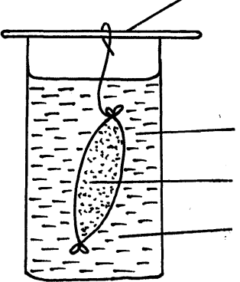

Visking tubing

Starch suspension
Iodine solution

After 30 minutes, starch suspension had turned blue-black while iodine solution retained its colour.
- Name the physiological process that was being investigated in the experiment. (1mk)
………………………………………………………………………………………………….
………………………………………………………………………………………………….
- Account for the results observed after 30 minutes. (3mks)
………………………………………………………………………………………………….
………………………………………………………………………………………………….
………………………………………………………………………………………………….
- a)(i) Name the bacteria found in the root nodules of leguminous plants. (1mk)
………………………………………………………………………………………………….
………………………………………………………………………………………………….
(ii)What is the nutritional relationship between this bacteria and the leguminous plant. (1mk)
………………………………………………………………………………………………….
………………………………………………………………………………………………….
- (a) Distinguish between homodonts and heterodonts. (1mk)
………………………………………………………………………………………………….
………………………………………………………………………………………………….
(b)A certain mammal has no incisors, no canines, 6 premolars and 6 molars in the upper jaw.
In the lower jaw, there are 6 incisors, 2 canines, 6 premolars and 6 molars.
- Write down the dental formular of this mammal . (1mk)
………………………………………………………………………………………………….
………………………………………………………………………………………………….
- What is the mode of nutrition of this mammal? ( 1mk)
………………………………………………………………………………………………….
………………………………………………………………………………………………….
- (a) (i) Name the blood vessel that supplies the cardiac muscles with its requirements. (1mk)
………………………………………………………………………………………………….
………………………………………………………………………………………………….
- State the corgenical defect of the above blood vessel resulting from prolonged large intake of cholesterol in the blood. (1mk)
………………………………………………………………………………………………….
………………………………………………………………………………………………….

(b) What is the importance of the thicker muscular wall of the left ventricle of a mammalian heart?
(2mks)
…………………………………………………………………………………………………
………………………………………………………………………………………………….
- (a) (i) Name the respiratory surface in insects. (1mk)
………………………………………………………………………………………………….
………………………………………………………………………………………………….
(ii)State any one feature that adapts the structured named in a(i) above to its function. (1mk)
………………………………………………………………………………………………….
- Why are the fish gills highly vascularized? (1mk)
………………………………………………………………………………………………….
………………………………………………………………………………………………….
- a) (i) what would happen if a person secreted lee A.D.H? (1mk)
………………………………………………………………………………………………….
………………………………………………………………………………………………….
(ii) Name the condition described in a(i) above. (1mk)
………………………………………………………………………………………………….
………………………………………………………………………………………………….
(b)What is the role of the loop of Henle in homeostasis? (1mk)
………………………………………………………………………………………………….
………………………………………………………………………………………………….
- (a) Name the products of anaerobic respiration in plants. (1mk)
………………………………………………………………………………………………….
………………………………………………………………………………………………….
(b)Give any two economic importances of the products named in (a) above. (2mks)
………………………………………………………………………………………………….
………………………………………………………………………………………………….
- The diagram below illustrate part of phloem tissue.
X

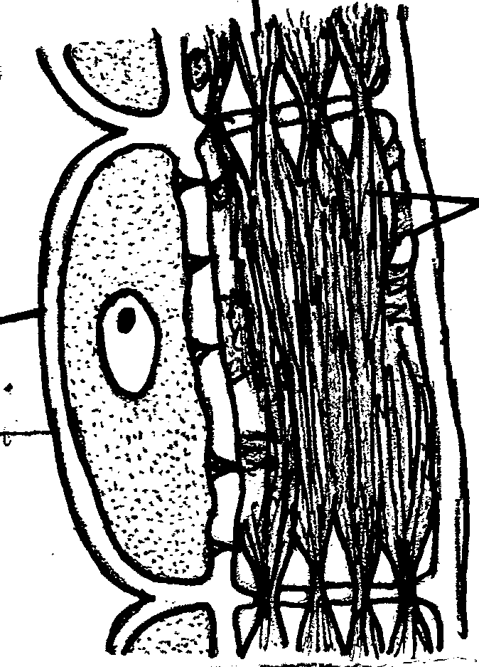

Y

Z

- Name the parts labeled. (2mks)
X…………………………………………………………
Y…………………………………………………………
(b)State the function of the part labeled Z (1mk)
………………………………………………………………………………………………….
………………………………………………………………………………………………….
- State two roles of water in germination? (2mks)
………………………………………………………………………………………………….
………………………………………………………………………………………………….
- (a) State any one role of the pollen tube during fertilization. (1mk)
………………………………………………………………………………………………….
………………………………………………………………………………………………….
- A female frog lays many eggs, spaced out along jelly – like straw.
State two importance of this. (2mks)
………………………………………………………………………………………………….
………………………………………………………………………………………………….
- The following charts illustrate the quantity of urine passed out by four mammals of different species in different habitats.

Quantity of Urine

C
B
A
Animals

- Name the forms in which the following organisms are likely to excrete their nitrogenous wastes.
(2mks)
Animal B
………………………………………………………………………………………………….
Animal C
………………………………………………………………………………………………….
- Give two structural modification of the nephron of animal B that enables it to survive in its habitat. (2mks)
………………………………………………………………………………………………….
………………………………………………………………………………………………….

- After an ecological study of nutritional relationships in an ecosystem, a student constructed the following food web.

Large bird

mussels
algae
Zooplanton
Small Fish
Bird K
Bird L
Bird J

- Name the ecosystem in which the ecological study was done. (1mk)
………………………………………………………………………………………………….
………………………………………………………………………………………………….
- State one short term effect of the eradication of all mussles from this ecosystem. (1mk)
………………………………………………………………………………………………….
………………………………………………………………………………………………….
- Some organisms which play a role in the ecosystem were not included.
Name one of them. (1mk)
………………………………………………………………………………………………….
………………………………………………………………………………………………….
- The diagram below represents the vertical section of a fruit.
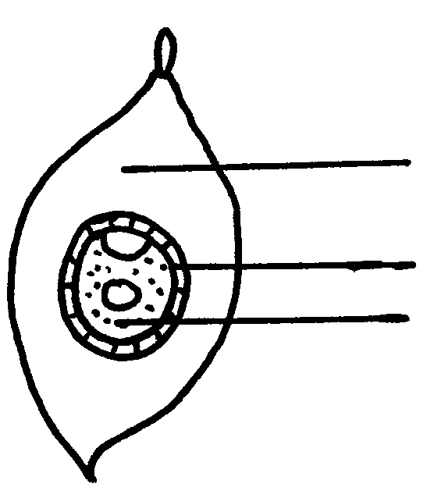
Fibrous Mesocarp

Hard waterproof endocarp
Endosperm

- Suggest the possible agent of dispersal of this fruit. (1mk)
………………………………………………………………………………………………….
………………………………………………………………………………………………….
- Explain two observable features that adapt the fruit to its mode of dispersal.
………………………………………………………………………………………………….
………………………………………………………………………………………………….
- State one function of each of the following hormones. (3mks)
- Follicle stimulating hormone
………………………………………………………………………………………………….
- Oxytocin
………………………………………………………………………………………………….
- Oestrogen
………………………………………………………………………………………………….
- State two advantages of natural selection. (2mks)
………………………………………………………………………………………………….
………………………………………………………………………………………………….
- (a) What are alleles? (1mk)
………………………………………………………………………………………………….
………………………………………………………………………………………………….
- Stateany two advantages of hybrid vigour. (2mks)
………………………………………………………………………………………………….
………………………………………………………………………………………………….
- What is meant by the term vestigial structures? (1mk)
………………………………………………………………………………………………….
………………………………………………………………………………………………….
- Name the type of evolution illustrated by (3mks)
(i) Hind limbs of birds
………………………………………………………………………………………………….
………………………………………………………………………………………………….
(ii)Wings of birds and insects
………………………………………………………………………………………………….
………………………………………………………………………………………………….
- The diagram below illustrate a neurne
Axon
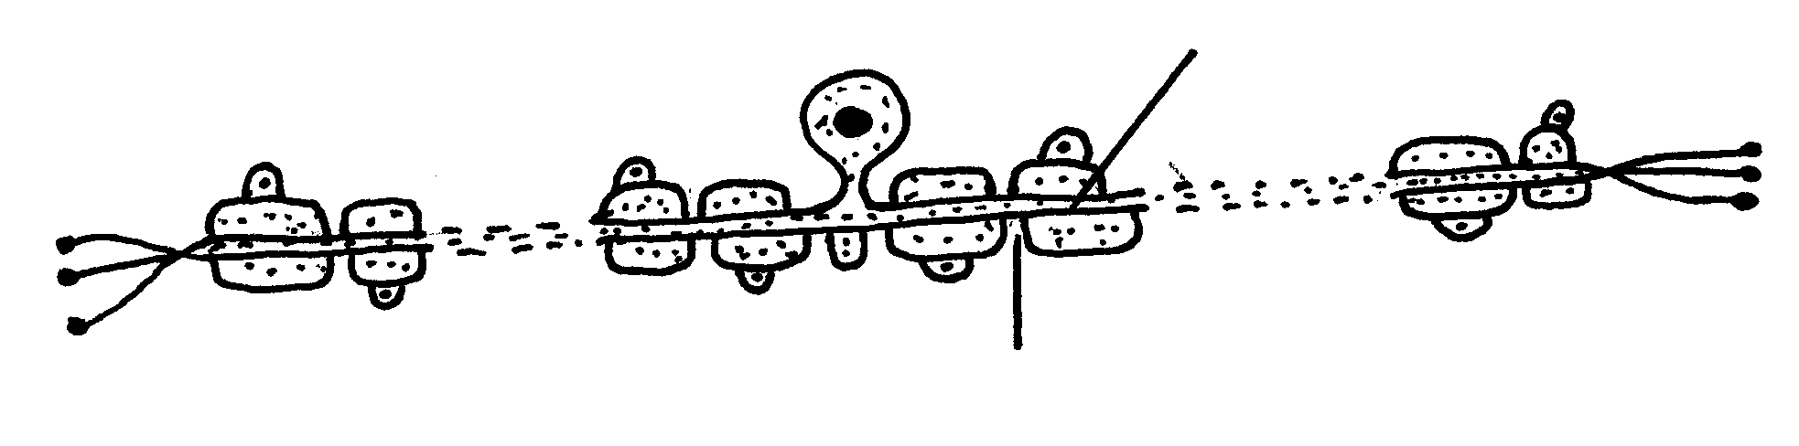

Node of ranvier

- Name the neurone drawn above. (1mk)
………………………………………………………………………………………………….
………………………………………………………………………………………………….

- (i) What is the function of the neurone named in (a) above? (1mk)
………………………………………………………………………………………………….
………………………………………………………………………………………………….
(ii)What is the role of the node of ranvier? (1mk)
………………………………………………………………………………………………….
………………………………………………………………………………………………….
- (a) Distinguish between a hinge-joint and a ball and socket joint. (1mk)
………………………………………………………………………………………………….
………………………………………………………………………………………………….
(b)(i) Name the cartilage found between the bones of the vertebral column. (1mk)
………………………………………………………………………………………………….
………………………………………………………………………………………………….
(ii) State the function of the cartilage named in b.(i) above. (1mk)
………………………………………………………………………………………………….
………………………………………………………………………………………………….
- In an experiment, it was observed that when termites are exposed to light, they move to darker areas.
(a)Name the type of response exhibited by the termites. (1mk)
………………………………………………………………………………………………….
………………………………………………………………………………………………….
(b) What are survival values of the type of response exhibited by the termites? (2mks)
………………………………………………………………………………………………….
………………………………………………………………………………………………….
26. Oil can be applied on stagnant water to control the spread of malaria.
(a) How does this practice control the spread of malaria? (1mk)
………………………………………………………………………………………………….
………………………………………………………………………………………………….
(b) Give a reason why this practice should be discouraged. (1mk)
………………………………………………………………………………………………….
………………………………………………………………………………………………….
- Give three reasons for the loss of energy from ne trophic level to the next in a food chain. (3mks)
………………………………………………………………………………………………….
………………………………………………………………………………………………….
………………………………………………………………………………………………….
………………………………………………………………………………………………….

