**Name**……………………………………………………..………… Index No:………………………….

**231/2** Candidate’s Signature …………..……………

**BIOLOGY** Date: …………………………

**PAPER 2**

**THEORY**

**JULY/AUGUST- 2014**

**TIME: 2 HOURS**

***Kenya Certificate of Secondary Education (K.C.S.E.)***

**2312**

**Biology**

**Paper 2**

**INSTRUCTIONS TO CANDIDATES**

* Write your **name** and **index number** in the spaces provided above
* **Sign** and write the **date** of examination in the spaces provided.
* This paper consists of two sections A and B
* In section B answer questions 6 compulsory and either question 7 or 8 in the spaces provided after question 8
* Answer ***all*** the questions in the spaces provided.
* Candidates should answer all the questions in English

**For Examiners Use Only**

|  |  |  |  |
| --- | --- | --- | --- |
| **Section** | **Question** | **Maximum score** | **Candidate’s score** |
| A | 1 | 8 |  |
| 2 | 8 |  |
| 3 | 8 |  |
| 4 | 8 |  |
| 5 | 8 |  |
| B | 6 | 20 |  |
| 7 | 20 |  |
| 8 | 20 |  |
| TOTAL |  | 80 |  |

*This paper consists of 8 printed pages. Candidates should check to ascertain that all pages are printed as indicated and that no questions are missing.*

1. The flow diagram below represents passage of a meal through the human digestive system. Study the diagram and answer the questions that follow.

Digestive juice A

Ugali and Meat stew

Mouth cavity

Stomach

Digestive juice B

Ileum

Digestive juice C

1. Name the physical process that will occur in mouth cavity (1mk)

………………………………………………………………………………………………….

………………………………………………………………………………………………….

1. Name the digestive juices **B** and **C** (2mks)

**B**…………………………………………………….

**C**…………………………………………………….

1. Explain **two** ways in which the digestive system is protected from corrosive effects of digestive juices. (2mks)

………………………………………………………………………………………………….

………………………………………………………………………………………………….

………………………………………………………………………………………………….

1. Name the hormone that stimulate secretion of juice **B**. (1mk)

………………………………………………………………………………………………….

1. Identify **two** contents of digestive juice **A**  (2mks)

………………………………………………………………………………………………….

………………………………………………………………………………………………….

1. The diagram below represents an experimental set up to investigate the effect of light and gravity on a growing seedling.

**Rubber band**

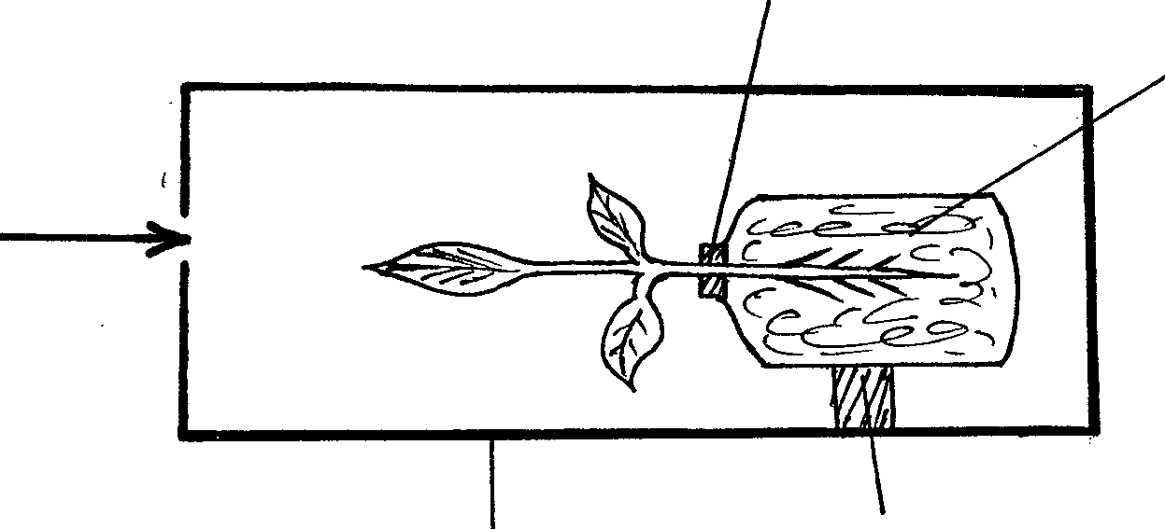

**Support**

**Wet cotton wool**

**Light**

**Box painted black inside**

1. Draw a diagram of the seedling to represent the expected results after three days. (2mks)
2. (i) State a control experiment for the effect of gravity in this experiment. (1mk)

………………………………………………………………………………………………….

………………………………………………………………………………………………….

(ii) Explain the results that would be obtained in the control experiment. (2mks)

………………………………………………………………………………………………….

………………………………………………………………………………………………….

1. State **three** differences between Endocrine and Nervous responses. (3mks)

………………………………………………………………………………………………….

………………………………………………………………………………………………….

………………………………………………………………………………………………….

1. (i) State **four** structural differences between skeletal muscles bicips and smooth muscles e.g gut

muscles. (4mks)

………………………………………………………………………………………………….

………………………………………………………………………………………………….

………………………………………………………………………………………………….

………………………………………………………………………………………………….

(ii) Name the cartilage found between the bones of the vertebral column. (1mk)

………………………………………………………………………………………………….

………………………………………………………………………………………………….

(iii) What are the functions of the cartilage named in d (ii) above (3mks)

………………………………………………………………………………………………….

………………………………………………………………………………………………….

………………………………………………………………………………………………….

1. The set of apparatus was assembled by a group of students to investigate some physiolocal process.

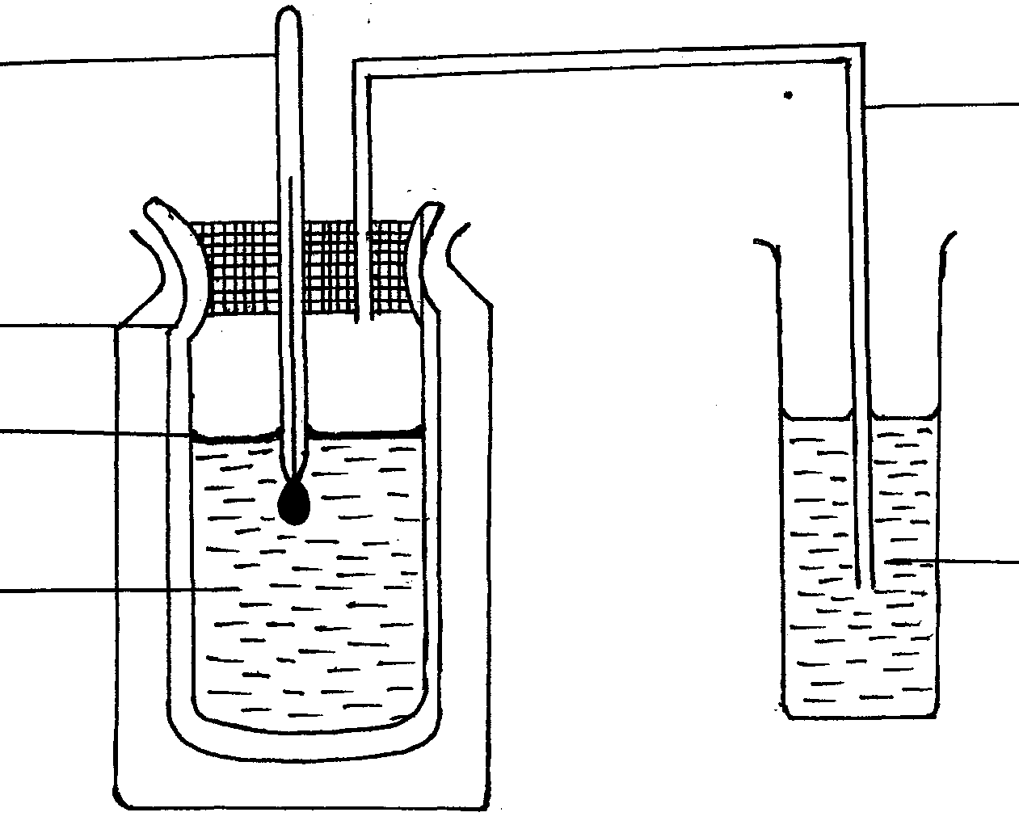

**Delivery tube**

**Thermometer**

**Vacuum flask**

**Oil layer**

**Yeast and 10% glucose**

**Bicarbante indicator**

1. (i) Give **two** aims of the experiment. (2mks)

………………………………………………………………………………………………….

………………………………………………………………………………………………….

(ii) Explain observations expected after 24 hrs (2mks)

………………………………………………………………………………………………….

………………………………………………………………………………………………….

1. Before the experiment., the glucose was boiled then cooled.
2. Why was it necessary to boil the solution (1mk)

………………………………………………………………………………………………….

………………………………………………………………………………………………….

1. What was the importance of oil layer in the experiment? (1mk)

………………………………………………………………………………………………….

………………………………………………………………………………………………….

1. Describe a control experiment for the set up? (1mk)

………………………………………………………………………………………………….

………………………………………………………………………………………………….

1. Suggest one industrial application of the process being investigated ? (1mk)

………………………………………………………………………………………………….

………………………………………………………………………………………………….

1. (a) Human somatic cells had 46 chromosomes in their nucleus. State the number of sex chromosomes

out of the 46 and name them in male human beings. (2mks)

………………………………………………………………………………………………….

………………………………………………………………………………………………….

(b) Haemophiliac is due to recessive gene. The gene is sex linked and located on the **x** chromosome.

A phenotypically normal parents gave birth to one boy who is haeophiliac .

(i) What are the possible parental genotypes. (2mks)

………………………………………………………………………………………………….

………………………………………………………………………………………………….

1. Work out the genotypes of off springs using the pinnate square. (4mks)

**SECTION B (40 MARKS)**

***Answer questions 6 (compulsory) and either question 7 or 8 in the spaces provided after question 8***

1. The length of a grasshopper femur and internode of a seedling were recorded in a period of 24 weeks. The results are recorded in the table below.

|  |  |  |  |  |  |  |  |  |  |  |
| --- | --- | --- | --- | --- | --- | --- | --- | --- | --- | --- |
| **Week** | **1** | **3** | **5** | **7** | **10** | **13** | **16** | **18** | **20** | **24** |
| **Average length of femur** | **8.0** | **9.0** | **9.0** | **9.0** | **13.0** | **13.0** | **15.0** | **19.0** | **19.0** | **19.0** |
| **Average length of internode(mm)** | **5.0** | **6.5** | **10.5** | **16.5** | **24.5** | **27.5** | **32.5** | **34.5** | **36.0** | **37.5** |

1. Plot a graph of length of femur and internode against time on the same axis (7mks)



1. (i)What was the average length of internode in the 8th week? (1mk)

………………………………………………………………………………………………….

………………………………………………………………………………………………….

(ii)Suggest how average length of internodes was obtained. (2mks)

………………………………………………………………………………………………….

………………………………………………………………………………………………….

1. Name the type of growth curve shown by
2. Grasshopper (1mk)

………………………………………………………………………………………………….

1. Seedling (1mk)

………………………………………………………………………………………………….

1. Account for the change in length for fermur between
2. 3rd and 7th week (2mks)
3. 16th and 20th week (2mks)
4. (i) State what causes increase in length of internodes in the seedling.

………………………………………………………………………………………………….

………………………………………………………………………………………………….

1. Which animal phylum exhibits the growth pattern of the fermur.

………………………………………………………………………………………………….

………………………………………………………………………………………………….

1. Name the hormone responsible for the growth pattern in grasshopper.

………………………………………………………………………………………………….

………………………………………………………………………………………………….

1. Work out the rate of growth of the seedling between week 7 to 10 (2mks)

………………………………………………………………………………………………….

………………………………………………………………………………………………….

1. Describe the structure and function of various parts of the skin (20mks)
2. (a) During a voting exercise tension was high one of the aspirants was furious and wanted to

face a very aggressive opponent. Explain the physiological changes that occur in his body to prepare him for the fight. (14mks)

(b) (i) Identify each of the following responses described below.

(a) A person coughs whenever a foreign body irritates the respiratory tract (1mk)

(b) Whenever a bell is rung, a dog is presented with a meal. After several days of

practice, the dog salivates once the bell is rung even if food is not available (1mk)

(ii) State the difference between the two responses identified in (b) above (4mks)

………………………………………………………………………………………………….

………………………………………………………………………………………………….

………………………………………………………………………………………………….

………………………………………………………………………………………………….

………………………………………………………………………………………………….

………………………………………………………………………………………………….

………………………………………………………………………………………………….

………………………………………………………………………………………………….

………………………………………………………………………………………………….

………………………………………………………………………………………………….

………………………………………………………………………………………………….

………………………………………………………………………………………………….

………………………………………………………………………………………………….

………………………………………………………………………………………………….

………………………………………………………………………………………………….

………………………………………………………………………………………………….

………………………………………………………………………………………………….

………………………………………………………………………………………………….

………………………………………………………………………………………………….

………………………………………………………………………………………………….

………………………………………………………………………………………………….

………………………………………………………………………………………………….

………………………………………………………………………………………………….

………………………………………………………………………………………………….

………………………………………………………………………………………………….

………………………………………………………………………………………………….

………………………………………………………………………………………………….

………………………………………………………………………………………………….

………………………………………………………………………………………………….

………………………………………………………………………………………………….

………………………………………………………………………………………………….

………………………………………………………………………………………………….

………………………………………………………………………………………………….

………………………………………………………………………………………………….

………………………………………………………………………………………………….

………………………………………………………………………………………………….

………………………………………………………………………………………………….

………………………………………………………………………………………………….

………………………………………………………………………………………………….

………………………………………………………………………………………………….

………………………………………………………………………………………………….

………………………………………………………………………………………………….

………………………………………………………………………………………………….

………………………………………………………………………………………………….

………………………………………………………………………………………………….

………………………………………………………………………………………………….

………………………………………………………………………………………………….