Name: …………………………………………………… Index no ……..…...................................

School: ……………………………………………....…. Candidate’s sign ……………………....

Date: ……………………………………………

231/3
BIOLOGY
PAPER 3
March - 2019
TIME:1 ¾ HOURS

MOMALICHE JOINT EXAMINAITON
Kenya Certificate of Secondary Education (K.C.S.E.)
BIOLOGY
PRACTICAL

INSTRUCTIONS TO CANDIDATES:
- Write your name and index number in the spaces provided.
- Sign and write date of examination in the spaces provided above
- Answer all the questions in the spaces provided.

For Examiner’s Use Only:

QUESTIONS | MAXIMUM SCORE | CANDIDATES SCORE
1 | 13
2 | 15
3 | 12
TOTAL | 40

1. You are provided with 8cm³ solution Q. Iodine solution, Benedict’s solution, dil HCL, sodium hydrogen carbonate, means of heating test tube rack, 3 dry test tube and a water bath.
Use the provided reageants and apparatus to establish food substances present in solution Q. Fill the observation and conclusion in the table provided.
(a) Take sample of solution Q and test them for the food substances present using the reagents provided. Record in a table, the food substance tested, the procedure of the test, the observations and conclusions. (9mks)
Food Substance | Procedure | Observations | Conclusions

(b) How would you test for the presence of vitamins in solution Q (2mks)
....................................................................................................................................................................................................................................................................................................................................................
(c) State two food substance in Q and enzymes in human beings that would digest them. (2mks)
Food substance | Enzyme

2. Use the photographs provided to answer the questions that follow.
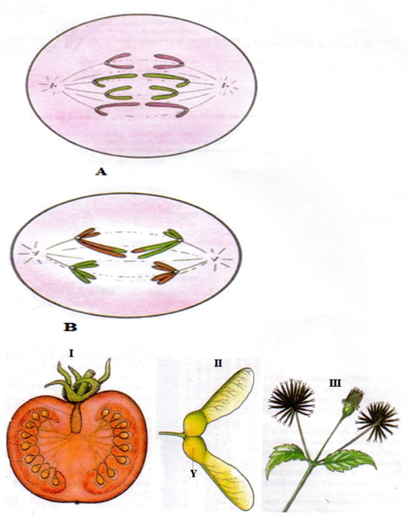

(a) (i) Identify the type of cell division represented in the photographs A and B (2mks)
A .................................................................................................................................................................
B ................................................................................................................................................................
(ii) with a reason, name the stage of cell division represented in each case (4mks)
A .............................................................................................................................................................
Reason
....................................................................................................................................................................................................................................................................................................................................................
B .............................................................................................................................................................
Reason
....................................................................................................................................................................................................................................................................................................................................................

(iii) Name the parts of human body where the process B represented above occur. (2mks)
....................................................................................................................................................................................................................................................................................................................................................

(b) (i) What type of fruits is represented by photograph I? Give two resons.
Type .............................................................................................................................................................
Reason
....................................................................................................................................................................................................................................................................................................................................................
(ii) Name the agent of dispersal for fruits II and III (2mks)
I ...............................................................................................................................................................
II ............................................................................................................................................................
(iii) How are the fruits adapted for the mode of dispersal stated in (b) (ii) above? (2mks)
I ..................................................................................................................................................................................................................................................................................................................................................
II ..................................................................................................................................................................................................................................................................................................................................................
(iv) Identify the type of placentation shown by photograph I (1mk)
.......................................................................................................................................................................

3. The photography below shows four specimens labelled P,Q R and S which were obtained from the same animal. Examine them.
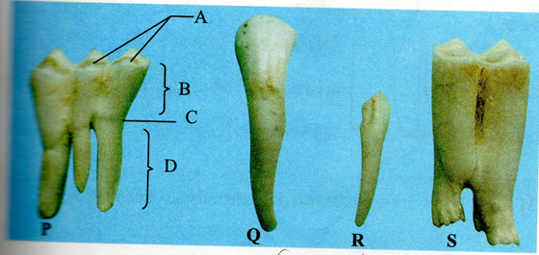

(a) With reasons identify P and Q (5mks)
P ..............................................................
Two reasons
.............................................................................................................................................................................................................................................................................................................................................................................................................................................................................................................................
Q ..................................................................
Reasons
.............................................................................................................................................................................................................................................................................................................................................................................................................................................................................................................................
(b) Based on their structure, suggest the functions of specimens P and Q. (2mks)
P ..........................................................................................................................................................
..............................................................................................................................................................
Q .............................................................................................................................................................
.................................................................................................................................................................
(c) In specimen P name the part labelled A (1mk)
A ...............................................................................................................................................
(d) Explain how specimen s is adapted for its functions. (2mks)
.............................................................................................................................................................................................................................................................................................................................................................................................................................................................................................................................
(g) Using observable features only, state
(i) One similarity between specimens Q and R (1mk)
....................................................................................................................................................................
(ii) One difference between specimens Q and R . (1mk)
....................................................................................................................................................................................................................................................................................................................................................

