NAME…………………………………………………ADM. NO………………CLASS………

MWAKICAN JOINT EXAMINATION (MJET)

BIOLOGY FORM 1

END OF TERM 1 2019

TIME:2 HOURS

INSTRUCTIONS

ANSWER ALL THE QUESTIONS IN THIS PAPER IN THE SPACE PROVIDED

1. What is biology? (1 mark)

2. Give two skills gained by a student learning Biology. (2 marks)

3a)Name the unit of classification that has the most organisms. (1 mark)

b)State the application of Binomial nomenclature in naming organisms. (1 mark)

4.What is the importance of using a hand lens in classification of organisms (1 mark)

5.State two main branches of biology. (2 marks)

6.Define each of the following terminologies as used in biology : (2 marks)
a). Ecology

b). Anatomy

7.What characteristics of living organisms is represented by the following characteristics:
a)A cat producing kittens. (1mk)

b)A girl dropping a hot pan. (1mk)

c)The exhalation of carbon (IV) oxide. (1mk)

8. The diagram below represents a plant cell.
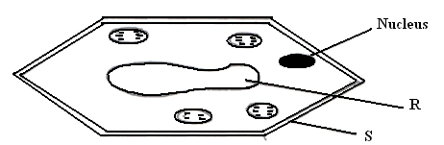

(a) Name a carbohydrate which forms part of the structure labelled S. (1mark)

(b) State two functions of the part labelled R. (2 marks)

(c) Name two structures present in the diagram but absent in the animal cell (2marks)

9 a) An electron microscope has a much greater resolving power than a light microscope. Explain the meaning of the term resolving power. (1 mark)

b) Give a reason why an electron microscope cannot be used to study life specimen. (1 mark)

10. What is taxonomy? (1mark)

11. Give two reasons why classsification is important in biology. (2marks)

12. (a) Distinguish between growth and development. (2marks)

(b) State the importance of growth in living organisms. (1mark)

13.During a practical lesson to estimate the size of a cell, using the sketch below which some students observed, calculate the length of one cell in micrometers given that the field of view was 8mm wide. (3 marks)
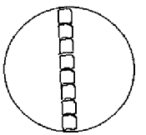

14. a) What is meant by the term Entomology. (1 mark)

b) The diagram below represents a certain apparatus used by biology students.
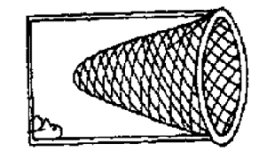
(i) Name the apparature above. (1 mark)

(ii) State the role of the apparatus named in b) (i) above. (1 mark)

15. Black jack (Bidens pilosa) belongs to the family Compositae.
What is it’s:
Genus. (1 mk)

Species. (1 mk)

16. a) Differentiate between multicellular and unicellular organisms. (1 mk)

b) i) identify the organelle represented by the diagram below. (1 mk)

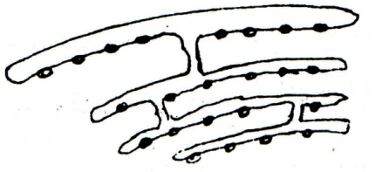

ii) State the function of the organelle identified in 2b(i) above. (1 Mark)

17. If a light microscope had an eye piece lens of X15 and an objective lens of X60, what would
the total magnification be? (2 mks)

18. a. State the importance of each of the following process in living things. (3 mks)
i. Respiration

ii. Gaseous exchange

iii. Reproduction

b. Apart from the characteristics of living things mentioned in (a) above, state any other four other characteristics common in living things. (4mks)

19. a). Give a reason why each of the following steps are followed when preparing cross sections
of a leaf for examination under a microscope:(4mks)
b)Cutting very thin sections

c)Using sharp razor blade (scalpel) during cutting.

d)Placing the sections in water

e)Staining the sections with iodine before observing under a microscope.

20. Calculate the magnification of the drawing of the termite below given that the actual length of the termite is 0.9cm long .Show your working (2mks)

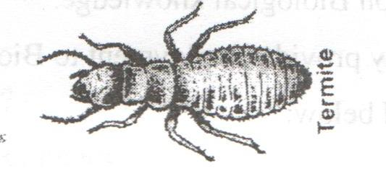

21. plasmodium Falciparum are transmitted by a mosquito.
(a) Identify two mistake made in writing the scientific name (2mks)

(b) Can the above organisms interbreed? Give reasons (2mks)

(c) Rewrite the above scientific name properly (1mk)

22. A student was using a light microscope to view onion cells with lens combination of eye piece lens X16 and objective lens X20.
a)Calculate the total magnification. (1 mk)

b)If he changed the objective lens magnification to X40, would the cells appear bigger or smaller? Explain. (2 mks)

23. State three importances of studying biology (3mks)

24.Name the seven taxonomic units of classification starting from the highest to the lowest (7mks)

25. The diagram below represents the structure of a light microscope. Study it and answer the
questions that follow.

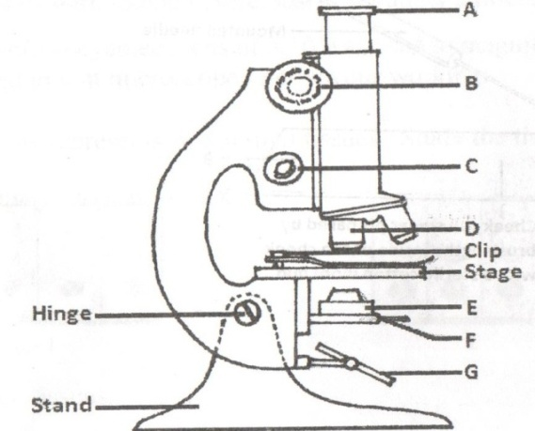

a)Name the parts of the microscope labeled A to E. (5 mks)
A
B
C
D
E
b) State the functions of each of the parts marked E and F. (2 mks)
E

F

c)Which part of the microscope (use letter symbols):
i. Contributes to the magnification of the specimen. (1 mk)

ii. Is used to move the body tube over very small distances when observing under high power magnification. (1 mk)

e)While trying to observe a specimen under a microscope, a student failed to see the field of view. Suggest one possible causes of this. (1 mk)

26. The diagram below shows a cell as seen under a microscope.

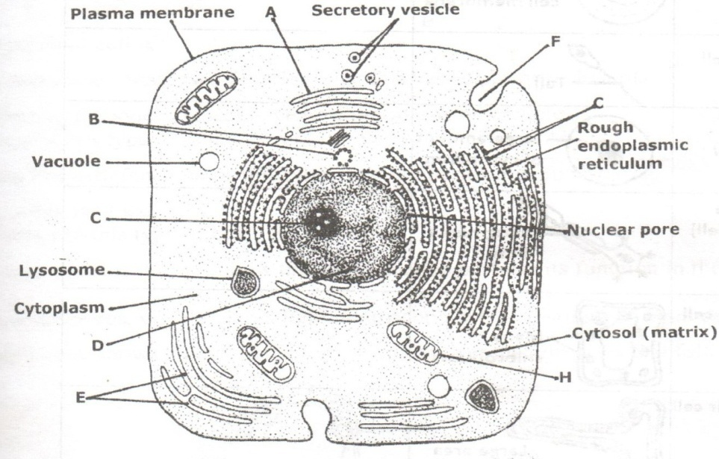

a)i. Is this observation under a light or an electron microscope? (1 mk)

ii. Give a reason for your answer. (1 mk)

i. Is this an animal or a plant cell? (1 mk)

ii. Give a reason for your answer in (b) (i) (1 mk)

b) Name the parts labeled H & E. (2 mks)
H
E
c) State the functions of each of the parts marked A,C,H. (3 mks)

A
C
H
27. Briefly and adequately explain how plants compensate for lack of movement in a constantly changing environment. (2 marks)

28. Below is a structure of a living organism; study it and answer the questions below.
Y

K

- Identify the structure (1mk)

- Name the part labeled (2mks)
K
Y
- State three properties of the structure name in (i) above. (3mks)

29. Outline three precautions that a student should observe when collecting specimens. (3mks)

