MWAKICAN JOINT EXAMINATIONS TEAM(MJET)
FORM THREE
BIOLOGY PAPER 1:231/1 MARKING SCHEME
TERM 2 - 2016
1(a) synthesize proteins/site of protein synthesis
(b) Transport of the packaged proteins and lipids
2 This is because the high power objective lens is too near the slide. It could damage the slide and the objective lens.

Mitochondria  3 | Chloroplast
- Inner membrane is greatly folded into cristae in order to increase the surface area for respiration | Inner membrane is smooth
- Sausage shaped | Oval/egg shaped
- Has matrix | Has stroma
- Lacks grana  - Lacks starch granules | Has grana with chlorophyll  Has starch granules

4 - gaseous exchange
- Absorption of soluble products of diffusion
- exchange of food substances and waste products between tissue fluid and cells
- Excretion of waste products
(any 2)

5 (a) osmosis
(b)(i) salt crystals did not dissolve to form a solution/no observable change
(ii) Boiling killed the potato cells thereby by destroying their cell membranes which could no longer act as a semi permeable membrane; Hence osmosis did not occur;
6 Wilting occurs when the rate of transpiration exceeds the rate of water absorption causing the plants cells to lose their turgidity hence resulting to drooping.
(b) the droops of leaves seen during wilting is advantageous because it reduces the surface area exposed to the sunlight and atmosphere thus reducing the rate of transpiration.
7(a) A - Isotonic solution
B- hypertonic solution
C- hypotonic solute
(b) plasmolysed cell
8(a) transparent to allow penetration of light to the palisade cells
(b) Contains large numbers of chloroplasts containing the chlorophyll which traps or absorbs light energy necessary for photosynthesis
(c) The lamina is broad and flat to provide a large surface area for absorption of carbon IV oxide and sunlight energy.
9(a) Enzyme inhibitors are substances that slow down or completely inhibit or stop the enzyme activity.
(b) - Raising the temperature
-Altering the PH
- Addition of an inhibitor
10(a) Emulsification of fats/breakdown of large fat droplets into tiny fat droplets to increase their surface area for digestion.
- Provide an alkaline medium in which the enzymes works best.
(b) The alimentally canal is coated by mucus which forms a protective barrier against digestion by protein digesting enzymes
- C) cellulose is roughage
11(a) Potometer
(b) - stem of the shoot should be cut and fixed into the potometer under water to prevent air entering into the xylem vessels (any 2)
- Ensure that the whole apparatus is filled with water.
- All joints should be watertight
12(a) - prevents loss of blood
- Prevents entry of disease causing organisms
(b) Rupture on injured tissues to release thromboplastin which neutralize heparin(anticlotting factor). It also activates prothrombin to thrombin
(c) thromboplastine/thrombokinase
Thrombin
13 - single circulation is the type of circulation where blood passes through the heart only once in a complete circulation eg. Fish
- double circulation is where blood enters the heart twice during a complete circulation.
e.g mammals
14 -xylem – transports water and mineral salts to photosynthesizing cells
- phloem transports the manufactured foods
- VEINS – supports the leaf to be upright for the maximum absorption of light for photosynthesis
15 -In both cases the respiratory surface i.e alveoli in the lungs and gill filaments in gills has a thin epithelial lining. (any 3)
- in both cases the epithelial lining is moist
- both are richly supplied with blood (are highly vascularised)
- Both have large surface area offered by the large number of alveoli and gill filament respectively.
- Both have an efficient ventilation mechanism.
16(a) 4% - 0.03% = 3.97%
(b) Exhaled air has more carbon IV oxide than the inhaled air due to release of CO₂ from the tissues inhaled air has higher concentration of Oxygen than the exhaled air. This is because some of the oxygen diffuses into the blood stream and it is transported to the tissues for respiration.
17(a) Respiratory quotient refers to the ratio of the relationship between the amount of carbon IV oxide produced against the amount of oxygen used in respiration.
(b)(i) RQ = $\frac{18}{26}$ = 0.6923
$\sim$ 0.7

(II) Lipids(fat)
(iii) Aerobic respiration

18(a) Osmoregulation is the process through which the osmotic pressure of the body fluids is regulated. It involves the regulation of the volume of water and solute contents in the body fluids
b)
Urine | Glomerular filtrate
1. lacks glucose | Has glucose
2. lacks amino acids | Has amino acids
3. more water content | Low water content
4. high concentration of urea | Lower concentration of urea

c) Pituitary gland

d) due to deficiency in insulin secretion from the pancreas malfunctioning of the pancreas so that it does not secrete adequate insulin

19(a)(i) Diffusion
(ii) sea water contains a high concentration of sodium ions than the cell sap

b(i) iodine ions
(ii) sea water has a lower concentration of iodine ions than the cell hence requires energy to take up the iodine ions(by active transport)

20(a) phylum – Arthropoda
Class - Arachnida
b) has four pairs of jointed leg
Lacks antennae
21(a)`counter current flow system
(b) It facilitates maximum gaseous exchange between the water flowing over the gills and the blood in the gills
(c) Kidneys i.e in the loop of Henle

22 $\frac{6000}{55}$ = 108.8$μm$ $\sim$ 109$μm$

23(a) 3

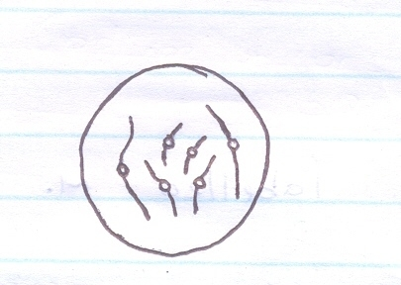
(b)(i) (ii)

Mitosis
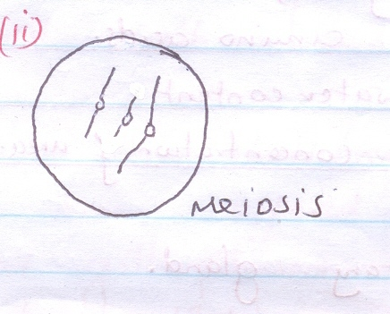

24(a)(i) Anaphase 1
(ii) - Homologous chromosomes separate at the equator
- Chromosomes start migrating to opposite poles
- sister chromatids attached to spindle fibres at the centromeres.
(b) Spindle fibres

25(a) Green plants mice snakes wild cat
Green plants grasshoppers lizards Domestic cat
(b) Mice
(c) - green plants will dry up and decrease in numbers due to drought
- The number of grass hoppers and mice would reduce due to starvation
Secondary consumers i.e snakes and cats would die or migrate to other ecosystems

