MWAKICAN JOINT EXAM TEAM (MJET)

FORM 3 BIOLOGY PAPER 2

END OF TERM 2 – 2016

- Answer all the questions in SECTION A in the spaces provided.

- In section B answer question 6 (Compulsory) in the spaces provided and either question 7 or 8 in the space provided after question 8.

SECTION A (40MKS)
- The two cells shown below are obtained from two different potato cylinders which were immersed in two different solutions P and Q.
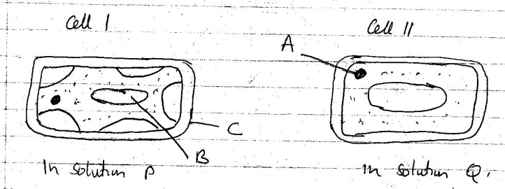

- (i) Name the structures labelled A and C (2mks)

A -

B -

(ii) State the function of structure B. (1mk)

- Suggest the identity of the solution Q (1mk)

- Account for the change in Cell 1 above (2mks)

- State two importance of the physiological process being demonstrated above in living organisms. (2mks)

- Study the following food web and answer the questions that follow.
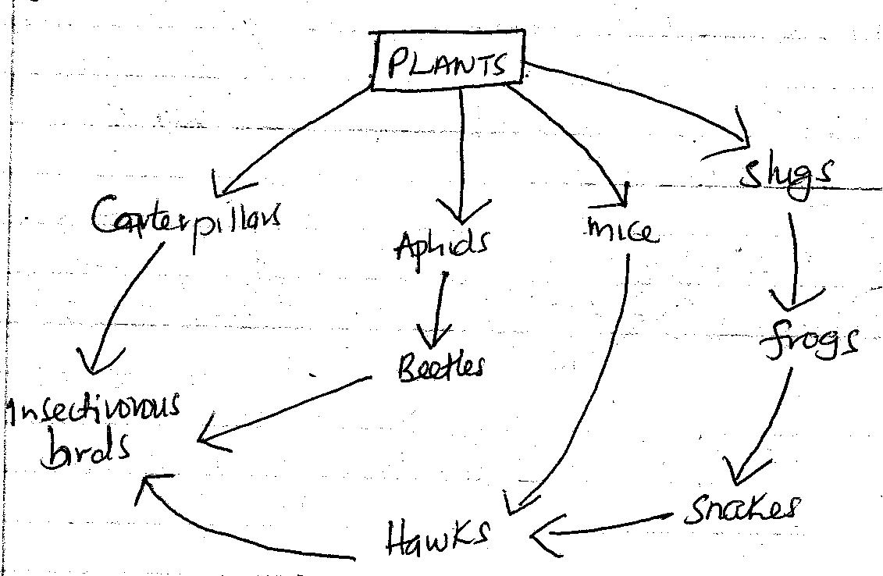

- (i) Name the organisms that occupy the second trophic level (2mks)

(ii) What is the other name for the second trophic level (1mk)

- Write down two food chains from the web that
- End with hawks as tertiary consumer (1mk)

- End with hawks as Quaternary consumer. (1mk)

- Giving reasons state;
- The organism with largest biomass (1mk)

- The organism with least biomass (1mk)

- Name the source of energy in the above ecosystem. (1mk)

- The diagram below represents a longitudinal section through the ileum wall.

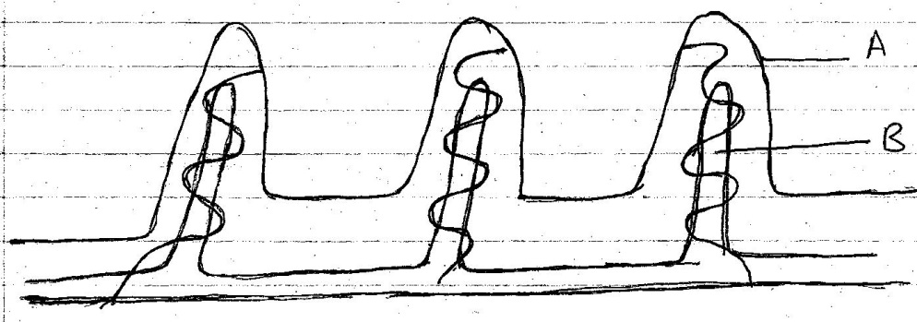

- Identify the structure labeled A and B (2mks)

A -

B -

- State one function of A and B (2mks)

A -

B -

- State two functions of the ileum. (2mks)

- Explain the role of the liver in digestion. (2mks)

- The equation below represents a metabolic process that occurs in a certain organ in the mammalian body.

Ammonia enzymes Organic compound Q + water
Carbon (IV) Oxide

- Name the process represented in the equation. (1mk)

- Name the organ in which the process occurs. (1mk)

- Why is the process important to the mammal? (1mk)

- Identify the organic compound Q. (1mk)

- What happens to organic compound Q ? (1mk)

- A person was found to pass large volume of dilute urine frequently. Name the; (3mks)

- Disease the person was suffering from.

- Hormone that was deficient.

- The gland that secretes the above hormone.

- Some glucose was boiled and cooled in a boiling tube. Some yeast was added and a layer of oil put on top. The set up below was used.

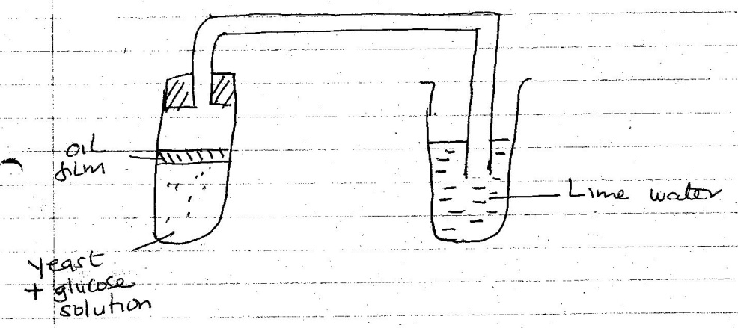

- Why was the glucose solution boiled before the experiment. (1mk)

- What is the use of the oil film in the experiment ? (1mk)

- Name the process being investigated by the above experiment. (1mk)

- State what happens to the lime water as the experiment proceeds to the end. (1mk)

- Explain what would happen if the temperature of glucose and yeast was raised beyond 45⁰C. (2mks)

- State two industrial applications of the process being investigated above in the experiment. (2mks)

SECTION B (40MKS)
Question 6 (Compulsory) and either question 7 or 8.

- In an ecological study, a locust population and that of crows was estimated in a grassland area over a period of one year. The results were tabulated as shown below:-

Months | J | F | M | A | M | J | J | A | S | O | N | D
Number of locusts | 90 | 20 | 11 | 25 | 200 | 450 | 652 | 15 | 10 | 35 | 192 | 456
Number of crows(birds) | 4 | 2 | 0 | 1 | 8 | 16 | 22 | 2 | 1 | 1 | 5 | 15
Amount of rainfall | 20 | 0 | 55 | 350 | 520 | 400 | 350 | 10 | 25 | 190 | 256 | 350

- Draw a graph of population of locusts and crows (birds) against time. (8mks)

- (i) State the relationship between rainfall and locust population. (1mk)

(ii) Account for the relationship you have stated in (b) (i) above (1mk)

- What happens on the populations of locusts and crows in the months of January to
March ? Give a reason. 2mks)

- State one method used to estimate the population of locust. (1mk)

- (i) State the trophic level of the; (2mks)

Locusts -

Crows -

(ii) Construct a simple complete food chain involving these organisms (2mks).

- If the locusts were removed from the food chain, what would be its effect ? (1mk)

- Define the following terms (2mks)

(i)Biomass

(ii)Ecosystem

- Describe how hydrophytes and xerophytes are adapted to deal with environmental problems in the regions where they grow. (20mks)

- Describe how the mammalian skin regulates body temperature.(20mks)

