MWAKICAN EXAMS TERM 2 YEAR 2016
FORM THREE BIOLOGY PAPER 3 (231/3)
Time :1 hr. 45 Mins

NAME…………………………………………………………………………………………………………ADM.NO………………CLASS……..
INSTRUCTIONS TO CANDIDATES
- Write your name and admission number in the spaces provided above
- Answer all the questions in the spaces provided.
- You are require to spend the first 15 minutes of the 1 ¾ hours allowed for this paper reading the whole paper carefully before commencing your work.

1. You are provided with
- Liquid cooking oil
- B1
- B2
- Irish potato
Label two test tubes X and Y. Into each test tube, put 2cm³ of water and 8 drops of liquid cooking oil. To the test tube labeled X add 8 drops of liquid B₁, shake both test tubes and allow the content to stand for 2 minutes
(a) (i) Record your observations in (2mks)
Test tube X
Test tube Y
(ii) Name the process that has taken place in test-tube X (1mk)

(iii) State the significance of the process named in a (ii) above in digestion (1mk)

(iv) Name the digestive juice in humans that has the same effect on oil as liquid B₁ (1mk)

(v) Name the region in the digestive system into which the juice is secreted (1mk)

(b) Label two test tubes E and F. Place 2cm³ of liquid B₂ into each. Add a drop of iodine
solution into each test tube.
(i) Record your observation (1mk)

(ii) Suggest the identity of liquid B₂ ………………………………………………… (1mk)
(iii) Cut out a cube whose sides are 1cm from the irish potato provided. Crush the cube to
obtain a paste and place the paste in the test tube labeled E. Leave the set up for at least 30minutes.
Record your observation (2mks)
Contents of test tubes F after 30 min

Contents of test tube E after 30 min

(iv) Account for the results in b (iii) above. (1mks)

(c) (i) Cut out another cube whose sides are 1cm from the Irish potato and crush it. Place the
crushed paste into a test tube. Carry out food test with the reagent provided. Record the procedure
and results. (2mks)

Food being tested | Procedure | Observation | Conclusion

(ii) Account for the results in (c) (i) above. (3mks)

Q2. The photographs labelled J, K and L are all related to mammalian kidney.

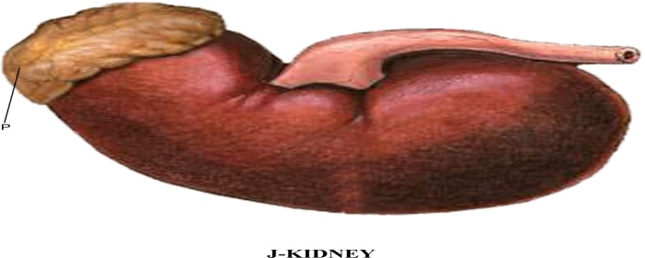
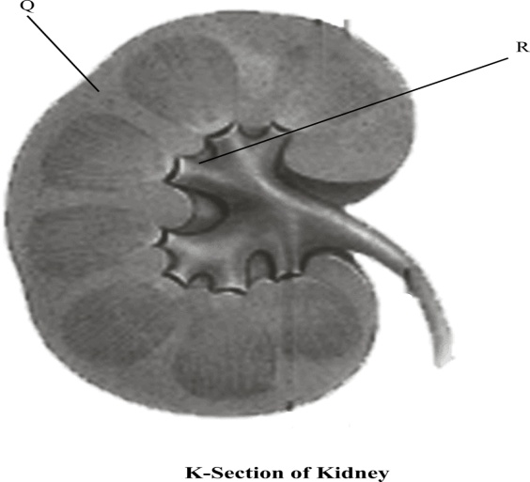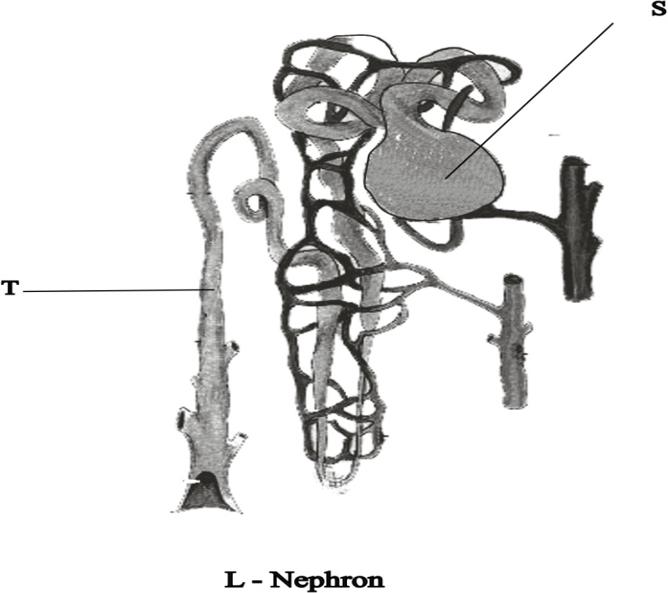

(a) Name the hormone produced by the structure labelled P. (1 mk)
- Name the parts labelled Q, R and T. (3 mks)
Q………………………………………………………………….
R…………………………………………………………………..
T…………………………………………………………………..

- State the process by which wastes are filtered from blood in the structure labelled S. (1 mks)

(d) (i) Give two components of blood that that are not filtered at structure S. (2 mks)

(ii) Give reason why the components you have named in d (i) above are not filtered. (2mks)

(e) Give two nutrients reabsorbed at the part labelled S. (2 mks)

(f) What two adaptations would be expected in the structure L in a desert animal like a camel. (2 mks)

3. Below are drawings of specimens from plants. Study them and answer the questions that follow

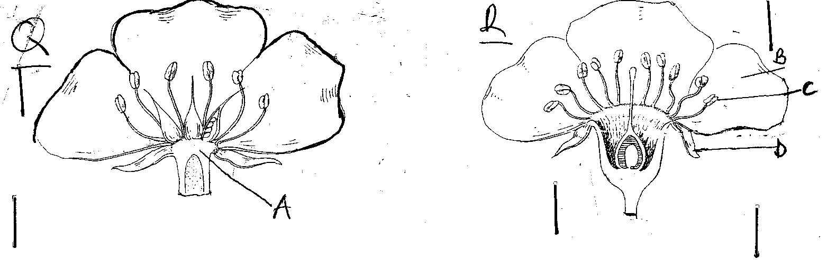
a) What is the role of the specimens to the plants. (1mk)

b) Differentiate the specimen Q from specimen R. ( 2mks)

c) Label the parts labelled C and D ( 2mk)
C ………………………………………………………………
D ………………………………………………………………
d) Explain what happens to the floral structures after fertilization. (4mks)

e) With a reason state the class of plants from which the specimens were obtained. (2mks)

