LARI SUB-COUNTY
END OF TERM TWO 2019 EXAMINATION
FORM FOUR BIOLOGY PAPER 1
231/1
BIOLOGY PAPER 1
2HOURS
1. Name two sites of gaseous exchange in amphibians. (2mks)
2. State two roles of green plants in fish ponds other than providing food. (2mks)
3. Name three forces that maintain transpiration stream. (3mks)
4. Name the fins that prevent the following movements of fish during swimming. (3mks)
i) Yawing……............. ii) Pitching…………... iii) Rolling…
5 a) Name two disorders in humans caused by gene mutation. (2mks)
b) Describe the following chromosomal mutations; (2mks)
i) Inversion
ii) Translocation
6. State three reasons for loss of energy from one trophic level to another in a food chain. (3mks)
7. a) Name the part of the eye where image is formed. (1mk)
b) State two characteristics of the image formed on the retina. (2mks
8. Name a support tissue in plants that is thickened with cellulose. (1mk)
9. State two functions of luteinizing hormone in reproduction. (2mks)
10. Give the meaning of the following terms. (2mks)
i) Protandry…………
ii) Self-sterility…………
11. a) State the difference between ball and socket and hinge joint. (1mk)
b) State the functions of synovial fluid. (2mks)
12. A group of students from Awasi Boys High School set up an experiment to demonstrate a certain process. The experimental set up were as shown in the diagrams below.
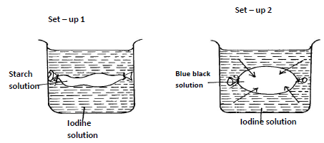

After 10 minutes the students recorded their observation in a table as shown below.
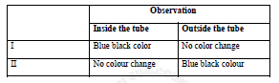

a) Name the process being demonstrated by this experiment. (1mk)
b) Explain the result in the experiment set up I. (3mks)
13. a) Name the structures in phloem that are involved in the translocation of sugars. (2mks)
b) Other than sugars, name two compounds that are translocated in the phloem. (2mks)
14. State four ways in which the red blood cells are adapted to their function. (4mks)
15. a) What is oxygen debt? (1mk)
b) Give the differences in products of anaerobic respiration in plants and animals. (1mk)
16. State the aspects of light that affect the rate of photosynthesis. (2mks)
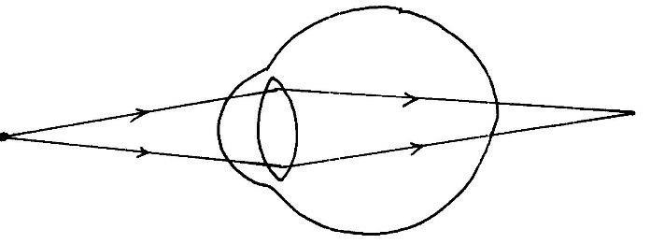17. The diagram below shows the position of an image formed in a defective eye.

a) Name the defect. (1mk)
b) Explain how the defect named in (a) above can be corrected. (2mks)
18. Explain continental drift as an evidence of evolution. (3mks)
19 a) A certain animal has no incisors, no canines, 6 premolars and 6 molars in its upper jaw. It has 6 incisors, 2 canines, 6 premolars and 6 molars on the lower jaw. Write its dental formula. (1mk)
b) State the likely mode of feeding for the animal. (1mk)
c) Give a reason for your answer in (b) above. (1mk
20. State how the following structures of the skin are adapted to their functions; (3mks)
i) Malphigian layer
ii) Sebaceous glands
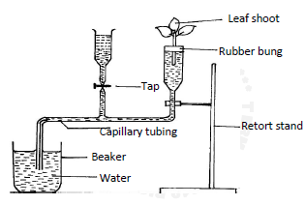
21. A set up that was used to investigate a certain process in plants as shown in the diagram below.

a) What process was being investigated? (1mk)
b) i) State two precautions that should be taken when setting up the experiment. (2mks)
ii) Give a reason for each precaution stated in b(i) above. (2mks)
22. State the functions of;
a) Ribosomes (1mk)
b) Golgi apparatus (2mks)
23. What is meant by the terms; 2mks)
a) Allele
b) Test-cross
24. Give the difference between Darwinian and Larmackian theories of evolution. (2mks)
25. a) How is the starch utilized by the seedling? (3mks)
b) Name the hormone that is responsible for fruit ripening. (1mk)
26. Give the meaning of the term binomial nomenclature. (1mk)
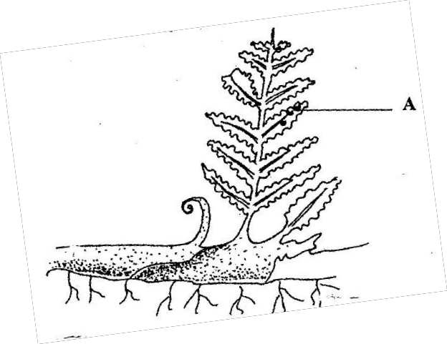27. Wanganga students collected the plant shown below during an education trip.

a) Name the part labelled A. (1mk)
b) i) State the division to which the plant belongs. (1mk)
ii) Give two reasons for the answer in b(i) above. (2mks)
28. Name the causative agents of the following diseases in humans. (2mks)
i) Candidiasis
ii) Cholera
29. State the form in which energy is stored in muscles. (lmk)

