NAME........................................................................................................CLASS..........................
INDEX NO......................... DATE ........................SIGN................... ADM NO ………………..
231/1
BIOLOGY
PAPER 1
MAY 2019
TIME: 2 HOURS
MARKING SCHEME
CASPA EXAMINATIONS
(Kenya Certificate of Secondary Education)
BIOLOGY THEORY
FORM FOUR
Instructions

For Examiner’s Use Only
Question | Maximum Score | Candidate’s Score
1-33 | 80

This paper consists of 13 printed pages. Candidates should check the question paper to ascertain that all the pages are printed as indicated and no questions are missing

1. Below is an image of a biological vector. Use it to answer questions that follow.
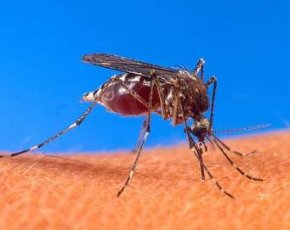
(a) Identify the parasite transmitted into human blood by the organism. (1 mark)
Plasmodium species//Plasmodium vivax//Plasmodium malariae//Plasmodium ovale//Plasmodium falciparum
(b) Name the blood cells that are destroyed by the parasite in (a) above.(1 mark)
Red blood cells//Erythrocytes.
(c) State one biological method used to eradicate the larvae of this organisms. (1 mark)
Fish feeding on the larvae;
2. Give the structural adaptations of the following in an insect pollinated plant.
(a) Pollen grain. (1 mark)
Rough //sticky to stick onto the body of the insect.
(b) Stigma. (1 mark)
Occur inside the flower ensuring that the insects brush against them as they look for nectar;// Sticky so that pollen grains from the body of an insect stick onto it; any 1
3. State the causative agents of the following diseases
(i) Tuberculosis. (1 mark)
Mycobacterium tuberculosis; should be underlined separately.
(i) Syphilis (1 mark)
Treponemapallidum; should be underlined separately.
- a) What do you understand by the term ecologically balanced ecosystem? 1mk
Equilibrium between living organisms and their environment that ensures survival of all organisms.

b) Give two reasons for loss of energy from one trophic level to another in a food web 2mks
- Some energy is lost as heat during respiration
- Excretion
5. Identify the following types of responses:
(a) Pollen tube growing towards the ovary (1 mark)
Positive Chemotropism;
(b) Maggots moving away from light. (1 mark)
Negative Phototaxis;
6. State two activities of the cell that are controlled by the nucleus. (2 marks)
Cell division;//Growth;//respiation
7. Distinguish between botany and zoology. (1 mark)
Botany is a branch of science that deals with study of plants while zoology is a branch of science that deals with study of plants;

8.The field of view of a light microscope appeared as shown below in diagram A and the diameter in A
was occupied by cells as shown in B.
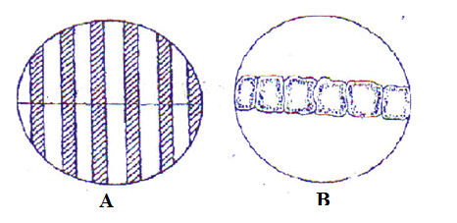
Calculate the length of one cell. (2 marks)
Length of one cell= Diameter of field of view in um ;6000 um = 1000um;
Number of cells 6
9. State two importance of water in germination of seeds. (2 marks)
Dissolve food substances//soften testa//hydrolyze food substances//activate enzyme any 2
10. Why is sexual reproduction advantageous in flowering in plants? (2 marks)
Hybrid vigour;
Causes variations;

11. Below is an illustration of an organism captured by students during a practical lesson.
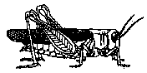
(a) Identify two features that enable the organism to be placed in the phylum Arthropoda.(2 marks)
Segmented body;
Jointed appendages;
Bilateral symmetry;
Presence of exoskeleton;
(b) Explain why the organism will die when Vaseline is applied on its thorax. (1 mark)
Blocks the spiracles and thus no inhalation;
12. Name two properties of enzyme amylase. (2 marks)
Works best under alkaline pH;
Substrate specific;
Protein in nature;
Calatlyst;
Affected by temperatures;
13. State the significance of natural selection. (2 marks)
Formation of new species;
Elimination of undesirable characteristics;
14. Explain why a plant shoot develops lateral branches when its tip is removed. (2 marks)
Tip has a higher concentration of auxins,when the tip of shoot is removed auxin concentration is lowerd; less auxin concentration stimulates sprouting of lateral btranches;

15. Why is eating a lot of biscuits harmful to the teeth. (2 marks)
Sugar in biscuits get logged in between teeth, bacteria break down the sugars releasing acids; that corrode the enamel that cause tooth decay;

16.a)Name the part of the chloroplast where each of the following activities take place.
Light stage………… granum
Dar stage…………..stroma
b)Name two types of cells in a leaf that carry out photosynthesis.
Guard cells
Palisade cells
Spongy mesophyll cells.
17. State any three disorders due to gene mutation in human beings.
Albinism
Sickle cell anemia
Haemophilia
Colour blindness
18. Why is it important that the radicle develops first during germination? (2 marks)
For absorptions of minerals salts and water;
Anchorage;

19. (a) Explain one event of mitosis that restores the genetic constitution of an organism. (1 mark)
Replication of chromosomes during interphase produces doubling chromosomes for sharing out;/ Alignment of spindle at equator during metaphase without association of homologous chromosomes prepares for separation of replicated chromatids;/the separation of chromatids during anaphase will result in same number of chromosomes in daughter cells;
(b) Identify the following types of cell division:
(i) Division of generative nucleus into male nuclei. (1 mark)
Mitosis;
(ii) Division of cells lining the seminiferous tubules. (1 mark)
Meiosis;
20. State two observable characteristics that show discontinuous variations in Drosophila melanogaster
(2 marks)
Wing length;-long dominant over vestigial wing
Eye colour;-red eyes dominant over white eye.
Size of abdomen;-broad abdomen dominant over narrow abdomen
Body colour ;-grey body colour dominant over black body colour

21. Explain why athletes breathe quickly and deeply after a 100 meters sprint. (3 marks)
To increase the supply of oxygen; required to get rid of lactic acid; due to anaerobic respiration;
22.(a) State two proteins that determine human blood groups. (1 mark)
Antigen A;/antigen B;/rhesus factor/ all mentioned to get a mark:
(b)(i) What is the role of blood capillary? (1 mark)
Site for exchange of substances;
(ii) Explain why blood does not clot in undamaged blood vessels. (1 mark)
Presence of prothrombin in blood//presence of heparin;
23.(a) List one type of chromosomal aberrations. (1 mark)
Deletion //duplication//inversion//tranlocation//non disjunction// any 1
(a) State one advantage of polyploidy in modern farming. (1mark)
Increased yields//early maturity//resistance to drought,pests and disease//any 1

24. Explain:
(a)Why insulin is not administered orally. (1 mark)
Insulin is a hormone that is transmitted through blood;
(b) Why stomach wall is lined with mucus (1 mark)
To prevent autodigestion;
25.(a) what is homeostasis? (1 mark)
Self adjusting mechanism that maintains a steady internal state in organisms;
(b) State two behavioral mechanisms used by snakes to increasetheir body temperature. (2 marks)
Coiling;
Basking;

26. Explain why only a small amount of food materials taken up by herbivores is passed on to secondary consumers. (2 marks)
Absorbed food is used in cell metabolism;
Lost in excretion;

27. Below is a diagram of a respiratory surface. Use it to answer questions that follow.
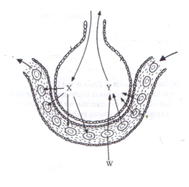
(a) Name the physiological process involved in the exchange of gases in the structure above. (1 mark)
Diffusion;
(b) Identify the substance in cell labeled w that has high affinity for gas X. (1 mark)
Haemoglobin;
(c) State the advantage of gas Y being transported in cells labeled W(1 mark)
Does not affect the pH of blood;
Efficient in loading and offloading of oxygen;

28.(a) Explain why when transplanting a young plant, it is advisable to remove some leaves. (2 marks)
Reduce the surface area/number of stomata exposed to envinronmental factors; thus lower the rate of transpiration;
(b) Give one role of xylem vessels other than transport(1 mark)
Mechanical support;

29. (a) Protoctista; Rej– Starting with a small letter(i.e. protoctista)
– Wrong spelling
(b) Osmoregulation;
30. State two characteristics of a bony fish which enable it to reduce friction in water. (2 marks)
Streamlined body;/inflexible head;/scales overlap and are pointed backwards;/mucus covering the body;
31.(a) Identify the structural difference between the wing of a bird and the wing of an insect (1 mark)
Wing of a bird | Wing of an insect
originates from theendoskeleton | originates from the exoskeleton;
Has bones | No bones;any 1
(b) Identify the type of evolution exhibited by the wings of birds and insects and state the name given to such structures. (2 marks)
Convergent evolution; analogous structures;
32.a) Name two characteristics that are controlled by genes located on
Y chromosomes
premature baldness
Tuft hair in ear pinna and nose
X chromosomes
Colour blindness
haemophilia 2mks

- How is the rib adapted for its function? 2mks
- It is long and curved to increase surface area for muscle
- Has tuberutum and captulum / projections for articulation with thoracic vertebrae;
- * Curved to form a ribcage

33.(a) what is the role of a pollen tube. (1 mark)
Facilitates transfer of male nuclei to the embryo sac;
(b) Identify the role of the following hormones in males:
(i) Follicle stimulating hormone. (1 mark)
Synthesis of sperms;
(ii) Testosterone. (1 mark)
Development of secondary sexual characteristics in males/production and maturation of sperms;any 1

