LARI SUB-COUNTY
END OF TERM TWO 2019 EXAMINATION
FORM FOUR BIOLOGY PAPER 2
231/2
BIOLOGY PAPER 2
2HOURS
SECTION A: (40 MARKS)
Answer all the questions in this section in the spaces provided:
1. Sickle cell anaemia is a hereditary disease due to a recessive gene which changes normal haemoglobin (Hb – A) to abnormal haemoglobin (Hb – S). The red blood cells of people with sickle cell anaemia are sickle shaped.
(a) What are the possible phenotypes of the offspring of a man who is heterozygous and a woman who is also heterozygous? Show your working. (5 marks)
(b) Sickle cell trait is more prevalent in tropical countries than in temperate countries. Give an explanation for this observation. (3 marks)
2. Three tubes each containing 1ml saliva and 1ml water were incubated in water baths at different temperatures as shown in the diagram below for 30 minutes. Another one tube containing 1ml starch Solution was incubated for the same length of time in each water bath. The contents of the two tubes in each water bath was then mixed and incubated for further 30 minutes. The content of each tube was then tested for starch using iodine solution.
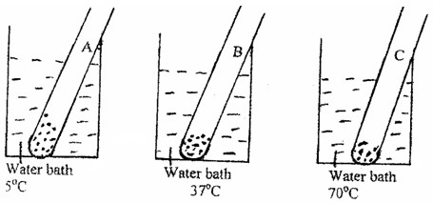

(a) What was the aim of the experiment? (1 mark)
(b) Why was it necessary to incubate the tubes for 30 minutes before mixing their contents? (1 mark)
(c) State the colour changes you would expect to observe after adding iodine solution. (3 marks)
(d) Account for the expected observations. (3 marks)
3. Below is a diagram of a sperm cell.
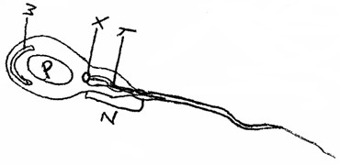

(a) Identify parts labeled X and Y. (2 marks)
(b) Explain how parts W and Z adapt the cell to its function. (4 marks)
(c) Using letter P identify or label on the diagram the part of the cell rich in DNA. (1 mark)
(d) State the function of part X. (1 mark)

4. The figure shown below represents a kidney nephron. Use it to answer the questions that follow.
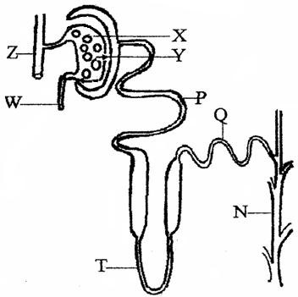

(a) (i) X is made up of a tuft of capillaries. How do they differ from other capillaries in the body? (1 mark)
(ii) What structural difference exist between W and Z? (1 mark)
(iii) State the significance of the difference stated in (a) (ii) above. (1 mark)
(b) State three adaptations that enable P to perform its function. (3 marks)
(c) What is counter flow and in which part of the nephron does it occur. (2 marks)
5. The diagrams below represent a set up to investigate the conditions necessary for seed germination.
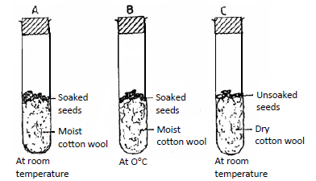

(a) What conditions were being investigated in the experiment? (2 marks)
(b) State three reasons for soaking seeds in set ups A and B. (3 marks)
(c) What were the expected results after seven days? (3 marks)
SECTION B
Answer question 6 (COMPULSORY) and EITHER question 7 or 8 in the spaces provided after question 8.
6. An experiment was carried out to investigate the effect of hormones on growth of lateral buds of three pea plants.
The shoots were treated as follows.
(a) Shoot A – Apical bud was removed.
(b) Shoot B – Apical bud was removed and gibberellic acid placed on the cut shoot. (c) Shoot C – Apical bud was left intact.
The lengths of the branches developing from the lateral buds were determined at regular intervals.

The results obtained are shown in the table below.
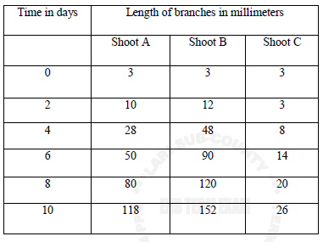

i) Using the same axes, draw graphs to show the lengths of branches against time. (8 marks)
ii) (a) What was the length of the branch in Shoot B on the 7th day? (1 mark)
(b) What would be the expected length of the branch developing from Shoot B on the 11th day? (1 mark)
iii) Account for the results obtained in the experiment. (6 marks)
iv) Why was Shoot C included in the experiment? (1 mark)
v) What is the importance of gibberellic acid in agriculture? (1 mark)
vi) State two physiological processes that are brought about by the application of gibberellic acid on plants. (2 marks)
7. Explain how structures of the human ear are adapted to their functions. (20 marks)
8. Explain how abiotic factors affect plants. (20mks)

