LARI SUB-COUNTY
END OF TERM TWO 2019 EXAMINATION
FORM FOUR
231/2 - BIOLOGY PAPER 2
MARKING SCHEME
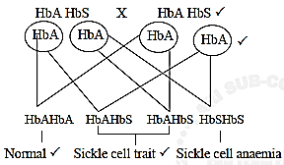
1.

(b) In tropical countries malaria incidence is high ; those who are heterozygous have immunity to malaria; this is called heterozygous advantage.
or
In tropical countries malaria incidences is high; those who are heterozygote have some red blood cells with crescent shape thus low oxygen carrying capacity plasmodium content therefore survive in such conditions making them to have an immunity ;
2. (a) Effect of temperature on enzymes ;
(b) So that contents of the tubes will have attained the temperature of the waterbath.
(c) A - Would turn blue black
B - Would turn brown / colour of iodine remained
C - Would turn blue black
(d) A - Very low temperature which inactivated enzyme / ptyalin / salivary amylase thus no digestion of starch.
B - Suitable temperature / favourable temperature / optimum / best temperature for activity of enzyme /salivary / amylase / ptyalin thus starch digested.
C - Temperature high / above optimum thus denaturing enzyme thus no digestion of starch.
3. (a) X Centriole
Y Axial filament
(b) W / acrosome release (hydrolytic) enzymes which digest the plasma membrane of ovum enabling the penetration of sperm.
(c) Z / middle piece has many mitochodria; to generate energy; (used in swimming of the sperm cell towards ovum)
(d) Formation of spindle fibres / pay a role in cell division
4. (a) (i) They are more permeable to water than capillaries.
(ii) Z has a wider lumen than N (acc converse)
(iii) This increases high blood pressure within the glomerulus.
(b) - One cell thick to reduce distance for reabsorption.
- Cells have numerous mitochondria to produce energy for active transport ; have microvilli to increase surface area for re-absorption ; Highly coiled to reduce spread of flow to increase time available for reabsorption.
(c) A condition where fluids flow in opposite directions / glomerular filtrate flow opposite direction to blood in capillaries; parts T and Q.
5. (a) Water, temperature, moisture (Acc. warmth)
(b) Mobilise /hydrolyse stored food / activate enzymes / breaking of dormancy.
Softening the testa / seed coat (acc. as a solvent / transport media)
(c) Those in set A will germinate
Those in set up B will not germinate
Those in set up C will not germinate
6. (a) (i)

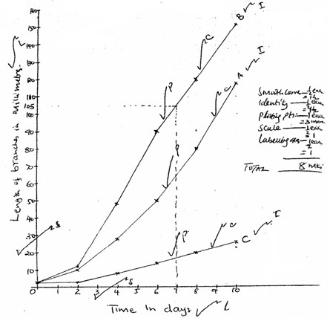

(ii) (a) 104mm ± 1mm (from 103mm to 105mm) (b) 164 mm
(iii) A. Removal of apical bud led to less auxin synthesis hence less auxin migrated to the stem;leading to increase in length of lateral bud;
B. Removal of apical bud led to less auxin migrating to the stem but with addition of G. A (Gibberellic acid) there is more cell elongation leading to increase in length of the lateral branches; C. Presence of apical bud led to more synthesis of Auxin; leading inhibition of elongation of lateral buds hence to slow rate of increase in length of lateral branches; (iv) To act as a control experiment.
(v) - Help / stimulate formation of side branches.
- Ends dormancy in buds.
- Activate growth of adventitious root.
- Brings about parthenocarpy / initiated flowering / setting fruits without fertilization.
- Break seed dormancy
- Affect leaf expansion.
- Retard leaf abscission.
(vi) - Activates enzymes during germination thus breaking seed dormancy.
- Promote cell division / elogation.
TOTAL 22 MAX 20
7. The pinna;- is funnel shaped; cartilaginous structure that collects and directs sound waves into the ear; The external auditory canal; - a tube that directs sound waves from the pinna to the eardrum lining the auditory canal; The canal contains wax-secreting cells; and hair which traps dust particles; and pathogenic bacteria hence prevent them from getting into the ear;
The eardrum; - has a thin tough membrane; that easily vibrates when hit by sound waves;transferring them into vibrations.
The ear ossiscles; - they act like a layer and they easily move forward and backward to amplify sound vibrations that hit them;
The suspensory ligaments; - suspends the ear ossicles and prevents excessive vibration that would otherwise damage the inner parts of the ear;
The eustachian tube - it connects the middle ear with the pharynx; and it equalises air pressure between the middle and the outer ear so as to prevent distortion of the eardrum; The oval window;- has thin membrane that transmits sound vibrations into the endolymph; The cochlea;- highly coiled to occupy a small area but to accommodate a large number of sensory cells;
The perilymph and endolymph; - these are fluids that absorb mechanical shock; hence protect the delicate\parts in the inner ear; They also transmit vibrations to the inner parts of the ear; The sensory cells; - when stimulated, they generate nerve impulses; which are transmitted by the auditory nerve to the brain;
The semi-circular canals; - these are tubular cavities that maintains body balance and posture; They contain special cells that are sensitive to changes in gravity;
TOTAL 29 MAX 20
8. Explain how a biotic factor affect plants (20mks)

Wind;
In windy conditions the rate of transpiration increase; wind disperses fruits/seeds
Is an agent of pollination Acc. Spores for seed Temperature;
Changes in temperature affect the rate of photosynthesis and other biochemical reactions/metabolic reactions/enzymatic reaction, temperature increases rate of transpiration;
Light
Plants need light for photosynthesis some plants need light for flowering/photoperiodism (seeds like lettuce require light for germination;
Humidity
When humidity is low, the rate of transpiration increases;
pH;
Each plant requires a specific ph to grow well/acidic /alkalinity/neutral
Salinity
Plants with salts tolerant tissues grow in saline area; plants in estuaries adjust to salt fluctuations;
Topography
North facing slopes in temperature land have more plants than south facing slopes plants on wind ward side have stunted /distorted growth; Acc comparisons of mountains and valleys
Acc. Description of other areas with other topographies e.g. river, rainwater/water;
- Fewer plants in areas/semiarid /and
- Water is needed for germination is a raw material for photosynthesis/dissolves .Mineral salts provides turgidity for support/fruits/seeds
Pressure
Variation in atmospheric pressure affects availability of CO2 which affects photosynthesis and low pressure increase rate of transpiration and affect amount of oxygen; for respiration
Mineral salts/trace elements
- Affects distribution of plants in the soil;
- Plants thrive well where there are mineral salts in the soil;
- Plants living in the soil deficient in particular mineral element
- Have special methods obtaining it; for example legumes obtaining of Nitrogen by fixation or carnivorous.

