**231/1**

**BIOLOGY (Theory)**

**July/August 2019**

**2 Hours**

**KENYA CERTIFICATE OF SECONDARY EDUCATION**

**FORM FOUR BIOLOGY PAPER 1**

**MARKING SCHEME**

**SECTION A**

1.State two features of leaves which enable a plant to reduce the loss of water. (2mk)

- Sunken stomata ✓ 1

- leaves needle – like / spine- like ✓1

2.a)State the phylum where all members have open circulatory system. (1mk)

Arthropoda Rej: Anthropoda, arthropods.

b) Explain two advantages of closed circulatory system over open circulatory system. (2mk)

xygenated and deoxygenated blood are completely separated / do not mix;

Blood flow to organs is well regulated based on demand;

Animals tend to be more active due to efficient transport of gases and nutrients

Blood circulates over longer distances at faster rate due to high blood presence;

*(mark any 2 correct)*

3. a) Under which of the following magnifications would one see a larger part of the specimen X 40 or X500? Give a reason. (2 Marks)

X40; it is a lower magnification thus giving a wider view;

(b) State how magnification is worked out in a light microscope. (1 Mark)

Magnification = Eye piece lens x objective lens;

4..Name two components of blood that are not present in glomerular filtrate.(2mks)

Plasma proteins ;✓ 1

Blood cells;✓1

5.The following is an equation representing a type of respiration

C6H12O6 2C3H6O3 + Energy

a)Identify the type of respiration. (1mk)

Anaerobic respiration in animals ; Rej anaerobic respiration alone

b) Suggest one industrial application of the process name in (a) above. (1mk)

- Beer brewing

- Bread baking / leavening of bread

- Processing dairy products;

Acc. Correct examples)

- Biogas production

- Sewage treatment

- Manufacture of wines and spirits ;

- Production of organic acids;

*(Mark any first one )*

6a)What is meant by the term binomial nomenclature. (1mk)

Scientific system of giving living organism two names ‘✓1

b)A dog is called Canis familiairis. Name the taxonomic unit represented by canis.(1mk)

Genus name ;✓1

7.Give two functions of the exoskeleton in arthropods. (2mks)

- Protects inner delicate tissues / organs against mechanical damage✓1

- Prevent water loss / desiccation ✓1

- Provides sites for muscles attachment ✓1

8. The colour of tips of hair in Shepherd dog is controlled by a gene with three alleles B for Black, R for red and C for copper. A cross between pure breeding red and copper hair tips produce offsprings with scarlet hair tips. Crossing pure breeding red and black hair tips yields all red offsprings. A cross between pure breeds of copper and black produce offsprings that are all copper.

a) Comment on the inheritance of the three alleles B, R and C. (2 marks)

R and C alleles are co-dominant;

R and C are dominant overer B;

b) A dog breeder wishes to know the genotype of a dog with red hair tips. State and explain the cross needed to determine the dog’s genotype.

A test cross; a dog with red hair tips is crossed with a black dog (homozygous) recessive;

9. What is the importance of seed dispersal? (3mks)

- Avoids overcrowding ;

- Plants inhabit new habitats;

- avoids competition for nutrients , light;

10. State two adaptations of guard cells to function. (2 Marks)

Have many chloroplasts for photosynthesis;

Have thick inner wall than outer wall; to enhance stomatal opening;

11. Describe the censor mechanism of seed dispersal. (2mks)

. - Fruit is capsule shaped; capsule is usually attached to a long stalk; when swayed by wind the seeds are released and scattered;

12. Explain “struggle for existence” and “survival of the fittest” as they apply to natural

Selection. (4mks)

Struggle for existence

- Environmental pressure; on the population causes competition within the population in an effort to survive;

Survival of the fittest:-

* Individuals with advantageous variations survive; poorly adapted individuals perish and do not transmit their characteristics; OWTTE,

13. (a) Define the following term

Incomplete metamorphosis. (1mk)

Development in some insects involving the egg, nymph and adult;

(b) State one function of each of the following hormones (2mks)

(i) Juvenile hormone.

formation of larval cuticle;

- Retention of juvenile characteristics

(ii) Ecdysone.

Moulting in insects;

14. a) Name the organelle where the cell wall components are synthesized. (1mk)

Golgi body/apparatus/chloroplast

b) State two roles of cell wall to a plant. (2mks)

* Maintain the shape of the cell
* Prevent cell from bursting when turgid
* If fully permeable allowing materials to pass through

15. The diagram below represents a section through the mammalian ear.



a) Name the structures labelled R and T. (2 mark)

R Eustachian tube;

T semi circular canal;

b) State how the structures Q and S are adapted to their functions. (2 mark)

Q -it is funnel shaped to concentrate sound waves to external auditory meatus;

S -it is long and spiral / coiled increasing surface area for attachment of many sensory cells that detect sound vibrations;

* Has Sensory cells in the organ of corti, that are stimulated by the vibration received from the oval window;
* Is fluid filled/contain perilymph and endolymph which transmit sound vibration from oval window to the sensory cells;

any one correct

16. The diagram below represents some gaseous exchange structures in humans

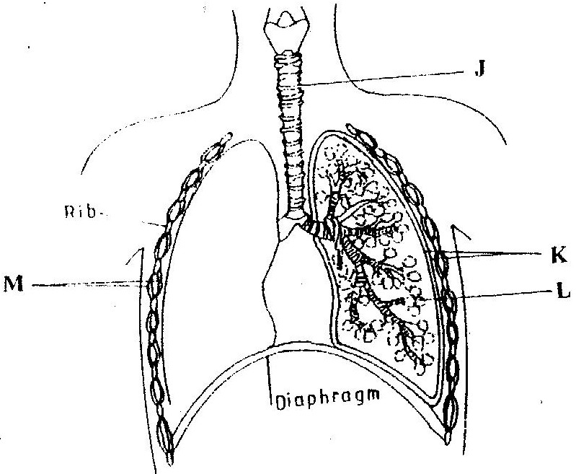

(a) Name the structures labeled K ( 1 marks)

K Pleural membranes .

(b) State two ways in which the structure labeled J suited to its function? ( 1 marks)

Has c- shaped cartilage rings that support it preventing it from collapsing and allow free flow of air;

-Inner lining has mucus secreting cells/goblet cells that secrete mucus which trap fine dust particles and micro- organisms;

-Inner lining has hair like structures called cilia that enhance upward movement of the mucus to the larynx;

Mark any one correct

(c) Name the process by which inhaled air moves from the structure labeled L into

blood capillaries ( 1 mark)

Diffusion

(d ) Give the scientific name of the organism that causes tuberculosis in humans

( 1 mark)

*Mycobacterium tuberculosis*

17. The diagram below represents the anterior view of a certain vertebra.

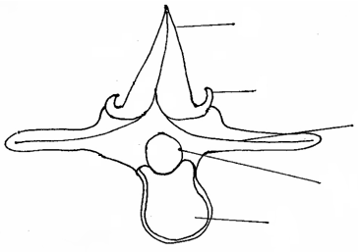

**A**

**B**

**C**

**D**

**E**

(a) With a reason, identify the type of vertebra shown above. (2mks)

Lumbar;

Reason - Has large/ broad transverse processes;

- Has large neural spine;

- Broad Centrum;

- Has metapophyses;

b)Name the parts labeled.

(i) A Neural spine; (1mk)

(ii) DNeural canal; (1mk)

c) State the function of part E. (1mk)

Supports the trunk;

18. State THREE adaptations of a leaf to gaseous exchange. (3 marks)

It has stomata for efficient diffusion of gases;

It is thin to allow gases to diffuse through short distances;

It has air spaces for easy circulation of gases;

it has broad and flat lamina to provide large surface area for absorption; Mark 1st three

19. What is the importance of the pollen tube in fertilization in plants? (1 marks)

. Pollen tube is a passage of male nuclei to reach the ovum in the ovary;

20.The following are events suggested by the theory of natural selection.

1. Reproduction of organism with favourable variation
2. The emergence of new species
3. Variation between individuals
4. A struggle for existence
5. The survival to the fittest
6. Who postulated the theory of natural selection? (1 mark)

Charles Darwin

1. What is meant by natural selection? (1 mark)

Process by which the environment allows those organisms with favourable adaptive to survive , reach maturity and pass on the favourable traits to their offsprings and those without the favourable traits die young without passing on to the next generation

1. Arrange in an order that best illustrate the sequence of events leading to evolution by natural selection (1 mark)

iii,iv,v,i and ii;

21.The diagram below shows a vertical section through human brain.

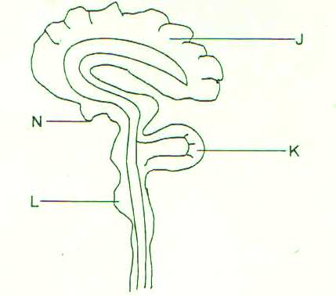

1. Name the part labeled K (1 mark)

Cerebellum;

1. State why the part labeled J is large and highly folded. (1 mark)

increase surface area accommodation of more neurons for processing impulses

1. Give a letter on the diagram which:
2. Serve as endocrine gland (1 mark)

N

1. Control breathing, swallowing and blood circulation (1 mark)

L

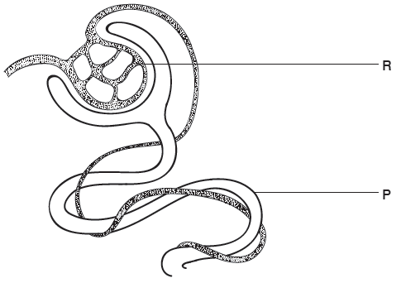**22.** The diagram below shows part of a nephron from the human kidney.

1. (i) Name the structure labelled **R**. (1 mark)

Glomerulus rej glomeruli

(ii) Name the process carried out at **P**. (1 mark)

Selective reabsorption

(b) The hormone ADH affects water reabsorption from the nephron.

(i) Which part of the brain releases ADH? (1 mark)

Pituitary gland

(ii) Name a part of the nephron where water is reabsorbed. (1 mark)

loop of Henle acc distal convoluted tubule,collecting duct

23.The figure below illustrates a food web in a certain ecosystem.

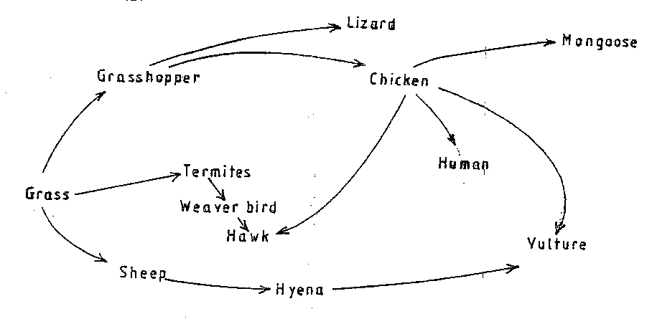

From the food web:

1. Draw the shortest food chain; (1mk)

Grass grasshopper lizard;

1. identify the organisms with the highest
2. Number of predators (1mk)

Chicken;

(ii) Biomass (1mk)

Grass;

24.The diagram below represents a certain organism collected by a student at the sea shore.

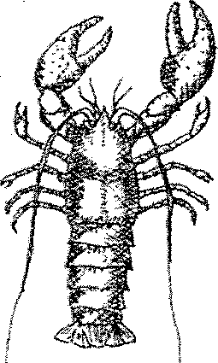

(a) Name the class to which the organism belongs. (1mk)

Crustaceae/ Crustacea;

(b) Give three reasons for your answer in (a) above. (3mks) - Head fused with thorax/ has cephalothorax; (Reject 2 body parts)

- Have two pairs of antenae

- Have compound eyes/ a pair of compound eyes;

- Have five to twenty pairs of limbs;

- Have external gills;

(Mark first 3 only)

25.In an experiment, disinfection soaked bean seeds were put in a vacuum flask which was then fitted with a thermometer as shown in the diagram below.

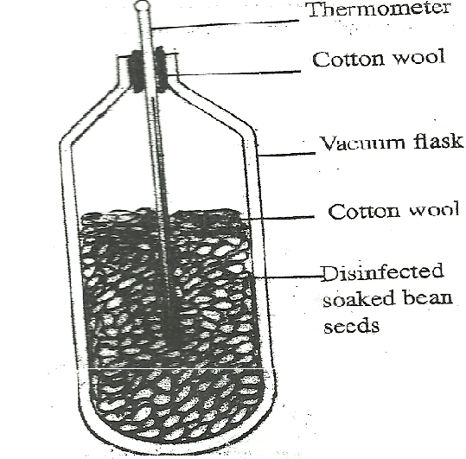

The temperature readings were taken every morning for three consecutive days.

1. Which process was being investigated? (1 mark)

Respiration (Rej: external respiration/ anaerobic respiration )

Acc: aerobic respiration

b)i) what were the expected results? (1 mark)

Rise/ increase in thermometer / temperature reading.

ii) Account for the answer in (b) (i) above? (2 marks)

stored starch/ glucose/ carbohydrates in germination seeds are broken down/ oxidized to

get energy. Some of the energy is released to get energy; some of the energy is released

as heat.

26. The diagram below shows a specialized plant cell

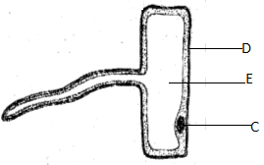

(a) i) name the cell (1mk)

Root hair(cell)

ii) name the cell parts labeled D and E

D – cell wall

E – cell sap (vacuole)

b)state the functions of the part labelled C

Controls the functioning of the cell/ controls cell activity