NAME: ……………………………………………………………………… INDEX NO:……………

SCHOOL: .………………………………………………………………………………………………

BIOLOGY
PAPER 2
THEORY
MARCH/APRIL 2019
TIME 2 HOURS

MALIET EXAMS
Kenya Certificate Of Secondary Education (2019)

FORM FOUR

INSTRUCTIONS TO CANDIDATES
- Write your name and Index number in the space provided above.
- This paper has two sections A and B.
- Answer ALL the questions in section A in the spaces provided on the question paper.
- In section B answer question 6(compulsory) and either question 7 or 8 in the spaces
Provided after question 8.

For Examiner’s Use Only.

SECTION | QUESTIONS | MAXIMUM  SCORE | CANDIDATES  SCORE
 | 1 | 8
 | 2 | 8
 | 3 | 8
 | 4 | 8
 | 5 | 8
 | 6 | 20
 | 7/8 | 20
TOTAL SCORE |  | 80

This paper consists of 10 printed pages. Candidates should check the question paper to ensure that all the pages are printed as indicates and no questions are missing.

SECTION A (40 MARKS)
Answer ALL the questions in this section in the space provided.
- The diagram below illustrates an experiment to demonstrate a certain biological process.
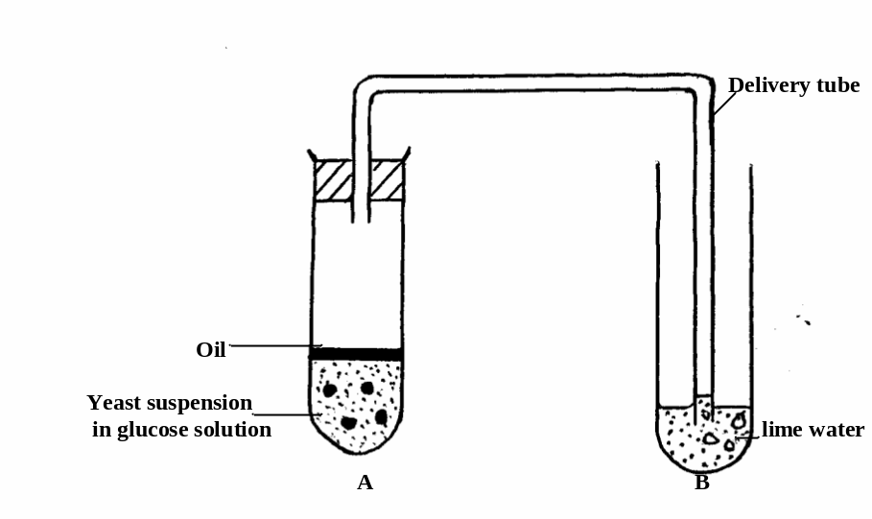
Before adding yeast suspension in tube A, the glucose solution was first boiled and cooled.

  - What biological process was being demonstrated? (1mark)
………………………………………………………………………………………………………………………………………………………………………………………………

(b) (i) What observation would be made in tube B after 20 minutes of the experiment?
(2marks)
………………………………………………………………………………………………………………………………………………………………………………………………………………………………………………………………………………………………
………………………………………………………………………………………………………………………………………………………………………………………………

(ii) Account for the observations made in (b) (i) above (2marks)
………………………………………………………………………………………………………………………………………………………………………………………………………………………………………………………………………………………………
………………………………………………………………………………………………………………………………………………………………………………………………

(c) Write down an equation to summarise the reaction taking place in tube A. (1mark)

- State two industrial applications of the chemical reaction taking place in tube A.
(2marks)
………………………………………………………………………………………………………………………………………………………………………………………………………………………………………………………………………………………………

- Haemophilia is due to a recessive gene located on the X- chromosome. A phenotypically normal male married a normal female and one of sons was a haemophilic.
  - Work out the genotype of the other children (use letter H to denote the gene for normal blood clotting ) (4marks)

  - Explain why in a human population there will be more cases of haemophilia in males than females. (2marks)
………………………………………………………………………………………………………………………………………………………………………………………………………………………………………………………………………………………………
………………………………………………………………………………………………

  - Apart from haemophilia, name one other genetic disorder of human blood caused by gene mutation (1mark)
………………………………………………………………………………………………………………………………………………………………………………………………

  - State the importance of vitamin K in blood clotting. (1mark)
…………………………………………………………………………………………
…………… ……………………………………………………………………………

3. The diagram below shows a fresh water ecosystem. Study it carefully and answer the questions that follow.
Q
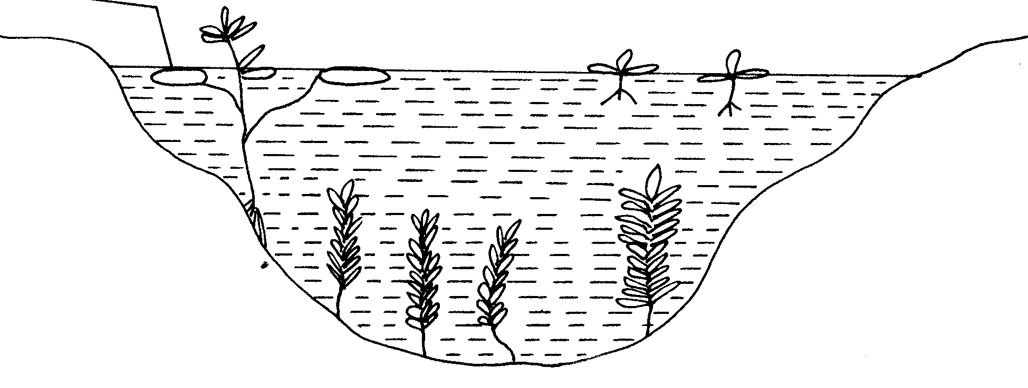
S
P
a) What is an ecosystem. 1mk
………………………………………………………………………………………………………………………………………………………………………………………………

b) Identify the type of plants labeled S,P and Q. 3mks
………………………………………………………………………………………………………………………………………………………………………………………………
………………………………………………………………………………………………………………………………………………………………………………………………

c) Explain adaptations of plant P to their environment. 4mks
………………………………………………………………………………………………………………………………………………………………………………………………
………………………………………………………………………………………………………………………………………………………………………………………………
………………………………………………………………………………………………………………………………………………………………………………………………
4. The diagrams below illustrate the behaviour of Red Blood Cells when placed into two different solutions X and Y.
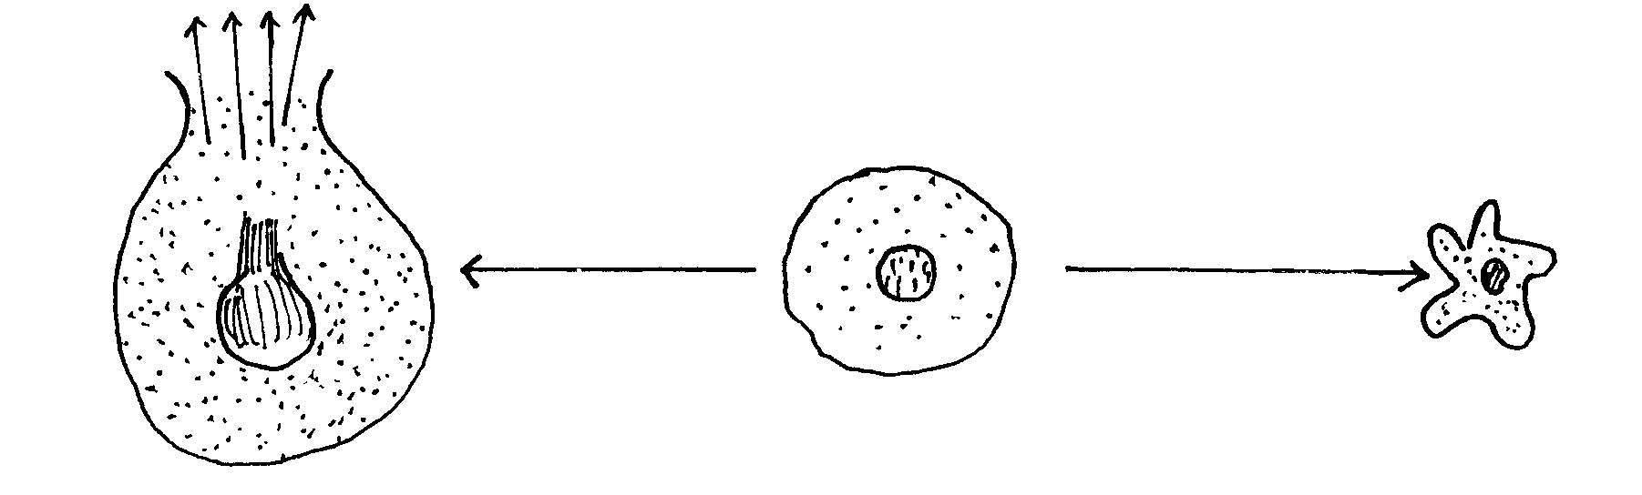
Placed in solution X

Process
A
Placed in solution Y

Process
B
a) Suggest the nature of solutions X and Y. (2mks)
X ……………………………………………………… Y ………………………………………
b) Name the processes A and B (2mks)
A …………………………………………………….. B ……………………………………….
c) What would happen to normal blood cells if they were placed in an isotonic solution. (1mk)
……………………………………………………………………………………………………
……………………………………………………………………………………………………
d) Explain the mechanisms by which water moves from the soil into the root hair cell in plants (3mks)
…………………………………………………………………………………………………………………………………………………………………………………………………………
…………………………………………………………………………………………………………………………………………………………………………………………………………
……………………………………………………………………………………………………
………………………………………………………………………………………………………………………………………………………………………………………………………………………………………………………………………………………………………………
5. The diagram below shows a portion of a lower epidermis of a sukuma wiki leaf.
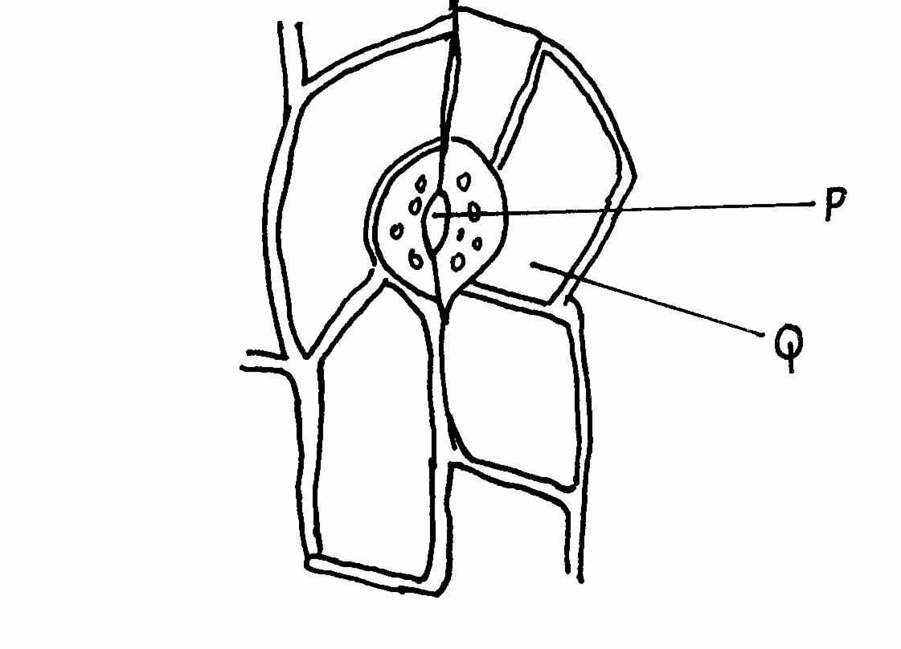

a) Name the parts labelled P and Q. ( 2mks)
P……………………………………………….
Q ……………………………………………….
b) Briefly describe the photosynthetic theory of stomatal opening. ( 5mks )
…………………………………………………………………………………………………………………………………………………………………………………………………………
…………………………………………………………………………………………………………………………………………………………………………………………………………
…………………………………………………………………………………………………………………………………………………………………………………………………………
…………………………………………………………………………………………………………………………………………………………………………………………………………
c) State one modification in the stomata of xerophyte plant other than being sunken and hairy.
( 1mk)
………………………………………………………………………………………………………………………………………………………………………………………………

SECTION B ( 40 marks)
Answer question 6 ( compulsory ) in the spaces provided and either question 7 or 8 in the spaces provided after question 8.

6. An experiment was carried out to investigate the growth rate of pollen tube of a morning glory flower over a period of time. The results are as shown in the table below.

Time ( mins ) | 0 | 20 | 40 | 60 | 80 | 100 | 120 | 140 | 160
Growth of pollen tube ( mm) | 00 | 02 | 06 | 12 | 17 | 19.2 | 20.4 | 21 | 21.4

- Using a suitable scale, draw a graph of growth of pollen tube against time. ( 6mks)



b) i) What was the length of the pollen tube at 90 minutes. ( 1mk )
…………………………………………………………………………………………………………………………………………………………………………………………………………
ii) At what time was the length of the pollen tube 9 mm? ( 1mk )
…………………………………………………………………………………………………………………………………………………………………………………………………………
- With reasons, describe the growth pattern of the pollen tube between-;
i) O to 80 minutes ( 2mks )
…………………………………………………………………………………………………………………………………………………………………………………………………………
…………………………………………………………………………………………………………………………………………………………………………………………………………
ii) 100 to 160 minutes ( 2mks )
…………………………………………………………………………………………………………………………………………………………………………………………………………
…………………………………………………………………………………………………………………………………………………………………………………………………………
- State the importance of the growth of pollen tube to the morning glory flower. ( 2mks )
…………………………………………………………………………………………………………………………………………………………………………………………………………
…………………………………………………………………………………………………………………………………………………………………………………………………………
e) Describe the process of fertilization in a flowering plant. ( 6mks)
…………………………………………………………………………………………………………………………………………………………………………………………………………
…………………………………………………………………………………………………………………………………………………………………………………………………………
…………………………………………………………………………………………………………………………………………………………………………………………………………
…………………………………………………………………………………………………………………………………………………………………………………………………………
…………………………………………………………………………………………………………………………………………………………………………………………………………
- Discuss the various ways in which seeds and fruits are adapted for dispersal. (20mks)

- Describe the adaptations of the mammalian heart to it’ s functions ( 20 mks )
…………………………………………………………………………………………………………………………………………………………………………………………………………
…………………………………………………………………………………………………………………………………………………………………………………………………………
…………………………………………………………………………………………………………………………………………………………………………………………………………
…………………………………………………………………………………………………………………………………………………………………………………………………………
…………………………………………………………………………………………………………………………………………………………………………………………………………
…………………………………………………………………………………………………………………………………………………………………………………………………………
…………………………………………………………………………………………………………………………………………………………………………………………………………
…………………………………………………………………………………………………………………………………………………………………………………………………………
…………………………………………………………………………………………………………………………………………………………………………………………………………
…………………………………………………………………………………………………………………………………………………………………………………………………………
…………………………………………………………………………………………………………………………………………………………………………………………………………
…………………………………………………………………………………………………………………………………………………………………………………………………………
…………………………………………………………………………………………………………………………………………………………………………………………………………
…………………………………………………………………………………………………………………………………………………………………………………………………………
…………………………………………………………………………………………………………………………………………………………………………………………………………
…………………………………………………………………………………………………………………………………………………………………………………………………………
…………………………………………………………………………………………………………………………………………………………………………………………………………
…………………………………………………………………………………………………………………………………………………………………………………………………………
…………………………………………………………………………………………………………………………………………………………………………………………………………
…………………………………………………………………………………………………………………………………………………………………………………………………………
…………………………………………………………………………………………………………………………………………………………………………………………………………
…………………………………………………………………………………………………………………………………………………………………………………………………………
…………………………………………………………………………………………………………………………………………………………………………………………………………
…………………………………………………………………………………………………………………………………………………………………………………………………………
…………………………………………………………………………………………………………………………………………………………………………………………………………
…………………………………………………………………………………………………………………………………………………………………………………………………………
…………………………………………………………………………………………………………………………………………………………………………………………………………
…………………………………………………………………………………………………………………………………………………………………………………………………………
…………………………………………………………………………………………………………………………………………………………………………………………………………
…………………………………………………………………………………………………………………………………………………………………………………………………………
…………………………………………………………………………………………………………………………………………………………………………………………………………
…………………………………………………………………………………………………………………………………………………………………………………………………………
…………………………………………………………………………………………………………………………………………………………………………………………………………
…………………………………………………………………………………………………………………………………………………………………………………………………………
…………………………………………………………………………………………………………………………………………………………………………………………………………
…………………………………………………………………………………………………………………………………………………………………………………………………………

