Name......................................................... Index No. ................... Stream...........
Candidate’s Signature...................................... Date......................................
231/1 BIOLOGY FORM 4
PAPER 1
THEORY
NOVEMBER 2021
TIME: 2 HOURS
NAMBALE ACK DIOSECE TERM 2 2021
JOINT EVALUATION EXAMINATION
FORM 4 231/1 BIOLOGY THEORY PAPER 1
Instructions to candidates
(a) Write your name and index number in the spaces provided above.
(b) Sign and write the date of examination in the spaces provided above.
(c) Answer all the questions in this question paper.
(d) All answers must be written in the spaces provided.
(e) This paper consists of 12 printed pages.
(f) Candidates should check the question paper to ascertain that all the pages are printed as indicated and that no questions are missing.
(g) Candidates should answer the questions in English.

For Examiner’s Use Only
Question Number | Maximum  Score | Candidate’s  Score
1- 31 | 80

1. Below is an image of a biological vector. Use it to answer questions that follow.
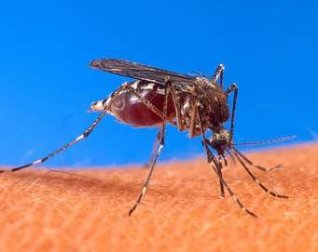
(a) Identify the parasite transmitted into human blood by the organism. (1 mark)
………………………………………………………………………………………………………………
(b) Name the blood cells that are destroyed by the parasite in (a) above. (1 mark)
………………………………………………………………………………………………………………
(c) State one biological method used to eradicate the larvae of this organism. (1 mark)
………………………………………………………………………………………………………………
2. Give the structural adaptations of the following in an insect pollinated plant.
(a) Pollen grain. (1 mark)
………………………………………………………………………………………………………………………………………………………………………………………………………………………………
(b) Stigma. (1 mark)
………………………………………………………………………………………………………………………………………………………………………………………………………………………………
3. A certain plant was found to have the following features
- Parallel venation of leaves.
- Sheath like petiole.
- Flower parts in multiple of three.

- Name the class to which the plant belongs. (1mark)
………………………………………………………………………………………………………
- Suggest the expected arrangement of vascular bundle in the stem of the plant. (1mark)
………………………………………………………………………………………………………
4. In an experiment, the rate of gaseous was determined and recorded as shown in the table below. Using these figures, suggest which plant gaseous structure were responsible for these figures
Structure | Gaseous exchange in %
A | Approximately 97
B | Approximately 2.5
C | Approximately 0.5

A………………………………………………………………………………………….. (1mark)
B……………………………………………………………..…………………………….. (1mark)
C………………………………………………………………………………………….…(1mark)

5. The diagram below shows an experiment set up using a seedling enclosed in a desk box with a hole on one side at the beginning of the experiment and after five days of growth.
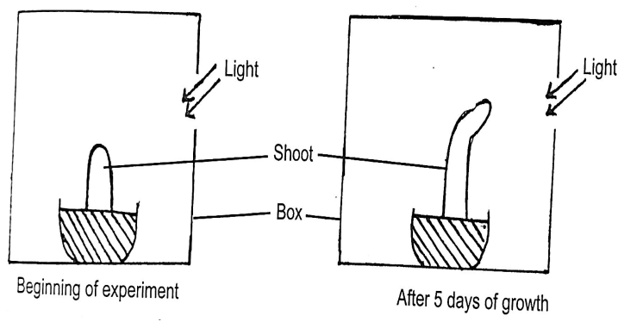

(a) What type of response is shown by the above shoot? (1 mark)
................................................................................................................................................................
(b) State two observable changes which took place in the seedling after five days of growth. (2 marks)
..............................................................................................................................................................
................................................................................................................................................................
(c) Account for the observable changes in (b) above. (2 marks)
...........................................................................................................................................................................................................................................................................................................................................................................................................................................................................................................................

6. a) State the reason for the following adaptation of the xylem vessels (2marks)
i) Narrow lumen
………………………………………………………………………………………………………………………………………………………………………………………………………………………………
ii) Lack of cross wall
………………………………………………………………………………………………………………………………………………………………………………………………………………………………
7. Name the organism that causes each of the following diseases.
i) Gonorrhea (1mark)
………………………………………………………………………………………………………………
ii)Amoebic dysentery (1mark)
………………………………………………………………………………………………………………
8. a) What is a species? (1mark)
………………………………………………………………………………………………………………. ……………………………………………………………………………………………………………….
b) A horse and a donkey can interbreed to give rise to an offspring, the mule. However they are still considered to belong to different species. Explain (1mark)
………………………………………………………………………………………………………………………………………………………………………………………………………………………………

9. The diagram below represents a set up to investigate the conditions necessary for seed germination. The set up was left for 5 days.
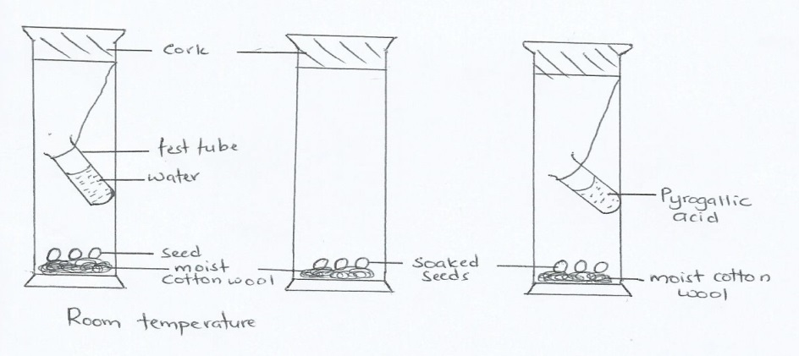
- What conditions were being investigated in the experiment? (2marks)
………………………………………………………………………………………………………………………………………………………………………………………………………………………………

b) Explain the role of water during seed germination. (2marks)
………………………………………………………………………………………………………………………………………………………………………………………………………………………………………………………………………………………………………………………………………………
10. Explain what happens to excess amino acids in the liver of humans. (2marks)
………………………………………………………………………………………………………………………………………………………………………………………………………………………………………………………………………………………………………………………………………………………………………………………………………………………………………………………………
11. State the branch of Biology that deals with: (2 marks)
(a) Study of birds
.........................................................................................................................................................................
(b) Study of the chemical composition of organisms
.........................................................................................................................................................................
12. The apparatus below illustrates breathing in a mammal.
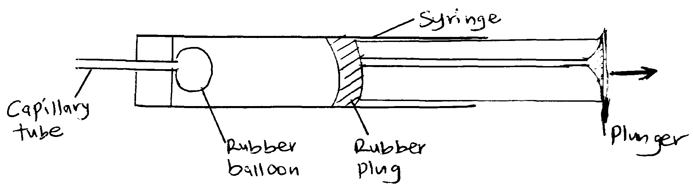
(a) State the organs represented by:
(i) Rubber (1 mark)
.........................................................................................................................................................................
(ii) Rubber plug. (1 mark)
.........................................................................................................................................................................

(b) Explain what happens if the rubber plug is pulled in the direction shown by the arrow. (2 marks)
...........................................................................................................................................................................................................................................................................................................................................................................................................................................................................................................................
13. (a) Calculate the respiratory Quotient(RQ) from the equation below. (2 marks)
2C₅₁H₉₅O₆ + 145O₂ 102CO₂ + 98H₂O

(b) Identify with a reason the substrate being respired from the equation above. (1 mark)
..................................................................................................................................................................................................................................................................................................................................................
14. The diagram below shows the base sequence of part of a nucleic acid strand. Study it and answer the questions that follow.
G−T−T−A−G−C−T−G−A
(a) With a reason state whether the strand above is from a DNA or RNA molecule. (2 marks)
..................................................................................................................................................................................................................................................................................................................................................
(b) State two structural differences between DNA and RNA strands. (2marks)
.............................................................................................................................................................................................................................................................................................................................................................................................................................................................................................................................................................................................................................................................................................................................................................................................................................................................................
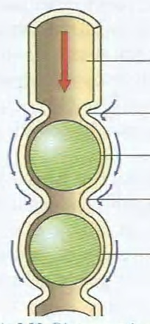
15. The diagram below shows how food bolus moves along the alimentary canal and intestines.

1
2

(a) Identify the process illustrated on the diagram. (1 mark)
.........................................................................................................................................................................
(b)Briefly explain how the movement of food bolus from position 1 to position 2 in the diagram above is achieved. (2 marks)
...........................................................................................................................................................................................................................................................................................................................................................................................................................................................................................................................
16. A person was complaining of thirst most of the times. A sample of the patient’s urine was found to contain a lot of sugar.
(a) Name the hormone the person’s body was deficient of. (1 mark)
.........................................................................................................................................................................
(b) Which disease was the person likely to be suffering from? (1 mark)
.........................................................................................................................................................................
17. Name two mechanisms that hinder self fertilization in flowering plants. (2 marks)
.........................................................................................................................................................................
.........................................................................................................................................................................
18. The diagram below represents a cross section of a plant organ. Study it and answer the questions that follow.
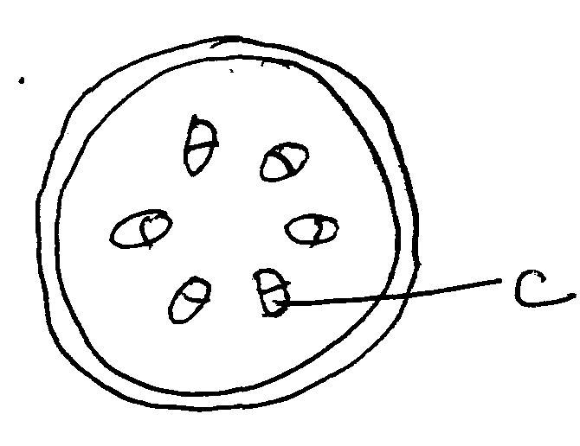
(a) (i) From which plant organ was the section obtained from? (1 mark)
.........................................................................................................................................................................
(ii) Give a reason for your answer in (a) (i) above. (1 mark)
.........................................................................................................................................................................
(b) What is the function of the part labeled C? (1mark)
..................................................................................................................................................................................................................................................................................................................................................
19. (a)What is meant by vestigial structures? (1 mark)
..................................................................................................................................................................................................................................................................................................................................................
(b) Give two examples of vestigial structures in humans. (2 marks)
..................................................................................................................................................................................................................................................................................................................................................

20. Julie observed 8 onion epidermal cells across a field of view of a light microscope. The field of view was 4 mm in diameter; calculate the average of the cells in micrometres. (2 marks)
...........................................................................................................................................................................................................................................................................................................................................................................................................................................................................................................................
21. State the use of the following plant waste products to humans. (2 marks)
(i) Papain........................................................................................................................................................
(ii) Colchicine................................................................................................................................................
22. A student dropped a small piece of fresh liver in a beaker containing hydrogen peroxide. A lot of fizzling and froth was observed.
(a) Name the gas produced. (1 mark)
.........................................................................................................................................................................
(b) Write the word equation for the reaction above. (1 mark)
..................................................................................................................................................................................................................................................................................................................................................
23. Give the functions of the following ecological instruments (2marks)
(a) Seechi disc
………………………………………………………………………………………………………………
(b) Photographic light meter
………………………………………………………………………………………………………………
24. (a) Explain why fertilization must take place in the fallopian tube but not uterus (1mark)
………………………………………………………………………………………………………………………………………………………………………………………………………………………………………………………………………………………………………………………………………………………………………………………………………………………………………………………………

(b) Explain double fertilization in flowering plants (2marks)
………………………………………………………………………………………………………………………………………………………………………………………………………………………………………………………………………………………………………………………………………………………………………………………………………………………………………………………………

25. The diagram below represents a mammalian bone of the appendicular skeleton

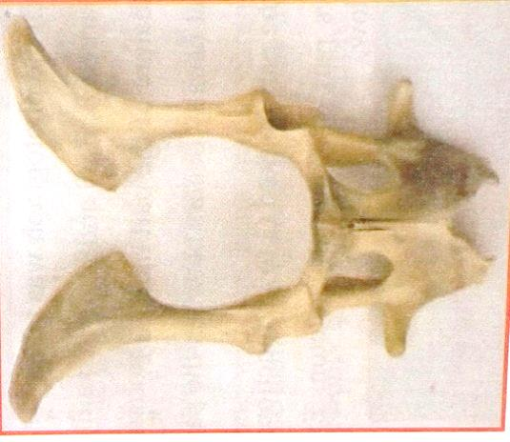

N
M

X

(a) Name and state the functions of the part labeled M and N. (2marks)
………………………………………………………………………………………………………………………………………………………………………………………………………………………………
(b) State how the structure X is adapted to its function (1mark)
………………………………………………………………………………………………………………………………………………………………………………………………………………………………………………………………………………………………………………………………………………

26. Use the illustration below to answer questions that follow.
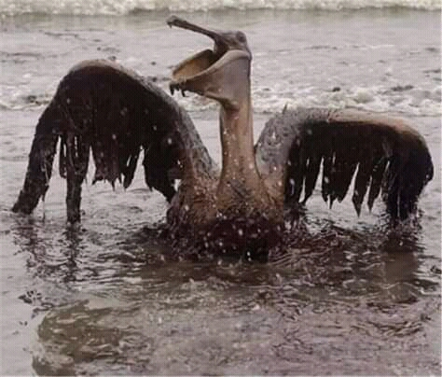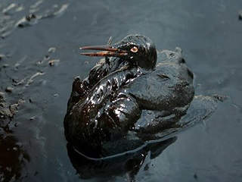
(a) Identify the type of pollution that has such an effect. (1 mark)
………………………………………………………………………………………………………………
(b) State two effects of the type of pollution identified in (a) above to the organism. (2 marks)
………………………………………………………………………………………………………………………………………………………………………………………………………………………………………………………………………………………………………………………………………………
27. The curve below shows the rate of photosynthesis at difficult light intensities

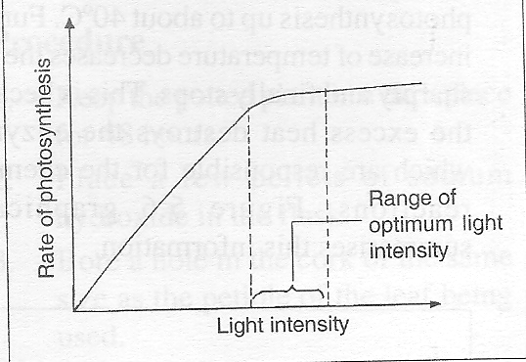
s
r
q
P
- With reference to photosynthesis, give the meaning of the phrase limiting factor. (1mark)
..........................................................................................................................................................
- Name the limiting factor between the following points (2marks)
- P and Q
..........................................................................................................................................................
- R and S
........................................................................................................................................................
- Study the food web below and answer the questions that follow.

Water scorpion Trout fish

Tadpole May fly Caddis fly larva
larva

Algae
Detritus (Simple Plant)

- Write down a food chain whose all consumers are Arthropods. (1mark)
………………………………………………………………………………………………………………
- What would be the short term effects on the habitat if all trout fish were eliminated? (2marks)
................................................................................................................................................................
................................................................................................................................................................
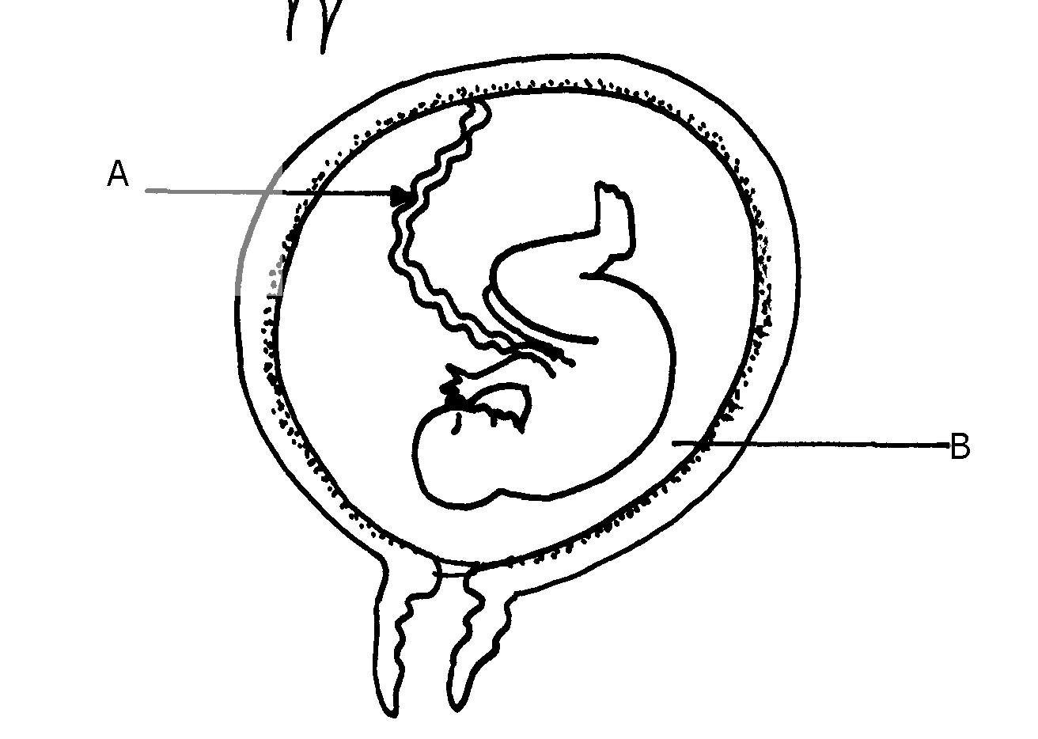
29. The diagram below represents a stage in the development of human foetus

(a) State one function of each of the structures labelled A and B. (2marks)
A ………………………………………………………………………………………………
B………………………………………………………………………………………………..
(b) Apart from the size of the foetus what else from the diagram illustrates that parturition was about
to occur. (1mark) ………………………………………………………………………………………………………
………………………………………………………………………………………………………
30. Explain why growing grass die a few days when salt is sprinkled on it. (2marks)
……………………………………………………………………………………………………………………………………………………………………………………………………………………
31. (a) What is carbonic anhydrase? (1 mark)
………………………………………………………………………………………………………………………………………………………………………………………………………………………………
(b) State the role of haemoglobin in the transport of carbon (IV) oxide. (2 marks)
………………………………………………………………………………………………………………
………………………………………………………………………………………………………………

