**NAME** …………………………………………………………. **INDEX NO** ………………….

**SCHOOL** …………………………………………………………… **DATE** ……………………

**CANDIDATE’S SIGNATURE** …………………..

**231/1 BIOLOGY PAPER 1 FORM 4**

**JULY 2019 TIME: $2 HOURS$**

**Kenya Certificate of Secondary Education**

**END OF TERM II EXAMINATION**

**QUESTIONS**

**instructions**

**attempt all the questions**

1. Some form one students wanted to collect the following animals for study in the laboratory. State the suitable apparatus they should use.

i) Housefly (1 mark)

……………………………………………………………………………………………………..

ii) Scorpion (1 mark)

. ..........................................................................................................................................................

iii) Ants (1 mark)

………………………………………………………………………………………………….......

2. The diagram below represents a mammalian vertebra.

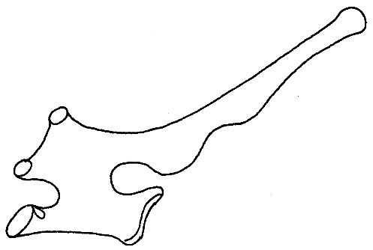

(a) Identify the vertebra represented above. (1mk)

……………………………………………………………………………………………………..

(b) Give a reason for your answer. (1mk)

........................................................................................................................................................................................................................................................................................................................................................

3. (a) Explain the role of oxygen in Active transport (1mk)

……………………………………………………………………………………………………………………………………………………………………………………………………………………………………

(b) Name two processes that depend on Active transport in animals (2mks)

……………………………………………………………………………………………………………………………………………………………………………………………………………………………………............................................................................................................................................................................

4. Explain how sunken stomata lower the rate of transpiration (2mks)

…………………………………………………………………………………………………………………………………………………………………………………………………………………………………………………………………………………………………………………………………………..

5. State how xylem vessel is adapted to its function (3mks)

………………………………………………………………………………………………………………………………………………………………………………………………………………………………………………………………………………………………………………………………………………………………………………………………………………………………………………………………………...

6). a) Define the term immunity. (1mk)

……………………………………………………………………………………………………………………………………………………………………………………………………………………………......

b) Distinguish between natural immunity and acquired immunity. (1mk)

……………………………………………………………………………………………………………..…………………………………………………………………………………………………………….

c) Identify one immunizable disease in Kenya. (1mk)

……………………………………………………………………………………………………………….

7. State two adaptations of the alveolus to its functions. (2mks)

…………………………………………………………………………………………………………………………………………………………………………………………………………………………………..

1. Why may an asthmatic patient produce a wheezing sound during breathing? (1mk)

..........................................................................................................................................................................

(b) What is the significance of the cartilage found in the human trachea being incomplete (c- shaped rings) (1mk)

........................................................................................................................................................................

8. Define the following terms;

(i) Inter specific competition. (1mk)

......................................................................................................................................................................

(ii) Carrying capacity (1mk)

…………………………………………………………………………………………………………………………………………………………………………………………………………………………….....

9. Suggest two methods that can be used to determine the type of food eaten by animals.(2mks)

………………………………………………………………………………………………………………………………………………………………………………………………………………………………………………………………………………………………………………………………………….

10. (a) State one significance of genetics counseling (1mk)

......................................................................................................................................................................…………………………………………………………………………………………………………….

(b) Part of a strand of DNA molecules was found to have the following sequence

A-T-C-G-G-G-A-T-C-T. What is the sequence?

(i) Of the complementary strand? (1mk)

……………………………………………………………………………………………………………

(ii) On a m- RNA strand copied (1mk)

……………………………………………………………………………………………………………

11). The paddles of whales and the fins of fish adapt these organisms to aquatic habitats.

a) Name the evolutionary process that may have given rise to these structures. (1mk)

.......................................................................................................................................................................

b) What is the name given to such structures? (1mk)

……………………………………………………………………………………………………………..

c) Give two examples of vestigial organs in man. (2mk)

………………………………………………………………………………………………………………

.......................................................................................................................................................................

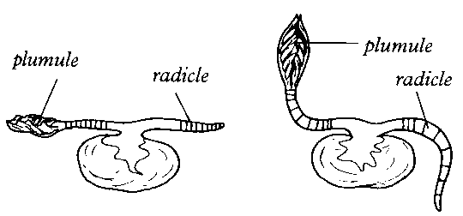12). An experiment was set to investigate a certain aspect of response. A seedling was put on a horizontal position as shown in figure M below. After 24 hours, the set up was as shown in figure N.

**N**

**M**

a) Name the response exhibited. (1mk)

………………………………………………………………………………………………………………..

b) Explain the curvature of the shoot upwards. (3mk)

…………………………………………………………………………………………………………………………………………………………………………………………………………………………………………………………………………………………………………………………………………………………………………………………………………………………………………………………

13. The following is an equation representing a type of respiration

C6H12O6 2C2H5OH + 2CO2 + Energy

a) Identify the type of respiration. (1mk)

………………………………………………………………………………………………………..

b) Suggest industrial applications of the process shown in the equation above (2mks)

……………………………………………………………………………………………………………………………………………………………………………………………………………………………………

14.

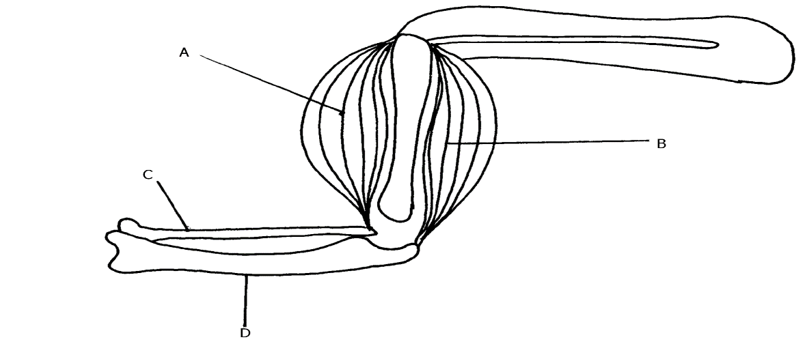

a) Name the bones labeled C and D. (2 mark)

C-……………………………………………………………………………….

D-……………………………………………………………………………….

b) What happens to structure A and B as the arm is straightened (1 mark)

…………………………………………………………………………………………………………………………………………………………………………………………………………....

15. Below is a graphical representation of the effects of different concentration of auxins on shoot and root growth. Study it carefully and then answer the questions that follow.

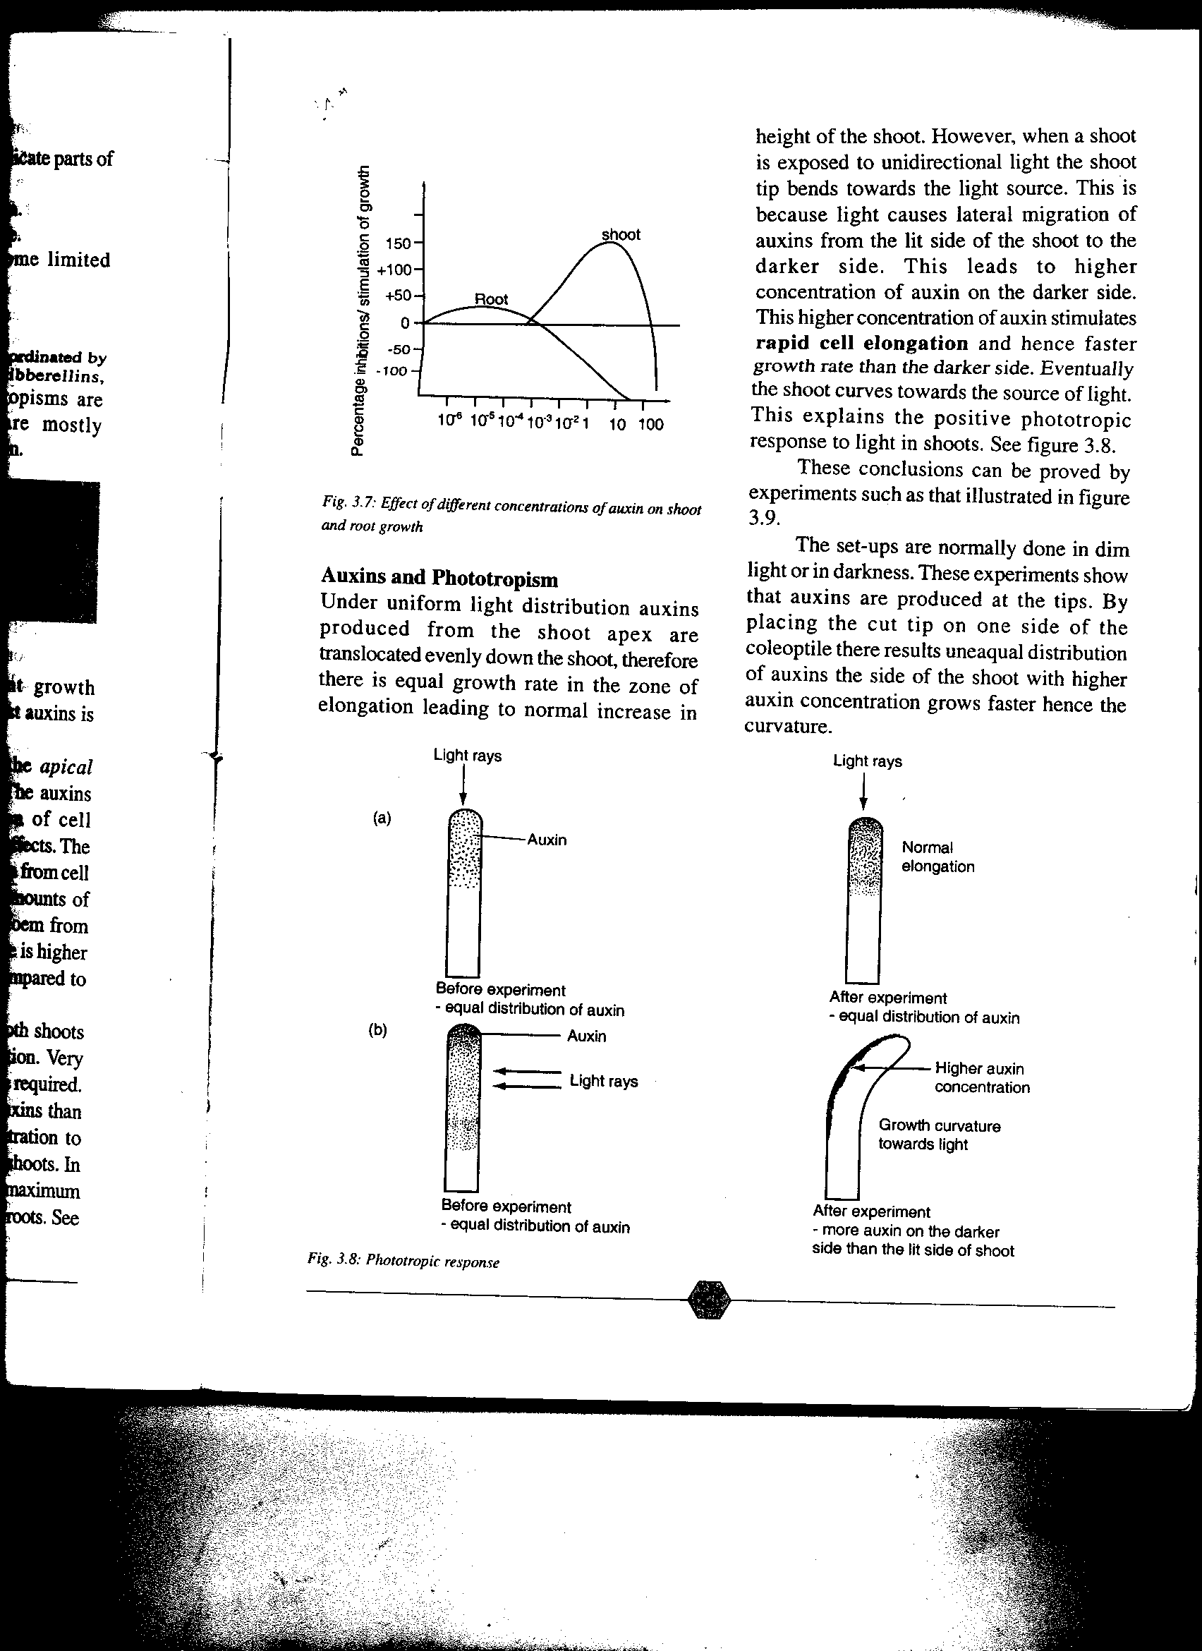

Auxin concentration (ppm)

(a)Identify conclusions that can be drawn from the graph. (3mks)

**………………………………………………………………………………………………………………………………………………………………………………………………………………………………………………………………………………………………………………………………………………………**

16. The illustration below shows a transverse section through a mammalian kidney.

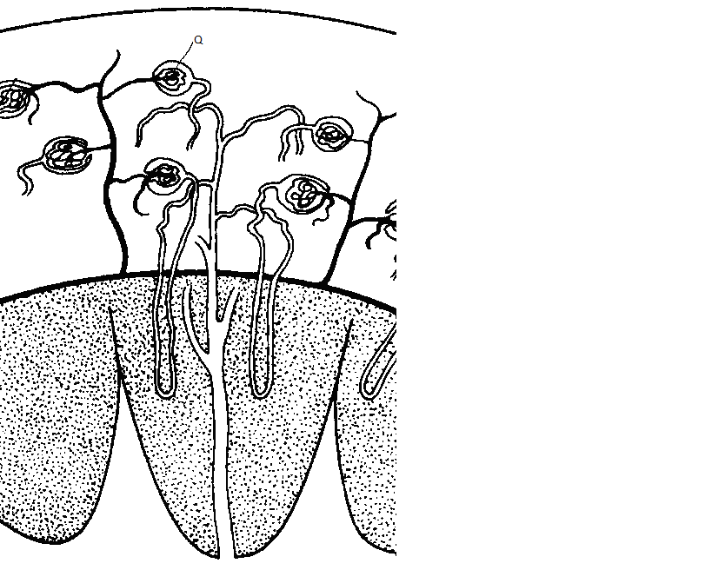

**Y**

**X**

(a) Name the structures labelled **X** and **Y**.

**X …………………………………………………………………………………………………( 1mk)**

**Y** …………………………………………………………………………………………………(1mk)

(b) State the process in **Q** that leads to the formation of glomerular filtrate. (1mk)

**......................................................................................................................................................................**

17. State **three** differences in composition between umbilical artery and umbilical vein. (3 marks)

|  |  |
| --- | --- |
| **Umbilical vein** | **Umbilical artery** |
|  |  |
|  |  |
|  |  |
|  |  |

18. (a)What is meant by the term taxonomy? (1mk)

……………………………………………………………………………………………………………..

(b)When are two organisms considered to belong to the same species. (2mks)

………………………………………………………………………………………………………………………………………………………………………………………………………………………………………………………………………………………………………………………………………………………

19).The diagram below shows part of alimentary canal of a mammal

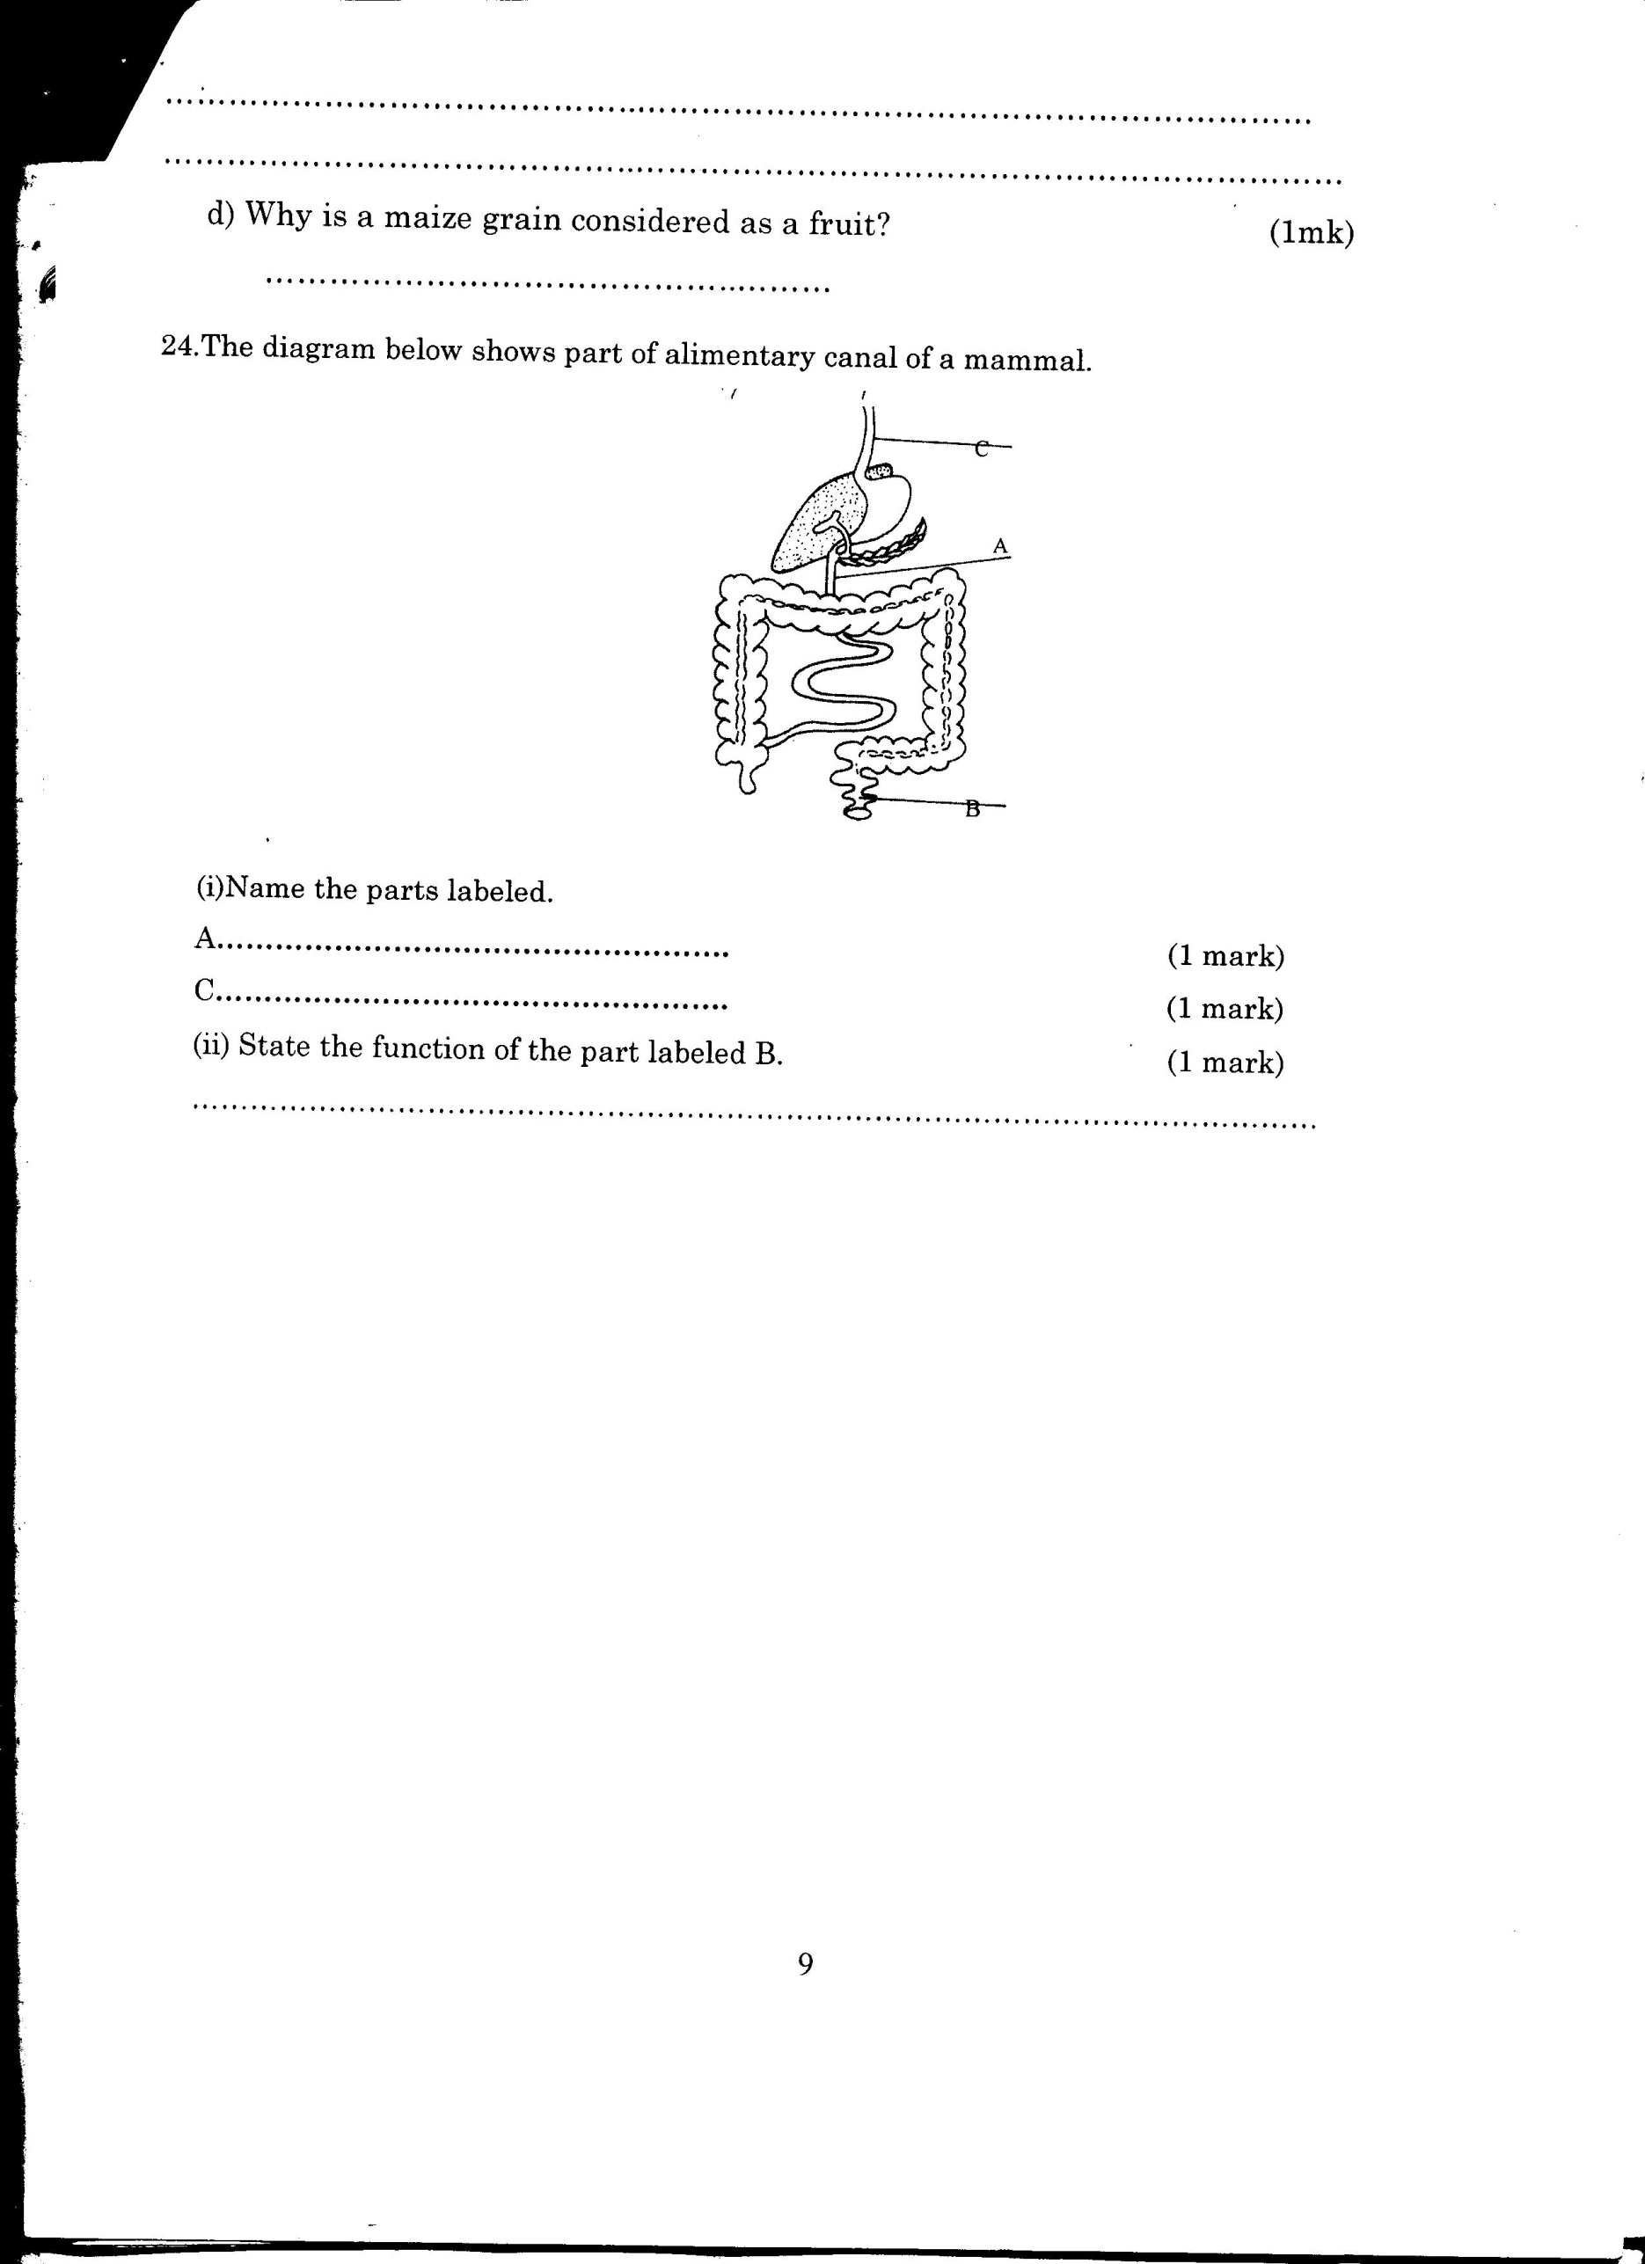

(i)Name the parts labeled A and C (2mks)

A –…………………………………………………………………………………………

C –………………………………………………………………………………………….

(ii)State the function of the part labeled B (1mk)

........................................................................................................................................................................................................................................................................................................................................................

20). The graph below shows the relationship between body temperatures and external temperatures in a human being and a snake. Study it and answer questions that follow.

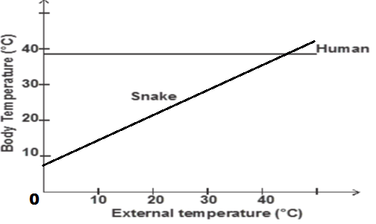

 a**)** What happens to the temperature of each organism as the external temperature increases.(2 marks)

Human –……………………………………………………………………………………………………

Snake –.........................................................................................................................................................

**b)** Humans are described as homoithermic. State the advantage of this condition. (2marks)

*………………………………………………………………………………………………………………………………………………………………………………………………………………………………………………………………………………………………………………………………………………………………………………....*

21. **a)**Name two products of light stage during photosynthesis. (2 marks)

……………………………………………………………………………………………………………………………………………………………………………………………………………………………………………………………………………………………………………….……………………………

**b)** State three differences between light stage and dark stage of photosynthesis. (3 marks)

|  |  |
| --- | --- |
| Light | Dark |
|  |  |

 22.The diagram below represents a cell organelle.



**a)** Identify the organelle. (1 mark)

……………………………………………………………………………………………………………

**b)** Name the part labelled B (1 mark)

 ………………………………………………………………………………………………………………

**c)** State the functions of the part labelled A (1 mark)

  ….……………………………………………………………………………………………………………………………………………………………………………………………………………………………

23 **.**The diagram below represents a plant cell that was subjected to a certain treatment.



**At the start At the end of the experiment**

**a)** Account for the shape of the cell at the end of the experiment. (2 marks)

........................................................................................................................................................................................................................................................................................................................................................................................................................................................................................................................................................................................................................................................................................

**b)** Draw a diagram to illustrate how an animal cell would appear if subjected to the same treatment.(1 marks)

24.a)Give a reason why each of the following steps are followed when preparing cross sections of a leaf for examination under a microscope.

i) Cutting thin sections. (1 mark)

**………………………………………………………………………………………………………………..**

ii) Placing the sections in water. (1 mark)

............................................................................................................................................................................

25.a ) Name two tissues in plants that provide mechanical support. (2 marks)

…………………………………………………………………………………………………………………

...........................................................................................................................................................................

b. Name the types of joints formed by each of the following pairs of bones:

i) Axis and atlas. (1 mark)

…………………………………………………………………………………………………………………

ii)Humerus with clavicle and scapula. (1mk)

…………………………………………………………………………………………………………………

26.) The diagram below represents a simple reflex arc

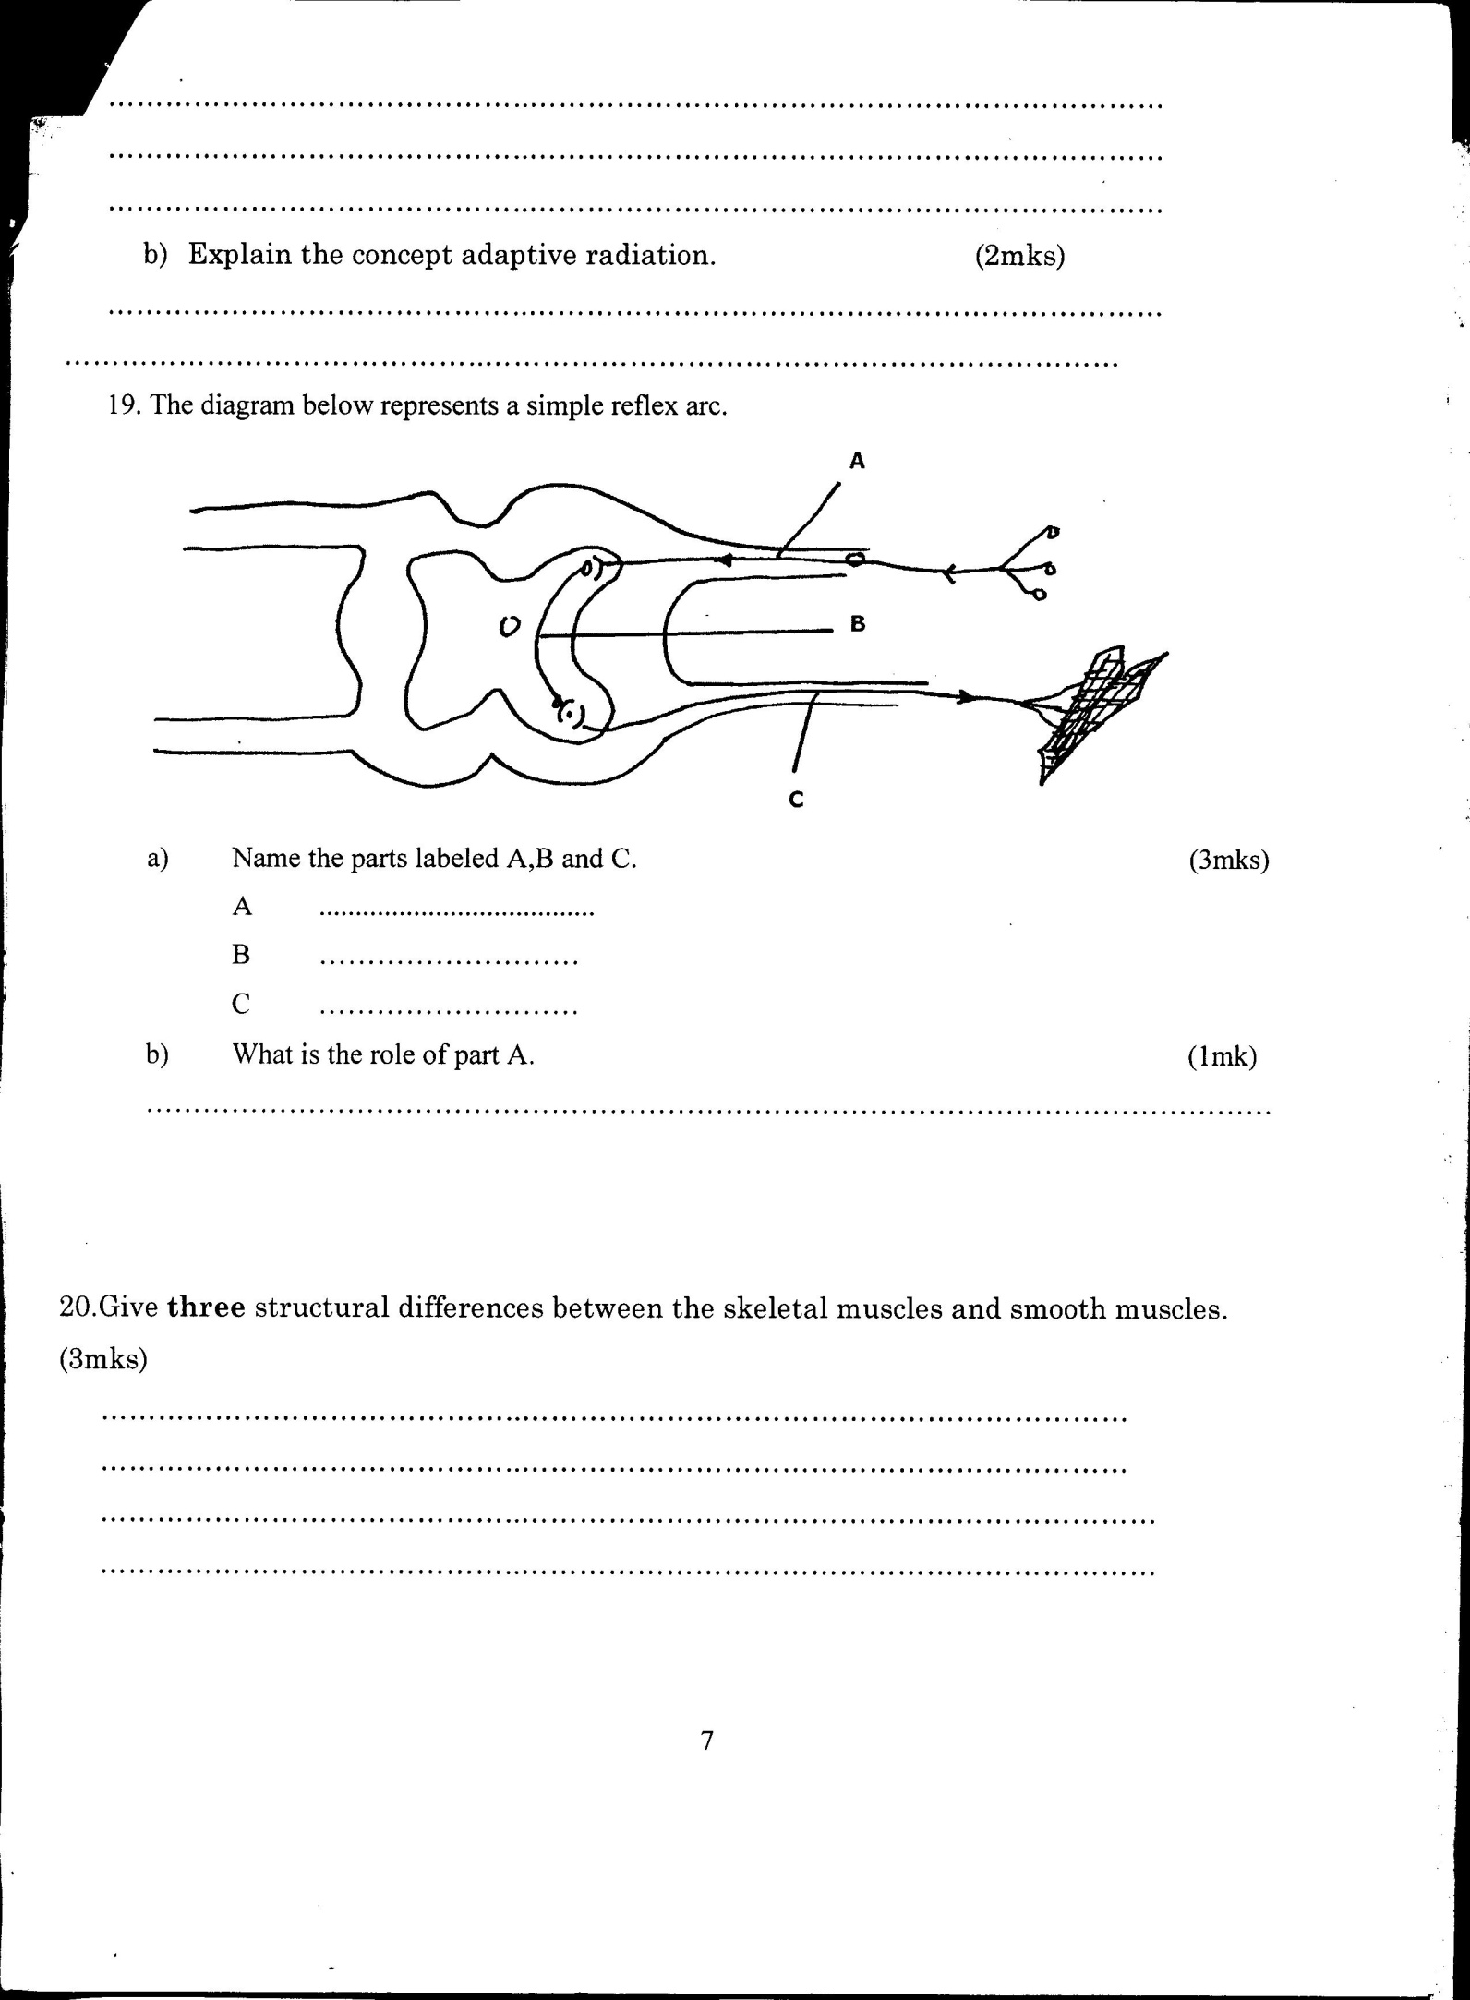

-p

(a)Name the parts labeled A, B and C (3mks)

A …………………………………………………………………………………………………..

B…………………………………………………………………………………………………..

C………………………………………………………………………………………………….

(b)What is the role of part A (1mk)

……………………………………………………………………………………………………………