NAME: ………………………………………ADMNO:……………DATE…………………..

SCHOOL:.………………………………………………: SIGN………………………………...

BIOLOGY
PAPER 2
THEORY
2021
TIME 2 HOURS

CASPA AMUKURA PARISH JOINT EVALUATION
EXAMINATION FORM FOUR 2021.
231 / 2
BIOLOGY
PAPER 2

INSTRUCTIONS TO CANDIDATES
- Write your name and Admission number in the space provided above.
- This paper has two sections A and B.
- Answer ALL the questions in section A in the spaces provided on the question paper.
- In section B answer question 6(compulsory) and either question 7 or 8 in the spaces
Provided after question 8.

For Examiner’s Use Only.

SECTION | QUESTIONS | MAXIMUM  SCORE | CANDIDATES  SCORE
 | 1 | 8
 | 2 | 8
 | 3 | 8
 | 4 | 8
 | 5 | 8
 | 6 | 20
 | 7 | 20
 | 8 | 20
TOTAL SCORE |  | 80

This paper consists of 9 printed pages. Candidates should check the question paper to ensure that all the pages are printed as indicates and no questions are missing.
- The diagram below shows a portion of a lower epidermis of a sukuma wiki leaf.

a) Name the parts labeled P and Q. ( 2mks)

P ___________________

Q ____________________

b) Briefly describe the photosynthetic theory of stomata opening. ( 5mks )
…………………………………………………………………………………………………………………………………………………………………………………………………………
…………………………………………………………………………………………………………………………………………………………………………………………………………
…………………………………………………………………………………………………………………………………………………………………………………………………………
…………………………………………………………………………………………………………………………………………………………………………………………………………
…………………………………………………………………………………………………………………………………………………………………………………………………………

c) State one modification in the stomata of xerophyte plant other than being sunken and hairy.
( 1mk)
………………………………………………………………………………………………………………………………………………………………………………………………………………

- The diagram below represents an experimental set-up to investigate an aspect of photosynthesis.
The set up was placed in darkness for 24 hrs and then exposed to light for 5 hrs.
  - What was the aim of the experiment? (1mark)
………………………………………………………………………………………………………………………………………………………………………………………………

(b) Leaves A and B were tested for starch.
(i) What would be the expected results? (2marks)
………………………………………………………………………………………………………………………………………………………………………………………………………………………………………………………………………………………………

(ii) Give reasons for your answer in (b) (i) above. (2marks)
………………………………………………………………………………………………………………………………………………………………………………………………………………………………………………………………………………………………

- What was the role of leaf B in the experiment (1mark)
………………………………………………………………………………………………

(d) Why was the set – up placed in darkness for 24 hours? (1mark)
………………………………………………………………………………………………

(e) Name the organelle in a plant where photosynthesis takes place (1mark)
………………………………………………………………………………………………

- The diagram below illustrates an experiment to demonstrate a certain biological process.
Before adding yeast suspension in tube A, the glucose solution was first boiled and cooled.

  - What biological process was being demonstrated? (1mark)
………………………………………………………………………………………………………………………………………………………………………………………………

(b) (i) What observation would be made in tube B after 20 minutes of the experiment?
(2marks)
………………………………………………………………………………………………………………………………………………………………………………………………………………
………………………………………………………………………………………………………………………………………………………………………………………………………………

(ii) Account for the observations made in (b) (i) above (2marks)
………………………………………………………………………………………………………………………………………………………………………………………………………………………………………………………………………………………………
………………………………………………………………………………………………………………………………………………………………………………………………

(c) Write down an equation to summarize the reaction taking place in tube A. (1mark)

- State two industrial applications of the chemical reaction taking place in tube A.
(2marks)
………………………………………………………………………………………………………………………………………………………………………………………………………………………………………………………………………………………………
- The diagram below represents a flower.
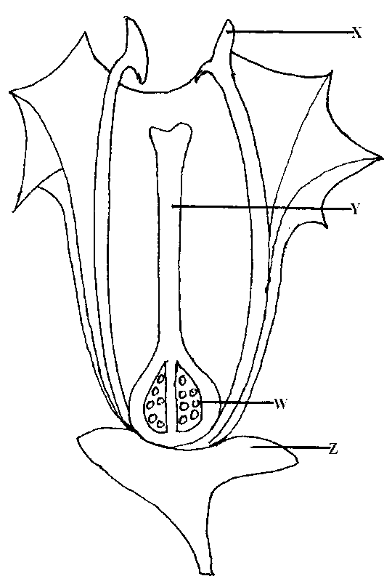
- Name the parts labeled X and Y. (2mks)

X ………………………………………………………………………………………
Y ………………………………………………………………………………………

- Describe the ovary position. (1mk)
………………………………………………………………………………………………
- (i) Suggest an agent of pollination of the flower above (1mk)
………………………………………………………………………………………………
………………………………………………………………………………………………

(ii) Give a reason for your answer above. (1mk)
………………………………………………………………………………………………

- On the diagram above, which part do you expect to find haploid nucleus after meiosis? (1mk)
………………………………………………………………………………………………

- In the flower above its sepals cell was found to have 20 chromosomes. What would be the number of chromosomes found in the endosperm cell of the flower embryo sac after fertilization? (1mk)
………………………………………………………………………………………………

- State one way in which flowers prevent self – pollination. (1mk)
………………………………………………………………………………………………

- When the offspring of purple and white flowered pea plants were crossed, they produced purple and white flowered plants in the ratio of 3: 1
Using letter H to represent the gene for purple colour
(a) State the genotype of:
(i) Parents ( 2 mks)
………………………………………………………………………………………………………………………………………………………………………………………………
(ii) F₁ Generation ( 1 mk)
………………………………………………………………………………………………
(b) Work out the cross between plants in the F₁ generation ( 4 mks)

(c) Account for the colour the flowers in plants of the F₁ generation
……………………………………………………………………………………………………………………………………………………………………………………………… ( 1 mk)

SECTION B (40 marks)
Answer question 6 (compulsory) in the space provided and either question 7 or 8 in the spaces provided after question 8.

6. In an experiment to investigate the effect of temperature on the activity of salivary amylase enzyme, test tubes containing 5 cm³ of starch solution were placed in water baths maintained at different temperatures. After 30 minutes, 0.1cm³ amylase solution was added into each of the tubes.
At one minute intervals, a drop of the mixture in each tube was tested for presence of starch. The time taken for all the starch to be digested was taken and recorded. The results were as shown in the table below.

Temperature (⁰c) | 5 | 10 | 15 | 20 | 25 | 30 | 35 | 40 | 45
Time taken to digest all starch (mins) | 80 | 60 | 48 | 26 | 18 | 9 | 3 | 14 | 75

- On the grid provided plot a graph of time taken to digest all the starch against temperature.
(6 marks)

- What was the optimum temperature range for this enzyme? (1mark)
………………………………………………………………………………………………………………………………………………………………………………………………………………

(c) Account for the results obtained at
  - 5⁰C (2marks)
…………………………………………………………………………………………………………………………………………………………………………………………
……………………………………………………………………………………………

  - 45⁰C (2marks)
…………………………………………………………………………………………………………………………………………………………………………………………
……………………………………………………………………………………………

(d) Apart from temperature name three other factors that would affect the above reaction.(3marks)
………………………………………………………………………………………………………………………………………………………………………………………………………………………………………………………………………………………………………………………

(e) Name two regions in a human body where digestion of starch occurs. (2marks)
………………………………………………………………………………………………………………………………………………………………………………………………………………

(f) (i) Give three metallic ions that act as enzyme co- factors in a human body. (2marks)
………………………………………………………………………………………………………………………………………………………………………………………………………………………………………………………………………………………

(ii) What is the role played by enzyme co- factors in the physiology of human body? (1mark)
…………………………………………………………………………………………………………………………………………………………………………………………

(g) Name the major respiratory substrate in a mammalian body during severe starvation. (1mark)
……………………………………………………………………………………………………

7. How are leaves of mesophytes suited to their function? (20mks)

8. Describe the adaptations of the mammalian skin to its functions. (20mks)
………………………………………………………………………………………………………………………………………………………………………………………………………………
………………………………………………………………………………………………………………………………………………………………………………………………………………
………………………………………………………………………………………………………………………………………………………………………………………………………………
………………………………………………………………………………………………………………………………………………………………………………………………………………
………………………………………………………………………………………………………………………………………………………………………………………………………………
………………………………………………………………………………………………………………………………………………………………………………………………………………
………………………………………………………………………………………………………………………………………………………………………………………………………………
………………………………………………………………………………………………………………………………………………………………………………………………………………
………………………………………………………………………………………………………………………………………………………………………………………………………………
………………………………………………………………………………………………………………………………………………………………………………………………………………
………………………………………………………………………………………………………………………………………………………………………………………………………………
………………………………………………………………………………………………………………………………………………………………………………………………………………
………………………………………………………………………………………………………………………………………………………………………………………………………………
………………………………………………………………………………………………………………………………………………………………………………………………………………
………………………………………………………………………………………………………………………………………………………………………………………………………………
………………………………………………………………………………………………………………………………………………………………………………………………………………
………………………………………………………………………………………………………………………………………………………………………………………………………………
………………………………………………………………………………………………………………………………………………………………………………………………………………
………………………………………………………………………………………………………………………………………………………………………………………………………………
………………………………………………………………………………………………………………………………………………………………………………………………………………
………………………………………………………………………………………………………………………………………………………………………………………………………………
………………………………………………………………………………………………………………………………………………………………………………………………………………
………………………………………………………………………………………………………………………………………………………………………………………………………………
………………………………………………………………………………………………………………………………………………………………………………………………………………
………………………………………………………………………………………………………………………………………………………………………………………………………………
………………………………………………………………………………………………………………………………………………………………………………………………………………
………………………………………………………………………………………………………………………………………………………………………………………………………………
………………………………………………………………………………………………………………………………………………………………………………………………………………
………………………………………………………………………………………………………………………………………………………………………………………………………………
………………………………………………………………………………………………………………………………………………………………………………………………………………
………………………………………………………………………………………………………………………………………………………………………………………………………………
………………………………………………………………………………………………………………………………………………………………………………………………………………
………………………………………………………………………………………………………………………………………………………………………………………………………………

