231/3
BIOLOGY NAME ________________________________________
PAPER 3
JULY 2019 CLASS______________ ADM. NO. ________________
TIME: 1 ¾ HOURS

BIOLOGY
PAPER 3

INSTRUCTIONS TO CANDIDATES

- Write your name and index number in the spaces provided above.
- Sign and write the date of examination in the spaces provided above.
- You are required to spend the first 15 minutes of the 1 ¾ hours allowed for this paper reading the whole paper carefully before commencing your work.
- Answers must be written in the spaces provided in the question paper.

For Examiner’s Use only:-

Question | Maximum Score | Candidate’s Score
1 | 12
2 | 14
3 | 14
TOTAL | 40

This paper consists of 4 printed pages. Candidates should check to ascertain that all pages are printed as indicated and that no questions are missing.

- You are provided with a specimen labeled T which is a fruit. Use it to answer the questions that follow.
- Make a transverse section of the specimen T. Draw and label at least 3 parts. (Save the specimen for use in question 2) 5mks
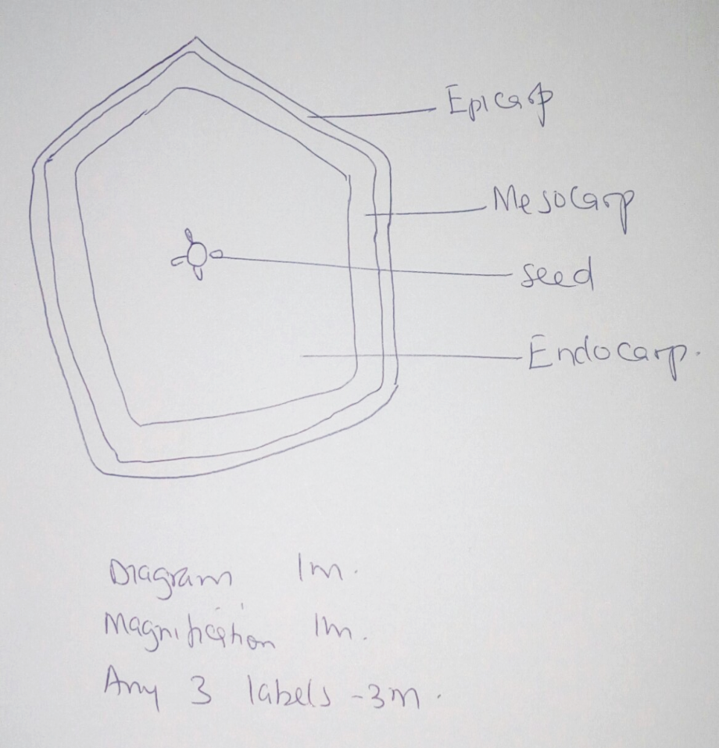
Magnification between X1 and X5

- With reasons, state the identity of fruit T.
Type of fruit Berry 1mk
Reason has many seeds 1mk
- Suggest the possible agent of dispersal and give two reasons
Agent Animal 1mk
Reason brightly coloured; scented; fleshy; large; first 2mk
- What is the placentation of T? Axile; 1mk
- Specimen T was green in colour before it was treated with a plant hormone.
Suggest the plant hormone.
Ethylene/ ethyne; 1mk
- (a) Crush a piece of the specimen T in a test tube using a stirring rod, add some water and shake. decant into another test tube. Use the reagents available to establish the food substances present in specimen T extract by filling in the table below. 9mks
FOOD | PROCEDURE | OBSERVATIONS | CONCLUSION
Reducing sugar | To extract add Benedict’s solution, then heat; | Yellow / orange / brown colour observed; | Reducing sugars present;
Protein | To extract add sodium hydroxide solution, then copper (II) sulphate drop by drop; | No colour change observed / blue colour persist; | Protein absent;
Ascorbic acid/ Vitamin C | Add DCPIP to extract drop wise; | DCPIP decolourized; | Vitamin C / ascorbic acid present;
(b) Identify one type of organic substance absent in T Protein Rj. Any other 1mk
(c) Based on the tests you have carried out above, give one reasons why consuming a lot of T may be unsuitable to a diabetic person.
A diabetic person is unable to regulate blood sugar; too much T will increase sugar levels to dangerous levels; 2mks
(d) How can you show that somebody suffer from diabetes mellitus in the school laboratory?2mks
Take a urine sample and test for reducing sugars; if present, the person is diabetic
- Below are photographs of two specimens, J and K. Both of them belong to the same phylum and class. Observe them carefully before you answer the questions that follow.
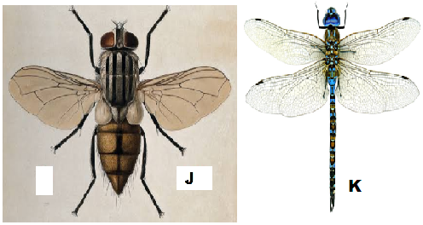
- Name the class to which J and K belong and support your answer with two reasons.
Class Insecta; 1mk
Reasons 2mks
- Six legs; three body parts; two antennae; two compound eyes;
- Suggest why the circulatory fluid in J and K has no haemoglobin. 2mks
Haemoglobin used to transport oxygen/ carbon (IV) oxide in the body; oxygen is taken directly to tissues/ carbon (IV) oxide taken directly from tissues by tracheoles;
- Observe their wings and suggest the type of evolution that could have taken place to give rise to J and K, and then give a reason for your answer.
- .
Type of evolution divergent evolution; 1mk
Reason one pair of wings in J reduced to halters/ are vestigial; but both are functional in K 2mks
- Below is a diagram showing the life cycle of specimen J.
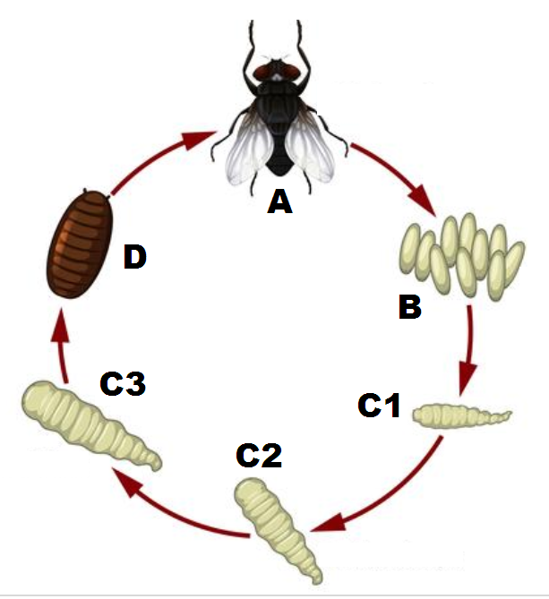
- Identify the stage labeled D. pupa stage; 1mk
- Name the hormone responsible for the change from D to A. 1mk
Ecdysone; accept Moulting hormone
- Explain the differences in the change from C2 to C3 and from C3 to D. 4mks
C2 to C3 – moulting hormone / Ecdysone induce moulting; but presence of juvenile hormone prevent formation of pupa;

C3 to D – moulting hormone / Ecdysone induce moulting; but abscence of juvenile hormone lead to formation of pupa;

