MWAKICAN PRE-MOCK
FORM 4
231/1
BIOLOGY PAPER 1
INSTRUCTION: ANSWER ALL THE QUESTIONS
1(a) State the function of cristae in mitochondria (1mk)

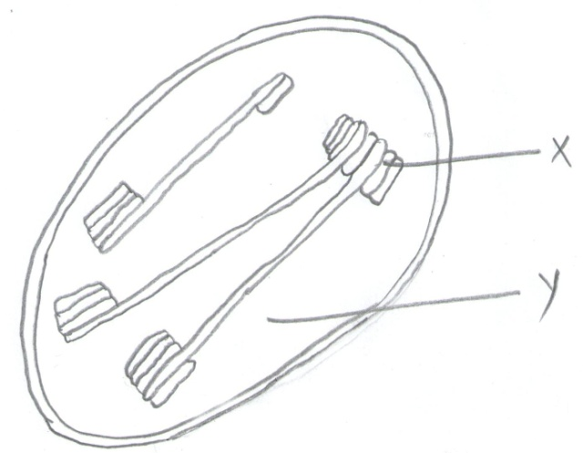
(b) The diagram below represents a cell organelle.
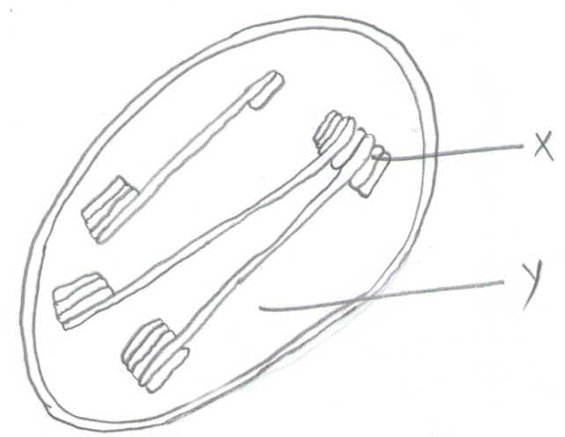

(i) Name the part labeled Y (1mk)

(ii) State the function of the part labeled x. (1mk)

2 Name the part of a flower that develop into
(a) seed (1mk)
(b) fruit (1mk)

3(a) Name two tissues in plants which are thickened with lignin (2mks)

(b) How is support attained in herbaceous plants (1mk)

4 What causes the following diseases (3mks)

(a) Typhoid
(b) Gonorrhea

(c) Tuberculosis

5 State two mechanisms that hinder self-fertilization in flowering plants. (2mks)

6 The following organisms were found in a grassland ecosystem-caterpillars,aphids,praying mantis,spiders,grass,acacia trees,rabbits,wild dogs,hyenas,carnivorous bettles and gazelles.
(a) Name two organisms from the list that can be classified as:
(i) producers (1mk)

(ii) tertiary consumers (1mk)

b) Construct a food chain ending with a secondary consumers (1mk)

7 State three adaptations of plants which enable them to reduce water loss. (3mks)

8)(a) Name the hormone responsible for apical dominance in plants. (1mk)

(b) The hormone aldosterone is involved in urine formation
(i) Name the gland that produces aldosterone (1mk)

(ii) State the function of aldosterone. (1mk)

9 Explain the effect of increasing enzyme concentration in an enzyme controlled reaction. (1mk)

10(a) State two processes which occur during anaphase of mitosis. (2mks)

(b) What is the significance of meiosis (1mk)

11 The rate of breathing increases during a vigourous exercise. Explain (2mks)

12 State the role of insulin in the human body. (1mk)

13 An experiment was set up as shown in the diagram below
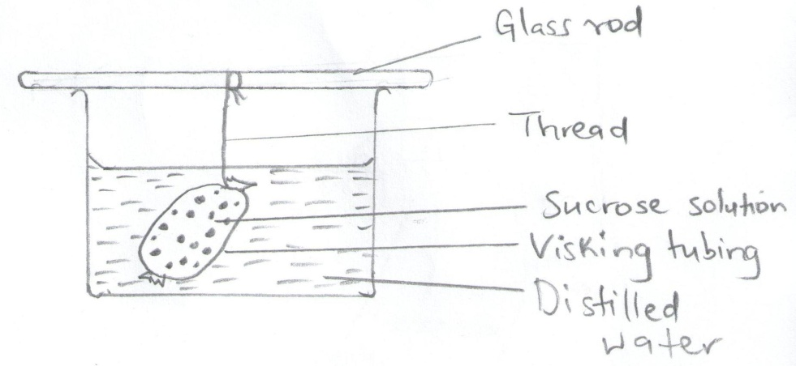

The set up was left for 30 minutes.
(a) State the expected results (1mk)

(b) Explain your answer In (a) above (3mks)

14(a) Name the fluid that is produced by sebaceous glands. (1mk)

(b) What is the role of sweat on human skin? (2mks)

15 State the role of vitamin C in humans. (2mks)

16(a) Distinguish between the terms homodant and heterodont (1mk)

(b) What is the function of carnassials teeth. (1mk)

(c) A certain animal has no incisors,no canines,6 premolars and 6 molars in its upper jaw. In the lower jaw there are 6 incissors,2 canines 6 premolars and 6 molars. Write its dental formular. (1mk)

17(a) A dog weighing 15.2kg requires 216KJ while a mouse weighing 50g requires 2736KJ per day. Explain. (2mks)

(b) State two economic importance of anaerobic respiration. (2mks)

18 State one economic importance of each of the following plant excretory products. (3mks)
(a) Tannin

(b) Quinine

c) Caffeine

19(a) State three characteristics of the class crustacea. (3mks)

(b) Name the spore bearing structure in pteridophyta. (1mk)

20(a) State three effects of dumping untreated sewage into a river. (3mks)

(b) Name one process that is responsible for loss of energy from one trophic level to the next. (1mk)

21 What is the function of the following structures in the human reproductive organs.
(a) Fallopian tubes (1mk)

(b) Epididymis (1mk)

(c) ovaries (1mk)

22(a) Explain why the garden pea is suitable for genetic experiments. (2mks)

(b) Differentiate between the following terms
(i) Dominant gene and recessive gene (1mk)

(ii) Continous variation and discontinuous variation (1mk)

23 During germination and early growth,the dry weight of the endosperm and the cotyledons decreases while that of the embryo increases. Explain (3mks)

24(a) What is a fossil? (2mks)

(b) State two limitations of fossils as an evidence of evolution. (2mks)

25 The diagram below represents a simplified nitrogen cycle.
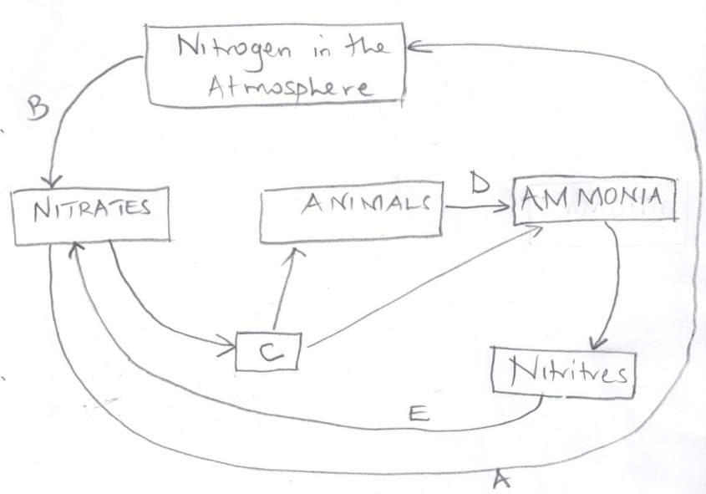

(a) Name the organisms that cause processes A and E (2mks)
A-
E-
(B) Name the processes labeled B and D. (2mks)
B-
D-
c) Name the group of organisms represented by C. Give a reason (2mks)

26(a) A student collected an organism and observed the following features: simple eyes,four pairs of legs and two body parts.
(i) State the class to which the organism belongs (1mk)

(ii) Give an example of an organism in this class. (1mk)

b) Name the kingdom to which plasmodium belongs. (1mk)

27 Explain three ways in which red blood cells are adapted to their functions. (3mks)

