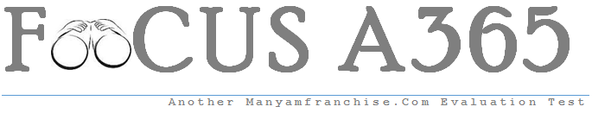

Gatitu Mixed Secondary School
Form 4 | Term 1 | 231 - Biology | 06-Jan-16 | Opener
1. What components of blood are absent in the tissue fluid. (2marks)

2(a) State the kingdom to which chamydomonus belong. (1mark)

(b) An organism has the following characteristics: Four pairs of wings, cephalothorax and abdomen, Absence of antennae, Presence of a pair of chelicerae.Name the phylum and class that the organism belongs to?(2marks)
Phylum __________________________________________
Class_____________________________________________
3. A certain solution was boiled in a clean test tube containing five drops of Benedict’s solution for three minutes. The color turned orange. Suggest the food material likely to be present. (1mark)

4. (a) State functions of the following organelles
(i) Centrioles (2mark)

(ii) Golgi bodies (2mark)

5. The following is an equation representing a type of respiration
C₆H₁₂O₆ 2 C₃H₆0₃ + Energy
(a) Identify the type of respiration. (1mak)
(b) Suggest two examples of industrial application of the process named in part (a) above. (2maks)

6. Suggest three characteristics of gaseous exchange organs in frogs. (3marks)

- The diagram below shows a seed of a certain plant.
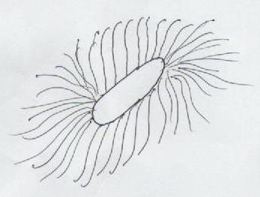
(a) Name the likely agent of dispersal . (1mark)
(b) Give a reason for your answer. (1mark)
8. (a) Name the source of hydrochloric acid in the mammalian stomach. (1mark)
(b) The diagram below represents internal structure of a mammalian tooth.
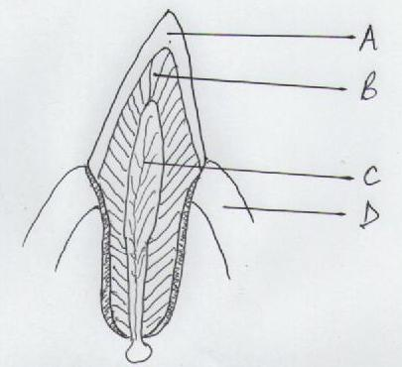
(c) Label the parts labeled B and D (2marks)
9. Give two reasons why blood pressure is greater in arteries than in the veins of mammals. (2marks)

10. Differentiate between intracellular and extracellular enzymes. (2marks)

11. (a)Name secretion from sebaceous gland of mammals (1mark)
(b) State two functions of the secretion named above. (2marks)

12. The scientific name of organism that causes malaria is PLASMODIUM VIVAX. How would a form one student write the name in her exercise book correctly? (2marks)

13. (a) Name the part in the chloroplast where light stage take place. (1mark)

(b) State the differences between photosynthesis and chemosynthesis. (2marks)

14. The diagram below represents a mature embryo sac. Study it and answer the questions below
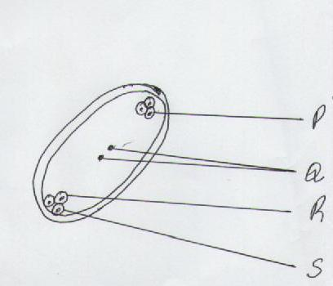

(a) On the diagram name part P, R and S (3marks)

(b) What is the name given to the type of fertilization in flowers? (1mark)

(c) What is an entomorphillus flower? (1mark)

15. The diagram below represents a longitudinal section of a dicotyledonous root.
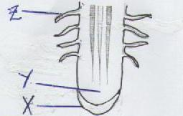
(a) Name the parts labeled X (1mark)

(b) Identify the cells found at part labeled Y. (1mark)

(c) In which zone of growth are structure labeled Z found. (1mark)

