MARKING SCHEME BIOLOGY FORM 1
- a) Give two main branches of Biology. (2mks)
- Zoology
- Botany
- Microbiology
b) Outline two precautions to take during collection and observation of
specimens. (2mks)
- Collect only the number of specimens needed to avoid wastage.
- Do not destroy the natural habitat of the specimens.
- Live specimens should be returned to their habitats.
- Dangerous specimens should be handled with care.

- State the kingdoms to which the following organisms belong. (3mks)
- Plasmodium - Protoctista
- Bat - Animalia
- Yeast - Fungi

- Name the most appropriate biological tool that an ecologist student can use for collecting:
- grasshoppers from grass (1 mark)
Sweep net
(ii) Ants from a tree trunk (1 mark)
Pooter
- Mangifera indica is the name given to a mango tree. What does each of the name represent?
Indica – Genus (1 mark)
Mangifera – Specific (1 mark)
(b) Name this method of identifying organisms. (1 mark)
Binomial nomenclature
- (a) What do you understand by the term cell specialization as used in biology? (2 marks)
This is where cells are modified to perform specific functions.
(b) Name any two specialized cells in plants and state how each is modified.
Cell Modification (4 marks)
(i) Palisade cells Contain Chlorophyll to trap light energy
(ii) Root Hair cell An extension
(iii) Guard cells Chloroplasts, bean shaped
- The equation below represents a process that takes place in plants.
6CO₂ + 6H₂O C₆H₁₂O₆ + 6O₂
(Carbon IV) Oxide Water (Glucose) (Oxygen)

- Name the process. (1mk)
Photosynthesis

- State three conditions necessary for the process to take place. (3mks)
- Presence of light
- Carbon IV Oxide
- Optimum temperature
- Water
- Chlorophyll
- State three ways in which leaves are adapted to carry out the process named in
- Above efficiency (3mks)
- Broad flat lamina to provide large surface area for absorption light and Carbon IV Oxide.
- Thin leaf for light and CO2 to pass through a short distance.
- Presence of stomata for efficient diffusion of Carbon IV Oxide.
- Transparent cuticle to allow penetration of light to cells.
- Veins conduct water and mineral.
- What is the role of light during the light stage of photosynthesis? (1mk)
- Light energy is absorbed by Chlorophyll and is used to split water molecules into Oxygen + Hydrogen.
- Light energy is also converted to Chemical energy that is used in dark stage.
- The diagram below represents the lower jaw of a mammal.

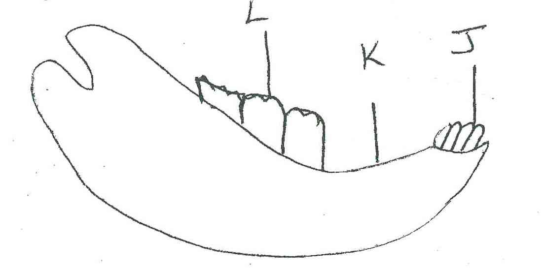

- Name the mode of nutrition of the mammal whose jaw is shown. (1mk)
Holozoic Nutrition.
- Give reason for your answer in (a) above. (1mk)
-Presence of teeth- shows feeds on solids.
- State one structural and one functional difference between the teeth labeled J and L. (2mks)
J
Sharp edge
One root

L
Wide flat surface
Three roots.
- i) Name the toothless gap labeled K. (1mk)
diastema
- State the function of the gap.
Allows the tongue space for turning and moving food materials.
- Name the substance that is responsible for hardening of teeth. (1mk)
Enamel
- Name two dental hygiene practices. (2mks)
- Regular brushing of teeth after every meal.
- Eating diet rich in calcium, phosphates
- Eating hard food
- Use teeth for the proper function
- List two dental diseases. (2mks)
- Dental carries
- Periodontal disease.
- Define the following terms. (3mks)
- Ingestion
Introduction of food into mouth

- Digestion
Breakdown of complex food substances into simple soluble substances that can be absorbed into the body

- Egestion
Removal of undigested and indigestible food materials from the **.

- Name two salivary glands in humans. (2mks)
- Sublingual salivary glands
- Sub-mandibular salivary glands
- Parotid salivary glands
ii) State two functions of saliva. (2mks)
- Contains salivary amylase that digest starch
- Saliva is alkaline that provides optimum PH for enzyme.
- Has mucus that lubricates food hence smooth flow.
- Name two nutrients that are absorbed without being digested by enzymes in humans.(2mks)
- Water
- Vitamins
- Mineral salts.
- State the functions of the following enzymes (4mks)
- Salivary amylase
Digest starch to maltose
- Pepsin
Digest proteins to peptides
- Rennin
Digest protein caseinogens to casein
- Pancreatic lipase
Digest lipids to fattyacids and glycerol.
- State two functions of hydrochloric acid produced at the stomach. (2mks)
Provides acidic medium optimum for enzyme in the stomach.

- State two functions of the bile juice in the digestion of food. (2mks)
- Neutralizes acidic chyme
- Emulsifies fats/lipids
- Provides alkaline medium
- List four adaptations of ileum to its functions. (4mks)
- Long to provide large surface area absorption
- Narrow to bring digested food into close contact
- Highly coiled to slow down movement of chyle to allow more time for absorption.
- Inner surface has villi & micro-villi to increase surface area of contact for absorption.
- Thin layer of cells through which digested food diffuses.
- Give the name given to the study of:-
- Inheritance and variation (1mk)
Genetics
- Insects (1mk)
Entomology

- State the function of the following cell organelles
- Ribosome (1mk)
Site for protein synthesis
- Lysosome (1mk)
Breakdown of worn out organelles
- State the functions of the following parts of a light microscope.
- Objective lens (1mk)
Magnifies the specimen
- Diaphragm (1mk)
Regulates amount of light passing through to the specimen.
- a) State two properties of monosaccharide. (2mks)
- sweet taste
- soluble in water
- What is the main function of monosaccharide in organisms? (1mk)
Provision of energy.
- State the formula for calculating magnification when using the following
- Hand lens/naked eyes (1mk)
$$Mg=\frac{drawing length of object}{actual length of the object}$$
- A light microscopic. (1mk)
Objective lens magnification x eye piece lens magnification
- Explain why a mule, a product of mating between a horse and a donkey is sterile. (1mk)
Are not of the same species.
- Name the taxonomic unit with:
- The greatest number of organism. (1mk)
Kingdom
- With the least number of organisms. (1mk)
Species
- What name is given to the process whereby :
- Red blood cells wrinkle after losing their water to a hypertonic solution?(1mk)
Crenation
- Plant cells become flaccid after losing their water to a hypertonic solution?(1mk)
Plasmolysis
- The figure below shows a small piece of visking tubing which is filled with potassium permanganate solution. Its free ends were tied tightly to prevent leakage .It was then dipped in a beaker full of distilled water. The set up was left for 2 hours .Its was observed that the distilled water was coloured purple.
- What physiological process was being investigated.(1mk)

Diffusion
- Account for the observation made in (a) above.(3mks)
The molecules of potassium permanganate moved from where they were highly concentrated in the visking tubing to the distilled water where they were lowly concentrated through diffusion.
- State three factors that affect the rate of diffusion (3mks)
Temperature
Surface area to volume ratio
Surface area
Thickness of the membrane
Type of medium
- What does a semi-permeable membrane correspond to in an animal cell? (1mk)
Cell membrane

- The cells shown below were obtained from two different plant cells which were immersed in 25% and 2% salt solution.
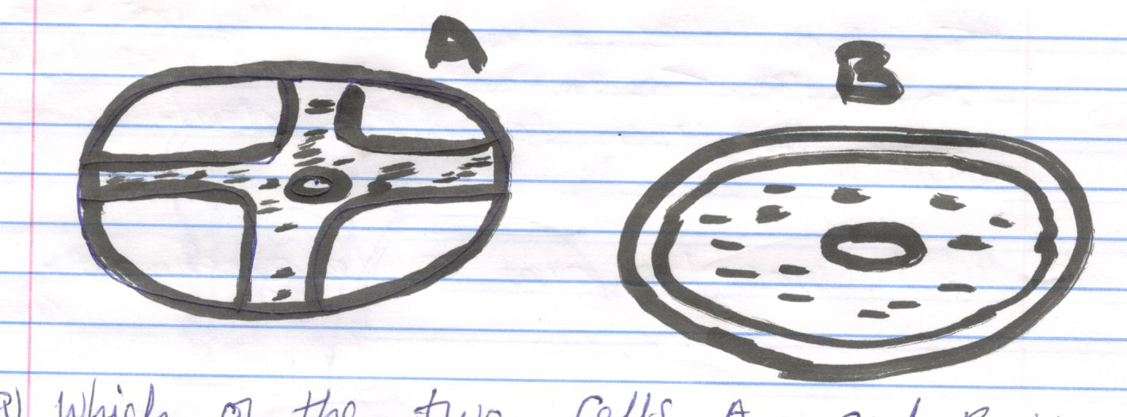
- Which of the two cells A and B was immersed in; (2mks)
- 25% salt solution………………………………………………A
- 2% salt solution………………………………………………..B
- Comment on the cell placed in 25% salt solution (2mks)
The cell placed in 25% salt solution lost water through osmosis & it became flaccid as the 25% salt solution was Hypertonic to the cell cap of the plant cell.
- What biological process was being investigated (1mk)

Osmosis
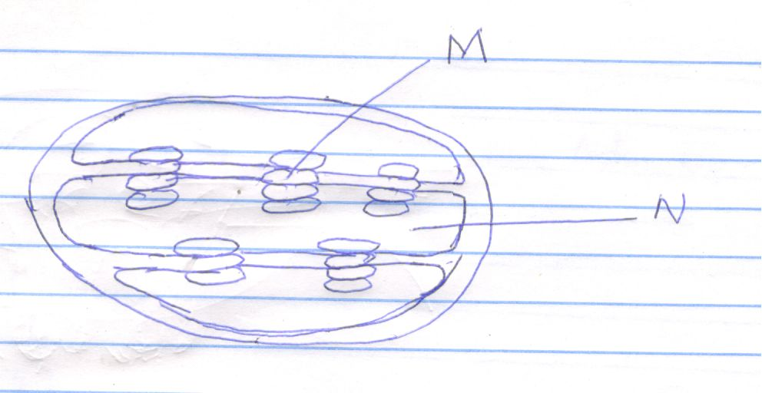
- Identify the organelle (1mk)
Chloroplast
- State the function of the organelle (1mk)
Site for photosynthesis
- i) Name the part labeled N (1mk)
Stroma
ii) Name the chemical compound contained in the structure labeled M. (1mk)
Chlorophyll

- a) Classify the following carbohydrates into monosaccharides, disaccharides and polysaccharides:
Starch, sucrose, maltose, fructose, glucose, and cellulose. (3mks)

Monosaccharides | Disaccharides | Polysaccharides
Glucose  Fructose | Sucrose  Maltose | Starch  Cellulose

- What are the names given to the types of reactions shown in (i) and (ii) below? (2mks)
- C₂H₁₂O₆ + C₂H₁₂O₆ C₁₂H₂₂O₁₁ + H₂O
Glucose fructose sucrose water

Condensation

- C₁₂H₂₂O₁₁ + H₂O C₆H₁₂O₆ + C₆H₁₂O₆
Sucrose water glucose fructose

Hydrolysis

- The apparatus shown below is used to investigate an aspect of photosynthesis. Examine it carefully and answer the questions that follow.

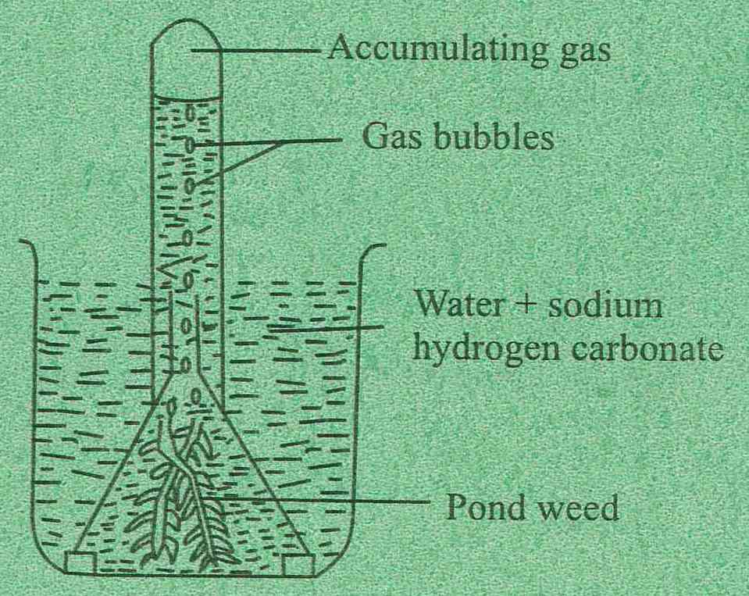

- What aspect of photosynthesis is being investigated? (1mk)
To show oxygen is released during photosynthesis.

- How can you verify the identity of the gas that accumulates in the test tube? (1mk)
By inserting a glowing splint which should burst into flames.

- What is the role of sodium hydrogen carbonate? (1mk)
To release Carbon (IV) Oxide

- What environmental factors are required in order to get a positive result? (2mks)
Adequate temperature
Light

