NAME: ____________________________________ ADM NO: __________________
DATE: _______________________________
BIOLOGY
FORM ONE
END OF TERM 2 EXAMS YEAR 2016

MWAKICAN EXAMINATIONS

Instructions to candidates:
a) Write your Name and Admission number in the spaces provided
b) Write the date of examination in the space provided
c) Answer all questions in the spaces provided

1. a) Name the branch of science that deals with the study of living things(1mk

b) Name the branch of Biology that deals with the study of ;( 2mks
I. plants

ii. Animals

2. State three differences between plants and animals (3mks
Plants Animals

3. a) Distinguish between taxonomy and taxon (2mks

b) Define the term species (2mks

c) State the seven classification units starting from the smallest unit (7mks

d) What is the name given to the system of assigning two scientific names to an organism?(1mk

e) A scientist discovered a new organism and decided to assign it a scientific name. What rules should be put in consideration while assigning the name?(4mks

4. Name five kingdoms used in classifying organisms and give an example in each (5mks

5. a) Give the functions of the following organelles(3mks
i) Mitochondrion

ii) Ribosomes

iii) Vacuole

b) In an experiment to estimate the size of a cell a student determined the field of view to be 3mm. On observing onion epidermal cells, he counted 11 cells across the field of view. Determine the size of each cell. (3mks

c) Explain the importance of the following procedures during preparation of the slides. (3mks)
i.Cuting thin sections

ii. Staining

iii. Placing section in water

6. The diagram below represents a cell organelle. Study it and answer the questions that follow
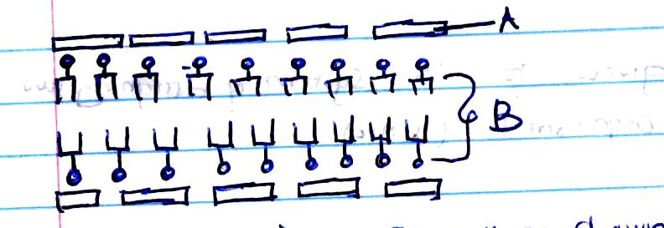

a) Name the organelle shown above (1mk

b) State two functions of the organelle (2mks
c) Name the parts labeled (2mks
A
B
d) State two properties of the organelle you have named (2mks

7. Explain the following terms (3mks
i) Diffusion

ii) Active transport

iii) Plasmolysis

8. A group of students set up an experiment to investigate a certain physiological process. The set up was as shown in the figure below
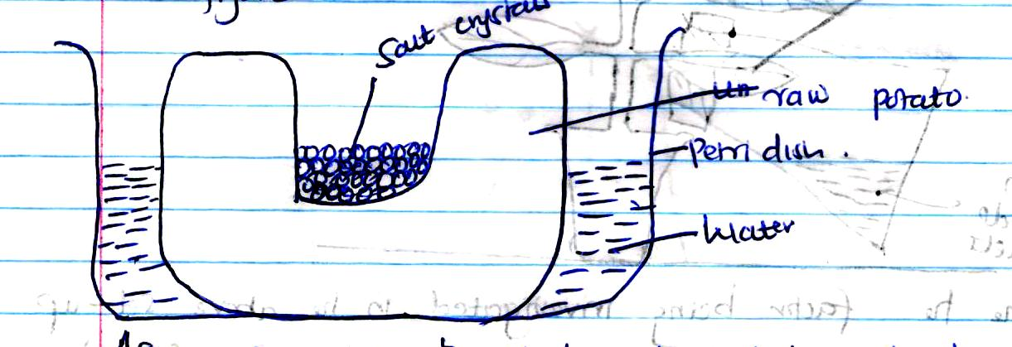
After sometimes the students observed that the level of the salt solution had risen
a) Name the physiological process being investigated (1mk

b) Account for the rise in the level of salt solution in the experiment (3mks

c) Suggest the results that the students would obtain if they repeated the experiment using a piece of boiled pawpaw (1mk

d) State the importances of the process named above in living organisms (3mks

9. Name two photosynthetic cells in plants (2 mks)

10. The diagram below represents an experiment set up by students of Kiboko Secondary School
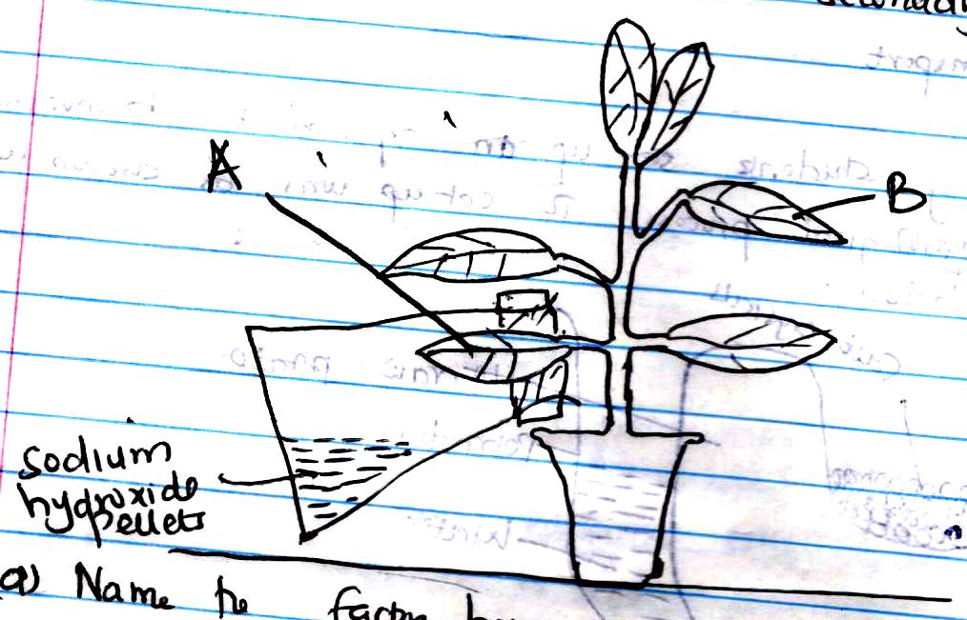
a) Name the factor being investigated in the above set up (1mk

b) Why is it necessary to first keep the set up in the dark for 48hrs? (1mk

c) What is the role of sodium hydroxide pellets in the experiment (1mk

d) When testing for starch in a leaf, explain the reasons for doing the following (3mks
i) Dipping the leaf in boiling water

ii) Boiling the leaf in methylated spirit

iii) Boiling methylated spirit indirectly in a water bath

e) Name the reagent used to test for starch (1mk

f) State the expected results for leaves A and B after a starch test (2mks

g) Explain the results in (f) above (2mks

11. The graph below shows the effect of temperature on an enzyme catalysed reaction. Study it and answer the questions that follow
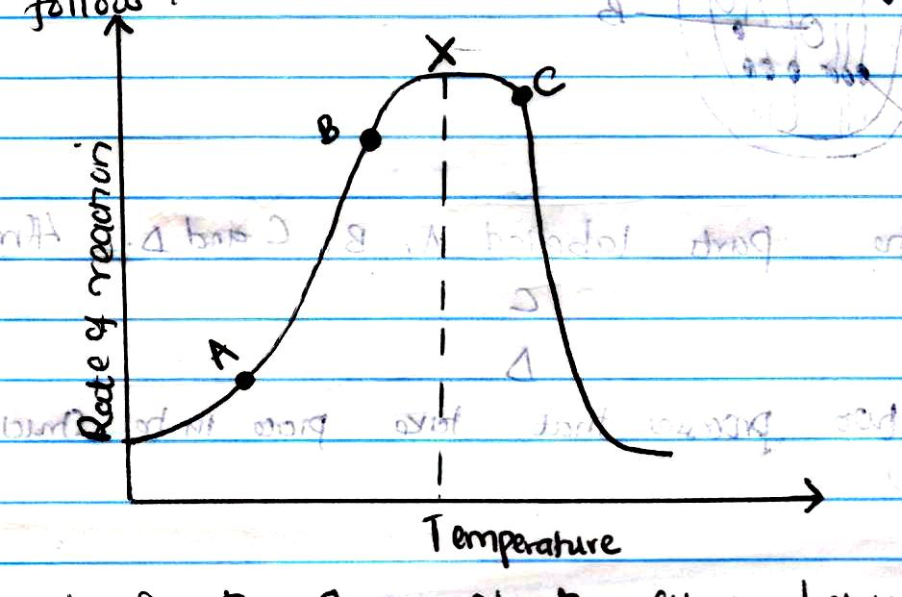
a) Account for the shape of the curve between points A and B(3mks

b) What does the point marked x represent? (1mk

c) Explain the curve beyond point c (2mks

12. a) Name the elements present in carbohydrates(3mks

b) Name carbohydrates that is3mks
i. Abundant in mammalian blood

ii. Stored in the liver

iii. Stored in seeds

13. The diagram below represents a chloroplast. Study it and answer the questions that follow
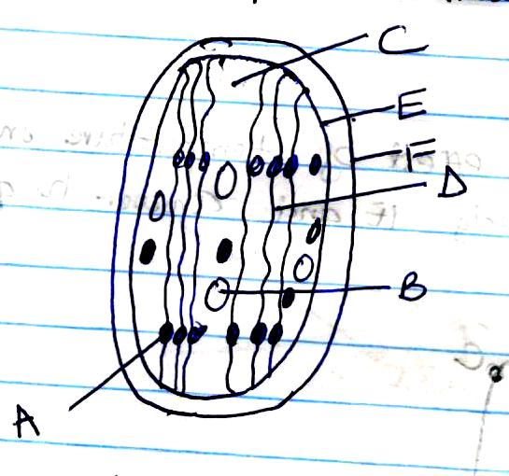
a) State the function of this organelle (1mk

b) Name the parts labeled A, and C. (2mks
A

C
c) List two processes that take place in the structure labeled A (2mks

d) Name the process that takes place in the structure labeled C (1mk

e) Name the chemical pigment found in the structure labeled A and state its function (2mks

14. State three adaptations of a leaf to its photosynthetic functions (3mks

15. State five factors that affect the process of diffusion (5mks

16. a. State the functions of the following parts of a microscope: (3 mks)
i. Condenser

ii. Fine adjustment knob

iii. Objective lens

b. State two differences between a light and electron microscope. (2 mks)

