MWAKICAN EXAMINATIONS
BIOLOGY
FORM 2
END OF TERM 1 2016 EXAM
NAME:………………………………………………………………………..ADM NO:………………………
DATE:………………………………………..
INSTRUCTIONS TO CANDIDATE
- Write your name and admission number in the spaces provided above
- Write the date of examination in the space provided
- This paper consists of three sections A,B and C
- Answer all the questions in the spaces provided

SECTION A (40 MRKS)
1.Define the following term and give an example (1mrk)
- Tissue
2.a)Name one structure found in a plant cell and not in an animal cell(1mrk)
b)Naomi observd an object using a microscope with an eye piece lens of nmagnification x5 and objective lens of magnification x20.What was the magnification of the object?(2mrks)
3.Define the following term(1mrk)
a)Osmosis
b)The following experiment was set up to demonstrate a physiological process.Two tubes A and B,made of sheep’s bladder were filled with different liquids and placed in a basin containing a liquid.
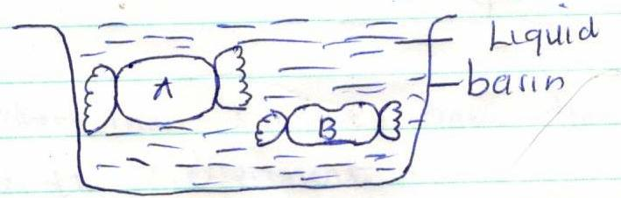
After 20minutes,it was found that tube A felt hard and the liquid in it had increased.Tube B was soft and contained less liquid.
- Explain what took place in tubes A and B (3mrks)
- Identify the liquid hypertonic to the liquid in the beaker(1mrk)
- What does the sheep’s bladder correspond to in a living organism?(1mrk)
4.a)Define the term photosynthesis(1mrk)
b)State three requirements for the process of photosynthesis(3mrks)

5.An experiment was set up as shown below to investigate a certain process.
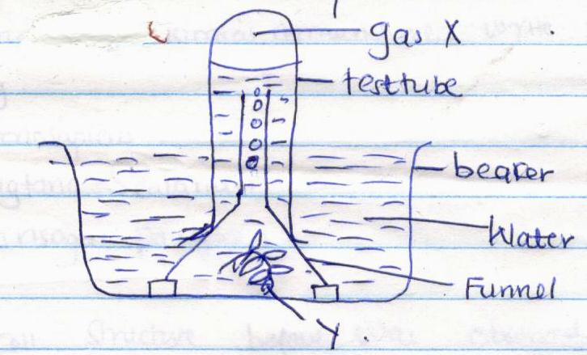
The set up was left in bright sunlight for several hours
- State the aim of the experiment(1mrk)
- Name x and y(2mrks)
X y
c.Other than sunlight,name three factors that would affect the experiment.(3mrks)
d.state how the identity of x could be confirmed(1mrk)
e.Write a chemical equation for this process(1mrk)
6.Name the most appropriate tool that Biology students can use for collecting(2mrks)
- Flying insects
- Crawling animals
7.State the name given to the study of (2mrks)
- Insects
- Classification of living organisms
8.a)Define the term species(1mrk)
b)Referring to Binomial nomenclature, write the following names correctly.(3mrks)
- Homosapiens
- Digtaria scalanum
- galinsoga pariflora

9.The cell structure below was observed under light microscope.
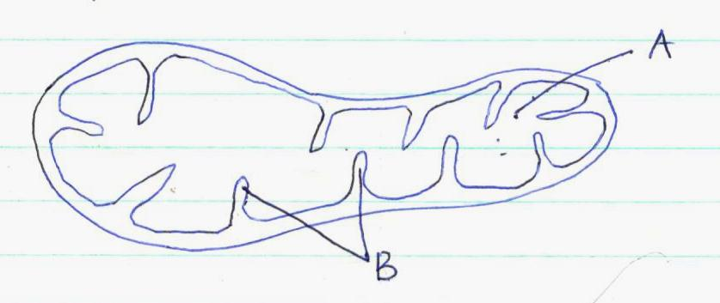
a)Identify the structure(1mrk)
b)Name the parts labeled A and B (2mrks)
A B
c)State how the organelle is adapted to its function(1mrk)
d)State the cells in the body where one is likely to get numerous number of organelle above(1mrk)
10.a)Distinguish between the following terms(2mrks)
- Open and Closed circulatory system
- Single and double circulatory system
b)State two structural differences between arteries and veins
Arteries Veins
1.
2.
c)People can die when they inhale gases from burning charcoal in poorly ventilated rooms.What compound is formed in the human body that leads to such deaths(1mrk)

SECTION B (40 MARKS)
11.The diagram below represents part of phloem tissue
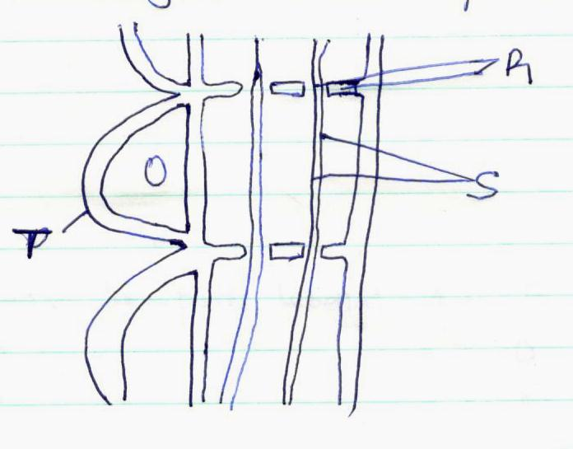
a)Name the structures labeled R and S and a cell labeled T(3mrks)
R
S
Cell T
b)State the functions of the structure labeled S(1mrk)
c)The diagram below represents an experiment that was set up to investigate a certain process.
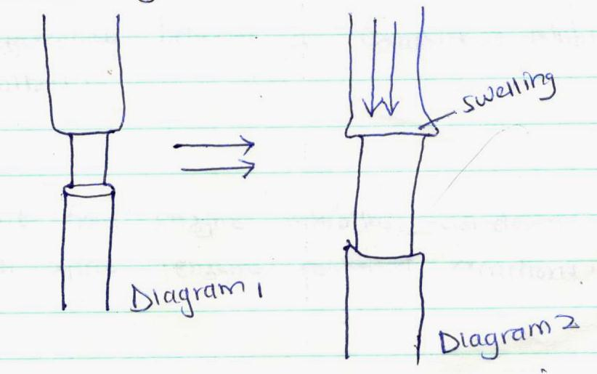
- Name the process that was being investigated (1mrk)
- Account for the swelling in diagram 2.(2mrks

12.The figure below is a diagram of a vertical section of a mammalian tooth.
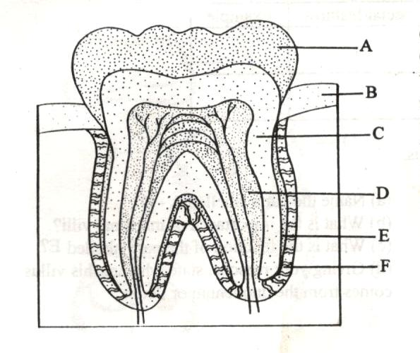
a)Name the parts labelled (A-F) (3mrks)
A D
B E
C F
b)How are the structures labelled A and D adapted to their functions(2mrk)
c)List down three ways of preventing teeth diseases(3mrks)
13. a)What are enzyme inhibitors(1mrk)
b)Differentiate between a competitive inhibitor and non-competitive inhibitors(2mrks)
c)Apart from enzyme inhibitors list down 3 other factors which affect controlled reactions (3mrks)
d)State four properties of enzymes(4mrks)
14.a)Distinguish between heterodont and homodont dentition.(1mrk)
b)What is the significance of the diastema in herbivorous mammals.(1mrk)
c)State the role of carnassial teeth in a lion (1mrk)
d)An organism was found to have the dental formula
i 1/1,c 0/0,p 3/2,m 4/4
- Calculate the total number of teeth in the organism(1mrk)
- With a reason, suggest the mode of feeding of the organism from which the dental formula was obtained(2mrk)
15.a)Name the reagents that are used to test the following food substances.(3mrks)
Food substance Reagent
- Starch
- Ascorbic acid/vitamin c
- Reducing sugars
b)Name three types of carbohydrates(3mrks)
c)State the deficiency diseases that are caused by lack of the following in the diet(3mrks)
- Vitamin C
- Proteins
- Vitamin D
SECTION C (20RKS)
16.
- Give two major functions of the small intestines(2mrks)
- Name the blood vessel that carries blood from the small intestines to the liver(1mrk)
- In what ways is the mammalian small intestine adapted for its function(7mrks)
17. State and explain briefly five structural factors affect the rate of transpiration

