NAME____________________________________________________ADM NO_________________-
231/1
BIOLOGY

MWAKICAN JOINT EXAM

FORM 2 BIOLOGY

INSTRUCTIONS TO THE STUDENT
(a) Write your name and admission number in spaces provided
(b) Answer all the questions in the spaces provided
(c) This paper consists of 7 printed pages

For Examiners use only
Question No | Maximum score | Candidates Score
1-15 | 100

1. Name the branches of biology that deal with study of
(a) Inheritance and variations (1mk)
(b) Chemical changes inside living organisms (1mk)
( c) The relationship between organisms and their environment(1mk)
(d) Insects (1mk)
2. (a) State two functions of cell membrane (2mk)
(b) Name the cell organelles that would be abundant in
(i) Skeletal muscles (1mk)
(ii) Palisade cells (1mk)
(iii) Fat cells (1mk)
3. Explain the importance of each of the following during the process of digestion in human beings
(a) Teeth (1mk)
(b) Saliva (2mks)
4. State two ways in which active transports differs from diffusion (2mks)

5. Name two important stages of photosynthesis and state where in the chloroplasts, each takes places. (4mks)

(b) Explain how the following factors affect the rate of photosynthesis
(i) Concentration of carbon (1v) Oxide (1mk)
(ii) Light intensity (1mk)

6. The diagram below shows the transverse section of a young stem
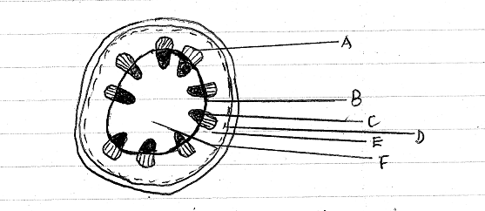
(a) What are the functions of the structures labeled A, B, C and D (4MKS)
A
B
C
D
(b) What type of cell are found in the part labeled E and F (1MK)
(c) If the shoot from which this section was obtained had been immersed in red coloured water for one hour, what part on the diagram would be stained (1mk)
(ii) Give a reason for your answer in c (i) above (1mk)

(d) Is this a monocot or a dicot stem? Give at least three reasons to support your answer (4mks)

7 The table below shows the percentage composition by volume of inhaled and exhaled air.
Gas | Inhaled air (%) | Exhaled air(%)
Oxygen | 21 | 16
Carbon(IV) oxide | 0.04 | 4.0
Nitrogen | 78 | 78
(a) By what percentage is
(i) Carbon dioxide concentration in exhaled air higher than inhaled air? (1mk)

(ii) Oxygen concentration in the exhaled air lower than the inhaled air. (1mk)

(b)Explain the difference in the composition of the gases between inhaled and exhaled air. (3mks)

8 In an investigation, a student extracted three pieces of pawpaw cylinders using a cork borer. The cylinders were cut back top 50mm length and placed in a beaker containing a solution. The results after 40 minutes were as shown in the table below.
Feature | Result
Average length of cylinders(mm) | 56mm
Stiffness of cylinders | Stiff

(a) Account for the results in the table above (3mks)

(b) What would be a suitable control set up for the investigation? (2mks)

9 The figure below is a diagram of a cell as seen under the light microscope.
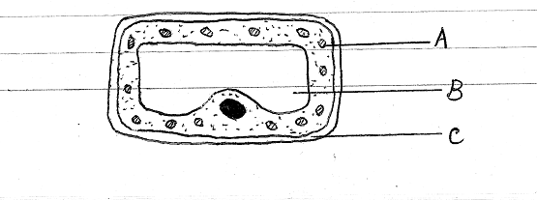
(a) Name three structures that shows this is a plant cell and not an animal cell. (3mks)

b) Name one chemical compound that is only found in the structure labeled A and state its function.
(2mks)
c) Name the fluid in the part labeled B and state its functions. (3mks)

d) What is the main chemical compound found in the structure labeled C? (1mk)
e) Suggest why the structures labeled A would more on one side than the other side. (2mks)

10(a) Name the structural units of lipids. (1mk)
b) State three important functions of lipids in living organisms. (2mks)

c) Other than through enzymatic action, how else can a disaccharide be hydrolyzed to its constituent monosaccharides. (1mk)
11.The diagram below represents part of a geasous system in a grasshopper.
P Q
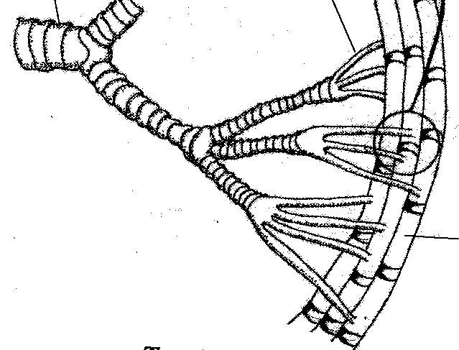
a) Name the structures labeled P and Q
P……………………………………………………… (1 mark)
Q ……………………………………………………… (1 mark)
b) State the function of the structure labeled P (1 mark)
c) Describe the path taken by carbon (IV) oxide from the tissues of the insect the atmosphere (3 marks)

d) How is the structure labeled Q adapted to its functions (2 marks)
12. State five differences between aerobic and anaerobic respiration. (5mks)
AEROBIC RESPIRATION | ANAEROBIC RESPIRATION
13.(a) State four characteristics of gaseous exchange or respiratory surfaces. (4mks)

(b) Describe the mechanism of breathing in a mammal under the following subheadings. (16mks)
Inhalation

Exhalation

14. The diagram below shows part of a longitudinal section of a root: -
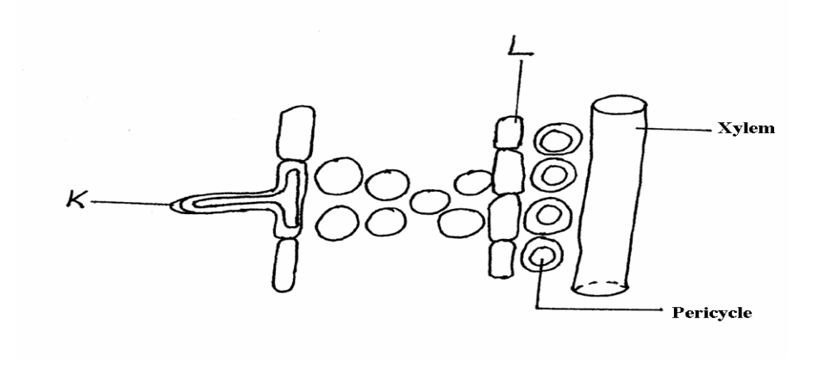
(a) Identify cells K and L :- (2 mks)
K
L
(b) State two adaptations of Cell K to its functions :- (2 mks)

15.The diagram below represents a section through a mammalian heart.
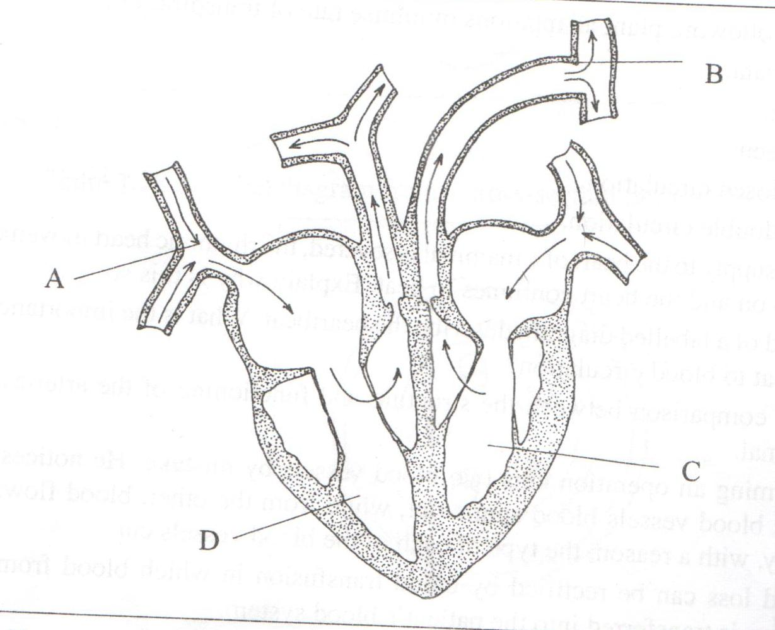

- Label the parts marked A ,B and C. (2 mks)

- State the structural differences between blood vessels labeled A and B. (3 mks)

- Explain why chamber C has thicker walls than the chamber labeled D. (2 mks)

