MWAKICAN JOINT EXAMINATION
NAME……………………………………………………………………ADM NO……………………..
BIOLOGY
FORM TWO
END OF TERM THREE 2019
TIME: 2HRS
INSTRUCTIONS
I. Write your name and admission number in the space provded.
2. Answer all the questions in the space provided

For examiner use only
Question No. Total score Student score
1-28 100

1(a) What is Biology? (1mk)

(b) State and define any two main branches of biology. (2mks)

2 Below is an illustration of a piece of apparatus strategically positioned to trap some organism
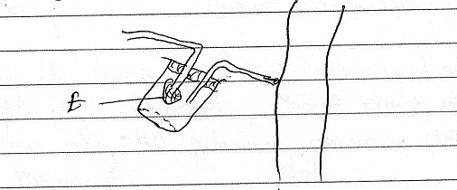

(a) Name the apparatus. (1mk)

(b) State the function of the part labeled E. (1mk)

3. State the name given to the study of (2mks)
(a) Micro-organism

(b) Living things and their surrounding

4 State the organelles that (2mks)
(i) provide site for protein synthesis

(ii) involved in cell division through formation of spindle fibre

5(a) Give two precautions that should be observed when placing a microscope on a bench. (2mks)

(b) To estimate the size of a cell A student observed 20 cells across a diameter of field of view of 5mm in diameter Calculate the cell diameter . Show your working. (2mks)

(c) Explain why course adjustment knob should not be used to lower the high power objective. (1mk)

6(a) Explain why the following processes are important during the preparation of a slide. (2mks)
(i) making a very thin section

(ii) placing a cover slip over the section

(b) The diagram represents a nucleus
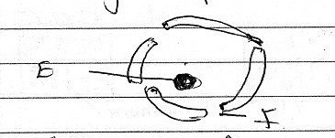
(i) State the function of part labeled E (1mk)

(ii) Name part labeled F. (1mk)

7. List two differences between plant and animals. (2mks)
Plants | Animals
8. A student named cockroach as AMERICAN PERIPLANTA.
(a) Identify two mistakes made in naming the cockroach. (2mks)

(b) Write the name correctly. (1mk)

9 The set up below illustrate a certain physiological process.
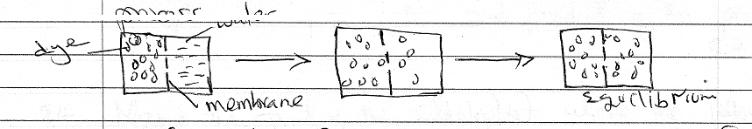

(i) Name the physiological process. (1mk)

(ii) Give two ways in which the movement of dye can be increased. (2mks)

(b) List at least three factors that affect the process named above. (3mks)

10 The diagram below show red blood cell that was subjected to certain treatment.
(a) Give the name given to cells appearance at the end. (1mk)

(b) Name the solution in which the cell was placed in (1mk)

11 The reation below represent a process that takes place in plants.
6 Co₂ + 6H₂O C₆H₁₂O₆ + 6O₂
(a) Name the process (1mk)

(b) State two factors affecting the process named above. (2mks)

(c) Explain the fate of the product of the process named above (2mks)

12 Name the part of the chloroplast where the following occur (2mks)
(i) Carbon (IV) oxide fixation

(ii) photolysis

13 Name three plant cells that contain chloroplasts (3mks)

/

14 The flow chart below shows classification of carbohydrates.
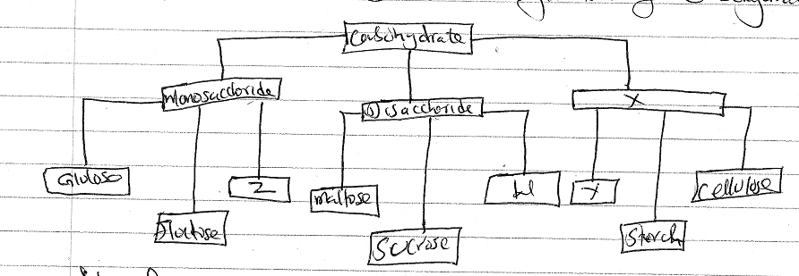
(a) Identify the form of carbohydrates represented by letters W,X,Y and Z. (4mks)
W
X
Y
Z
15(a) Differentiate between homodont and heterodont teeth (2mks)

(b) Name two enzyme in the digestive system secreted in their inactive form. (2mks)

(c) State the name of the juice secreted in the following region, (2mks)
(i) stomach

(ii) small intestine

d) State two functions of saliva. (2mk)

(e) What is the importance of including roughages in the diet. (1mk)

16 The diagram below represent a transverse section of a plant organ
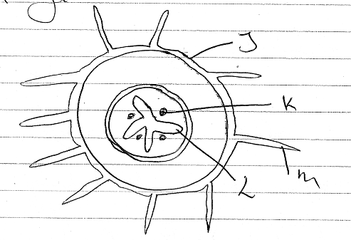

a) From which plant organ was the section obtained. (1mk)

b) Give two reasons for your answer in (a) above. (2mk)

c) Name the part labeled: (3mks)
J -
K -
L -
17(a) State why it is important for plant to lose water to the atmosphere. (2mks)

(b) Give the importance of mitochondria found in the companion cell of phloem. (1mk)

18(a) State two function of blood other than transport. (2mks)

b) State two forms in which carbon(IV) oxide is transported. (2mks)

19 State the role of the following during blood clotting process (2mks)
(a) Thromboplastin

(b) Calcium ions

20 Name two gaseous exchange structures in higher plants. (2mks)

21 What is a single circulatory system. (1mk)

22 The table provided shows the transportation of substances in the human body.
Substance | Transported by blood
 | From | To
Oxygen | M | Heart
N | Liver | Kidney
P | Intestine | All body

Name substance (3marks)
M
N
P

23 The diagram below represent a model used to demonstrate breathing in mammals.
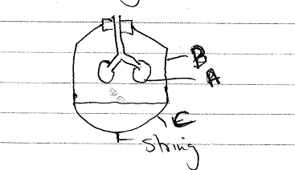

a) Name the mammalian structure represented by the part labeled Aand B. (2mks)
A
B
24(a) Name three characteristics of a gaseous exchange surface. (3mks)

(b)The diagram below represent an organ in a bony fish.
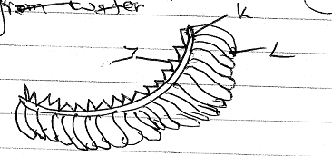

(i) Name parts labeled (2mks)
K -
J -
(ii) Explain why bony fish dies shortly after being removed from the water. (2mks)

25(a) Define the term respiration. (1mk)

(b) Give three products of anaerobic respiration in plants. (3mks)

26(a) What is oxygen debt (1mk)

(b) What happens to lactic acid formed in muscle during excersice when there is sufficient oxygen. (2mks)

(c) Write an equation to summarize the process of aerobic respiration. (1mk)

27(a) State two ways in which plant manage their waste. (2mks)

(b) State one function of each of the following plant product. (2mks)
(i) Papain

(ii) Colchicine

28(a) State two structure of the skin essential for its homeostatic function. (2mks)

b) Name two kidney diseases. (2mks)

