NAME ………………………………………………ADM. NO ………………CLASS:……….

DATE……………..
231/3
BIOLOGY
PAPER 3
PRACTICAL
JULY/AUGUST
TIME: 1³/₄HRS

MWAKICAN FORM 3 JOINT EXAMINATION - 2016

KENYA CERTIFICATE OF SECONDARY EDUCATION

Instruction to Candidates
- Write your Name, Adm. No., Class and Date in the spaces provided
- Answer all the questions
- You are required to spend the first 15 minutes of the 1³/₄Hrs around for this paper reading the whole paper carefully before commencing your work
- Answers must be written in the spaces provided in the question paper. Additional
Pages must not be inserted.
- The paper consists of six printed pages.

FOR EXAMINER’S USE ONLY
QUESTION | MAXIMUM SCORE | CANDIDATE’S SCORE
1  2  3 | 13  13  14
TOTAL SCORE | 40

- You are provided with a suspension labelled W
- Using the reagents provided only, carry out food test and complete the table below (12 mks)
Food substance | Procedure | Observations | Conclusions

- i) Name the enzymes that are required to digest the suspension W in the alimentary
canal (1mk)

ii) State the medium under which the enzymes named in a(i) above functions
best.(1mk)

- Name the deficiency diseases a child that is fed on the above suspension W only is likely to suffer from (2mks)

- Photographs J and KI represents specimens which were obtained from different habitats.
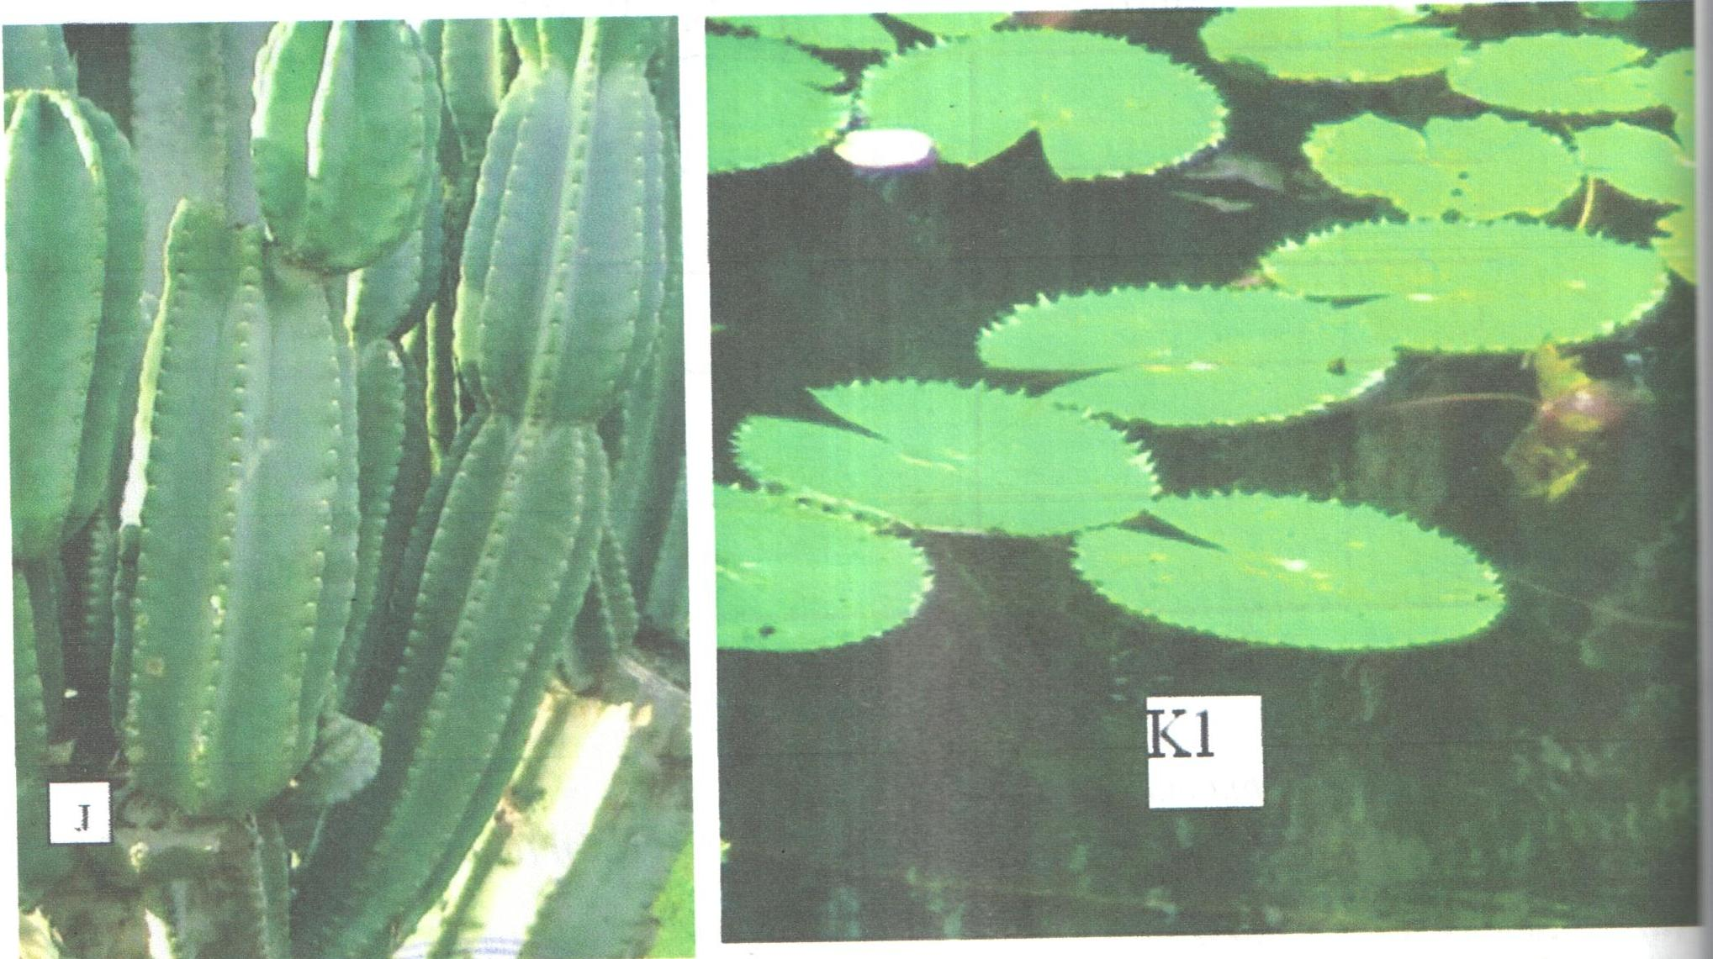
- With reasons identify the habitat of specimen J and KI (4mks)
KI –
Reason(s)

J –
Reason(s)

- Give the term used to describe plants found in the same habitat with specimen J (1mk)

- State three modifications found in the stomata of leaves found in the habitat of specimen J (3mks)

- The photograph below was obtained from a cross-section of part of specimen K₁
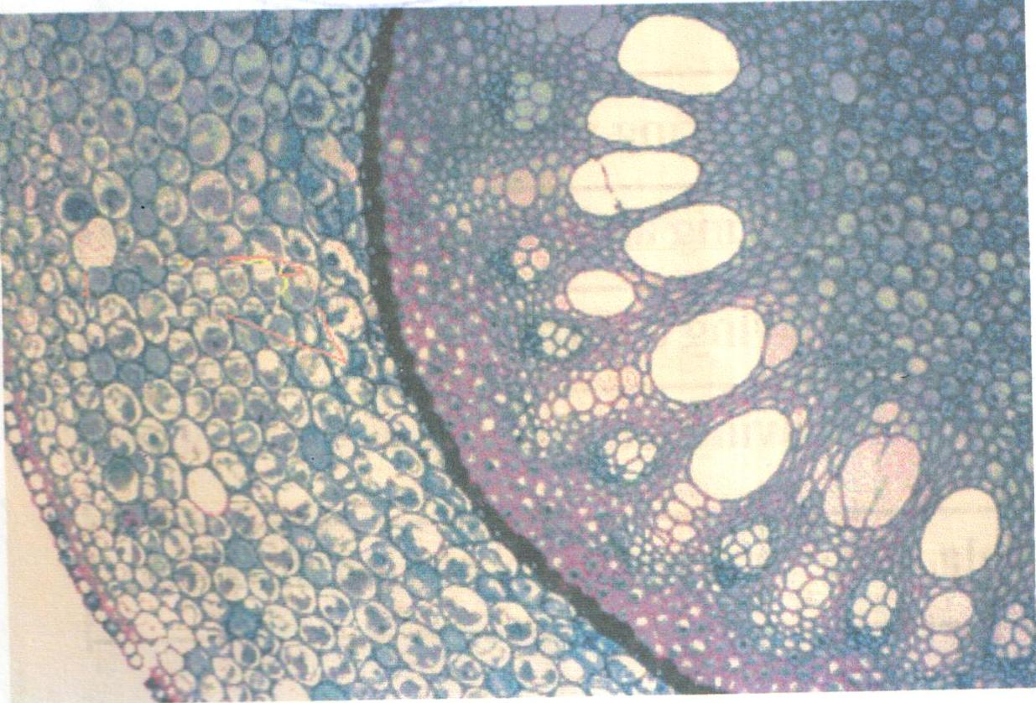

- From which part of plants was the cross section obtained? (1mk)

- Give reason for your answer in d(i) above (1mk)

- Draw a plan diagram of the cross-section shown and label any four parts (2mks)

- Below are photographs named J, X, Y and Z representing parts of a certain animal. Study them to answer the questions that follow.
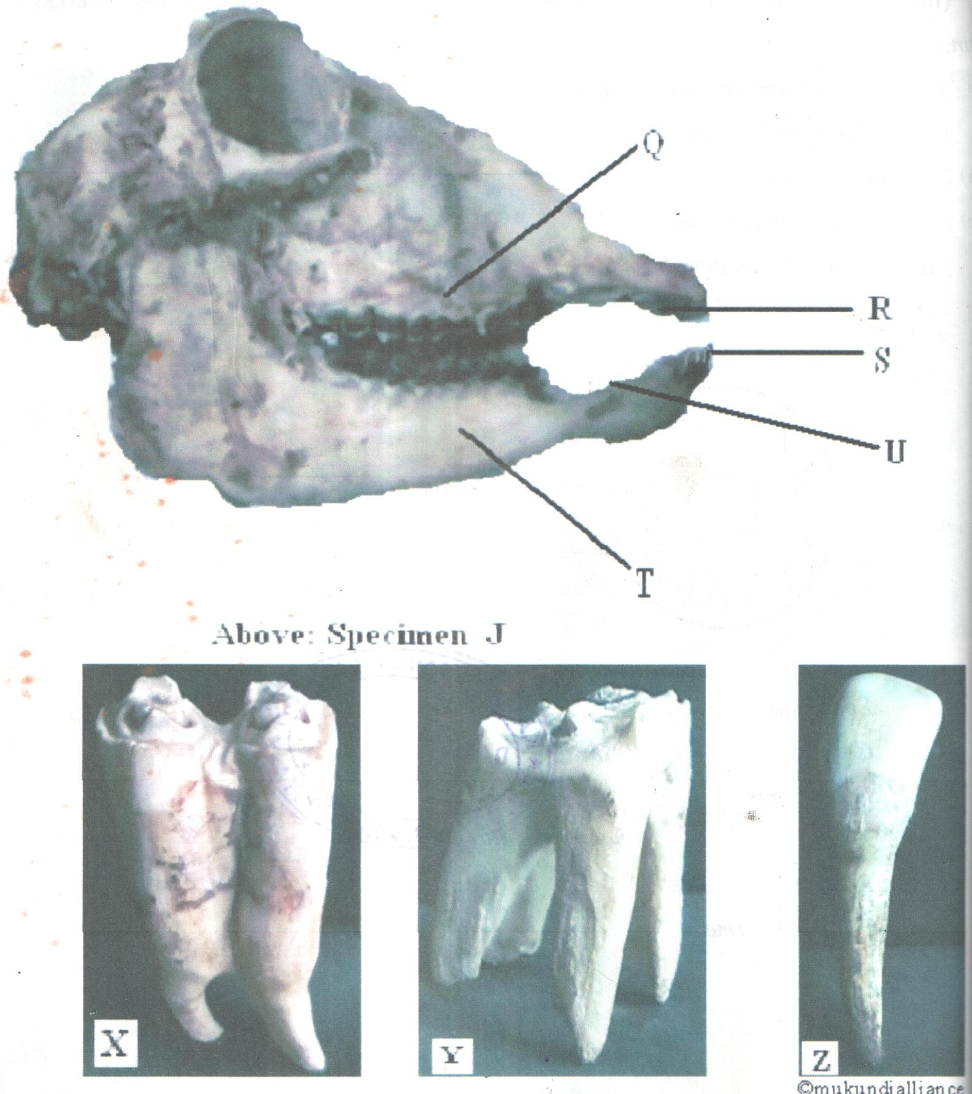
- Name the parts labeled in the photograph above as: (4mks)
Q –
R –
S –
T –
- What is the function of part labelled U? (1mk)

- What is the mode of feeding of the animal from which the specimens above were obtained? (1mk)

- Fill the table below to distinguish between specimen X, Y and Z above (9 mks)
Specimen | Name | Adaptation | Function
X

Y

Z

