FORM 3 BIOLOGY PAPER 3 MARKING SCHEME
Q1.
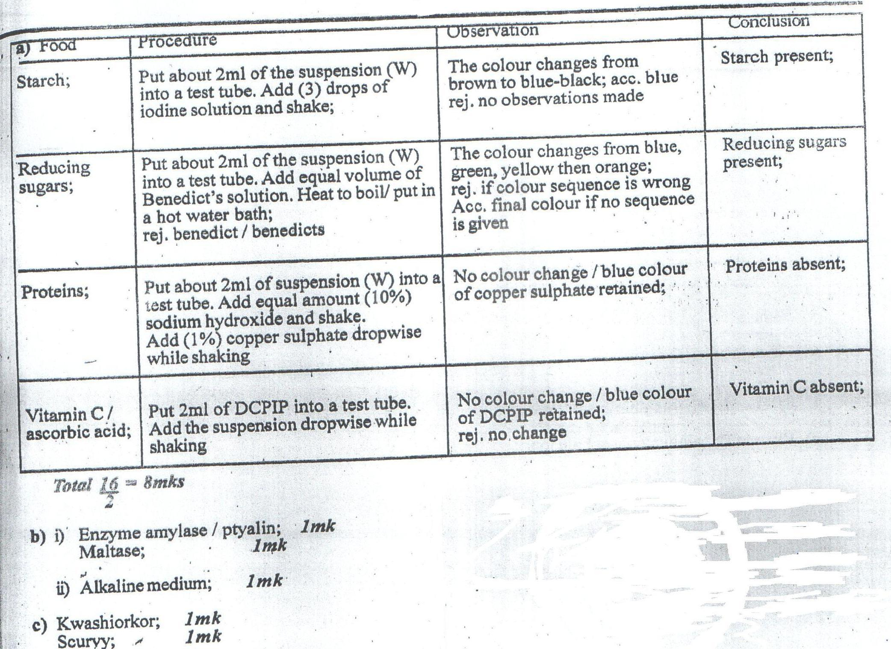

Q2. a) K1- Aquatic/fresh water (1mk)
Reason: Leaves have a large surface area (1mk)
J – Desert/semi arid/dry (ref. Terrestrial) (1mk)
Reason: Thick fleshy stem leaves reduced to thorns (res. spines) (1mk)
b) Xerophytes (1mk)
c) Sunken stomata (1mk)
Reversed stomatal rhythm (1mk)
Small stomatal pore (1mk)

d)

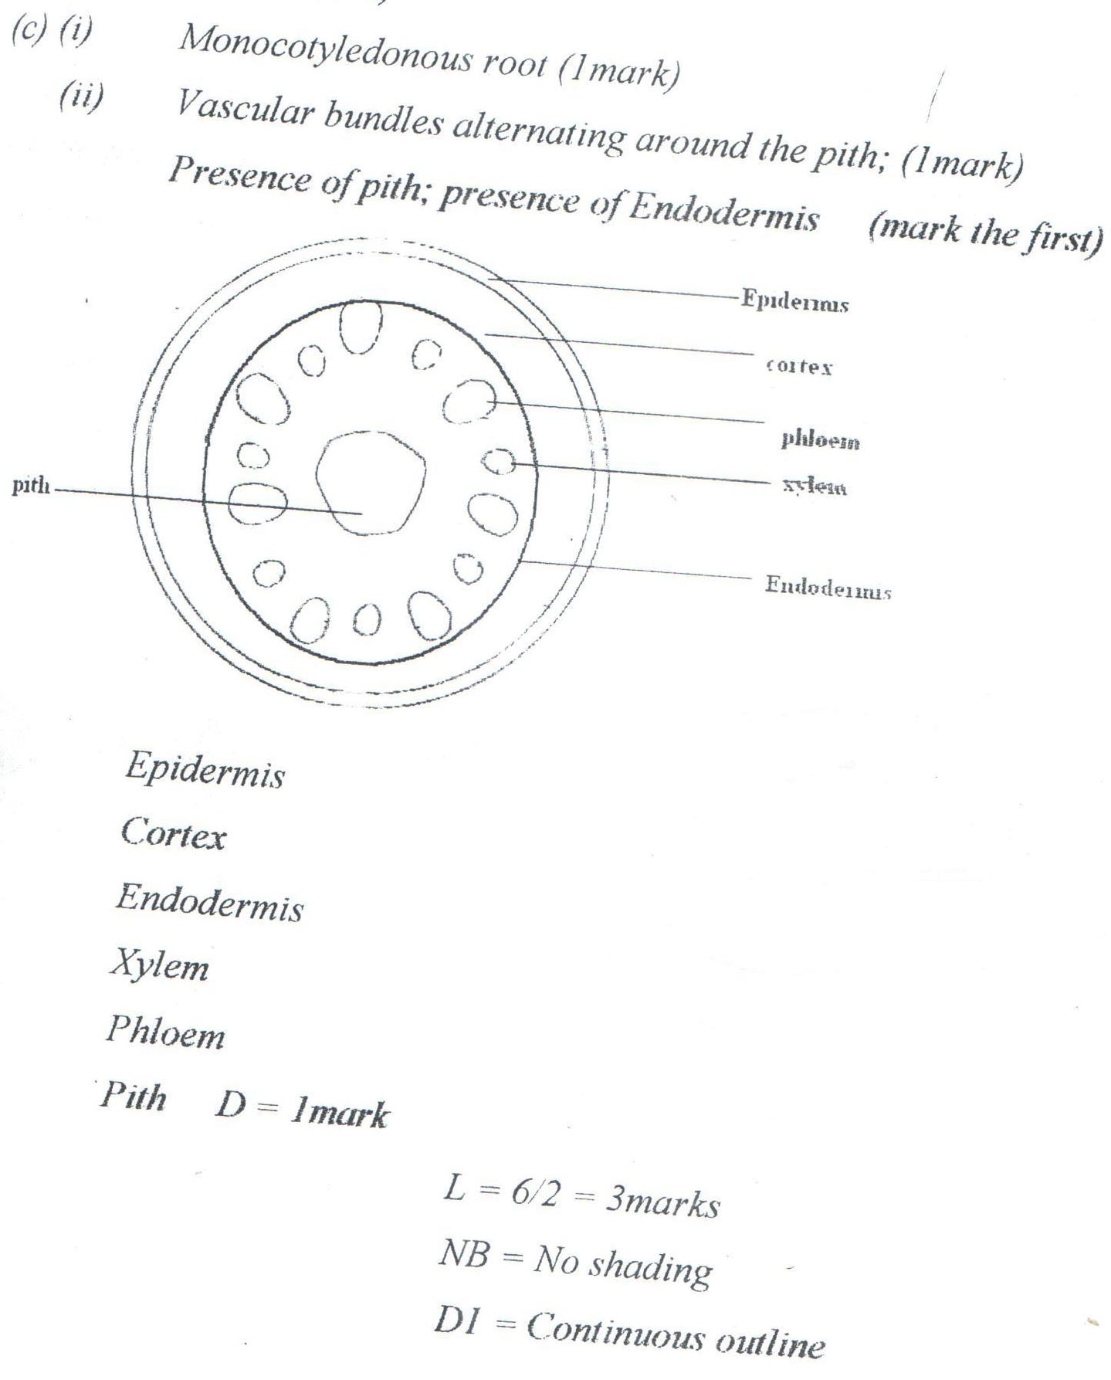

Q3.
