MWAKICAN (MJET)
END OF TERM 1 EXAM 2016
231/2
BIOLOGY FORM THREE
MARKING SCHEME
PAPER 2
( ; ) Means a marking point
1(a) J - Sporangium
K - Sporangiophore
L - Rhizoids (3mks)

(b) Absorption of soluble substances;
Anchorage of mould on substrate; (2mks)

(c) Saprophytism (1mk)

(d) Cause food spoilage;
Cause decomposition of organic materials; (2mks)

2(a) Chordata; (1mk)
(b) Interbreed to produce fertile / viable offsprings; (1mk)

(c)
Classes | Organisms | Reasons
Insecta | “Praying mantis;  Tsetse fly; | 3 body parts  3 pairs of legs;
Chilopoda | Centipede; | 1 pair of legs per segment
Diplopoda | Millipede; | 2 parts of legs per segment;
Arachnida | Tick;  Spider; | 2 body parts;  4 pairs of legs;
12 x 1 = 6mks
3(a) (i) Open circulatory system; (1mk)

(ii) Hepartic portal vein; (2mks)
Pulmonary vein;

(iii) Oxyhaemoglobin; (1mk)

(b) (i) Stem;

(ii) Monocotyledonae; reject monocot, monocotyledon

(iii) Vascular bundles are scattered and not arranged in a ring;
Absence of pith / cambium;
1 x 1 = 1mk
(iv) Epidermis

4(a) (i) Homeostasis is the maintenance of constant internal environment of
organism (despite fluctuations in the external environment) (1mk)

(ii) Osmoregulation is the maintenance of a concentration of water and salt ions in the body fluid / maintenance of constant osmotic pressure in the body; (1mk)

(b) Insulin; and Glucagon; (2mks)

(c) (i) (a) Efferent arteriole / vessels;

(b) Loop of Henle; (2mks)

(ii) Ultrafiltration; (1mk)

(iii) Glucose (Blood sugar / amino acids; (1mk)

5 (a) - Broad / flat lamina to absorb maximum light;
- Have chloroplasts which contain chlorophyll for trapping light;
- Transparent cuticle to allow light to pass through;
- Palaside cells are near the upper surface
for optimum absorption of light;
2 x 1 = 2mks

(b) X - Carbon (IV) Oxide;
Y - Oxygen; (2mks)

(c) Xylem - Water into the leaf;
Phloem - Sugar out of the leaf; (2mks)

(d) Light trapped is used to split water / photolysis;
into hydrogen ions and oxygen; (2mks)

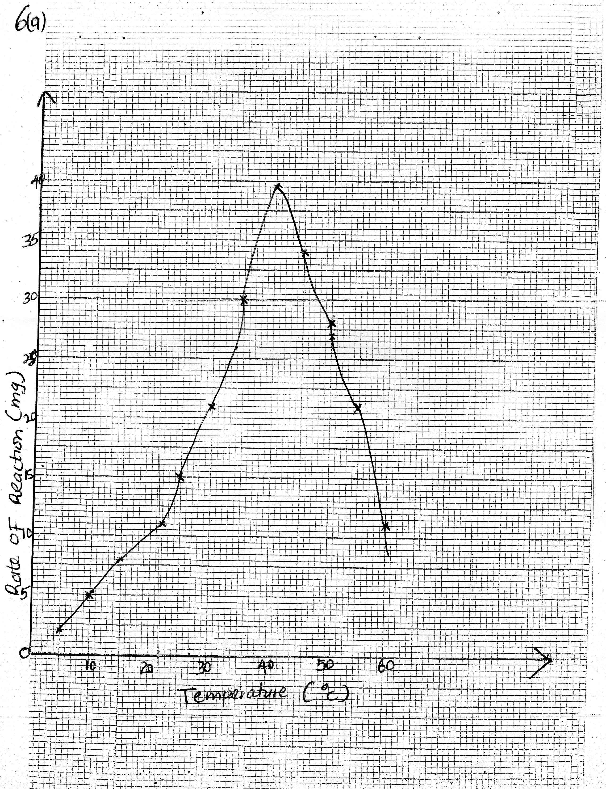

Scale - X - axis
Y - axis (2mks)

Labelling axes - 2 mks

Plotting - 1 mk

Curve - 1 mk

(b) 33⁰C (ŧ 0.5) reject if no units.

(c) (i) As temperature is increased rate of reaction is increased and more products
are formed per unit time because enzymes become more active catalyzing the rate of reaction.

(ii) As temperature increase rate of reaction decreases and less products are formed per unit of time because enzymes become denatured by high temperatures above 40⁰C, hence cannot act on substrate.

(d) Increase in enzyme and substrate concentration; use of cofactors and co-enzymes; (2mks)

e(i) Pepsin / rennin; (1mk)

(ii) Gastric juice; contain hydrochloric acid; (2mks)

f(i) Duodenum; (1mk)

(ii) Bile juice / sodium hydrogen carbonate in pancreatic juice; (1mk)

7. Wind
- During windy conditions the rate of transpiration increases, wind modifies the temperature which affect transpiration.
- Wind disperses fruits, seeds and spores.
- Wind is an agent of pollination.
- Strong winds break branches of trees and may uproot them.

Temperature
- Temperature affect enzymatic reactions.
- This influences the rate of photosynthesis and other biological processes.
- Increase in temperature increases transpiration.

Light
- Green plants need light for photosynthesis.
- Some plants need light for flowering or photoperiodism.
- Light affects opening and closing of stomata which affect transpiration, gaseous exchange and photosynthesis.

Humidity
- When humidity is low, rate of transpiration increases due to less amount of water vapour in atmosphere.
- When humidity is high, the atmosphere becomes saturated with water vapour, reducing rate of transpiration.

P^{H}
- Each plant requires a specific P^{H} to grow well.

Rainfall / water
- Water is necessary for germination.
- Water is raw material for photosynthesis.
- Water is a medium of transport of dissolved mineral salts and manufacture food.
- Water is needed for turgidity of cells to give plants support especially in herbaceous plants.
- Water is required by some plants for pollination, fruit and seed dispersal and during fertilization.

Salinity
- Plants with salt – tolerant tissues e.g mangroves grow in saline areas.
- Plants in estuaries adjust to salt fluctuations.

8. - Has cornified layer; which protects the body against entry of bacteria / micro-organism;
also protects the inner tissues against mechanical damage;
- The malphigian layer; contains actively dividing cells; that give rise to new cells; hence replace old and worn out ones. It also contain melanin; that protect body against ultraviolet rays;
- Has sebaceous glands; which secrete sebum; that is antiseptic, and prevent the skin from drying / cracking;
- Has sweat glands; that become stimulated when hot to produce sweat; which evaporates cooling the body;
- Has erector pili muscles; that regulate body temperature.
- Contain many blood capillaries; which supply the skin with oxygen /and nutrients; also remove waste products from skin;. Blood vessels also help in temperature regulation;
- Contain nerve cells / endings; to detect charges;
(in the external environment)
(Maximum 20 mks)

