MWAKICAN (MJET)
END OF TERM 1 EXAM 2016
NAME…………………………………….………………………………….... ADM …………………..
231/2
BIOLOGY FORM THREE
PAPER 2
(THEORY)

INSTRUCTIONS
- This paper consists of two sections; A and B.
- Answer all the questions in section A in the spaces provided.
- In section B answer question 6 (compulsory) and either question 7 or 8 in the spaces provided after question 8.

For Teacher’s use only
Section | Question | Maximum score | Student score
A | 1 | 8
 | 2 | 8
 | 3 | 8
 | 4 | 8
 | 5 | 8
B | 6 | 20
 | 7 | 20
 | 8 | 20
 | Total score | 80

- The diagram below illustrates the structure of bread mould.
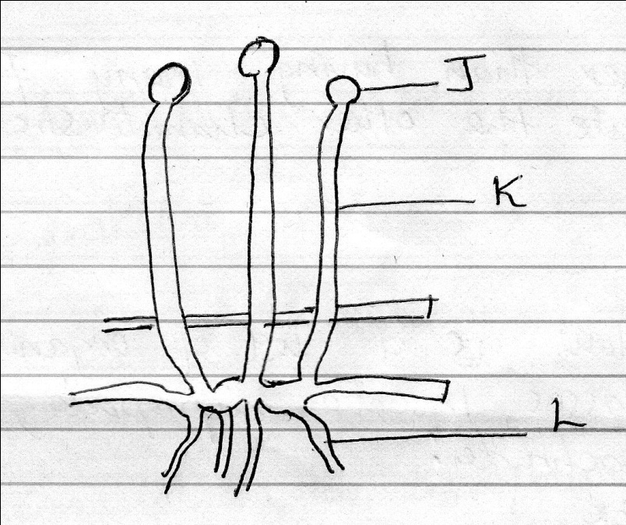

- Name the parts labelled J, K, L (3mks)
J

K

L

- State the functions of the structure labelled L. (2mks)

- Name the type of nutrition exhibited by the mould. (1mk)

- State two economic importance of the mould . (2mks)

(2a) Name the phylum whose members possess notochord. (1mk)

(b) Other than having many features in common, state the other characteristic of a species. (1mk)

(c) Below is a list of organisms, which belong to classes insect, diplopoda, chilopoda and Arachnida:
Tick
Centipede
Praying mantis
Tsetsefly
Millipede
Spider
Place the organisms in their respective classes in the table below. Give reason in each case. (6mks)
Classes | Organisms | Reasons
Insecta |  | 1.  2.
Diplopoda |  | 1.
Chilopoda |  | 1.
Arachnida |  | 1.  2.

3(a) (i) Name the type of circulatory system found in members of the class insect. (1mk)

(ii) Name the blood vessel that transports blood from:
Small intestine to the liver ……………………………………………..
Lungs to the heart ………………………………………………………...
(2mks)
(iii) In what form is oxygen transported from the lungs to the tissues. (1mk)

(b) The diagram below shows a transverse section of a plant organ.
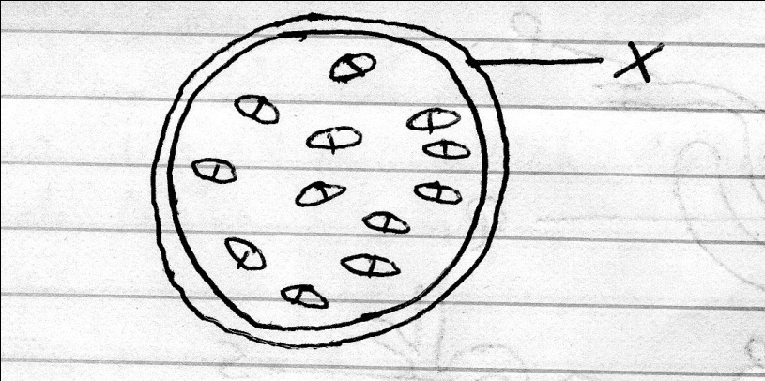

- Name the plant organ which the section was obtained. (1mk)

- Name the class to which the plant organ was obtained. (1mk)

- Give a reason for your answer (ii) above. (1mk)

- Name the part labelled X.

4(a) What is the meaning of the terms; (2mks)
- Homeostasis

- Osmoregulation

(b) Name the hormones involved in regulating glucose level in the blood. (2mks)

(c) The diagram below represents a mammalian nephron.
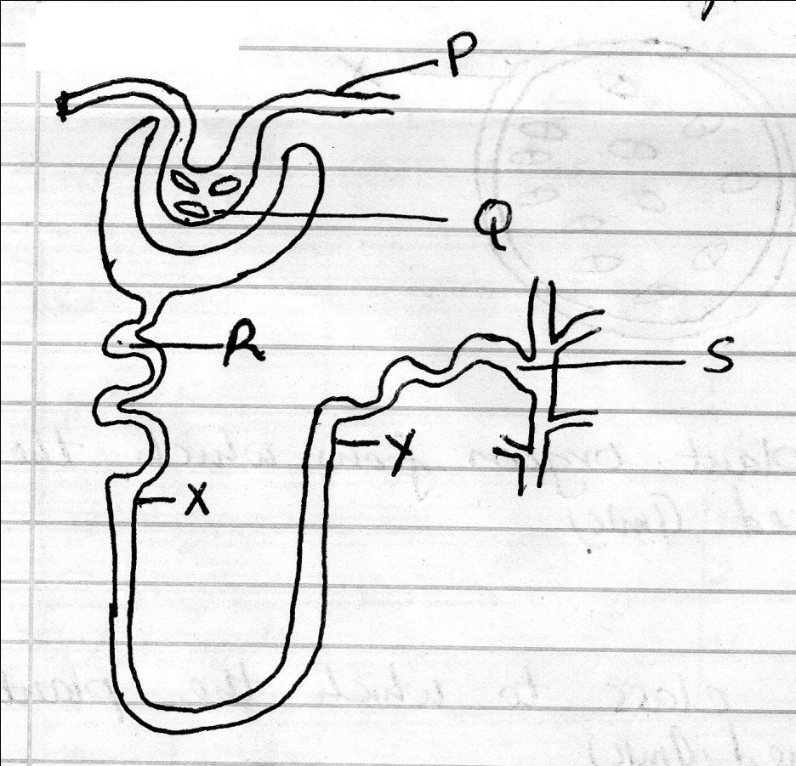

- Name the
- Structure labelled P

- Portion of the nephron between point X and Y.

- Name the process that takes place at point Q.

- Name one substance present at point R but absent at point 5 in a healthy mammal.

5. Leaves are organs of photosynthesis. The following diagram shows what happens in a plant during photosynthesis.
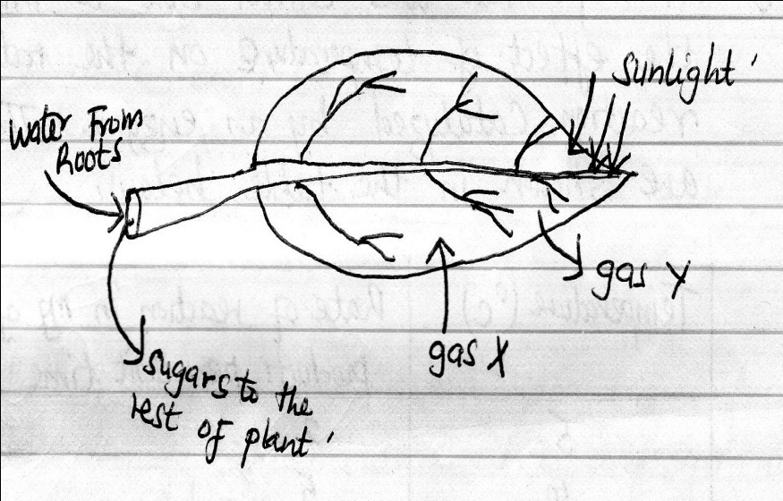

- Give two ways in which leaves are adapted to absorb light. (2mks)

- Name the gases X and Y (2mks)

X …………………………………………………………

Y …………………………………………………………..

- Name the tissues which transport water into the leaf and sugars out of the leaf. (2mks)

- Describe what happens during light stage of photosynthesis. (2mks)

SECTION B
Answer question 6 (compulsory) and either question 7 or 8 in the spaces provided after
question 8.

6. An experiment was carried out to investigate the effect of temperature on the rate of reaction catalysed by an enzyme. The results are shown in the table below.

Temperature (⁰C) | Rate of reaction in mg of products  Per unit time
5  10  15  20  25  30  35  40  45  50  55  60 | 2  5  8  11  15  21  30  37  34  28  21  11

- On the grid provided draw a graph of rate of reaction against temperature. (6mks)

- When was the rate of reaction 26mg of product per unit time. (2mks)

- Account for the shape of the graph between
- 5⁰C and 40⁰C (2mks)

- 45⁰C and 60⁰C

- Other than temperature name two ways in which the rate of reaction between 5⁰C and 40⁰C could be increased. (2mks)

- (i) Name one digestive enzymes in the human body which works best in acidic condition. (1mk)

(ii) How is the acidic condition for enzymes named in (e) above attained (2mks)

- The acidic conditions in (e) (ii) above is later neutralized.
- Where does the neutralization take place? (1mk)

- Name the substance responsible for neutralization. (1mk)

7. Explain how abiotic factors effect plants. (20mks)

8. How is the mammalian skin adapted to its functions. (20 MKS)

