FORM THREE MWAKICAN EVALUATION EXAMINATION
TERM ONE YEAR 2016

NAME………………………………………………………………………ADM NO………………………CLASS………….
231/3 BIOLOGY PRACTICAL
PAPER 3
TIME 1 ¾ HOURS

INSTRUCTIONS TO CANDIDATES

- Write your name and index number in the spaces provided at the top of this page.
- Answer all questions. You are required to spend the first 15 minutes of the 1 ¼ hours allowed for this paper reading the whole paper carefully before commencing your work.
- Answers must be written in the spaces provided in the question paper. Additional
Pages must not be inserted.

FOR EXAMINERS USE ONLY

QUESTION | MAXIMUM SCORE | CANDIDATE’S SCORE
1 | 15
2 | 12
3 | 13
TOTAL | 40

1. Label 4 test tubes J, K, L and M. Peel specimen X provided and obtain four cube of about 1cm³. Grind one of the cubes put in test tubes J add water and boil for about 5 minutes. Grind another cube and place it in test tube K. Grid the third piece and place it in test tube L. Place the remaining cube in test tube M. Measure 5ml of the Hydrogen peroxide provided and pour into each test tube
a) Record the observation in these test tubes. (4 mks)
J…………………………………………………………………………………………..
K………………………………………………………………………………………….
L…………………………………………………………………………………………..
M…………………………………………………………………………………………..
b) Compare the observations made in (2mks)
(i) K and M
………………………………………………………………………………………………………………………………..
………………………………………………………………………………………………………………………………..
(ii) K and J (2mks)
……………………………………………………………………………………………………………………………….
………………………………………………………………………………………………………………………………
c) Account for your answer in b(i) (ii) (4mks)
…………………………………………………………………………………………..…………………………………………………
…………………………………………………………………..…………………………………………………………………………
……………………………………………………………………………….……………………………………………………………
……………………………………………………………………………………………………………………………………………
d) Write a word equation for the reaction taking place in tube M. (2mks)
…………………………………………………………………………………………..
(f) Explain why hydrogen peroxide should not accumulate in living tissue (lmk)

2. Examine the diagrams below of various animals found in a sample of soil and decaying leaves collected from a local wood. Names of the specific organisms are :
Geophilus (A) Lycosa (B) Scutigenella (C) Enchytraeid (D) Porficala (E)

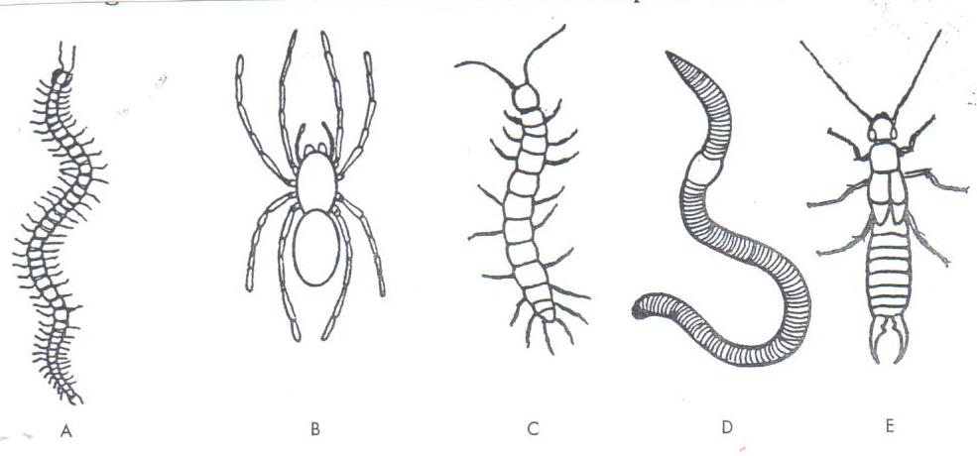

(a ) Using the features in the order given below, construct a dichotomous key that can be used to identify the specimens. (8marks)
- Presence of 8 or more legs or less than 8 legs.
- Length of legs compared to body.
- Presence of legs on every segment.
- Presence of pincers on tip of abdomen.

- Name the class in which the organisms B and E belong. (2 mks)
B …………………………………….
C ……………………………………
(c ) Label any four parts on diagram B. (2 mks)`

- The photomicrograph below shows the arrangement of different types of cells and tissues in a certain living organism. Study it carefully and answer the questions that follow.

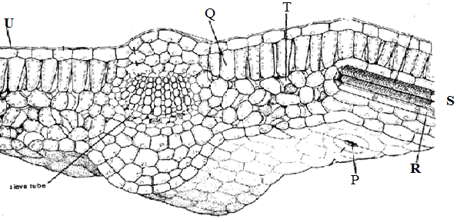
3rd cell

- (i) From what part of the plant was the photograph obtained? (1mark)

(ii) Name the parts labeled: - P, Q, U,T and U (5marks)

(iii) Give two major components that make up structure S. (2marks)

(iv) State the function of the part labeled Q and an adaptation to its function. (2marks)

(v) Give an environmental factor which regulates the function of the part labeled P. (1mark)

- Measure the length of the third (3rd) cell at the right side of structure labeled Q on the photograph whose magnification is X5000. What is the actual length of the cell in micrometers (µm)? Show your working. (2marks)

