Biology 231/1

MWAKICAN JOINT EXAM
BIOLOGY FORM I
END OF TERM THREE
YEAR 2019

TIME: 2 HOURS
NAME: ______________________________________________

ADM NO: _________________ DATE _____________________

INSTRUCTIONS:
- Write your Name and Admission number in the spaces provided
- Answer all the questions in the spaces provided
- Candidates should check the question paper to ascertain that all the pages are printed and no questions are missing.

/3
- Give the structure of the cell that perform the following functions.

- Synthesis of ribosomes (1 mark)

- Regulate exchange of substance in and out of the nucleus. (1 mark)

- Breakdown large molecules and destroy worn out organelles (1 mark)

- State the name given to the study of:
- Insect (1 mark)

- The cell (1 marks)

- a. Name two raw materials for the dark stage process of photosynthesis (2 marks)

b. The set up shows an experiment to investigate photosynthesis.
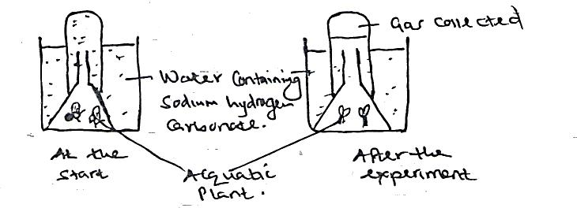
- What gas was collected in the test tube? (1 mark)

- Give three structural features that reduce water loss from a leaf. (3 marks)

- a. Name the process that involved in the uptake of mineral salts from the soil by the plants. (1 mark)

b. Explain what you understand by the term diffusion gradient. (1 mark)

- a. Define the term enzyme. (1 mark).

b. Give one factor that affect the rate of enzyme activity. (1 mark)

- a. Name one defect of circulatory system in humans. (1 mark)

b. State three functions of blood other than transport. (3 marks)

- State two ways in which floating leaves of aquatic plant are adapted for gaseous exchange (2 marks)

- List the changes that takes place during inhalation in the breathing cycle of mammal in the following
- Rib cage (2 marks)

- Diaphragm (1 mark)

- Study the word equation below:
Glucose Ethanol +Cabon(iv)Oxide
- Name the process shown in the equation above. (1 mark)

- Suggest the organism(s) in which it takes place. (1 mark)

- Give one application of the process in industry. (1 mark)

- Name the substances that do not undergo digestion but are absorbed directly from the alimentary canal to the blood stream. (2 marks)

- Sate one use of each of the following plants excretory products.
- Tannins (1 mark)

- Colchicines (1 mark)

- Quinine (1 mark)

- The diagram below represent a cell organelle
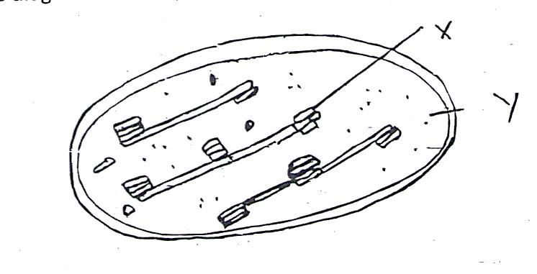

- Name the part labeled Y. (1 mark)

- State the function of the part labeled X. (1 mark)

- The diagram below represents a stage during cell division.
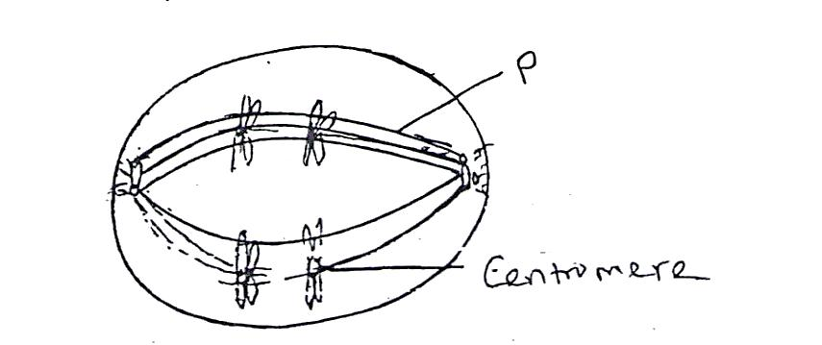
- Identify the stage of cell division. (1 mark)

- Give two reasons for your answer in (a) above. (2 marks)

- Name the structure labeled P. (1 mark)

- State the importance of each of the following features of mammalian ileum.
- Highly coiled.
(1 mark)

- Long (1 mark)

- The figure below illustrate a part of a kidney nephron.
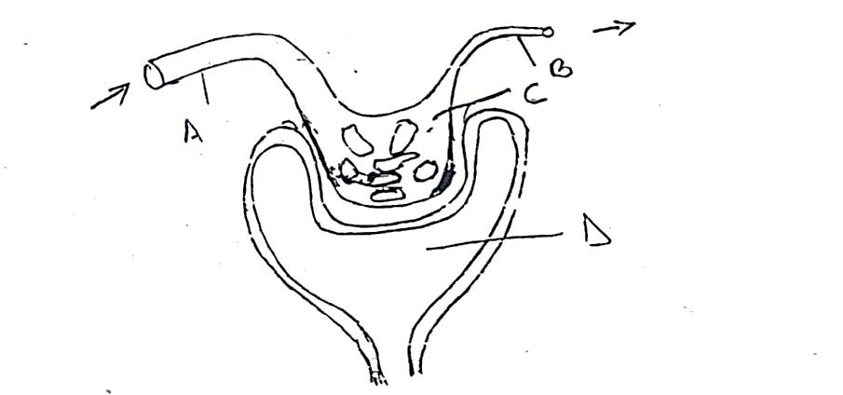
- Name the parts labeled A and D (2 marks)

- State one observable difference between part A and B. (1 mark)

- Name two components found in A but absent in part D. (2 marks)

- a. Pregnancy continues if the ovary of an expectant mother is removed after
the 4th month. Explain (2 marks)

b. What is the role of testis in the mammalian reproductive system (2 marks)

- a. State three characteristics of monera that are not found in other kingdoms. (3 marks)

- Name the class to which a termite belong. (1 mark)

- The diagram below shows a pollen tube as it grows down the style.
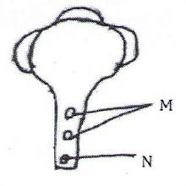

- Name the part labeled M,N (2 marks)

- State the functions of the part labeled M . (2 marks)

- Below is a diagram of moss
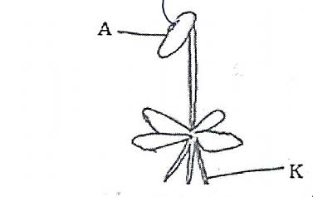
- Classify the moss into kingdom and division (1 mark)

- State the function of the part labeled A (1 mark)

- State one function of the part labeled K (1 mark)

- a. What is metamorphosis? (1 mark)

b. What is the biological importance of the larval stage during metamorphosis (2 marks)

- A plant stem was put in a solution. After 30 minutes a cell from the stem looked like the one drawn below;
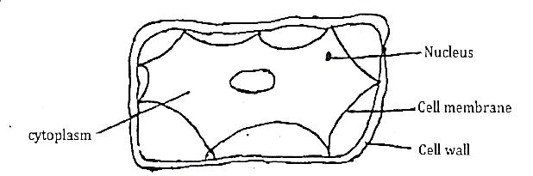
- State the type of solution the stem was put in (1 mark)

- What term is used to describe the cell (1 mark)

- Explain what happened (2 marks)

- a. A student visiting a game park observed an adult elephant flapping its ears twice as much as its
calf in order to cool its body when it is hot. Explain. (2 marks)

b. Explain why some desert animas excrete uric acid rather than ammonia. (2 marks)

- a. What is seed dormancy? (1 mark)

b. Name a growth inhibitor in seed. (1 mark)

c. Differentiate between hypogeal and epigeal germination in seeds. (2 marks)

- Name the causative agent of the following diseases in man. (1 mark)

- Candidiasis (1 mark)

- Syphilis (1 mark)

- To establish the population of tilapia using the capture method, 60 fish were captured and released. In the second capture out of 72 fish, 10 had been marked. Calculate the estimated population of tilapia. (show your working) (2 marks)

