MWAKICAN JOINT EXAMINATION TEAM
BIOLOGY PAPER 2 FORM 3
MARKING SCHEME

1(i)(a) Cellulose

(b) - Store sugars, salt and food.
- Carry out osmoregulation by inducing osmotic.
- Gradient that brings about water movement.
- Maintain the shape of the cell.

(c) Cell wall
Chloroplast

(ii)(a) Contractile vacuole
(b) Lysosomes
(c) Cilia

2(a)(i) B - Seta / Stalk
D - Rhizoid; Rej Rhizoids

(ii) A - Production of spores / sporulation
C - Photosynthesis; OWTTE

(b) (a) Phylum - Arthropod
Class - Insecta

(b) Jointed appendages
Segmented body

3(a) A - Epidermis
B - Xylem
C - Cortex / parenchyma

(b) Stores water
Stores food substances
Support the stem

(c)
Monocot stem | Dicot stem
Vascular bundles scattered | Vascular bundles arranged in a ring
No pith | Presence of pith
No vascular cambium | Presence of vascular cambium

4. (a) A - Afferent arteriole / vessel
B - Efferent arteriole / vessel
C - Bowman’s capsule

(b) Part A has wider lumen while part B has narrow lumen.

(c) Glomerular fitrate

(d) Proteins / plasma proteins
Blood cells
5(a) During fasting, no food is digested in the gut, thus vessel 3 has no sugar (glucose). Due to lack of food, glycogen (stored sugar) in the liver is broken down into glucose which is transported to the heart through vessel 2 for distribution into the body for respiration.

(b) Vessel 2

(c) - Has large lumen to reduce pressure.
- Has values to prevent blood from flowing backward.
- Has thin inelastic muscles because it carries blood under low pressure.

(d) Vessel 2 - Hepatic vein
Vessel 4 - Aorta
6(a)

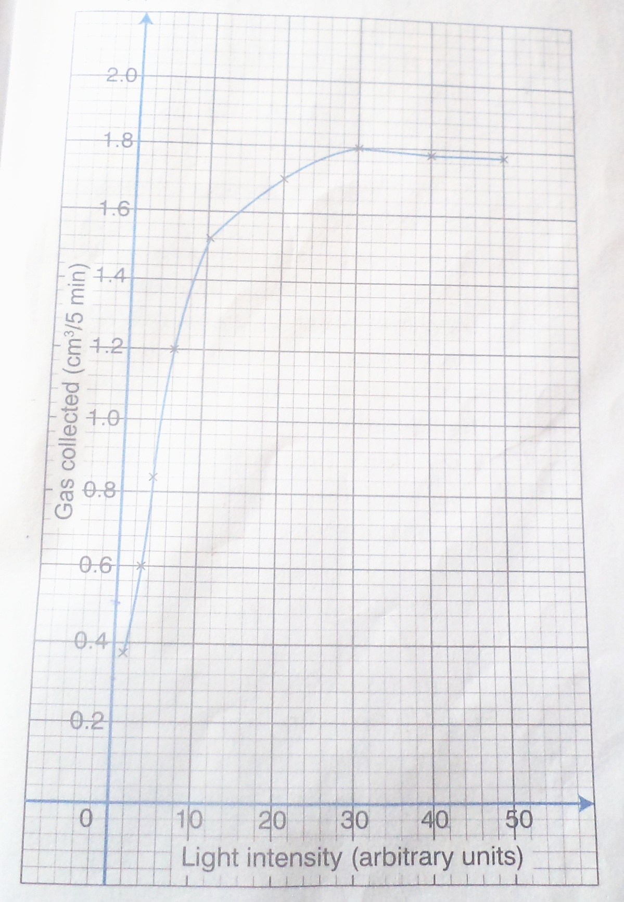

(b) (i) The rate of gas production increases due to the increase in light intensity. The light provided energy for photosynthesis which released the gas.

(ii) The rate of photosynthesis levels off / become constant. The optimum light intensity has been attained, so the gas production becomes constant due to other limiting factors.

Sunlight
(c) Carbon (iv) Oxide + water glucose + oxygen
Chlorophyll

(d) ATP, hydrogen atoms, oxygen.

(e) Light energy split the water molecules to oxygen and atoms / photolysis.

(f) - Availability of water
- Carbon (iv) oxide
- Presence of chlorophyll
- Temperature

7. a)
- Some bacteria causes disease in human beings such as vibrio used chlorine that causes cholera
- Bacteria are used to treat sewage.
- Bacteria cause dead plant and animals to decay this this realizing nutrients for us by plants.
- Bacteria cause food spoilage.
- Nitrogen fixing bacteria convert nitrogen to into nitrate which improves soil fertility.
- They are used to process cheese and yoghurt.
- Bacteria are used to produce organic acids alcohol, biogas and insulin.
- Bacteria cause diseases in plants and livestock lowering production.
- Used in bacteria and preserving tea and tobacco.
- Preparation of silage. 5x2=10mks

(b)
- Some fungi such as penicillium are used to make antibiotics.
- Some such as mushrooms are used as food.
- Yeast is used in the brewing and bread baking industries.
- Fungi cause decomposition of dead plants and animals releasing nutrients into the soil.
- Some causes diseased such as ring worms and athlete’s foot in human beings.
- Dry rot fungi destroy timber.
- Some fungi such as bread mould cause food spoilage. 5x2= 10mks

8. Wind.
- Increases transportation.
- Modifies the temperature which affects transpiration and photosynthesis.
- Wind disperses fruits, seeds and spores.
- Wind is an agent of pollination.
- Strong winds’ break branches of trees and may uproot some trees.

Temperature.
- Temperatures affect enzymatic reaction.
- Influences the rate of photosynthesis and other biological reactions.
- Increase in temperature increases the rate of transpiration.

Light
- Green plants need light for photosynthesis.
- Some green plants need light for flowering or photoperiodism.
- Some seeds require light for germinating.
- Light effect opening and closing of stomata which affect transpiration, gaseous exchange and photosynthesis.

Humidity
- When humidity is low, the rate of transpiration increases due to less amount of water vapour in the atmosphere. When humidity is high, the atmosphere becomes saturated with water vapour, reducing the rate of transpiration.
PH
Each plant requires a specific P^{H} to grow well; acidic, alkaline or neutral.

Salinity
- Plants with salt – tolerant tissues, such as mangroves, grow in saline areas.
- Plants in estuaries adjust to salt fluctuations.

Water / Rainfall
- Water is necessary for germination.
- Water is a raw material for photosynthesis.
- Solvent and dissolves mineral salts for absorption and transport.
- Transport medium for manufactured food.
- Agent of fruit and seed dispersal.
- Water is needed for turgidity of cells to give support to herbaceous plants.

Atmospheric pressure
- Variation in atmospheric pressure affects the amount of oxygen available for respiration and of carbon (IV) oxide for photosynthesis.
- These two gases affect the distribution of organism.
- Decreased atmospheric pressure increases the rate of transpiration.

Topography
- The windward side of a hill receives enough rainfall and plants grow well.
- The leeward side receives less rainfall and there is stunted plant growth.
- Water drains readily from steep slopes which dry more quickly than flat.

