NAME ………………………………………………ADM. NO ………………CLASS:……….

DATE……………..
231/3
BIOLOGY
PAPER 3
PRACTICAL
MARCH/APRIL
TIME: 1³/₄HRS

MWAKICAN FORM 4 JOINT EXAMINATION - 2016

KENYA CERTIFICATE OF SECONDARY EDUCATION

Instruction to Candidates
- Write your Name, Adm. No., Class and Date in the spaces provided
- Answer all the questions in section A in the spaces provided.
- You are required to spend the first 15 minutes of the 1³/₄Hrs around for this paper reading the whole paper carefully before commencing your work
- The paper consists of six printed pages.

QUESTION | MAXIMUM SCORE | CANDIDATE’S SCORE
1  2  3 | 15  14  11
TOTAL SCORE | 40

- You are provided with a specimen labelled Q and hydrogen peroxide.
- What part of the plant is specimen Q? (1mk)

- Cut two equal cubes whose sides are about 1cm from specimen Q. place one of the cubes into a boiling tube labelled A. Crush the other cube using pestle and mortar. Place the crushed material in another boiling tube labelled B. To each boiling tube add 4ml of hydrogen peroxide.
- Record your observations (2mks)
Test tube A:…………………………………………………………………….

Test tube B:…………………………………………………………………….

- Account for the results in b)(i) above (2mks)

- Write an equation for the break down of hydrogen peroxide (1mk)

- Peel half of specimen Q and crush in a mortar. Use the reagent provided to test for the various food substances in the extract obtained from the crushed material. Record the procedure, observation and conclusion in the table below (9mks)
Food Substance | Procedure | Observation | Conclusion

- The photograph below represents the lower and upper jaw of a mammal. Study it and answer the questions that follow.
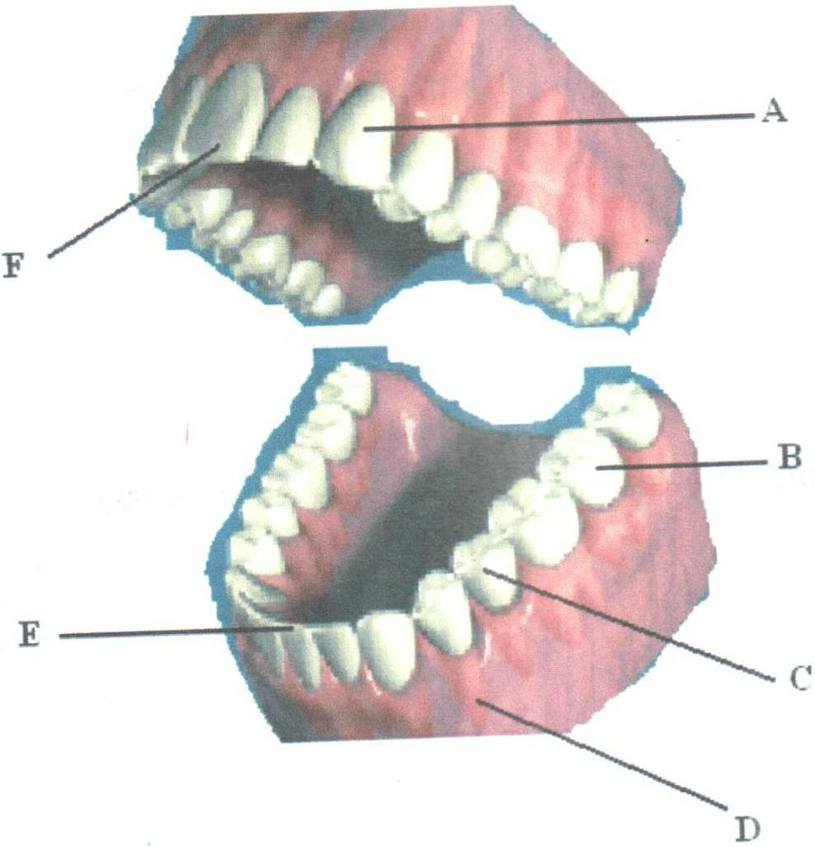

- Name the parts labelled (5mks)
A –
B –
C –
D –
F –
- Name one observable structural difference between B and C (1mk)

- i) Draw and label the external structure of part labelled B (3mks)

- i) Define the term “dental formula” (1mk)

ii) Write the dental formula from the diagram above (1mk)

- Suggest the mode of feeding in the above animal (1mk)

- Name one common disease that affect part labelled D (1mk)

- What class of food is digested in the cavity shown in the diagram? (1mk)

- You are provided with the photographs below labelled A, B, C, D, E, F, G and a dichotomous key. Use them to answer questions that follow.
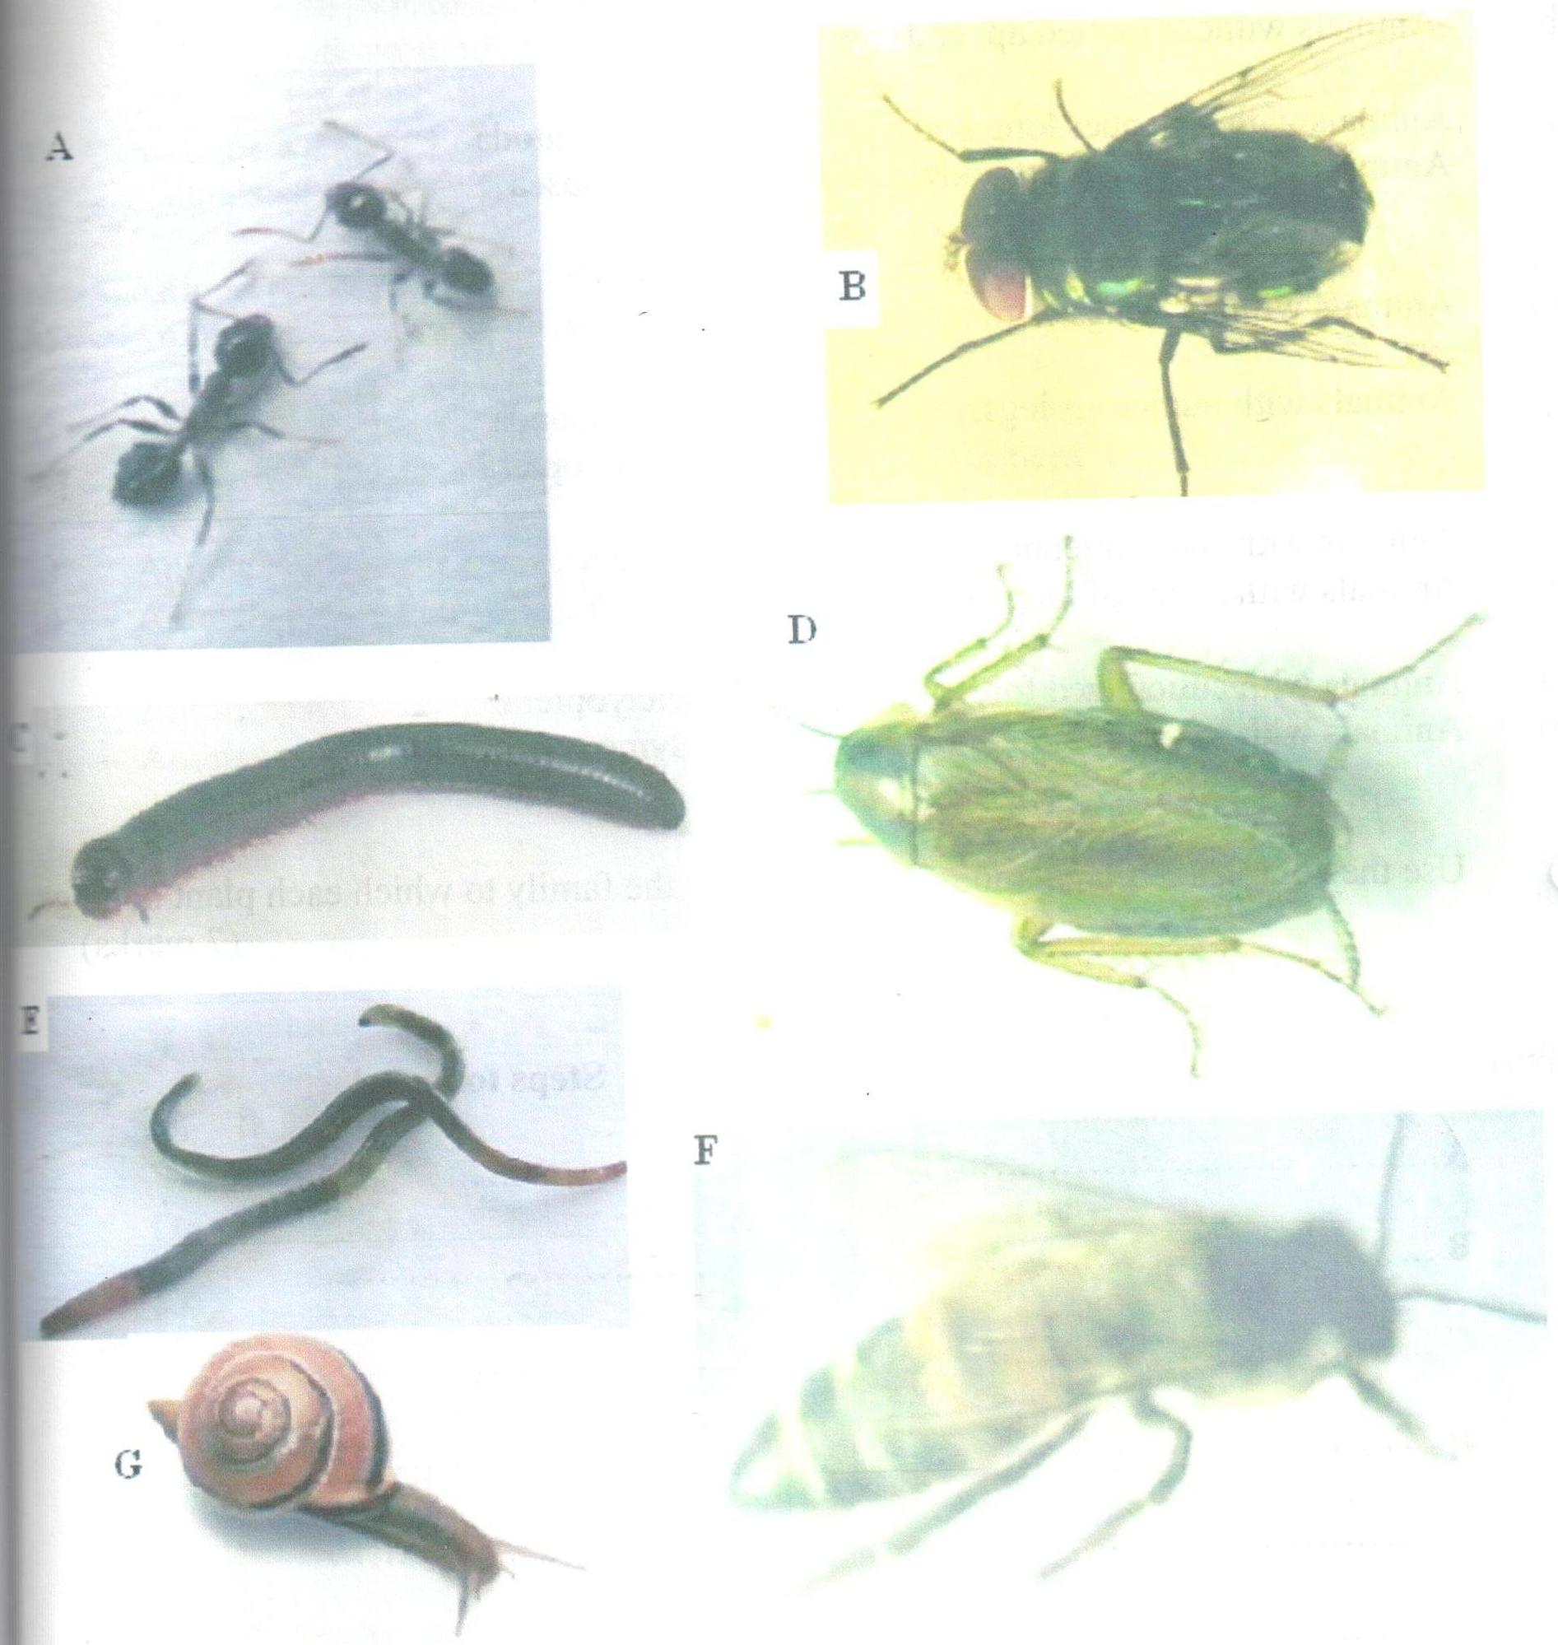

- Fill the missing information in the dichotomous key below (2mks)

1 (a) Animals with jointed appendages ……………………go to 3
(b) Animals without jointed appendages ………………...go to 2

2 (a) Animals with a slender long body ……………………Nematoda
(b) Animals with a thick short body ……………………..Mollusca

3 (a) ………………………………………………………..go to 5
(b) Animals without wings ………………………………go to 4
4 (a) Animals with numerous legs ……………………….Myrioponda
(b) ………………………………………………………Hymenoptera

5 (a) Animals with short antenna …………………………Diptera
(b) Animals with a pair of long antenna ………………..go to 6

6 (a) Animals with cuticulized fore wings ………………..Dictyoptera
(b) Animals with a pair of membranous wings………….Hymenoptera

- Use the completed dichotomous key to identify the family to which each plant belongs (7mks)
Identity Steps followed

A ……………………………... …………………………………………..
B ……………………………... …………………………………………..
C ……………………………… …………………………………………..
D ……………………………… …………………………………………..
E ……………………………… …………………………………………..
F ……………………………… …………………………………………..
G ……………………………… …………………………………………..

- Name two features that are used to classify B as phylum arthropoda.(2mks)

