MOKASA 2 EVALUATION EXAMINATION
231/1 - BIOLOGY - Paper 1
July- 2019 - 2 Hours
Name: ……………….…………………..………………………… Adm. No: …………….……………
Index No.……………..……. Signature ………..………………………. Date …………………….

INSTRUCTION TO CANDIDATES
- Write your name and admission number in the spaces provided above.
- Sign and write the date of the examination in the spaces provided.
- Answer ALL the questions in this question paper.
- Answers must be written in the spaces provided
- This paper consists of 10 printed pages.
- Candidates should check the question paper to ascertain that all the pages are printed as indicated and that no questions are missing.
- Candidates should answer all the questions in English.

FOR EXAMINER’S USE ONLY.
QUESTION NUMBER | Maximum Score | Candidate’s Score
1-23 | 80

- State the importance of biology in the following areas. (3marks)
- Agriculture.
................................................................................................................................................................
................................................................................................................................................................
- Environment
................................................................................................................................................................
................................................................................................................................................................
- Food technology
................................................................................................................................................................
................................................................................................................................................................
- The figures below represent two phases of actively dividing cell.
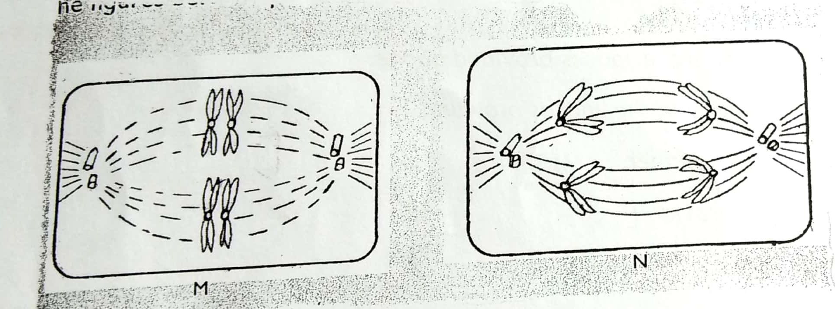

- Name the phases marked M and N. (2marks)
M …………………………………………………………………………………
N ……………………………………..………………………………………….
- Identify the type of cell division. (1mark)
………………………………………………………………………………….
- The Scientific name of confused beetle is TRIBOLIUM CONFUSAM. Identify any three mistakes made in writing the name. (3marks)
................................................................................................................................................................
................................................................................................................................................................

- Study the food web below and answer the questions that follow.

Water scorpion Trout fish

Tadpole May fly Caddisfly larva
larva

Algae
Detritus
(Simple Plant)

- Write down a food chain whose all consumers are Arthropods. (1mark)
……………………………………………………………………………………………………………………………………………………………..
- What would be the short term effects on the habitat if all trout fish were eliminated?
(2marks)
................................................................................................................................................................
................................................................................................................................................................
- a) State two ways in which energy flow in an ecosystem can be expressed. (2marks)
................................................................................................................................................................
................................................................................................................................................................
b) What is the role of decomposers in an ecosystem? (2marks)
................................................................................................................................................................
................................................................................................................................................................

- What is the role of the following parts of the ear.
i) Eustachian tube. (1 mark)
................................................................................................................................................................
................................................................................................................................................................
ii) Tympanic membrane. (1 mark)
................................................................................................................................................................
................................................................................................................................................................
- An experiment to investigate a certain response by termites, was set up as shown below. The set up was exposed to the sun for some time.
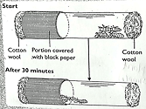
- What were the results at the end of the experiment? (1 mark)
................................................................................................................................................................
................................................................................................................................................................
- Name the type of response exhibited by the termites. (1 mark)
................................................................................................................................................................
- Give one survival value of the response. (1 mark)
................................................................................................................................................................
- State two unique physical characteristics of skeletal muscles. (2marks)
................................................................................................................................................................
................................................................................................................................................................
- Name two plant tissues that are thickened with lignin. (2marks)
…………………………………………………………………………..
…………………………………………………………………………..
- Study the diagram below and answer the questions that follow.
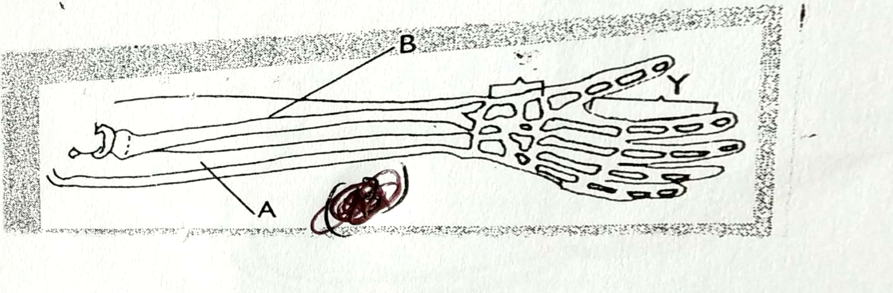

- Identify the bones labelled A and B. (2marks)
A ……………………………………………………………………..
B ……………………………………………………………………..
- Name the joint found in the region labelled Y. (1mark)
………………………………………………………………………..
- A student peeled off a piece of epidermis from an onion leaf and observed it under a microscope. He counted 10 cells across the diameter of the field of view. He then placed a transparent ruler across the field of view and observed the following.

Calculate the size of one cell in µm. show your working. (2marks)

- Study the diagram below and answer the questions that follow.
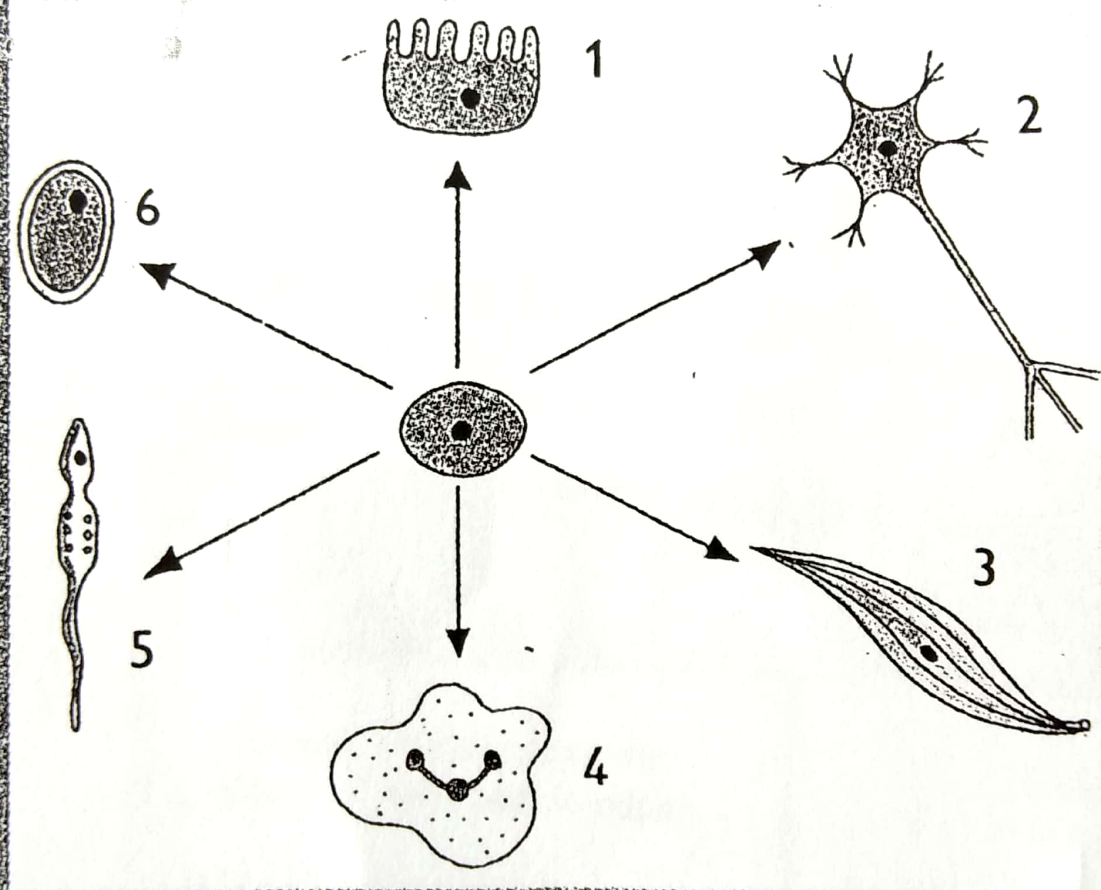

- Name the process represented by the arrows. (1mark)
……………………………………………………………………….
- Name the cell labelled 2. (1 mark)
…………………………………………………………………
- Name the tissue formed by each of the following cells. (2marks)
i) 1 ………………………………………………………………..
ii) 3 ………………………………………………………………
- a) Define the term wilting. (1mark)
………………………………………………………………………………………………………………………………………………………………
………………………………………………………………………………………………………………………………………………………………

b) When does wilting occur? (1 mark)
………………………………………………………………………………………………………………………………………………………………
……………………………………………………………………………………………………………………………………………………………..
c) Explain how a wilted seedling acquires an upright posture after irrigation. (3marks)
…………………………………………………………………………………………………………………………………………………………….
……………………………………………………………………………………………………………………………………………………………
…………………………………………………………………………………………………………………………………………………………..

- The diagram below shows blood circulation in a bony fish. Use it to answer the questions that follow.
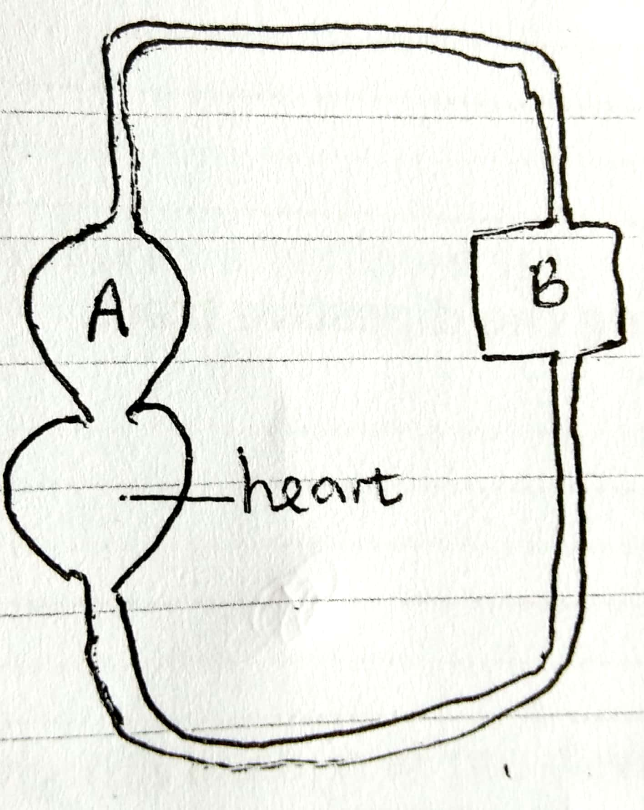

Name the structures labelled A and B. (2marks)
A ……………………………………………………………………..
B ……………………………………………………………………..
- Give three reasons why animals have specialised excretory organs. (3marks)
…………………………………………………………………………………………………………………………………………………………….
…………………………………………………………………………………………………………………………………………………………….
……………………………………………………………………………………………………………………………………………………………
…………………………………………………………………………………………………………………………………………………………..
- a) In relation to transport in animals, give a reason why carbohydrates are the best source of
energy. (1 mark)
…………………………………………………………………………………………………………………………………………………………….
b) Give reasons for the following
i) Veins have thin and less muscular walls. (1mark)
…………………………………………………………………………………………………………………………………………………………..
…………………………………………………………………………………………………………………………………………………………..
ii) Arteries lack valves. (1 mark)
…………………………………………………………………………………………………………………………………………………………..
…………………………………………………………………………………………………………………………………………………………..

c) Explain why an amoeba does not need an elaborate transport system. (2marks)
…………………………………………………………………………………………………………………………………………………………….
……………………………………………………………………………………………………………………………………………………………
…………………………………………………………………………………………………………………………………………………………..
- State two types of mechanical digestion along the digestive tract. (2marks)
…………………………………………………………………………………………………………………………………………………………….
……………………………………………………………………………………………………………………………………………………………
…………………………………………………………………………………………………………………………………………………………..

- Name two organisms that exhibit symbiotic relationship and explain how each benefits from the association. (2marks)

…………………………………………………………………………………………………………………………………………………………….
……………………………………………………………………………………………………………………………………………………………
- a) Name two gaseous exchange structures in plants. (2marks)
………………………………………………………………………………
……………………………………………………………………………..
b) How are pneumatophores adapted to their function? (2marks)
…………………………………………………………………………………………………………………………………………………………….
…………………………………………………………………………………………………………………………………………………………….
……………………………………………………………………………………………………………………………………………………………
…………………………………………………………………………………………………………………………………………………………..
- State the effects of the contraction of diaphragm muscles during inhalation in mammals. (3 marks)
…………………………………………………………………………………………………………………………………………………………….
…………………………………………………………………………………………………………………………………………………………….
……………………………………………………………………………………………………………………………………………………………
…………………………………………………………………………………………………………………………………………………………..
- What is the role of blood clotting in homeostasis. (3marks)
…………………………………………………………………………………………………………………………………………………………….
……………………………………………………………………………………………………………………………………………………………
…………………………………………………………………………………………………………………………………………………………..

- Explain why lactic acid level reduces after exercise. (2marks)
…………………………………………………………………………………………………………………………………………………………….
……………………………………………………………………………………………………………………………………………………………
…………………………………………………………………………………………………………………………………………………………..
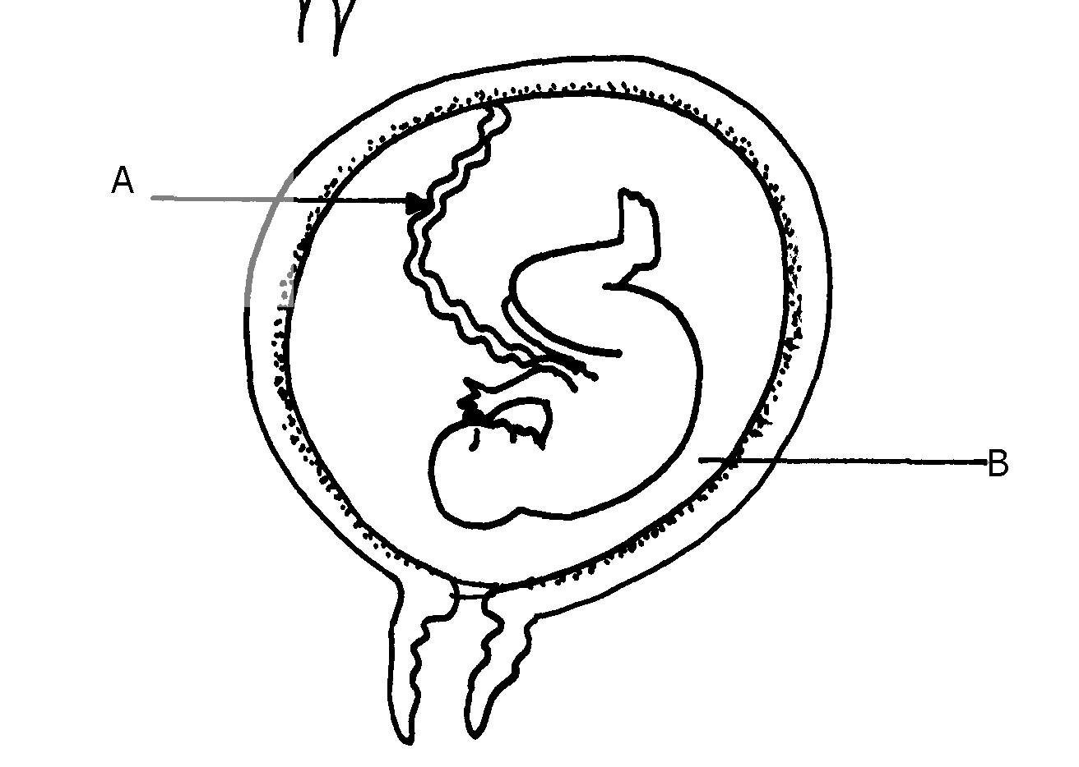23. The diagram below represents a stage in the development of human foetus

(a) State one function of each of the structures labelled A and B. (2marks)
A …………………………………………………………………………………………………………………….……………………..
B ………………………………………………………………………………………………………………………………………………
(b) Apart from the size of the foetus what else from the diagram illustrates that parturition was about
to occur. (1mark)
………………………………………………………………………………………………………………………………………………………………..
24. a) Give two examples of adaptive radiation in animals. (2marks)
…………………………………………………………………………………………..
……………………………………………………………………………………………
b) State two disadvantages of using fossils as evidence of evolution (2marks)
………………………………………………………………………………………………………………………………………………………………
…………………………………………………………………………………………………………………………………………….………………..

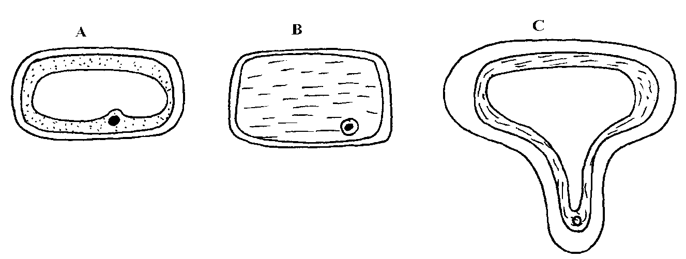
25. The cells shown below were obtained from different parts of a young root tip:

Give the name of the zone from which each cell was obtained A, B and C . (3marks)
A ………………………………………………………………………..…………………………………………………….
B ………………………………………………………………………………………………………………………………
C ……………………………………………………………………………………………………………………………….
26. A pure Red flowered plant was crossed with a pure white flowered plant. All the F₁ generation plants had pink flowers.
(a) Give an explanation for the absence of Red and white flowered plants in the F₁ generation. (1mk)
…………………………………………………………………………………………………………………………………………………………………………
…………………………………………………………………………………………………………………………………………………………………………
…………………………………………………………………………………………………………………………………………………………………………
(b) If the F₁ generation pea plants were selfed, work out the phenotypic ratio of the F₂ generation plants. (4marks)

