KOIMBI BOYS SECONDARY SCHOOL
END-TERM 2 EXAMS 2019
FORM 4 BIOLOGY
NAME………………………………………………………………………ADMNO…………… CLASS ……………
231/1
BIOLOGY
PAPER 1
FORM 4
2 HRS
INSTRUCTIONS TO CANDIDATES
1. Write your Nameand Admission number in the spaces provided above
2. Sign and write the date of examination in the spaces provided above.
3. Answer ALL the Questions in this paper in the spaces provided

- Name the organelle that:
- Forms secretory vesicles (1mk)

…………………………………………………………………………………………………………………………………..
- Control passage of substance in and out of nucleus (1mk)

…………………………………………………………………………………………………………………………………..
- Provide site for protein synthesis (1mk)

…………………………………………………………………………………………………………………………………
- Give two reasons why higher animals need an internal transport system (2mks)

……………………………………………………………………………………………………………………………………………………

……………………………………………………………………………………………………………………………………………………
- In what ways are gill filaments of fish adapted to their functions (3mks)

……………………………………………………………………………………………………………………………………………………

……………………………………………………………………………………………………………………………………………………

……………………………………………………………………………………………………………………………………………………

……………………………………………………………………………………………………………………………………………………
- Explain what happens to excess glucose in the body (3mks)

……………………………………………………………………………………………………………………………………………………

……………………………………………………………………………………………………………………………………………………

……………………………………………………………………………………………………………………………………………………

……………………………………………………………………………………………………………………………………………………

………………………………………………………………………………………………………………………………………………….

- a. Name the hard outer covering of members of phylum Arthropoda(1mk)

…………………………………………………………………………………………………………………………………………
b. State two roles played by the structure named in (a) above (2mks)

……………………………………………………………………………………………………………………………………………………

……………………………………………………………………………………………………………………………………………………

…………………………………………………………………………………………………………………………………………………..
c. State one other characteristics of the phylum Arthropoda (1mk)

…………………………………………………………………………………………………………………………………………
- Explain the role of water in photosynthesis (2mks)

……………………………………………………………………………………………………………………………………………………
…………………………………………………………………………………………………………………………………………………..
- Study the reaction below and answer the questions that follows:
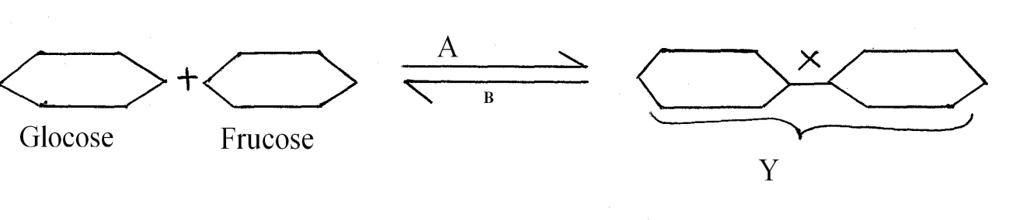
- State biological process that takes place represented by A (1mk)

…………………………………………………………………………………………………………………………………
- What biological process is represented by B (1mk)

…………………………………………………………………………………………………………………………………
- State the product Y (1mk)

…………………………………………………………………………………………………………………………………
- Explain how the following factors control population. (3mks)
- Predation

………………………………………………………………………………………………………………………………………………

………………………………………………………………………………………………………………………………………………
- Competition

………………………………………………………………………………………………………………………………………………
- Parasitism

…………………………………………………………………………………………………………………………………………
- a. What is the role of oxygen in active transport (1mk)

……………………………………………………………………………………………………………………………………………………
b. Name two processes that depend on active transport in animals (2mks)

……………………………………………………………………………………………………………………………………………………

……………………………………………………………………………………………………………………………………………………

……………………………………………………………………………………………………………………………………………………

……………………………………………………………………………………………………………………………………………………

- Study the diagram below and answer the question that follows:
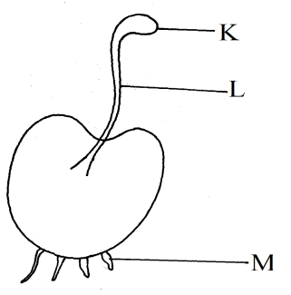
a. State the division the organisms belongs (1mk)
………………………………………………………………………………………………………………………………………………
b. Name the part labeled K and L (2mks)
K…………………………………………………………………………………………………………………………………
L…………………………………………………………………………………………………………………………………
- What is the function of part labeled M (1mk)

………………………………………………………………………………………………………………………………………………
- State two ways in which chloroplasts is adapted for photosynthesis (2mks)

……………………………………………………………………………………………………………………………………………………

……………………………………………………………………………………………………………………………………………………

……………………………………………………………………………………………………………………………………………………
- Below is a diagram of a plant tissue:

- Identify the tissue (1mk)

…………………………………………………………………………………………………………………………………..
- Name the structures labeled L and Q and the cell labeled K (3mks)

L……………………………………………………………………………………………………………………………..

Q……………………………………………………………………………………………………………………………

K………………………………………………………………………………………………………………………………..
- List the adaptation that make man the dominant species on earth (3mks)

……………………………………………………………………………………………………………………………………………………

……………………………………………………………………………………………………………………………………………………

……………………………………………………………………………………………………………………………………………………

- The diagram below shows a bean plant seedling pinned in a horizontal position inside a clinostat

- Explain what you would expect to observe after 48 hours is clinostat was not rotating (3mks)

………………………………………………………………………………………………………………………………………………

………………………………………………………………………………………………………………………………………………

………………………………………………………………………………………………………………………………………………

………………………………………………………………………………………………………………………………………………

…………………………………………………………………………………………………………………………………………….
- Explain what you would expect to observe after48 hours if the clinostat was rotating slowly (2mks)

………………………………………………………………………………………………………………………………………………

………………………………………………………………………………………………………………………………………………

…………………………………………………………………………………………………………………………………………......
- The following is a dental formula of a certain group of mammals
I3,c1, pm 4, m 2
3 1 4 3
- Work out the number of teeth present in the mammals (1mk)

…………………………………………………………………………………………………………………………………………

………………………………………………………………………………………………………………………………………..
- State the likely mode of feeding for the group of mammals (1mk)

…………………………………………………………………………………………………………………………………………

…………………………………………………………………………………………………………………………………………

…………………………………………………………………………………………………………………………………………
- Give a reason for your answer in (b) above (1mk)

…………………………………………………………………………………………………………………………………………

…………………………………………………………………………………………………………………………………………
- Oil can be applied on stagnant water to control the spread of malaria
a) How does this practice control spread of malaria? (1mk)

……………………………………………………………………………………………………………………………………………………

…………………………………………………………………………………………………………………………………………………….
b) Give reason why this practice should be discourage (1mk)

……………………………………………………………………………………………………………………………………………………

……………………………………………………………………………………………………………………………………………………

……………………………………………………………………………………………………………………………………………………
17 . Explain why after four months of pregnancy the ovaries can be removed without terminating
the pregnancy (2mks)
………………………………………………………………………………………………………………………………………………………………………………

………………………………………………………………………………………………………………………………………………………………………………

………………………………………………………………………………………………………………………………………………………………………………

………………………………………………………………………………………………………………………………………………………………………………

18. State the changes that occur in elector pill muscles in human skin on cold days(2mrk)
………………………………………………………………………………………………………………………………………………………………

………………………………………………………………………………………………………………………………………………………………

………………………………………………………………………………………………………………………………………………………………
19 .The equation below represents a process that occurs in animals
C₆H₁₂O₆ 2C₂H₆0₃+ 150 KJ
(glucose) Lactic acid Energy
a) Name the process (1mk)

……………………………………………………………………………………………………………………………………………………
b) State the effect of accumulation of lactic acid in the body (1mk)

……………………………………………………………………………………………………………………………………………………

…………………………………………………………………………………………………………………………………………………..

c) If the process shown above was occurring in plants, name the end products that would be produced (1mk)

……………………………………………………………………………………………………………………………………………………

……………………………………………………………………………………………………………………………………………………
20. Explain how red blood cell transports carbon (IV) oxide (2mks)
………………………………………………………………………………………………………………………………………………………………
………………………………………………………………………………………………………………………………………………………………
………………………………………………………………………………………………………………………………………………………………
……………………………………………………………………………………………………………………………………………………………

21. Study the graph below and answer the questions that follow

a) What is the give to describe the point M(1mk)
………………………………………………………………………………………………………………………………………………………………………………
……………………………………………………………………………………………………………………………………………………………………………..
b) State the importance of the part M(1mk)
………………………………………………………………………………………………………………………………………………………………………………
c) Name the type of curve illustrated by the above graph (1mk)
………………………………………………………………………………………………………………………………………………………………………………
22. State two features in flowering plant that hinders self pollination and self-fertilisation (2mks)
………………………………………………………………………………………………………………………………………………………………………………
………………………………………………………………………………………………………………………………………………………………………………
………………………………………………………………………………………………………………………………………………………………………………
…………………………………………………………………………………………………………………………………………………………………………

23 a) state two processes which occurs during anaphase of mitosis (2mks)
………………………………………………………………………………………………………………………………………………………………………………
………………………………………………………………………………………………………………………………………………………………………………
………………………………………………………………………………………………………………………………………………………………………………
b) What is the significance of meiosis (2mk)
………………………………………………………………………………………………………………………………………………………………………………
………………………………………………………………………………………………………………………………………………………………………………
………………………………………………………………………………………………………………………………………………………………………………
24 what is meant by the following terms as used in genetics (2mks)
I)Hybridvigour………………………………………………………………………………………………………………………………………………………
………………………………………………………………………………………………………………………………………………………………………………
II) Polyploidy………………………………………………………………………………………………………………………………………………………………………………
………………………………………………………………………………………………………………………………………………………………………………
25 An experiment was carried out to investigate the response of white termite to certain stimulus. Ten termites were placed out at the centre of glass tubing. Calcium chloride was placed at one end of the tubing and moist cotton wool at the other end as illustrated below

I) what observations were made after 20 minutes (1mk)
………………………………………………………………………………………………………………………………………………………………………………
II) What type of response was exhibited by the terminates (1mk)
………………………………………………………………………………………………………………………………………………………………………………
II) What is the survival valve of the above response (1mk)
………………………………………………………………………………………………………………………………………………………………………………
26 The table below is representations of chromosomal mutation
Before mutation | L | M | N | O | P | Q
After mutation | L | O | N | M | P | Q

I) Name the type of chromosomal mutation represented (1 mk)
……………………………………………………………………………………………………………………………………………………………………………
II) Name one inheritance condition in men that is caused by mutation (1mk)
………………………………………………………………………………………………………………………………………………………………………………
………………………………………………………………………………………………………………………………………………………………………………
………………………………………………………………………………………………………………………………………………………………………………
………………………………………………………………………………………………………………………………………………………………………………
27 below is a diagram of a mammalian bone. Examine it and answer the question that follows.
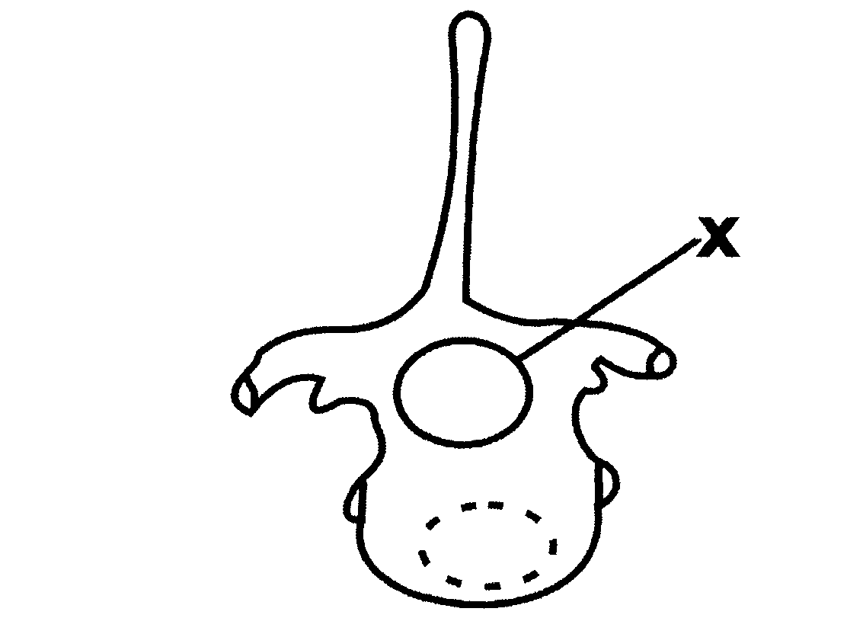
a) Giving two reasons, identify the bone(3mrks)
Identify
………………………………………………………………………………………………………………………………………………………………………
Reasons
………………………………………………………………………………………………………………………………………………………………………………
………………………………………………………………………………………………………………………………………………………………………………
b) Name the part labeled F on the bone above (1mks)
F…………………………………………………………………………………………………………………………………………………………………………..
28 Give two reasons why support is necessary in plants (2mks)
………………………………………………………………………………………………………………………………………………………………………………
………………………………………………………………………………………………………………………………………………………………………………
………………………………………………………………………………………………………………………………………………………………………………
……………………………………………………………………………………………………………………………………………………………………………..

