Kenya Certificate of Secondary Education 2019
SG Education Consultancy

231/ 1 Biology- Paper 1(Theory)
ENDTERM 1 -Time :2 hours

Name …………………………………………….……… Index Number…………………………..

Signature ………………….…...……….. Date …………………………………………………..

INSTRUCTIONS TO CANDIDATES
- Write your name and class in the spaces provided above.
- Append your signature and write the date of examination in the spaces provided above.

- Spelling errors especially of biological terms shall be penalized
- Answer ALL questions in the spaces provided.
- Candidates should answer the questions in English
- This paper consists of 9 printed pages.Candidates should check the question paper to ascertain that all the pages are printed as indicated and no questions are missing
For Examiner’s Use Only
Question | Maximum score | Candidate’s score
1 – 30 | 80

Turn over

1. Explain the importance of the following life processes
- Respiration (1mark)
………………………………………………………………………………………………………………………………………………………………………………………………………………………………………………

- Reproduction (1mark)
………………………………………………………………………………………………………………………………………………………………………………………………………………………………………………

2. a) Define binomial nomenclature (1 mark)
………………………………………………………………………………………………………………………………………………………………………………………………………………………………………………
(b) State four reasons why classification is important in biology (4 marks)
………………………………………………………………………………………………………………………………………………………………………………………………………………………………………………
………………………………………………………………………………………………………………………………………………………………………………………………………………………………………………
………………………………………………………………………………………………………………………………………………………………………………………………………………………………………………

3. (In an experiment a biology teacher set up the materials indicated below:

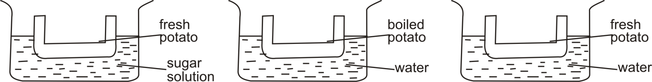

If the experimental set up was left overnight, explain the appearance of the potato tissue in:
A (1mark)
………………………………………………………………………………………………………………………………………………………………………………………………………………………………………………
B (1mark)
………………………………………………………………………………………………………………………………………………………………………………………………………………………………………………
C (1mark)
………………………………………………………………………………………………………………………………………………………………………………………………………………………………………………

4. Name structures used for gaseous exchange in higher plants (2marks)

………………………………………………………………………………………………………………………………………………………………………………………………………………………………………………
………………………………………………………………………………………………………………………………………………………………………………………………………………………………………………

5. State four adaptations of the Red blood cell to its function. (4 marks)
………………………………………………………………………………………………………………………………………………………………………………………………………………………………………………
………………………………………………………………………………………………………………………………………………………………………………………………………………………………………………

6. (a) State the importance of pleural fluid in the lung of a mammal. (2marks)
………………………………………………………………………………………………………………………………………………………………………………………………………………………………………………

(b) State two function that cilia of the trachea play during gaseous exchange in a mammal? (2 mark)
………………………………………………………………………………………………………………………………………………………………………………………………………………………………………………

(c) What significance does mucus offer a mammal during gaseous exchange? (1 mark)
………………………………………………………………………………………………………………………………………………………………………………………………………………………………………………

- State the role of each of the following components of the skin. (2 marks)
Sebum
………………………………………………………………………………………………………………Melanini
………………………………………………………………………………………………………………

- State three Biotic factors in an ecosystem. (3 marks)
………………………………………………………………………………………………………………………………………………………………………………………………………………………………………………………………………………………………………………………………………………

- The diagram below represents a male reproductive transverse section structure in plant

B

A

- Name structures A and B (2marks)
A
…………………………………………………………………………………………………………………B
…………………………………………………………………………………………………………………

- Name the type of cell division taking place in structure A (1 mark)
……………………………………………………………………………………………………………………………………………………………………………………………………………………………………
- State Two significance of the named type of cell division in (ii) above in Sexual Reproduction.
(2marks)
………………………………………………………………………………………………………………………………………………………………………………………………………………………………………………
- Give the full Name of the abbreviation. DNA (1 mark)
……………………………………………………………………………………………………………………………………………………………………………………………………………………………………
- An animal has the following dental formula:
I = ⁰/₂ C = ⁰/₀ PM = ³/₃ M = ²/₃
    - Suggest the type of diet for this animal. (1mark)
…………………………………………………

    - Give a reason for your answer in (a) above. (1mark)
…………………………………………………….
    - How many teeth does the animal have in total?
………………………………………
- The diagram below shows the transverse section of a young dicotyledonous root.

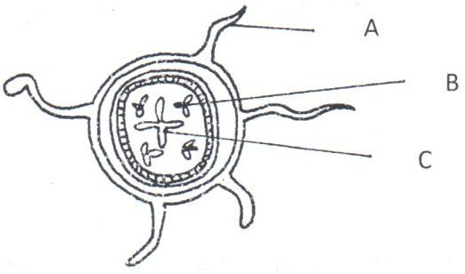

  - Name the parts labeled: A and B (2marks)
A
………………………………………………………………………………………………………………B
………………………………………………………………………………………………………………

  - What is the function of the structure labeled B. (1mark)
………………………………………………………………………………………………………………………………………………………………………………………………………………………………………………
- (a) State the function of glucagon hormone. (1mark)
………………………………………………………………………………………………………………………………………………………………………………………………………………………………

(b) Identify the gland responsible for its production. (1mark)
………………………………………………………………………………………………………………………………………………………………………………………………………………………………………………
- Differentiate between the following terms. (2marks)
    - Population and community:
………………………………………………………………………………………………………………………………………………………………………………………………………………………………
    - Parasite and predator:
………………………………………………………………………………………………………………………………………………………………………………………………………………………………………………
- The illustration below shows a part of the ovary of an angiosperm.
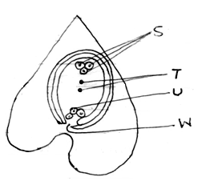

    - Identify the structure. (1mark)
………………………………………………………………………………………………………………………………………………………………………………………………………………………………
    - Name the parts labelled S, T, U and W. (2marks)
……………………………………………………………………………………………………………………………………………………………………………………………………………………………

- Name the causative agents of the following diseases in humans. (2marks)
Disease | Causative agent
Typhoid
Malaria

- The diagram below represents a bony fish.

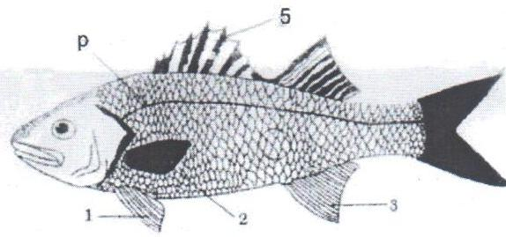
    - State two observable features that justify the inclusion of specimen above in class Pisces. (2marks)
………………………………………………………………………………………………………………………………………………………………………………………………………………………………………………
    - From the diagram, identify the fins which carry out the following functions:
(i) Balancing and braking. (1mark)
………………………………………………………………………………………………………………………………………………………………………………………………………………………………………………
- Give two functions of calcium in human body. (2marks)
………………………………………………………………………………………………………………………………………………………………………………………………………………………………

- (a) How do the etiolated plant differ from the normal plant? (2marks)
………………………………………………………………………………………………………………………………………………………………………………………………………………………………

(b) State the importance of etiolation in plants. (2marks)
………………………………………………………………………………………………………………………………………………………………………………………………………………………………………………

- a) The diagram below shows part of alimentary canal of a mammal.
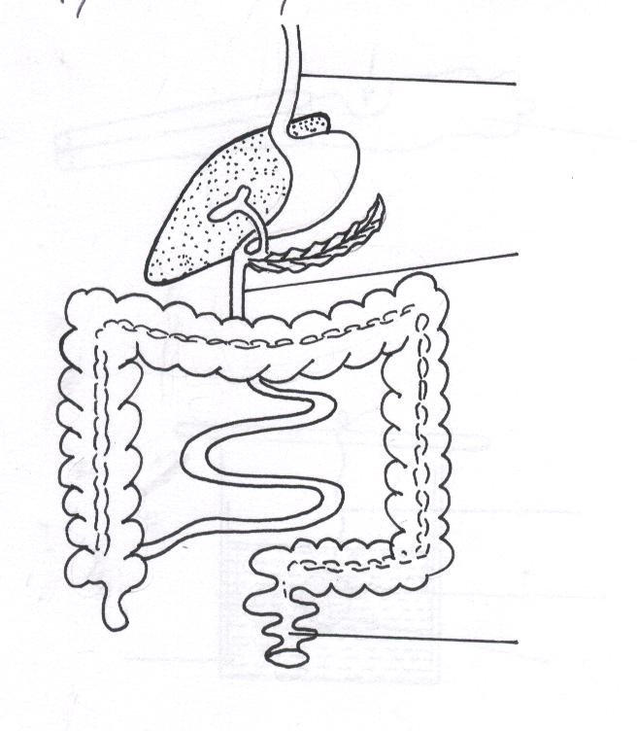
B
A
C

(i) Name the parts labeled.A and C. (2 marks)
A
………………………………………………………………………………………………………………………C
………………………………………………………………………………………………………………………

(ii) State the function of the part labeled B. (1 mark)
………………………………………………………………………………………………………………………………………………………………………………………………………………………………………………
b) Why is xylem tissue referred to as a mechanical tissue in plants (1mark)
………………………………………………………………………………………………………………………………………………………………………………………………………………………………………………
21. A patient was given a drug which caused afferent arteriole entering the glomerulus to dilate while efferent arteriole constricted. Explain the effect the drug had to the amount of urine produced. (3 marks
………………………………………………………………………………………………………………………………………………………………………………………………………………………………………………
………………………………………………………………………………………………………………………

22. a) What is homeostasis? (1mark)
………………………………………………………………………………………………………………………………………………………………………………………………………………………………………………
(b) Name three processes in the human body in which homeostasis is involved. (3marks)
………………………………………………………………………………………………………………………………………………………………………………………………………………………………………………
………………………………………………………………………………………………………………………………………………………………………………………………………………………………………………
23. Name the organelle that:-
a) Manufacture and transport lipids and steroids in a cell. (1mark)
………………………………………………………………………………………………………………………………………………………………………………………………………………………………………………
b) Contain enzymes that are capable of destroying old damaged cells. (1mark)
………………………………………………………………………………………………………………………………………………………………………………………………………………………………………………

c) Control all the processes in a cell. (1mark)
………………………………………………………………………………………………………………………………………………………………………………………………………………………………………………
d) Form cilia and flagella in cells that have them. (1mark)
………………………………………………………………………………………………………………………………………………………………………………………………………………………………………………
24. State the significance of sunken stomata in plants. (2marks)
………………………………………………………………………………………………………………………………………………………………………………………………………………………………………………
……………………………………………………………………………………………………………………………………………………………………………………………………………………………………………
25. . Highlight three importance of transpiration in plants. (3marks)
………………………………………………………………………………………………………………………………………………………………………………………………………………………………………………
………………………………………………………………………………………………………………………
26. Two students were observing bacteria using two slides that were duplicates of each other.
Student A saw 10 bacteria while student B saw 50 bacteria using identical microscopes.
(a) Suggest a reason why they observed different numbers of bacteria. (1mark)
………………………………………………………………………………………………………………………………………………………………………………………………………………………………………………
(b) Which of the following combination would give a higher total magnification? (1mark)
Eye piece × 10 Objective × 20
Eye piece × 10 Objective × 40
………………………………………………………………………………………………………………………………………………………………………………………………………………………………………………
27. The graph below show the growth curve of an organism.
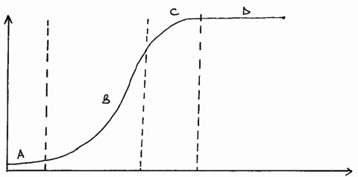
Growth parameter
Time

- Name the phase of growth labelled. Bnad D (2marks)
………………………………………………………………………………………………………………………………………………………………………………………………………………………………………………
(b) Account for the growth shown in phase A. (1mark)
………………………………………………………………………………………………………………………………………………………………………………………………………………………………………………

