END OF TERM 2 2019
FORM 4 BIOLOGY
231/2
NAME:………………………………………………ADM NO:…………………..CLASS:……………
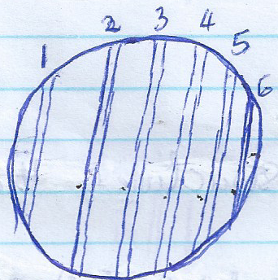
- The diagram below shows a microscope focused on a millimeter scale of a glass ruler

(i) How many millimeters fit in the microscope field of view? (1mk)
..............................................................................................................................................................................................................................................................................................
(ii) Work out the radius of the field of view in micrometers (2mks)
..............................................................................................................................................................................................................................................................................................
..............................................................................................................................................................................................................................................................................................
..............................................................................................................................................................................................................................................................................................
..............................................................................................................................................................................................................................................................................................
(iii) Work out the area of the field of view in millimeters squared. (2mks)
..............................................................................................................................................................................................................................................................................................
..............................................................................................................................................................................................................................................................................................
..............................................................................................................................................................................................................................................................................................
..............................................................................................................................................................................................................................................................................................

(iv) When onion epidermal cells well placed under the field of view, 10 cells were counted along the length of the field of view. Calculate the length of each epidermal cell (3mks)

..............................................................................................................................................................................................................................................................................................
..............................................................................................................................................................................................................................................................................................
..............................................................................................................................................................................................................................................................................................
..............................................................................................................................................................................................................................................................................................
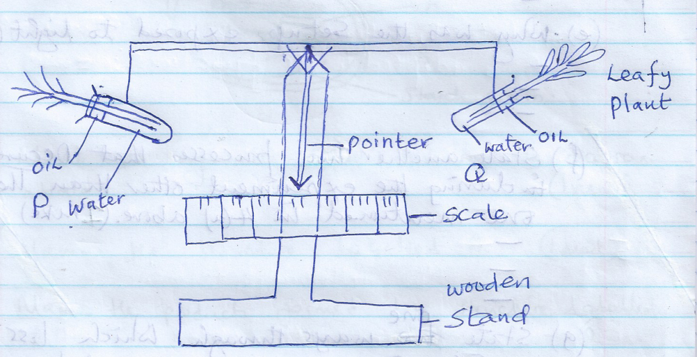
- The setup below was used by students to investigate a certain phenomenon in plants.
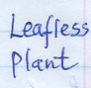

The setup was exposed to light for one hour.
(a) What was being investigated (1mk)
..............................................................................................................................................................................................................................................................................................
..............................................................................................................................................................................................................................................................................................

(b) What was the purpose of test tube p in the experiment? (1mk)
..............................................................................................................................................................................................................................................................................................
...............................................................................................................................................
(c) What was the role of the oil in the experiment? (1mk)
..............................................................................................................................................................................................................................................................................................
..............................................................................................................................................................................................................................................................................................
(d) State two changes that are likely to have occurred after one hour. (2mks)
..............................................................................................................................................................................................................................................................................................
..............................................................................................................................................................................................................................................................................................
(e) Why was the set up exposed to light (1mk)
..............................................................................................................................................................................................................................................................................................
...............................................................................................................................................

(f) State another process that occurred during the experiment other than the one mentioned in 4(a) above. (1mk)
..............................................................................................................................................................................................................................................................................................

(g) State one way through which loss of weight in test tube Q could be reduced/ minimized. (1mk)
..............................................................................................................................................................................................................................................................................................

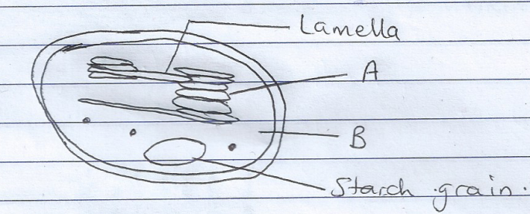
- The following diagram represents an organelle found in plant cells.

(a) Name the organelle represented by the diagram. (1mk)
..............................................................................................................................................................................................................................................................................................

(b) Name the structure labeled A (1mk)
..............................................................................................................................................................................................................................................................................................
(c) Name the products formed by structure labeled A (2mks)
..............................................................................................................................................................................................................................................................................................
..............................................................................................................................................................................................................................................................................................

(d) Name the substance labeled B (1mk)
..............................................................................................................................................................................................................................................................................................

(e) How is the structure represented in the diagram above adapted to its function? (3mks)
..............................................................................................................................................................................................................................................................................................
..............................................................................................................................................................................................................................................................................................
..............................................................................................................................................................................................................................................................................................

- The figure below show cell organelles. Observe them keenly
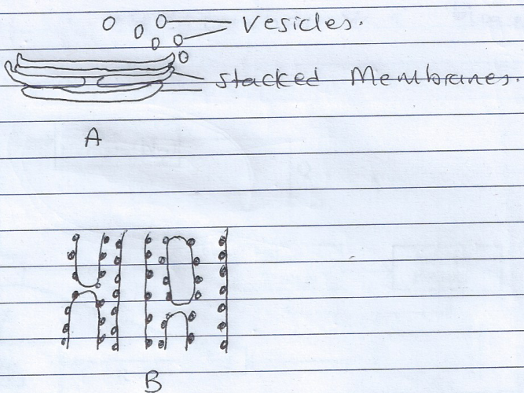

(a) Identify organelle A and B (2mks)
A:...........................................................................................................................................

B:............................................................................................................................................

(b) State two functions of organelle A (2mks)
..............................................................................................................................................................................................................................................................................................
..............................................................................................................................................................................................................................................................................................
(c) What is the function of organelle B (1mk)
..............................................................................................................................................................................................................................................................................................
..............................................................................................................................................................................................................................................................................................

(d) Why is organelle A usually close to organelle B? (1mk)
..............................................................................................................................................................................................................................................................................................
..............................................................................................................................................................................................................................................................................................

(e) Name the organelle that (2mks)
(i) Manufactures energy in the cell
..............................................................................................................................................................................................................................................................................................
...............................................................................................................................................

(ii) Controls all the cell activities
..............................................................................................................................................................................................................................................................................................
...............................................................................................................................................

- Below is a representation of a biogeochemical cycle.
Free Nitrogen (N₂)
P
Nitrates (NO₂)
Plant protein
Animal protein
B
T
Q
U

Z
R

(a) Name the above cycle. (1mk)
..............................................................................................................................................................................................................................................................................................
...............................................................................................................................................
(b) What is B and P (2mks)
B..................................................................................................................................................
P.................................................................................................................................................
(c) Name the micro-organisms labeled T and R. (2mks)
...........................................................................................................................................................................................................................................................................................................................................................................................................................................................
(d) Name process U and Z. (2mks)
U.................................................................................................................................................
Z..................................................................................................................................................
(e) Give specific name of free living bacteria. (1mk)
............................................................................................................................................................................................................................................................................................................................................................................................................................................................
- The table below shows how quantities of sweat and urine vary with external temperatures
External temperature (⁰c) | Urine cm³/h | Sweat cm³/h
0  5  10  15  20  25  30  35 | 100  90  80  70  60  50  40  30 | 5  6  10  20  30  60  120  200
(a) Using the same axes, draw a graph of quantity of urine and sweat against the external temperature. (7mks)

(b)
(i) State the quantity of urine and sweat produced when external temperature was 12.5⁰c. (2mks)
...........................................................................................................................................................................................................................................................................................................................................................................................................................................................
(ii) State the physical process through which the body was cooled by sweating as temperature was rising. (1mk)
...........................................................................................................................................................................................................................................................................................................................................................................................................................................................
(iii) Account for the quantity of urine produced as the temperature increased. (4mks)
....................................................................................................................................................................................................................................................................................................................................................................................................................................................................................................................................................................................................................................................................................................................................................................................................................................................................................................................................................................................................................................................................................................................................................................................................................................................................................................................................................................................
(c) State three nitrogenous wastes that could be eliminated in urine or sweat in human beings. (3mks)
............................................................................................................................................................................................................................................................................................................................................................................................................................................................................................................................................................................................................................................................................................................................................................................................................................................................................................................................................................................................................................................................................
(d) State three behavioral mechanism that poikilotherms use to regulate their body temperature under hot conditions. (3mks)
...........................................................................................................................................................................................................................................................................................................................................................................................................................................................
......................................................................................................................................................................................................................................................................................................................................................................................................................................................................................................................................................................................................................................................................................................................................................................................................................................................................................................................
- Describe how mammalian heart is adapted to its functions. (20 mks)
............................................................................................................................................................................................................................................................................................................................................................................................................................................................................................................................................................................................................................................................................................................................................................................................................................................................................................................................................................................................................................................................................................................................................................................................................................................................................................................................................................................................................................................................................................................................................................................................................................................................................................................................................................................................................................................
.................................................................................................................................................................................................................................................................................................................................................................................................................................................................................................................................................................................................................................................................................................................................................................................................................................................................................................................................................................................................................................................................................................................................................................................................................................................................................................................................................................................................................................................................................................................................................................................................................................................................................................................................................................................................................................................................................................................................................................................................................................................................................................................................................................................................................................................................................................................................................................................................................................................................................................................................................................................................................................................................................................................................................................
......................................................................................................................................................................................................................................................................................................................................................................................................................................................................................................................................................................................................................................................................................................................................................................................................................................................................................................................................................................................................................................................................................................................................................................................................................................................................................................................................................................................................................................................................................................................................................................................................................................................................................................................................................................................................................................................................................................................................................................................................................................................................................................................................................................................................................................................................................................

- (a) State four characteristics of respiratory surfaces. (4mks)
......................................................................................................................................................................................................................................................................................................................................................................................................................................................................................................................................................................................................................................................................................................................................................................................................................................................................................................................

(b) Describe the mechanisms of inhalation exhalation in mammals. (16mks)
............................................................................................................................................................................................................................................................................................................................................................................................................................................................................................................................................................................................................................................................................................................................................................................................................................................................................................................................................................................................................................................................................................................................................................................................................................................................................................................................................................................................................................................................................................................................................................................................................................................................................................................................................................................................................................................

