MARKING SCHEME

231/2 (THEORY)
SEPTEMBER EXAM
BIOLOGY PAPER 2
TIME: 2 HOURS

KASSU – JET EXAMINATIONS
BIOLOGY PAPER 2
2021

Instructions to candidates
- Write your name and index number in the spaces provided above
- Sign and write the date of examination in the spaces provided above
- This paper consists of two sections: A and B
- Answer all the questions in section A in the spaces provided
- In section B answer question 6 (compulsory) and either question 7 or 8 in the spaces provided after question 8
- This paper contains 8 printed pages
- Candidates should check the question paper to ascertain that all pages are printed as indicated and that no questions are missing
- Candidates should answer the questions in English

FOR EXAMINER’S USE ONLY
Section | Question | Max. score | Candidate’s score
A | 1 | 8
 | 2 | 8
 | 3 | 8
 | 4 | 8
 | 5 | 8
 | 6 | 20
 | 7 | 20
 | 8 | 20
Total score |  | 80
SECTION A (40 MARKS)
All all the questions in the spaces provided
- a) The inheritance of Duchene muscular dystrophy is sex-linked caused by a recessive gene located in the X chromosome. A marriage between normal parents Avital and Jorum resulted into a Dystrophic son Abednego and two normal daughters Rachael and Ariel. Their son Abednego had a normal daughter called Naomi while Ariel’s two sons, Aaron were dystrophy and Heron normal. Using letter D to denote the gene for normal ,draw a pedigree chart to represent the family indicating the probable genotypes of the parents and grandchildren ( 5marks)

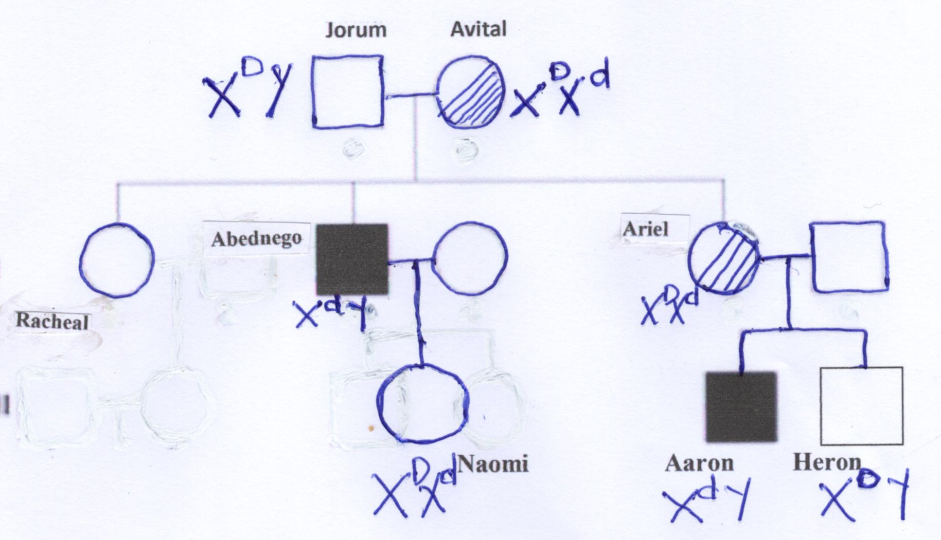

b) Suggest a reason why a pedigree chart is important in genetics (1 mark)
Geneticist can use it to trace the distribution of traits of related individuals

c) Drosophila melanogaster (fruit fly) is suitable for genetic study. Explain?
(2 marks)
Backcrossing can be done at will
Female lay many eggs resulting in large numbers of offsprings
They have numerous observable characteristics
Short generation time therefore studies can be done in a hort period
Easily bred in the laboratory

- The diagram below illustrates an experiment to determine the rate of respiration in a small insect
- Name the chemical compound labelled X and state its function (2marks)
Sodium hydroxide; absorbs carbon (IV) oxide
- Why is it necessary to place the flask in a water bath? (2marks)
To maintain a constant temperature reducing chances of contraction of air that may lead to erroneous observation
- What changes would you expect to observe in the level of coloured water in the capillary tube after the experiment has run for 5 minutes? (1mark)
The level of the coloured water in the capillary tube will rise

- Explain the changes you have stated in (c) above (2marks)
The grasshopper respired taking in oxygen and releasing carbon (IV) oxide which is absorbed by soda lime .uptake of oxygen caused a decrease in air pressure within the flask .These vacuum causes suction of the coloured water
- Explain how you can set up a control for the experiment? (1mark)
Use of a dead grasshopper

3. The figure below illustrates a process that takes place in the alimentary canal.
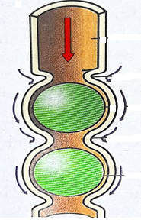
(a) Name the process. (1 mark)
Peristalsis;
(b) Name two muscles that enhance the above process. (1 mark)
Longitudinal and Circular muscles;
(c) Explain the importance of roughage to the above process. (1 mark)
Initiating the process of peristalsis;
Add to the bulk of food;
(d) State how the stomach protects its walls against digestion by enzyme pepsin. (2 marks)
Produces mucus
Production of enzymes in inactive form
(e) State any one function of HCl produced in the stomach during the digestion process. (1 mark)
Provide an acidic medium in which enzymes e.g pepsin work best;
- Kill some bacteria that may be present in food;
- Converts pepsinogen to pepsin;
-Unfolds proteins to be acted on by pepsin;
(f) Explain the reason why the digestion of starch stops shortly after food enters the stomach. (2 marks)
Hydrochloric acid in the stomach denatures salivary amylase, stopping its activity;
3. The table below shows the concentration of sodium and Iodine ions in pond water and in the cell sap of water lettuce plant
 | Sodium ion concentration | Iodine ion concentration
Pond water | 160 | 0.4
Cell sap | 70 | 500
- Giving reasons, name the process through which each of the ions is taken up by the plant
Sodium (2marks)
Diffusion; the sodium ions are highly concentrated in pond water than the cell sap hence ions move from region of high concentration to low concentration by diffusion.
Iodine (2marks)
Active transport; the iodine ions are highly concentrated in cell sap;

- The lettuce plant was then treated with a chemical substance that inhibits the synthesis of ATP. Giving a reason, state which ion uptake was affected by the treatment (2marks)
Iodine; no energy for active transport to take place;

- Explain why fresh water fish cannot survive in marine habitat (2marks)
Due to the differences in concentration of the the solution inside the fish i.e a hypotonic solution external one hypertonic; the fish cells loose water molecules by osmosis leading to crenation;

- Study the diagram below and answer the questions that follow
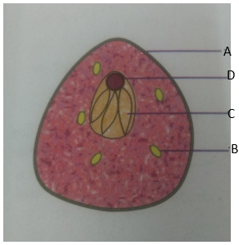

- Name the type of reproduction exhibited by the organism illustrated above? (1mark)
Asexual reproduction;
- State the advantages of this type of reproduction named in (a) above?
(3marks)
Organisms mature faster;
New offspring are identical to the parents hence important characteristics are retained;
New offspring obtain nourishment from their parents hence can survive during unsuitable environmental conditions;
- Name the parts labeled A, B and C (3marks)
A-Cell wall
B-glycogen granules
C-vacuole
- State one function of the part labeled D (1mark)
Controls the genetic information of the yeast cell;

SECTION B (40 MARKS)
Answer question 6 and either question 7 or 8 in the space after question 8
6. There are slightly more than seven thousand leucocytes per cubic millimetre of blood of an average healthy human being. However, the number changes sharply following an infection. The table below shows the concentration of leucocytes in man after a bacterial infection
Time in hours | 0 | 6 | 12 | 18 | 24 | 30 | 36 | 42 | 48
Number of bacteria per mm³ of blood (x10³) | 0 | 0.5 | 1.5 | 3.0 | 4.0 | 4.5 | 4.0 | 2.0 | 0
Number of leucocytes per mm³ of blood (x10³) | 7.0 | 7.0 | 10.0 | 13.0 | 14.0 | 14.0 | 13.0 | 12.0 | 10.0

- Using the values provided on the table, plot curves of number of bacteria and leucocytes in blood against time (8marks

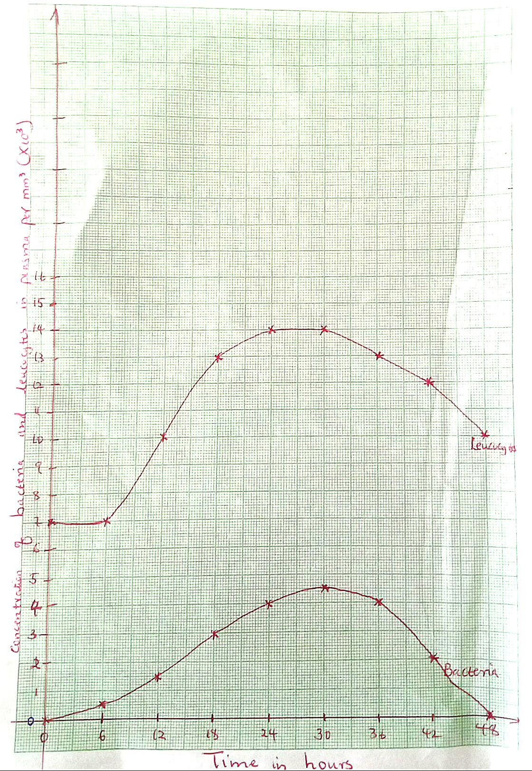

- What is the role of leucocytes in the human body (1mark)
Protection against infections by pathogenic microorganisms
- Account for the relationship between the concentration of bacteria and that of leucocytes in human blood. (3marks)
Increase in concentration of bacteria in blood causes an increase in the number of leucocytes .the increased number of leucocytes then destroy the pathogenic bacteria leading to their decline.

- What is the concentration of bacteria and leucocytes in blood 21 hours after infection
Bacteria 3.5+-0.1 x10³
Leucocytes 13.5+-0.1 x10³
- Name any two types of antibodies produced by lymphocytes and for each, give their mode of action. (4marks)
- Antitoxins: neutralise toxins produced by pathogens
- Agglutinins clumps pathogens stopping further multiplication
- Lysins:digest/destroys cell membrane the pathogens
- Opsonins adhere to the surfaces of the cell membrane masking the pathogen

- Give two sites where leucocytes are formed in the human body. (2marks)
- Lymph nodes;
- Bone marrow of long bones;

7.(a) Name two blood vessels found in umbilical cord and state the differences in the composition of blood in the vessels you each named. (4marks)
(b) Explain how the placenta is adapted to its function. (4 marks)
c) Discuss the effects of the following hormones in plant growth. (12 marks)
(i) Auxins
(ii) Abscisic acid
(iii) Gibberellins
8. a)Describe four causes of water pollution? (12marks)
b) Explain how the Human skin is a thermoregulatory organ (8marks)
7. a) Umbilical Artery; Umbilical Vein;
-Umbilical veins has more nutrients e.g glucose and Amino acids while umbilical artery has less nutrients;
-Umbilical vein has more oxygen while umbilical artery has less oxygen;
- Umbilical vein has less Carbon IV oxide while umbilical artery has more Carbon IV oxide;
- Umbilical vein has less excretory products e.g urea while umbilical artery has more excretory wastes e.g urea;
b) -Highly vascularized to maintain a steep concentration gradient;
- Has numerous villi to increase surface area for exchange of substances;
Auxins
- Stimulate cell division and cell elongation in stems and roots leading to primary growth;
-Auxins cause tropic responses , which are growth responses in plants due to external external stimuli acting from a given direction;
- Stimulates the growth of adventitious roots which develop from stem rather than the root;
-Induce parthenocarpy;
- Inhibits development of side branches from laterl buds hence enhance apical dominance;
- Induce formation of callus tissue which causes healing of wounds when in association with other plant hormones e.g cytokinins;
- In low concentration, it promotes formation of an abscission layer, leading to leaf fall;
Abscisic acid
-Inhibits seed germination leading to seed dormancy;
-Inhibit sprouting of buds from stems and retards stem elongation;
- In high concentration causes closing of stomata;
- Promotes leaf fall and fruit fall;
Gibberellins
-Induce the growth of ovaries into fruits after fertilization;
-Induce pathernocarpy;
- Promotes formation of side branches from lateral buds and breaks dormancy in buds;
-Inhibits sprouting of adventitious roots from stem cutting;
-retards formation of abscission layer hence reduces leaf fall;
-Breaks seed dormancy by activating enzymes;
8.a)
Domestic effluent;
Domestic effluents that include untreated sewerage that causes water borne diseases; raw sewage also broken down by saprophytic bacteria and fungi using dissolved oxygen in the water bodies leading to biological oxygen deficiency hence causes other aquatic organisms to die due to low oxygen supply;

Industrial effluents;
Industrial effluents that contain toxic chemicals e.g. heavy metals like mercury, lead, zinc, copper; hot water or the hot effluent which pollute water and may kill the aquatic organisms;
Heat;
Industries discharge hot water directly into water bodies; Hot water reduces concentration of dissolved oxygen in water killing the animals;
Oil spillage;
Oil spillage occurs in oceans from tankers and offshore oil refineries; the oil layer reduces the oxygen supply into the water which leads to suffocation and death of aquatic organisms, coats photosynthetic phytoplankton and kill them, marine birds get their feathers clogged hence have difficulty in flight;
Agrochemicals;
These include fertilizers, pesticides and herbicides that have heavy metals that are non-biodegradable; they reach water through seepage especially when it rains;
Silt;
Through soil erosion, silt is transported into water bodies. The silt reduces light penetration hence hindering photosynthetic activity, also clogs respiratory surface of aquatic organisms interfering with gaseous exchange;
Mercury;
Released by industries that manufacture chlorine, sodium hydroxide, also released during combustion of coal and petroleum oils, fungicides and some cosmetics also contain mercury;
Lead;
Lead comes from pipes and tanks in domestic water supply system;
b)
- Sweat glands;
When the temperature rises above optimum, the sweat glands become active and secrete sweat that is brought on the skin surface; as sweat evaporates, it absorbs latent heat of vaporization from the body cells and this brings a cooling effect to the body; when the temperature is low, the glands are made inactive hence reducing the amount of sweat produced, this leads to less loss of heat from the body;
- Blood vessels;
When temperature rise, superficial arteries on the skin vasodilate, the lumen become wider, more blood flows near the skin surface and heat is lost through radiation and conduction to the atmosphere; when the temperature decreases, they vasoconstrict diverting blood away and reduce blood flow near the skin surface hence less heat lost;
- Erector pili muscles
When temperature rise, erector pilli muscles relaxes altering the angle of the hair follicle, making the hair to lie flat on the skin surface, trapping less air and reducing insulation; more heat is lost by radiation and convection to the atmosphere; when temperature falls the erector pilli muscle contract making hairs to stand erect, trapping more air hence reduce heat loss;

