Kenya Certificate of Secondary Education 2019

231/ 2 BIOLOGY - Paper 2(Theory)
END TERM 1 2019- Time :2 hours

Name …………………………………………….……… Index Number…………………………..
Candidate’s Signature ………………….…...……….. Date ……………………………………

INSTRUCTIONS TO CANDIDATES
- Write your name and class in the spaces provided above.
- Sign and write the date of examination in the spaces provided above.

- This paper consists of two sections: A and B.
- Answer ALL the questions in section A in the spaces provided.
- In section B answer question 6 (compulsory) and either question 7 or question 8 in
he spaces provided after question 8Candidates should answer the questions in English.
- This paper consists of 12 printed pages. Candidates should check the question paper to ascertain
- that all the pages are printed as indicated and no questions are missing.

SECTION | QUESTION | MAXIMUM SCORE | CANDIDATES SCORE
A | 1  2  3  4  5 | 8  8  8  8  8
B | 6  7 or  8 | 20  20  20
TOTAL SCORE |  | 80 MARKS

@
Turn over

1.a) Excessive haemorrhage (blood loss) can be rectified through blood transfusion.
(i) Complete the table below (2 marks)
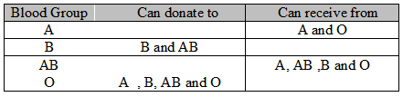

(ii) Explain the advantage and disadvantage of having blood group O. (2 marks)
…………………………………………………………………………………………………………………………………………………………………………………………………………………………………………………………………………………………………………………………………………………………………………………………………………………………………………………………………………………………………………………………………………………………………………………
(b) A person of blood group B marries another person with blood group B. State the possible blood groups of their children. (1 mark)
…………………………………………………………………………………………………………………………………………………………………………………………………………………………………………………………………………………………

(c) (i) A transfusion of Rh+veblood was given to a patient with Rh-ve blood. After one week a similar transfusion was given
to the same patient.Explain the likely effect of the second transfusion? (2 marks)
………………………………………………………………………………………………………………………………………………………………………………………………………………………………………………………………………………………………………………………………………………………………………………………………………………………………………

(ii) Other than blood transfusion, state one circumstance that can lead to the effect mentioned in (c) (i) above. (1 mark)
…………………………………………………………………………………………………………………………………………………………………………………………………………………………………………………………………………………………
2. a) Which branch of biology did the microscope give rise to? (1 mark)
…………………………………………………………………………………………………………………………………………………………………………………………………………………………………………………………………………………………

(b) Nucleus is one of the organelles which can be observed in a cell using a microscope.
(i) What is an organelle? (1 mark)
…………………………………………………………………………………………………………………………………………………………………………………………………………………………………………………………………………………………

(ii) What is the role the nucleus in a cell? (1 mark)
…………………………………………………………………………………………………………………………………………………………………………………………………………………………………………………………………………………………

(iii) Name the chemical material in the nucleus which enable it to perform its function. (1 mark)
…………………………………………………………………………………………………………………………………………………………………………………………………………………………………………………………………………………………

(c) Explain briefly why red blood cells have a short life span in a human being. (1 mark)
…………………………………………………………………………………………………………………………………………………………………………………………………………………………………………………………………………………………

(d) (i) Explain what happens inside the nucleus in interphase of mitosis. (1 mark)
…………………………………………………………………………………………………………………………………………………………………………………………………………………………………………………………………………………………

(ii) Give one difference between a nucleus of a somatic cell and gamete cell. (2 marks)
…………………………………………………………………………………………………………………………………………………………………………………………………………………………………………………………………………………………
…………………………………………………………………………………………………………………………………………………………………………………………………………………………………………………………………………………………

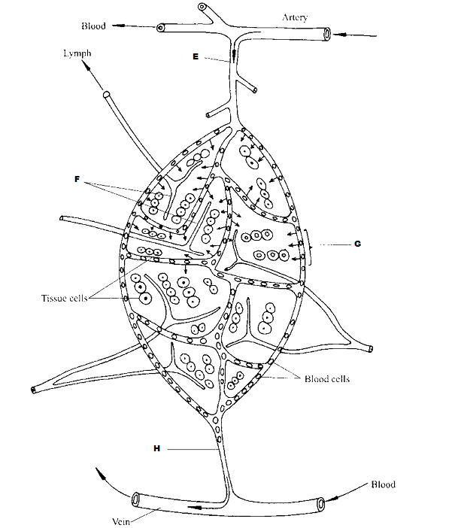
- Study the diagram below and answer questions that follow.

- Identify the parts labeled E, F and H. (3mark)
……………………………………………………………………………………………………………………………………………………………………………………………………………………………………………………………………………………
………………………………………………………………………………………………………………………………………………

- State the importance of the process represented by G in bodies of living organisms. (2mark)
…………………………………………………………………………………………………………………………………………………………………………………………………………………………………………………………………………………………

- Compare the composition of blood in vessel E and H. (3mark)
…………………………………………………………………………………………………………………………………………………………………………………………………………………………………………………………………………………………
…………………………………………………………………………………………………………………………………………………………………………………………………………………………………………………………………………………………
- The diagram below represents the nitrogen cycle.
Denitrifying
NITROGEN IN THE AIR
NITRATES
NITROGEN IN PLANTS
ANIMALS
AMMONIA
B
bacteria
A
D

Death and
decay Death and decay
E

      - Name the compound represented by B. (1mark)
……………………………………………………………………………………………………………………………………………………………………………………………………………………………………………………………………………
      - Name the group of organisms represented by E. (1mark)
………………………………………………………………………………………………………………………………………………………………………………………………………………………………………………………………………………
      - State the process labelled A and D. (2marks)
………………………………………………………………………………………………………………………………………………………………………………………………………………………………………………………………………………

      - (i) Name the part of the plant where nitrogen fixation takes place. (1mark)
………………………………………………………………………………………………………………………………………………………………………………………………………………………………………………………………………………

(ii) What is the effect of denitrifying bacteria in the soil? (1mark)
…………………………………………………………………………………………………………………………………………………………………………………………………………………………………………………………………………………………

      - How would excess pesticides in the soil interfere with Nitrogen fixation? (2marks)
………………………………………………………………………………………………………………………………………………………………………………………………………………………………………………………………………………

- The diagram below shows the results obtained in an experiment on graph of a bean seedling.

Marks made with
Waterproof ink
The same marks
After 5 days

Start of Experiment End of Experiment

- Suggest the aim of the experiment. (1mark)
……………………………………………………………………………………………………………………………………………………………………………………………………………………………………………………………………

- State the processes that occur in each of the regions marked A, B and C. (3marks)
…………………………………………………………………………………………………………………………………………………………………………………………………………………………………………………………………………………………

- Account for the observations made in the regions A and C. (4 marks)
…………………………………………………………………………………………………………………………………………………………………………………………………………………………………………………………………………………………………………………………………………………………………………………………………………………………………………………………………………………………………………………………………………

SECTION B (40 MARKS)
Answer question 6 (compulsory) and either 7 or 8
6. The table below shows the changes observed in the dry weight (in milligrams) of a barley seedling, its embryo and endosperm during the first ten days after the onset of germination.
 | DRY WEIGHT IN MILLIGRAMS
TIME (DAYS) | EMBRYO | ENDOSPERM | WHOLE SEEDLING
0 | 2 | 41 | 45
2 | 2 | 39 | 43
4 | 7 | 32 | 41
6 | 15 | 21 | 38
8 | 22 | 11 | 35
10 | 35 | 6 | 43

- Using a suitable scales on the same axis, plot graphs of dry weight of embryo endosperm and whole seedling against time. (8 marks)
State and account for the changes in dry weight shown by:

- Embryo (4 marks)
……………………………………………………………………………………………………………………………………………………………………………………………………………………………………………………………………………………………………………………………………………………………………………………………………………………………………………………………………………………………………………………………………………………………………………………………..
- Endosperm (4 marks)
………………………………………………………………………………………………………………………………………………………………………………………………………………………………………………………………………………………………………………………………………………………………………………………………………………………………………………………………………………………………………………………………………………………………………………………….

- Explain the role of water during germination. (4 marks)
……………………………………………………………………………………………………………………………………………………………………………………………………………………………………………………………………………………………………………………………………………………………………………………………………………………………………………………………………………………………………………………………………………………………………………………………

- Describe how seeds and fruits are adapted to their various methods of dispersal (20marks)

- Activities of humans are contributing to the pollution of water bodies. Describe the causes and methods of controlling water pollution in Kenya. (20marks)
……………………………………………………………………………………………………………………………………………………………………………………………………………………………………………………………………………………………………………………………………………………………………………………………………………………………………………………………………………………………………………………………………………………………….…………………………………………………………………………………………………………………………………………………………………………………………………………………………………………………………………………………………………………………………………………………………………………………………………………………………………………………………………………………………………………………………………………………………………………………………………………………………………………………………………………………………………………………………………………………………………………………………………………………………………………………………………………………………………………………………………………………………………………………………………………………………………………………………………………………………………………………………………………………………………………………………………………………………………………………………………………………………………………………………………………………………………………………………………………………………………………………………………………………………………………………………………………………………………………………………………………………………………………………………………………………………………………………………………………………………………………………………………………………………………………………………………………………………………………………………………………………………………………………………………………………………………………………………………………………………………………………………………………………………………………………………………………………………………………………………………………………………………………………………………………………………………………………………………………………………………………………………………………………………………………………………………………………………………………………………………………………………………………………………………………………………………………………………………………………………………………………………………………………………………………………………………………………………………………………………………………………………………………………………………………………………………………………………………………………………………………………………………………………………………………………………………………………………………………………………………………………………………………………………………………………………………………..

