Kenya Certificate of Secondary Education 2019

231/ 3 BIOLOGY -Paper 3
(Practical)
END TERM 12019-1 ¾ hours

Name …………………………………………….……… Index Number…………………………..

Candidate’s Signature ………………….…...……….. Date ……………………………………

Instructions to candidates
- Write your name and class in the spaces provided above.

- Sign and write the date of examination in the spaces provided above.
- Answer ALL questions in the spaces provided.
- Additional pages MUST NOT be inserted.
- Candidates will be penalized for incorrect spelling especially of technical terms and for use of slovenly language
- You are required to spend the first 15 minutes of the 1¾hours allowed for this paper reading the whole paper carefully before commencing your work.
- This paper consists of 5 printed pages.Candidates should check the question paper to ascertain that ALL the pages are printed as indicated and no questions are missing
For Examiner’s Use Only
Question | Maximum  Score | Candidate’s  Score
1 | 14
2 | 13
3 | 13
Total score | 40
©
Kenya Certificate of Secondary Educations
Turn over

1. You are provided with 10% glucose solution and substance labeled Y. Also provided is a solution labeled X. You are to investigate the reaction between the glucose solution and substance Y. Measure 20.00cm³ of the glucose solution and transfer it to the boiling tube provided. Transfer all the substance Y provided into the solution in the boiling tube. Tightly fit the rubber bung carrying a delivery tube to the boiling tube. Place the boiling tube in a water bath kept between 35 – 38⁰ c. Measure 1.0. Cm3of solution X and transfer to a test tube. Connect the delivery tube so that the open end enters the solution X. Allow the set – up to stand for about 30 minutes and during this time observe the changes occurring in the boiling tube and in the test tube having solution X.
a) Fill the table below (2 marks)
Tube | Observations
Boiling Tube
Test Tube

b) What conclusions can your draw from your observations in the test tube? (2 marks)
……………………………………………………………………………………………………………………………………………………………………………………………………………………………………………………………………………………………………………………………………………………………………………………………………………………………………………………………………………….
c) Name the process that took place in the test tube (1 mark)
……………………………………………………………………

d) Shake the contents of the boiling tube and using a dropper remove a little of the contents. Transfer a drop to a glass
slide; add two drops of methylene blue stain. Cover with a cover slip and observe using a microscope of x10 or x15 eye piece lens.
(i) Draw and label the substance Y which is in the slide (4 marks)

(ii) What is the possible identity of substance Y (1 mark)

……………………………………………………..
e) Why was the temperature of the water bath kept between 35 – 38⁰c (1 mark)

…………………………………………………….
f) If the experiment was done under the following conditions, suggest, giving reasons the expected results.
(i)Water bath was kept at 100⁰c (2 marks)
……………………………………………………………………………………………………………………………………………………………………………………………………………………………………………………………………………………………………………………………………………………………………………………………………………………………………………………………………………….

g) From the microscope
(i) Name the part labeled Q. (1 mark)
……………………………………..
(ii) Give the function of part labeled P. (1 mark)
………………………………………
h) Name the form in which substance Y stores its excess glucose (1 mark)
…………………………………………

2. The photomicrograph below shows the arrangement of different types of cells and tissues in a certain living
organism. Study it carefully and answer the questions that follow.
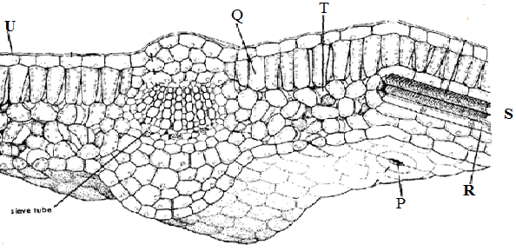
3rd cell
- (i) From what part of the plant was the photograph obtained? (1mark)
…………………………………………………………
(ii) Name the parts labeled: - P, Q, U,T and U (5marks)
P……………………………………………………………………………
Q……………………………………………………………………………
U…………………………………………………………………………
T………………………………………………………………………………
U………………………………………………………………………………
(iii) Give two major components that make up structure S. (2marks)
……………………………………………………………………………………………………………………………………………………………………………………………………………………………………………………………………………………………………………………………………………………………………………………………………………………………………………………………………………….

(iv) State the function of the part labeled Q and two adaptations to its function. (2marks)
……………………………………………………………………………………………………………………………………………………………………………………………………………………………………………………………………………………………………………………………………………………………………………………………………………………………………………………………………………….

(v) list threeenvironmental factor which regulates the function of the part labeled P. (3mark)
……………………………………………………………………………………………………………………………………………………………………………………………………………………………………………………………………………………………………………………………………………………………………………………………………………………………………………………………………………….

- Measure the length of the third (3rd) cell at the right side of structure labeled Q on the photograph whose magnification is X5000. What is the actual length of the cell in micrometers (µm)? Show your working. (2marks)
……………………………………………………………………………………………………………………………………………………………………………………………………………………………………………………………………………………………………………………………………………………………………………………………………………………………………………………………………………….

- The photograph below represents human male urinary system. Study it carefully and answer the questions that follow.
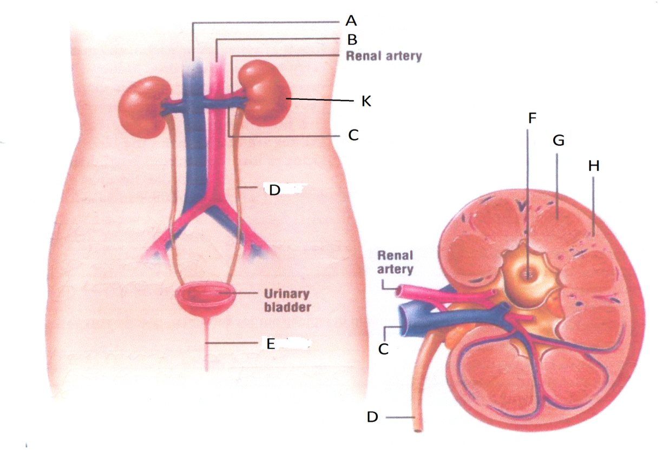
Longitudinal Section ofK

- State two functions of the part labeled K. (2 marks)
……………………………………………………………………………………………………………………………………………………………………………………………………………………………………………………………………………………………………………………………………………………………………………………………………………………………………………………………………………….

- Name the parts labeled A, B, C, D, F, G, and H. (7 marks)
A………………………………………
B………………………………………
C……………………………………..
D…………………………………….
F……………………………………..
G………………………………………
H………………………………………
- State the functions of each of the following parts;
- Renal artery (1 mark)
……………………………………………………………………………………………………………………………………………………………………………………………………………………………………………………………………………………………………………………
- Urinary bladder (1 mark)
……………………………………………………………………………………………………………………………………………………………………………………………………………………………………………………………………………………………………………………
- Part labeled E (1 mark)
……………………………………………………………………………………………………………………………………………………………………………………………………………………………………………………………………………………………………………………

THIS IS THE LAST PRINTED PAGE

