Name…………………………………………………………… Index No…………................
Candidates Signature................................
231/3
Biology
Practical
Paper 3
Time 1 ¾ hours END OF TERM 2 YEAR 2019
FORM 4 EXAMINATION
INSTRUCTIONS TO CANDIDATES
- Write your name and index number in the spaces provided at the top of this page.
- Answer all questions.
- You are required to spend the first 15 minutes of the1 ¾ hours allowed for this paper reading the whole paper carefully before commencing your work.
- Answers must be written in the spaces provided in the question paper. Additional pages must not be inserted.
For Examiners Use Only
Question |  | Maximum Score | Candidate’s Score
1 |  | 15
2 |  | 14
3 |  | 11
 | Total score | 40

1. You are provided with specimen labelled Q. cut the specimen into two halves.

(a) Cut four rectangular strips from one half of specimen Q, each strip should be of 20mm long
and 5mm wide. Place two stripes into solution R and the other two strips into solution S.
Allow the experiment set ups to stand for 10 minutes.

(i) Using your fingers feel the texture of the stripes and record your observations from each solution:
Solution R (1mark)

……………………………………………………………………………………………………………………………..

Solution S (1mark)

…………………………………………………………………………………………………………………………….

(ii) Account for your observations of no. (i) above. (4marks)

………………………………………………………………………………………………………………………………

………………………………………………………………………………………………………………………………

……………………………………………………………………………………………………………………………....

……………………………………………………………………………………………………………………………….

……………………………………………………………………………………………………………………………….

………………………………………………………………………………………………………………………………

b) Peel the other half of specimen Q, cut into small pieces and then crush in a mortar. Use the
Reagents provided to test for the various food substances in the extract obtained from the crushed material.

Record the procedures, observations and conclusions in the table below. |  |  | (9marks)
Food substance | Procedure | Observations | Conclusion

2. The Diagram below shows two organisms (R and S) belonging to the same phylum
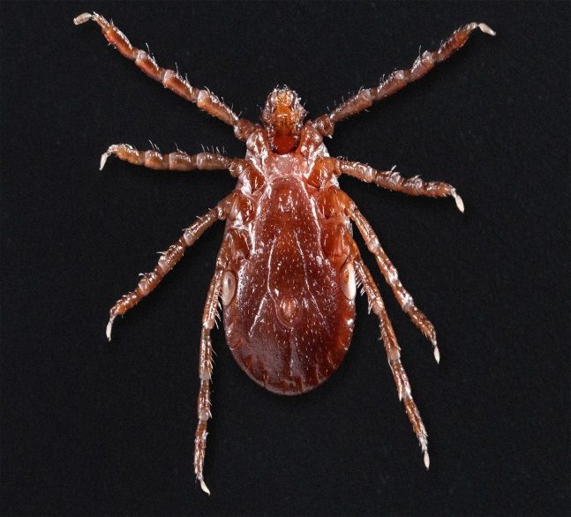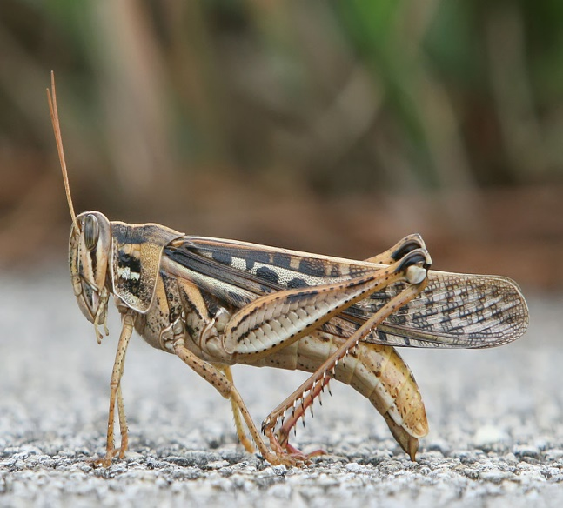

R S

(a) Name the class in which the organisms shown above belong. (2 Mark)

i) Organism R
………………………………………………………………………………………………………………………………………………………………………………………………………………
ii) Organism S
………………………………………………………………………………………………………………………………………………………………………………………………………………

b) Other than presence of exoskeleton, list two observable similarities between the two organisms (2 Marks)

…………………………………………………………………………………………………………………………………………………………………………………………………………………………………
…………………………………………………………………………………………………………………………………………………………………………………………………………………………………
…………………………………………………………………………………………………………………………………………………………………………………………………………………………………
…………………………………………………………………………………………………………………………………………………………………………………………………………………………………

c) List two observable differences between the two organisms (2 Marks)
P | S

d) Explain how the organism labelled R is adapted to safeguard itself from the predator (2 Marks)

……………………………………………………………………………………………………………………………………………………………………………………………………………….……………………………………………………………………………………………………………………………………………………………………………………………………………….……………………………………………………………………………………………………………………………………………………………………………………………………………….……………………………………………………………………………………………………………………………………………………………………………………………………………………………………………………………………………….

e) (i) Name the gaseous exchange system exhibited by organism S (1 Mark)
…….………………………………………………………………………………………………………………………………………………………………………………………………………

ii) State the respiratory surface used by organism S (1 Mark)
…….…………………………………………………………………………………………………………………………………………………………………………………………………….
f) Outline four functions of exoskeleton (4 Marks)
……………………………………………………………………………………………………………………………………………………………………………………………………………….……………………………………………………………………………………………………………………………………………………………………………………………………………….………………………………………………………………………………………………………………………………………………………………………………………………………………………………………………………………………………………………………………………………………………………………………………………………………………………………………………………………………………………………………………………………………………………………………………………………………………………………………………………………………………………………………………………………………………………………………………………………………………………………………………………………………………………………………………………………………………………………………...

3. (i) Examine photograph k 1and K2 then answer the questions that follow.

K2

K1

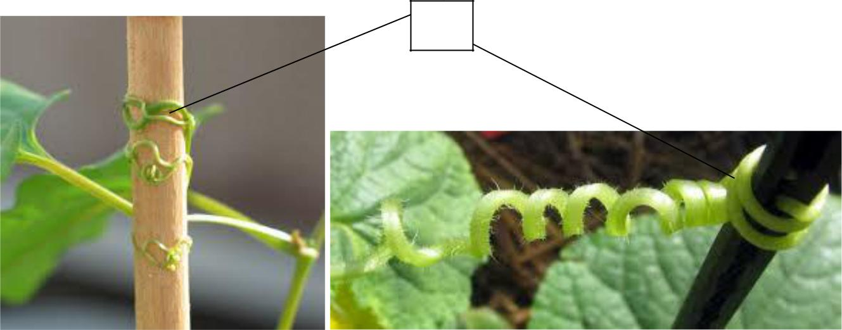
R1 x

R2

a) Name the response that is exhibited by the seedlings K1 and K2 (1mrk.)

…………………………………………………………………………………………………………………………………….

b) Explain how the response you have stated in (a) above occurs. (4mrks)
………………………………………………………………………………………………………………………………………………
………………………………………………………………………………………………………………………………………………
………………………………………………………………………………………………………………………………………………
………………………………………………………………………………………………………………………………………………
………………………………………………………………………………………………………………………………………………

(c) What is the significance (survival value) of the response you have stated in (a) above. (1 mrk)
………………………………………………………………………………………………………………………………………………
………………………………………………………………………………………………………………………………………………

d) Photographs R1 and R2 show a certain response in plants.

i) Name the response shown by plant X. (1mrk)

…………………………………………………………………………………………………………………………………………
…………………………………………………………………………………………………………………………………………….

ii) Explain how the response you have stated In (a) above occurs. (2mks)
..................................................................................................................................................................................................................
……………………………………………………………………………………………………………………………………………………………………………………………………………………………………………………………………………………………………………………………………………………………………………………………………………………………………………………………………………………………………………………………………………………………………………………………………………………………………………………………………………………………………………………..

iii) What is the biological significance of the response shown by X? (2 mks)
…………………………………………………………………………………………………………………………………………………………………………………………………………………………………………………………………………………………………………………………………………………………………………………………………………………………………………………………………………………………………………………………………………………………………………………………………………………………………………………………………………………………………………………………………………………………………………………………………………………………………………………………………………………………….....

