The figure below shows part of a human skeleton.

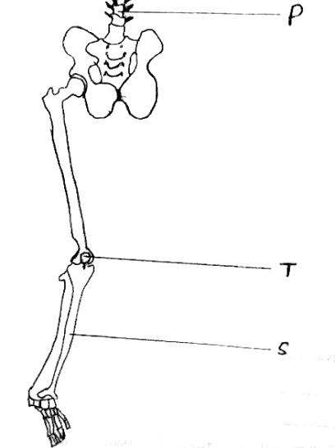

- Which part of the human skeleton is it? (1mk)

---------------------------------------------------------------------------------------------------------------------
- On the diagram label by name three types of joints. (3mks)

- Label the S, T and P. (3mks)

S -------------------------------------------------------------------------------------------------------------------

T -------------------------------------------------------------------------------------------------------------------

P -------------------------------------------------------------------------------------------------------------------

- Which two bones on the diagram manufactures red blood cells? (1mk)

-------------------------------------------------------------------------------------------------------------------
5. In maize the gene for purple colour is dominant to the gene for white colour.
A pure breeding maize plant with purple grains was crossed with a heterozygous plant.
a) Using letter G to represent the gene for purple colour, work out the genotypes of
the offspring. (4mks)

b) State the phenotype of the offspring. (1mk)
------------------------------------------------------------------------------------------------------------------

c) What is genetic engineering? (1mk)
-----------------------------------------------------------------------------------------------------------------------------------------------------------------------------------------------------------------------------------------d) Gene for smooth seed coat is dominant over gene for wrinkled seed coat.
Two heterozygous pea plants with smooth seed coats were crossed and produced a
total of 14640 seeds. How many seeds had wrinkled seed coat? Show your
calculations. (2mks)
-----------------------------------------------------------------------------------------------------------------------------------------------------------------------------------------------------------------------------------------------------------------------------------------------------------------------------------------------------------------------------------------------------------------------------------------------------------------------------------
6. The diagram below is obtained from measurements of growth in the leaf petiole of a certain plant. The relative growth rate is calculated and the data is obtained as shown below.

Time in days | 0 | 1 | 2 | 3 | 4 | 5 | 6 | 7 | 8 | 9
Relative growth rate(cm/day) | 0 | 0.1 | 0.3 | 0.8 | 2.0 | 4.0 | 4.5 | 3.5 | 0.2 | 0

a) Plot a graph of relative growth rate against time. (5mks)

b) State two functions of a leaf petiole. (2mks)
---------------------------------------------------------------------------------------------------------------------------------------------------------------------------------------------------------------------------------------------------------------------------------------------------------------------------------------------------------------------------------------------

c) State two characteristics of cells found in the region of cell division. (2mks)
--------------------------------------------------------------------------------------------------------------------------------------------------------------------------------------------------------------------------------------------------------------------------------------------------------------------------------------------------------------------------------------------
d) Account for the shape of the curve between the following days (3mks)
i) 2 – 5.
----------------------------------------------------------------------------------------------------------------------------------------------------------------------------------------------------------------------------------------------------------------------------------------------------------------------------------------------------------------------------------------------------------------------------------------------------------------------------------------------------------------------------
ii) 6 – 8 (3mks)
----------------------------------------------------------------------------------------------------------------------------------------------------------------------------------------------------------------------------------------------------------------------------------------------------------------------------------------------------------------------------------------------------------------------------------------------------------------------------------------------------------------------------
iii)6 – 8 (3mks)
----------------------------------------------------------------------------------------------------------------------------------------------------------------------------------------------------------------------------------------------------------------------------------------------------------------------------------------------------------------------------------------------------------------------------------------------------------------------------------------------------------------------------
d) Distinguish between primary growth and secondary growth in a flowering plant. (2mks)
----------------------------------------------------------------------------------------------------------------------------------------------------------------------------------------------------------------------------------------------------------------------------------------------------------------------------------------------------------------------------------------------------------------------------------------------------------------------------------------------------------------------------

7. How are flowers adapted to wind and insect pollination? (20mks)
8a) Name factors that affects the enzyme controlled reactions. (6mks)
b) Explain the factors that affect the rate of enzyme activity. (14mks)

------------------------------------------------------------------------------------------------------------------------------------------------------------------------------------------------------------------------------------------------------------------------------------------------------------------------------------------------------------------------------------------------------------------------------------------------------------------------------------------------------------------------------------------------------------------------------------------------------------------------------------------------------------------------------------------------------------------------------------------------------------------------------------------------------------------------------------------------------------------------------------------------------------------------------------------------------------------------------------------------------------------------------------------------------------------------------------------------------------------------------------------------------------------------------------------------------------------------------------------------------------------------------------------------------------------------------------------------------------------------------------------------------------------------------------------------------------------------------------------------------------------------------------------------------------------------------------------------------------------------------------------------------------------------------------------------------------------------------------------------------------------------------------------------------------------------------------------------------------------------------------------------------------------------------------------------------------------------------------------------------------------------------------------------------------------------------------------------------------------------------------------------------------------------------------------------------------------------------------------------------------------------------------------------------------------------------------------------------------------------------------------------------------------------------------------------------------------------------------------------------------------------------------------------------------------------------------------------------------------------------------------------------------------------------------------------------------------------------------------------------------------------------------------------------------------------------------------------------------------------------------------------------------------------------------------------------------------------------------------------------------------------------------------------------------------------------------------------------------------------------------------------------------------------------------------------------------------------------------------------------------------------------------------------------------------------------------------------------------------------------------------------------------

