- a) Appendicular;
b)
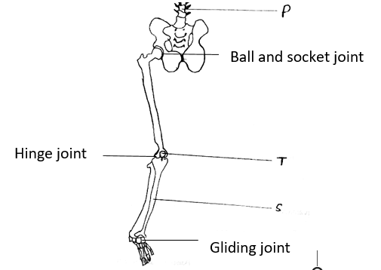

Gliding joint

c) S – Tibia

T – Patella
P – Lumbar verterae
d) – vertebrae
- Pelvis
- G - Gene for Purple
g – Gene for white
- Parental phenotype purple grains purple grains
Parental Genotype GG X Gg ;
G
G
g

G
Gametes ;

;

F1 GG Gg GG Gg ;
- All purple colored grained maize plants.
- Deliberate modification of characteristics of an organism by manipulating the DNA / Gene, by transferring genes from one organism to another;
- Phenotypic ratio; 3 smooth seed coat : 1 wrinkled seed coat
Seeds with wrinkled coats = ¼ X 14640;
= 3660;
6a
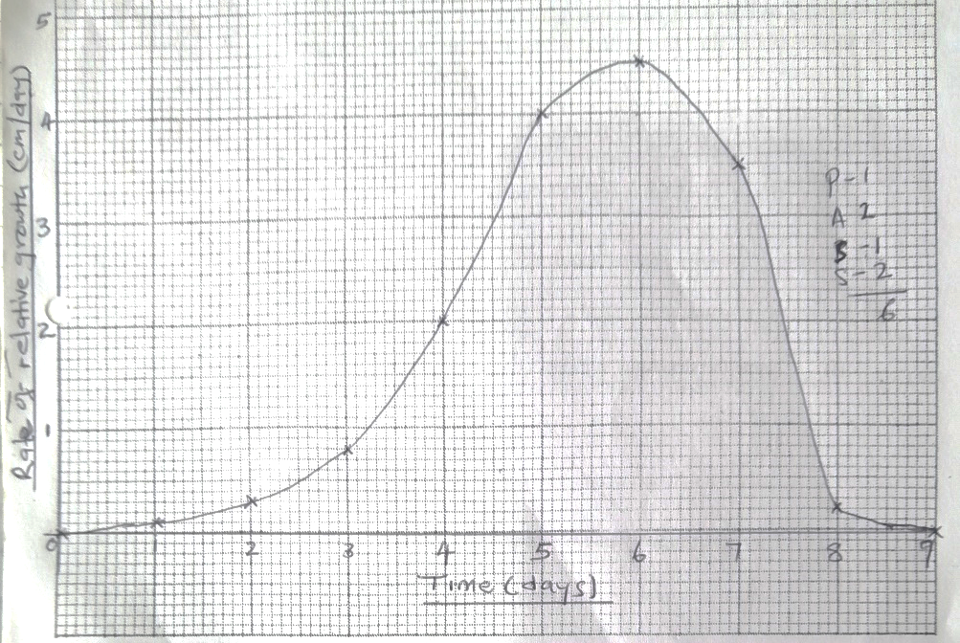
b) -Supports the leaf in position to trap light for photosynthesis;
- Contains xylem tissue to transport water and dissolved mineral salts to the leaf for
photosynthesis, and phloem to transport synthesized food to the rest parts of a plant;
c) – Dense cytoplasm;
-Thin cell wall;
- Numerous mitochondria;
-Very small / No sap vacuole;
di) 2-5 There is a fast growth rate; because the leaf is very young; and cells are actively dividing and
elongating;
ii) 6-8 There is reducing rate or relative growth; of the petiole. This is because the cells if the
petiole/leaf are no longer dividing and elongating; instead the cells are becoming differentiated;
iii) 8-9 Growth ceases; /very little growth because all cells are differentiated; and has formed
permanent tissues;
e) Primary growth takes place at shoot tip and root tip leading to increase in length due to activity of
apical meristems;
Secondary growth leads to increase in girth in stems due to activity of lateral meristems / vascular
cambium;
7.The flowers have the following features:
Insect pollination / Entomophilous flowers
- Are scented to attract insects
- Have small sticky, stigma that occur inside the flower for pollen grains to stick on it.
- Have nectaries to secrate nectar; nectar acts as a bait to attract insects
- Have nectar guides to guide the insects to the nectaries.
- Have special shaped corolla to provide landing platform i.e. tubular or funnel sheped corolla to increase chance of contact by insects.
- Large / heavy and rough / sticky / spiny / spiky pollen grains which stick on the body of insects on stigma.
- Large; conspicuous flowers with brightly colored petal, bracts or inflorescence to attract insects.
- Anthers are small and firmly attached to filament to ensure insect brush against the anthers as they crawl into the flower hence collect as many pollen grains.
- Stigmas are small, sticky and occur inside the flower, so that pollen grain from insect body can stick onto it.
- Another’s are situated inside the flower to ensure that they are into contact with the insects.
- Mimicry to attract insects / flowers mimic female insects which attract male insects for mating e.g orchids.
N/B- 1 mark per point
-Max 10mks

Wind pollinated / Anemophilous flowers
- Anthers and stigma hang outside the flowers to increase chances of pollination; style / filament is long to expose stigma / anthers.
- Stigma is hairy / feathery / branched / long to increase surface are over which pollen grains land / to trap pollen grains.
- Pollen grains are smooth / dry / light / small to be easily carried by wind; large amount of pollen grains to increase chances of pollination.
- Flowers are small with inconspicuous petals, bracts or inflorescence.
- Flowers not scented and lack nectar.
- Anthers are large and loosely attached to flexible filaments to enable them sway easily to release pollen grains. This ensures that pollen grains released readily when wind blows.
- Pollen grains may have structures which contain air to increase buoyancy, flowers have long stalks holding them out in the wind.
Max 10mks

- a) Temperature; PH value; co-factors; enzyme and co-enzymes; enzyme concentration; substrate concertation; metabolic poison / inhibitors; Max 6mks
b) - Temperature- increase in temperature increases rate of enzymatic activity; up to an optimum where enzymes work at best hence maximum / highest rate of reaction;
low temperature makes the enzymes less active; high temperatures above 40⁰c denatures enzymes; enzymatic activity reduces and eventually stops;
- PH – Enzymes work best at optimum PH; extreme PH denatures enzymes;
Some enzymes act best in acidic or basic medium while others work best at neutral pH; Optimum PH should be maintained.
- Enzyme concentration – Increase in concentration increases enzymatic activity as there is more active sites; to combine with substrate hence an increase in reaction;
- Co-enzymes – activates enzymes; increasing rate of activity;
- Substrate concentration – increase in substrate concentration increases enzymatic activity; up to certain level where enzymes become a limiting factor;
- Inhibitors – They compete with substrate for active sites or combines permanently with active sites of enzymes; They slow down or stop the rate of reaction;
Max 14mks

