FORM3 MARKING PP1 SCHEME; BUSINESS STUDIES
1. Features of perfect competition market
-there are large number of buyers and sellers
-homogeneity [uniformity] of the product
-each buyer and seller has a perfect knowledge of the market
-the buyers and sellers have the freedom to enter and leave the market
-there is no government interference
-there is no excess supply or demand
-there is perfect mobility of factors of production
-there is no transport costs incurred as its assumed the buyers and sellers are located in one area
2. Channels of imported vehicles
-Foreign producer –wholesaler-retailer-local consumer
-foreign producer-agent-wholesaler-retailer-local consumer
-Foreign producer-manufacturer’s representative-wholesaler-retailer-local consumer
-foreign producer-wholesaler-local consumer
-foreign producer-retailer-local consumer
3. Level of education
-inheritance -corruption
-nepotism in employment
-disparity in access to education /unequal education opportunities
-disparity in natural resources
4.Its a basic factor of production i.e. production cannot take place without it
-its supply is fixed
-it’s a natural resource
-its subject to the law of diminishing returns
-it has occupational mobility
-it lack geographical mobility
-quality is not homogeneous
-productivity of land can be increased by increasing quantity and quality of capital
5. When training juniors
-when evaluating the performance of employees
-when delegating duties from managers to the juniors
-when giving rewards
-when solving problems facing workers
-when dealing with those involved in misconduct
6.Polite request for payment before goods are sent to the buyer
-when the seller does not want to give credit to the buyer
- Its issued to an agent who sell goods on behalf of the seller
-used by importers to get customs clearance before goods are sent
-serves as quotation
- sent to the buyer to show what he would pay if he bought the goods
7.A=C+L X=1800,000
C=A-L Y=600,000
L=A-C W=700,000
C=A-L Z=6400,500-800,000=5600,500
8.proper storage facilities
-adequate communication within and outside the business
-adequate transport
-proper handling equipment
-well trained staff
-provision of safety facilities
-proper inventory and stock control system
9.Enables the holder to get goods and services from specified sellers without paying immediately
-convenient to carry around
-Enables the holder to get money from specified banks
-Increases credit rating of an individual.
- Its safe to carry the card around than to carry cash
-Some cards are internationally acceptable
10.clean air -clean water
-safe buildings -proper landscaping
-political goodwill
-Availability of auxiliary services
-favorable economic environment
-Reliable and efficient legal system
-No noise within accepted limits
12.commerce -Accounting
-office practice -Entrepreneurship
-Economics
13.Its a saving plan
-has surrender value
-Not indemnitiable
-Does not require annual renew
-can be assigned to beneficiaries
-can be used as security for loans
-cover for life until death or for a specified period
14.To ensure fairness in business\no discrimination in business
-To promote honesty and integrity in business
-To create good working relations
-To ensure that business complies with the laws of the land
-To ensure that there is no degradation and pollution of the environment
-To ensure that the business is socially responsible to the community
-creates fairness in competition
-Avoids consumer exploitation
-Eliminates use of unfair means of achieving business objectives
15.Trade discount 2/100x400,000=8,000
400,000-8000=392,000
-cash discount 1/100x392,000=3920
-Amount paid 392,000-3920=sh.388,080.00
16.If the goods are fragile
-If the consumers are concentrated in one area
-If the goods are technical
-If the goods don’t require the role of intermediaries
-If it’s a government policy that a trader sells the goods directly
17.cc=oc+p+I-d
=160,000+102,000+400,000-[13500]12
=662,000-162,000=sh.500,000
18.

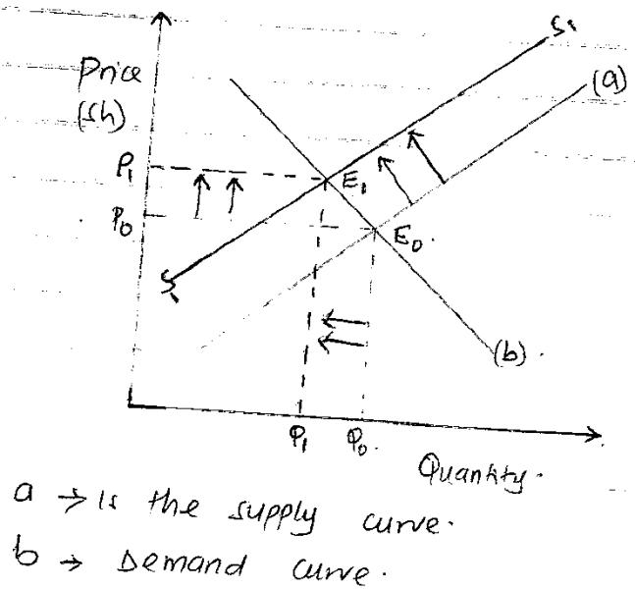
19.Grading -Blending Branding
-Breaking bulk
20.reduces government expenditure
-leads to efficiency in management
-Attracts foreign investors
-promotes invention and innovations
-Reduces political interference in the economy
-promotes accountability and reduce corruption
-Helps the government to raise revenue
-leads to production of high quality goods and services
-Leads to the production of a variety of goods and services
21.form utility -possessive utility
-time utility -place utility
22.a]internal or external
b]External c]Internal
d]Internal
23.have money value
-unevenly distributed -scarce in supply
-have utility -have alternative uses
-can change ownership -can be combined
Can be complimentary
24.Not disclosing the side effects of the product
-cheating on the performance of the product
-false pricing
-advertising that has negative effect on environment
-making offers that cannot be fulfilled
Promoting products as genuine but selling their counterfeits
-social cultural conflicts
25.Increase in sales volume
-Higher profit margins are realized
-goods can be repossessed if the buyer defaults payment
-ownership of the goods is retained until the payments is completed

