Name: …………………………………………………………… …………Adm. No.……..….........................

Date: …………………………………………………………… Class: ………......…………….

565/1
FORM 3 BUSINESS STUDIES
PAPER 1
JULY/AUGUST 2015
TIME: 2 HOURS

MWAKICAN JOINT EXAMINATION TEAM (MJET) 2015

Kenya Certificate of Secondary Education (K.C.S.E.)

FORM 3 BUSINESS STUDIES
PAPER 1
TIME: 2 HOURS

INSTRUCTIONS TO CANDIDATES:

- Write your name and your Admission Number in the spaces provided above.
- Write the date of examination and class in the spaces provided above.
- Answer all the questions in the spaces provided.
- All answers should be written in English.
- This paper consists of 9 printed pages. Candidates should check the question paper to ascertain that all the pages are printed as indicated and that no questions are missing.

FOR EXAMINERS USE ONLY:-
Question | 1 | 2 | 3 | 4 | 5 | 6 | 7 | 8 | 9 | 10 | 11 | 12 | 13
Score

Question | 14 | 15 | 16 | 17 | 18 | 19 | 20 | 21 | 22 | 23 | 24 | 25
Score

TOTAL MARKS

- Outline 4 ways in which commercial attaches may promote trade between their country and other countries. (4marks)

(i) …………………………………………………….…………………………………………………….
(ii) ……………………………………………….……………………………….…………………………
(iii) …………………………………………………………………………………………………………..
(iv) ………………………………………………………………………………………………………….
- A lucrative manufacturing firm has been constantly releasing toxic wastes into the neighbourhood. Outline four measures you can take to stop the firm from such malpractice. (4marks)

(i) …………………………………………………….…………………………………………………….
(ii) ……………………………………………….……………………………….…………………………
(iii) …………………………………………………………………………………………………………..
(iv) ………………………………………………………………………………………………………….
- Outline four factors that should be considered in the choice of a means for transporting perishable goods (4marks)

(i) …………………………………………………….…………………………………………………….
(ii) ……………………………………………….……………………………….…………………………
(iii) …………………………………………………………………………………………………………..
(iv) ………………………………………………………………………………………………………….
- Outline four circumstances under which face to face communication may be ineffective (4marks)
(i) …………………………………………………….…………………………………………………….
(ii) ……………………………………………….……………………………….…………………………
(iii) …………………………………………………………………………………………………………..
(iv) ………………………………………………………………………………………………………….
- Highlight four benefits that would accrue to a firm located near other existing firms (4mks)

(i) …………………………………………………….…………………………………………………….
(ii) ……………………………………………….……………………………….…………………………
(iii) …………………………………………………………………………………………………………..
(iv) ………………………………………………………………………………………………………….

- KAMBO owned a motor vehicle valued at sh.1,000,000. He comprehensively insured the car at sh.800,000. The motor vehicle was involved in an accident and declared a write off. Calculate the amount KAMBO should get from the insurer (4marks)

- State four reasons why the government should create an enabling environment for investors (4marks)

(i) …………………………………………………….…………………………………………………….
(ii) ……………………………………………….……………………………….…………………………
(iii) …………………………………………………………………………………………………………..
(iv) ………………………………………………………………………………………………………….
- State four importances of intermediaries in the chain of distribution (4marks)

(i) …………………………………………………….…………………………………………………….
(ii) ……………………………………………….……………………………….…………………………
(iii) …………………………………………………………………………………………………………..
(iv) ………………………………………………………………………………………………………….
- Highlight four challenges that a person may encounter when using a cell phone (mobile phone) (4marks)

(i) …………………………………………………….…………………………………………………….
(ii) ……………………………………………….……………………………….…………………………
(iii) …………………………………………………………………………………………………………..
(iv) ………………………………………………………………………………………………………….

- The diagram below represents the relationship between population and income per capita
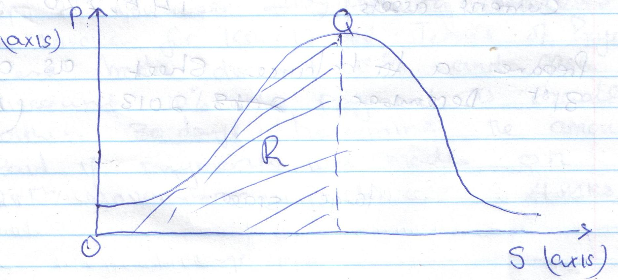
State what is represented by P and S axes and letters R and Q (4marks)
(i) …………………………………………………….…………………………………………………….
(ii) ……………………………………………….……………………………….…………………………
(iii) …………………………………………………………………………………………………………..
(iv) ………………………………………………………………………………………………………….
- The balances given below relate to Korir Traders for the year ended 31st December 2013.
Sh.
Capital ?
2 year bank loan 230,020
Creditors 95,200
Fixed assets 480,000
Current assets 145,220
Prepare a balance sheet as at 31st December 2013 (5mks)

- Identify the types of wholesalers described in the statements given below (4marks)

- A wholesaler who trades in maize grain only ……………………………..

- A wholesaler who supplies goods to most of the traders in Kerugoya, Mwea and Sagana in Kirinyaga County……………………………………..
- A wholesaler who buys tomatoes from farmers in rural areas and sells the same to other wholesalers in urban areas. ………………………………
- A wholesaler who trades in a wide variety of human medicine …………………………

- On 2nd November 2010, Mwaura received an invoice for Ksh.12,000. Terms of payment were trade discount 5% and cash discount 10%, if payment is made within 30 days. Determine the amount paid if payment was made on 28th November 2010. (4marks)

- The following transactions were extracted from the books of Sarah Traders for the month of March 2014.
March 10: Purchased goods on credit worth Kshs.200,000 from Salim Traders.
March 25: Sold goods on credit worth Kshs.420,000 to Shah Traders. Record the above transactions in the relevant ledger accounts (4marks)

- Highlight four circumstances under which the capital of a business may change (4marks)

(i) …………………………………………………….…………………………………………………….
(ii) ……………………………………………….……………………………….…………………………
(iii) …………………………………………………………………………………………………………..
(iv) ………………………………………………………………………………………………………….
- Outline four features of liners in sea transport (4marks)
(i) …………………………………………………….…………………………………………………….
(ii) ……………………………………………….……………………………….…………………………
(iii) …………………………………………………………………………………………………………..
(iv) ………………………………………………………………………………………………………….
- Fatuma operates a matatu business. State four factors in the internal environment that may influence the business (4marks)
(i) …………………………………………………….…………………………………………………….
(ii) ……………………………………………….……………………………….…………………………
(iii) …………………………………………………………………………………………………………..
(iv) ………………………………………………………………………………………………………….
- State 4 features of monopolistic competition (4marks)
(i) …………………………………………………….…………………………………………………….
(ii) ……………………………………………….……………………………….…………………………
(iii) …………………………………………………………………………………………………………..
(iv) ………………………………………………………………………………………………………….
- Apart from selling shares. Outline 4 sources of finance for a public limited company (4marks)

(i) …………………………………………………….…………………………………………………….
(ii) ……………………………………………….……………………………….…………………………
(iii) …………………………………………………………………………………………………………..
(iv) ………………………………………………………………………………………………………….

- There has been a decline in the demand for wooden furniture. State 4 factors that may have caused this trend. (4marks)

(i) …………………………………………………….…………………………………………………….
(ii) ……………………………………………….……………………………….…………………………
(iii) …………………………………………………………………………………………………………..
(iv) ………………………………………………………………………………………………………….

- Karanja Ltd had the following ledger account balance as at 31st May 2015.
Details shs.
Purchases 3,880
Sales 3,350
Returns outwards 150
Returns inwards 160
D. Simola (Debtor) 2,550
P. Mwendo (Creditor) 3,100
Wages 800
Cash 960
Capital 1,750
Required: Prepare Karanja’s trial balance as at 31st May 2015 (5mks)

- State four merits of promoting products through personal selling (4marks)

(i) …………………………………………………….…………………………………………………….
(ii) ……………………………………………….……………………………….…………………………
(iii) …………………………………………………………………………………………………………..
(iv) ………………………………………………………………………………………………………….

- Complete the table below by indicating the relevant account to be debited and credited. (3marks)
Statement | Account to debit | Account to credit
- A debtor paid by cheque
- Bought goods on credit
- Draw cash from bank for office use

- Highlight four essentials of a good warehouse (4marks)

(i) …………………………………………………….…………………………………………………….
(ii) ……………………………………………….……………………………….…………………………
(iii) …………………………………………………………………………………………………………..
(iv) ………………………………………………………………………………………………………….

- Outline 3 features of economic resources (3marks)
(i) …………………………………………………….…………………………………………………….
(ii) ……………………………………………….……………………………….…………………………
(iii) …………………………………………………………………………………………………………..

