BUSINESS EDUCATION PAPER 2
END TERM 1 2019
MARKING SCHEME

- a) i) Overdraft facilities- A customer who operates a current account with
a commercial bank may require the bank to allow him overdraw his account
ii) Discounting of bills of exchange/promissory note. A customer may request a commercial bank to discount a bill of exchange before maturity date
iii) Loans. A customer can apply commercial bank for a personal loan
iv) Plastic money. Credit cards holders may present such cards and have credit advanced to them by commercial bank
v) Treasury bills/bonds. Commercial banks advance money to the government in exchange for treasury bills/bonds
vi) Mortgage. Commercial banks advance money against real properties
vii) Debentures. Limited companies advance money against debentures
(2 x 5=10 marks)
b) i) Nature of the product- when goods to be distributed are perishable and
complex a shorter channel is suitable
ii) Government policy- the government may set rules that should be followed when
distributing some goods
iii) Cost of distribution- when distributing goods one should go for a channel which is less expensive/affordable
iv) Nature of competition- where competition is stiff a producer may want to be closer to the consumer, hence shorter channel
v) Availability of the channel- before distributing the producer is to use the channel available as some areas may be lacking certain channels.
vi) Size and nature of the market- smaller market a smaller channel is to be used/a larger market a longer channel is to be used
vii) Technical nature of the product – when the goods are technical in nature producer distribute direct to the consumers.
viii) Marketing risks. When the market for the products is not predictable, the producer may not wish to shoulder all the risks, hence use long channel.
(2 x 5=10 marks)
- a) Differences between co – operative society and public limited company.
Co-operative Society Public Limited Company
i) Formation is usually very easy i) Formation requires long legal procedures
ii) Requires a minimum of ten members. ii) Requires a minimum of seven members.
iii) Registered under the co-operative Act. iii) Registered under the Company Act.
iv) Serves various sectors of the economy iv) Limited by the object clause.
v) It is regionally located i.e. found within a certain v) Usually its operations are not locally confined.
locality.

b) Importance of entrepreneurship in Kenya.
- Develop new ways of using local resources thereby saving foreign exchange which would be used to import such commodities.
- It increases participation of indigenous Kenyans in the economic activities of the country.
- It encourages savings and promotes investments by the local Kenyans. This lead to use of local resources leading to more effective use of capital.
- It becomes the training ground for business managers and other entrepreneurs. A pool of skilled workers forms the basis for future industrial expansion.
- It improves the standard of living for Kenya as many people will be employed.
- It creates employment as many people will be involved directly or indirectly in production activities.

- a) Benefits of indirect production
- High quality of goods are produced.
- High production capacity.
- Variety of goods.
- Better utilization of resources
- Facilities exchange hence generation of income.
- Goods are cheaper because of low cost of production when the production is done on large scale.
- Leads to higher standards of living.
- Creates employment.
- Leads to division of labour/specialization.
- It encourages invention and innovation.
- Use of modern technology/mechanization.
GtaukuyuEnterprises
Trading, Profit and Loss Account
For the year ended 31st Dec. 2009.
Shs. | Shs.
Opening stock 46,100  Add: Purchases 284,400  Carriage in 27,900  312,300  Less: return out 6,700  305,600  Goods available for sale 351,700  Less: closing stock 55,300  Cost of sales 296,400  Gross profit c/d 115,300  411,700  Expenses  Furniture (Deprecition) 2,500  Motor  Vehicle (Deprecition 21,705  Carriage outward 10,000  Discount allowed 3,400  Net profit c/d 79,595  117,200 | Sales 415,300  Less: Returns in 3,600  Net sales 411,700  411,700  Gross profit b/d 115,300  Dividend income 1,900  117,200
21 x ¹/₃ = 7mks
ii)
Gatukuyu Enterprises
Balance Sheet
As at 31/12/2009
Shs.  Fixed Assets  Premises 100,000  Motor vehicle 122,995  Furniture 22,500  245,495  Current Assets  Debtors 48,500  Stock 55,300  Cash at bank 2,050  105,850  351,345 | Shs.  Capital 250,000  Add: Net profit 79,595  329,595  Less: Drawings 32,500  297,095  Liabilities 54,250  351,345
10 ticks x ½ = 5mks

4. (a) Factors determining the size of a firm.
- Number of employees
- Volume of output
- Floor area covered by premises/size of land occupied.
- Capital invested.
- Production methods/techniques/technology.
- Market served/size of market
- Sales volume/profit earned.
[mention 1 mark otherwise 2 mks]
4. (b)
Kagendo Traders
Trading profit and loss account
For the year ended 31/12/2006

Opening stock 6,000 Sales 195,000
Add purchases 122,000
128,000

Less closing stock 8,000
Cost of sales 120,000
Gross profit c/d 75,000
195,000 195,000

Gross profit b/d 75,000
Rent income 116,000

Depreciation
Motor vehicle 20,000
Office machines & eqp. 3,500
Salaries 103,000
Insurance & rates 15,000
Net profit 49,500
191,000 191,000

36 x @¹/₃ = 12 mks

Kagendo Traders
Balance sheet as at 31/12/2006

Capital 313,000
Add net profit 49,000
362,500

Fixed assets Less drawings 12,000
350,500
Premises 150,000
M. Vehicles 165,000
Less depreciation 20,000, 145,000
Office machine 35,000 31,500 Current liabilities
Less depreciation 3,500 326,500 Creditors 20,000
Advan + part 4,000
Salaries 8,000 32,000

Current Assets
Stock 8,000
Debtors 28,000
Bank 18,000
Cash 2,000 56,000

382,500 382,500

5. (a) Factors that have hindered the creation of 500,000 jobs in Kenya.
- Lack of political will
- Shortage of economic resources
- Political instability/wrangles etc
- Poor government planning/priorities
- In adequate co-operant factors (inputs)
- Corruption
- Natural disasters

[Mention x1mk explain x 1mk @ 2mks x 5 = 10 mks]

- Importance of filling documents in an organization.
  - Easy retrieval of documents
  - Keeps office very tidy
  - Safety of documents
  - Documents are kept neat
  - Documents are kept away from unauthorized persons
  - Space is well utilized.
  - Information for future reference is kept.
  - Filed documents are used as evidence in case of disputes.

[Mention x 1mk explaining x1mk @ 2mks x 5 = 10 mks]
6. a) Contribution of transport system in economic development in a country
- Creates employment, giving them a source of income
- Encourages large scale production by transporting surplus goods to areas of deficiency
- It promotes industrialization by ensuring constant supply or raw materials to the firm and finished product from the firm
- Promotes specialization by allowing people to concentrate in producing what they can produce cheaply and exchange through transport
- It minimizes wastage by ensuring that perishable goods are taken to the market when they are still in fresh state
- Source of government revenue through levies on fuel, driving license fees
- Enabling the government to get fund to finance development projects.
b)
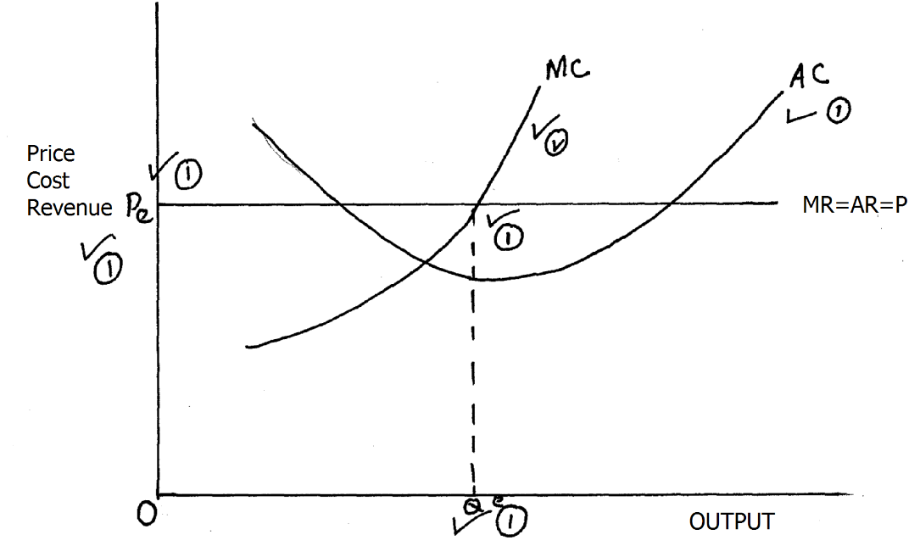

The firm will produce at 1 Qe where MC = MR1 and sell at Pe1

