565/2/
BUSINESS STUDIES
PAPER 2
JULY/AUGUST 2019

BUURI EAST STANDARDS
Kenya Certificate of Secondary Education
MARKING SCHEME

- a) Reasons why it would be beneficial to assign each workers a specific
job in production.
- Output per worker is greatly increased thus reducing cost per unit.
- Workers engage in the trade they are best suited /talented leading to increased productivity /quality production.
- Encourage invention and innovation , one becomes a better worker after doing certain tasks repeatedly over some sometime.
- Enhances the use of modern machines making production faster and more efficient.
- Enables a worker to acquire skills in a particular field thus improving efficiency /productivity.
- Less mental /physical effort is spent when one gets used to a particular job/less fatigue.
Any 5x2=10mks
b) Differences between gambling and insurance.
 | INSURANCE | GAMBLING
 | Person taking policy should have insurable interest. | A gambler has no such interest.
 | It aims at restoring one’s financial position he/she enjoyed before the occurrence of the loss. | The gambler’s aim at improving his/her financial position.
 | Insured pays regular premiums for insurance cover to remain in force . | In gambling money is only paid once.
 | It involves pure risks. | Gambling involves speculative risks.
 | Events of loss might never occur. | The events of bet must happen to determine the winner and the loser.
Differences must match to score. Any 5x2=10mks
- a) Reasons why a commercial bank may not honor a cheque.
- Insufficient funds in the drawers account.
- Signature of the account holder/drawer may differ from the specimen in the bank.
- Post dated cheque - presented for payment earlier than the date indicated on it.
- Stale cheque - presented six months after the date issued.
- If the drawer has closed his/her account with the bank thus no transaction can go on his account.
- Death /insanity /bankruptcy of the drawer the bank gives to instructions to the bank not honour the cheque when presented.
- When the cheque has been altered and the drawer has not signed gained the alteration.
Any 5@ 2mk=10mks

b)
Jamal traders’
Three column cash book√
Dr Cr.
Date | Details | lf | Dis. | cash | Bank | Date | Details | LF | Dis. | cash | Bank
1/7/2018  2/7/18  6/7/18  18/7/18  22/7/18  28/7/18  30/7/18  31/7/18 | √  Bal.  Sales√  Mwala√  Sales √  bank√  kajairo √  Cash√  Balance | b/d  c  c  b/d | 3200√  196 √  660√  3860√ | 87,000√  50,000√  150,000√  30,000√  16,500√  333500  10,000√ | 250,000√  76,800√  255,300√  582100  365,600√ | 3/7/18  12/7/18  16/7/18  21/7/18  22/7/18  25/7/18  30/7/18  30/7/18 | salaries √  furniture√  Kiogora√  wages√  cash√  drawings √  bank√  balance √ | C  c c/d | 800√  800√ | 39,200√  24,000√  5,000√  255,300√  10,000√  333,500 | 101,500√  85,000√  30,000√  365,600√  582,100
40 ticks X ¼ = 10Mks
- a) Ways in which Kenya is likely to benefit from a properly prepared development plan.
- Enables mobilization and allocation of resources appropriately / best way possible.
- It can be used to secure foreign aid since it is a requirement by finances.
- Used to evaluate projects at different stages of implementation to assess whether they are in line with expected outcome.
- It enables coordinated investment to prevent regional imbalances.
- It helps to minize wastage or duplication of industries.
- It is used to increase the rate of capital formation.
- It stimulates effort of the people towards a given direction.
- Solves problems of incorrect imperfections in the market due to presence of monopolies and oligopolies.
Any 5x2= 10mks
b) Effects of a decrease in supply on the equilibrium price and quantity.
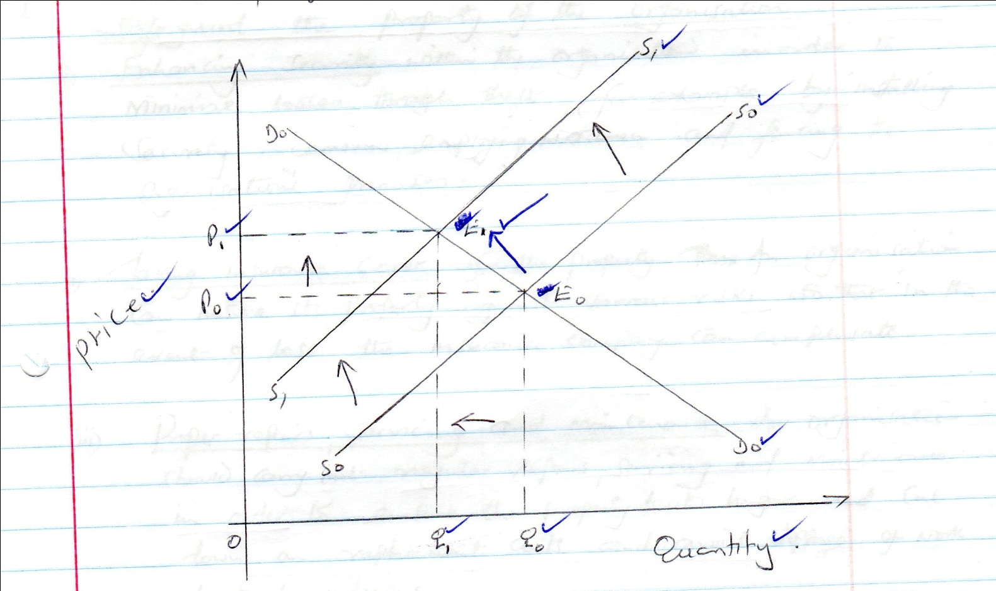

When the supply curve shifts from SoSo to S1 S1, The quantity demanded decreases from Qo to Q1 and the price increases from Po to P1 hence changing the equilibrium point from Eo to E1. 10 ticks @ 1 mk= 10mks

4. a) Measures that can be taken by an office to safeguard the property of the organization.
- Enhancing security within the organization in order to minimize losses through theft for example by installing security cameras, employing watchmen and fencing the organizations premises.
- Taking insurance cover for the property. An organization can insure its property against various risks so that in the event of loss the insurance company can compensate.
- Proper repairs, serving and maintenance An organization should carry out regular repairs serving and maintenance in order to ensure the property lasts longer and cut down on replacement costs and avoid stoppage of work due to breakdowns.
- Physical stock taking of each property. An organization should conduct regular verification of the number of its property to ascertain that the property is secure and prevent losses.
- An organization should maintain records of movement and usage of each of its property in order to monitor where and who is using its property in order to minimize misuse and losses of the property.
- An organization should ensure that individuals using its property take care of it so that no losses or damages are suffered .
any 5 @ 2mks=10mks
b)
Purchases journal
Date | Particulars | Invoice | LF. | Amount
2/1/16  18/1/2016  26/1/2016  30/1/2016 | Jirani ltd. √  Chuma ltd√  Mwanaishi traders√  Totals posted to the purchase a/c (dr) √ |  | Pl  Pl  Pl | 80,000√  140,000√  160,000√  380,000√

Sales Journal
Date | Particulars | Invoice | LF. | Amount
5/1/16  20/1/2016  25/1/2016  30/1/2016 | Mungi traders . √  Moto traders √  Juakali traders√  Totals posted to the sales a/c (cr) √ |  | Sl  Sl  Sl | 50,000√  150,000√  70,000√  270,000
Sales returns journal
Date | Particulars | Invoice | LF. | Amount
10/1/16  28/1/2016  26/1/2016  30/1/2016 | Mungi traders. √  Jua kali traders . √  Totals posted to the Return inwards account a/c (dr) √ |  | Sl  Sl  Pl | 60,000√  4,000√  10,000√
Purchases returns journal
Date | Particulars | Invoice | LF. | Amount
12/1/16  24/1/2016  30/1/2016 | Jirani traders√  Chuma traders. √  Mwanaisha traders√  Totals posted to the returns outwards a/c (cr) √ |  | Pl  Pl  Pl | 3,000√  8,000√  12,000√  23,000√

30ticks @1/3=10mks

5.a) Roles played by the Kenya external trade authority (KETA) in promoting
Kenya’s external trade.
- Expansion and diversification of exports.
- Exploration of foreign market with the aim of identifying business opportunities.
- Provision of valuable information about the nature and conditions in the foreign markets.
- Developing trade agreements between Kenya and other countries.
- Arrange courses and seminars for local business people to inform them on how to promote exports.
5x2mks=10mks
b) Factors which determine the size of a country national income .
- Labour supply - where a county with more people would be expected to produce more than a country with less people.
- Capital - whereby a country that uses modern equipment such as tractors in ploughing would be able to produce more than a country using simple tools.
- Entrepreneurship - where factors that are organized in the correct proportions, output is likely to increase thereby increasing national income.
- Land where national income depends on national resources endowment of that country.
- Level of technology - used the higher the output hence national income.
- Political stability - conducive political atmosphere attracts both local and foreign investors who in turn contribute to increasing size of national income.
- Altitude of citizens towards work work- where had working citizens registers high level of national income.
- Size of the subsistence sector -which lowers or increases the country’s national income depending on the level.
- Foreign investment which increases production or goods and services.

5x2=10mks

6.a) Causes of breakdown in communication.
- Language barrier – where the recipient does not understand the language used by the sender /foreign language /different dialect/ accents used.
- Poor listening skills where the recipient does not pay full attention/concentration hence falls to understand the message.
- Emotional responses/problems- when communicating under emotional distress/anger/excitement may lead to distortion of message.
- Breakdown of medium of communication especially when using mobile phones where the network is poor /unclear systems within organization.
- Negative attitude towards the sender/receiver. Thus may create mistrust and prejudice hence deliberately /unintentionally misunderstanding the message involved.
- Premature judgment where the sender /receiver make conclusions before they fully understand the message thus making communication difficult.
- Poor communication skills – when one cannot express him/herself well leading to wrong interpretation of the message.
- Noise/sound that comes in during communication thus preventing the communicating parties from understanding one another.
Any 5x2=10mks

b..

Njoroge Traders
Trading profit & loss a/c
For the period ended 31/12/2017

Sales 390,000√
Less return Inwards 10,000√
Net sales 380,000

380,000
Gross profit b/d 115,000 √
Commission received 36,000√
Discount received 7000√

158,000
Opening Stock 30,000√
Add purchases 275,000√
Add .carriage inwards 16000√
Less Return outwards 6,000√
(C.O.G.A.F.S) 315,000√
Less closing stock 50,000
Cost of sales 265,000√
Gross profit c/d 115,000 √√
380,0000

Bad debts 3,000√
Discount allowed 5,000√
Wages 20,000√
Rates 12,000√
Insurance 19,000√
Carriage outwards 8,000√
Net profit c/d 91000√
158,000

NB: i) Wrong profit c/d but correctly b/d awards a tick
ii) penalize foreign items in the trading profit &loss a/c and in the balances sheet.

Njoroge traders
Balance sheet
As at 31stDecember 2017

Capital 689,000√
Add Net Profit 91,000√
Less: Drawings 25,000√
Net capital 755,000
Liabilities

Bank overdraft 210,000√
Creditors 52,000√

1,017,000

30ticks @1/3 = 10Mks
Fixed Asset
Building 450,000√
Furniture and Fittings 180,000√
Current Assets

Cash at bank 250,000√
Cash at hand 40,000√
Debtors 47,000√
Stock 50,000√

1,017,000

